**1) Clean Start (Service Worker + Cache)**

* Application tab → Service Workers:
  + Click “Unregister” (or “Update” then “Skip waiting”), then check “Bypass for network” (if available).
* Network tab → check “Disable cache”.
* Hard reload the page (Shift+Refresh).
* Confirm the top of DevTools Console is empty (no prior errors).

What to copy back:

* A screenshot of the Application → Service Workers state after unregister/bypass.

**These are the screenshots after the step 1 is completed**

**2) Reproduce Once And Capture Network**

* On the Profile page, change:
  + Username to a new value (e.g., “testuser123”).
  + Pick a built-in avatar (click any avatar square; don’t upload yet).
* Click Save.
* Network tab → Filter “save_user.php”.
* You will likely see two entries:
  + One “initiator: service-worker.js” (actual network).
  + One “initiator: profile.js” (fulfilled by SW).
* Click the entry with a non‑zero “Size” (usually the service‑worker one).

Capture these:

* Headers → General: “Request URL”, “Status Code”.
* Request URL
* http://localhost:8081/endpoints/user/save_user.php
* Request Method
* POST
* Status Code
* 200 OK
* Remote Address
* [::1]:8081
* Referrer Policy
* no-referrer
* ﻿
* profile.php:67 GET http://localhost:8081/images/avatars/user.svg 404 (Not Found)
* profile.php:345 GET http://localhost:8081/images/avatars/user.svg 404 (Not Found)
* ﻿
* Headers → Response Headers: “content-type”.

<br />

<b>Parse error</b>: Unmatched '}' in <b>/var/www/html/endpoints/user/save_user.php</b> on line <b>329</b><br />

* Request → Form Data: all fields (username, firstname, lastname, email, avatar, main_currency, language, optionally profile_pic if you uploaded).
* avatar

images/avatars/user.svg

* profile_pic

(binary)

* username

Kambo

* firstname

Newton

* lastname

Ochieng

* email

newton.ochieng97@gmail.com

* password
* confirm_password
* main_currency

1

* language

en

* Response → full response body text (copy it, even if it looks like HTML or a PHP warning).
* Right‑click in Network pane → “Save all as HAR” (attach the HAR if you can).

What to copy back:

* Content-Type value.
* Complete Response body (paste as text).
* Request Form Data (screenshot is fine).
* The HAR file.

Why this matters: If the body isn’t valid JSON (polluted by PHP warnings/notices), the UI shows “Unknown error”. Seeing the raw body confirms it.

Here I could not see two of them. Check screenshot below, there is only save.php and save_user.php

* You will likely see two entries:
  + One “initiator: service-worker.js” (actual network).
  + One “initiator: profile.js” (fulfilled by SW).

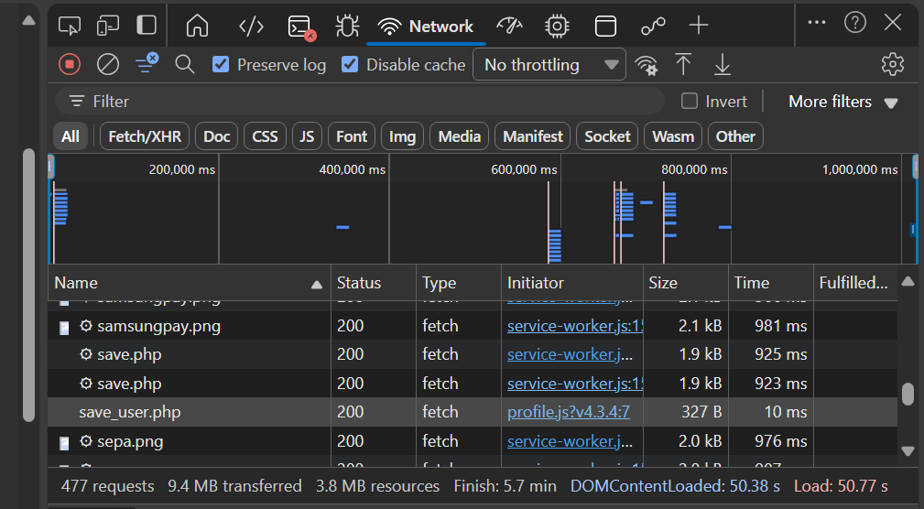

**3) Console Errors + Form State At Click Time**

* Console tab:
  + Copy any red errors (especially right after the Save).
  + In the console, run these and paste results:
    - document.getElementById('avatarUser')?.value
    - document.getElementById('avatarImg')?.src
    - document.getElementById('username')?.value
    - document.getElementById('language')?.value
    - document.getElementById('currency')?.value
* Note any “Failed to load resource: 404 user.svg” (means the app is trying to load a root-level /user.svg — a strong hint of avatar path format problems).

What to copy back:

* Console errors (verbatim).
* The five values printed by those commands.

