# **PatientApp Notes**

## Architecture:

**Backend**

* logging
* Mediator
* CQRS
* Clean-Architecture
* Controller Versioning
* Behaviors
  + Logging
  + Performance
  + Fluent Validation
* CORS
* JWT Token
* Authentication
* Authorization
* Fluent Validation
* Middleware
* Consolidated Dependency Injection

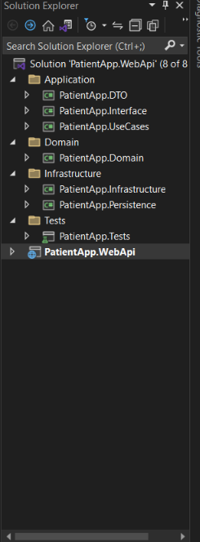

**Front End:**

* React
* Environment Variables
* Reducers
* Actions
* Dispatchers
* Material UI

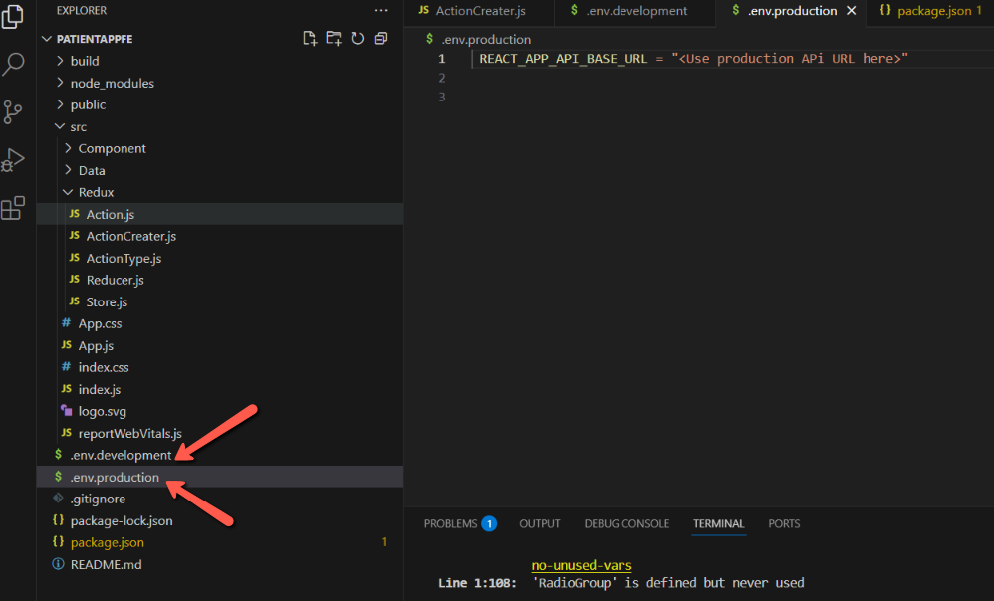

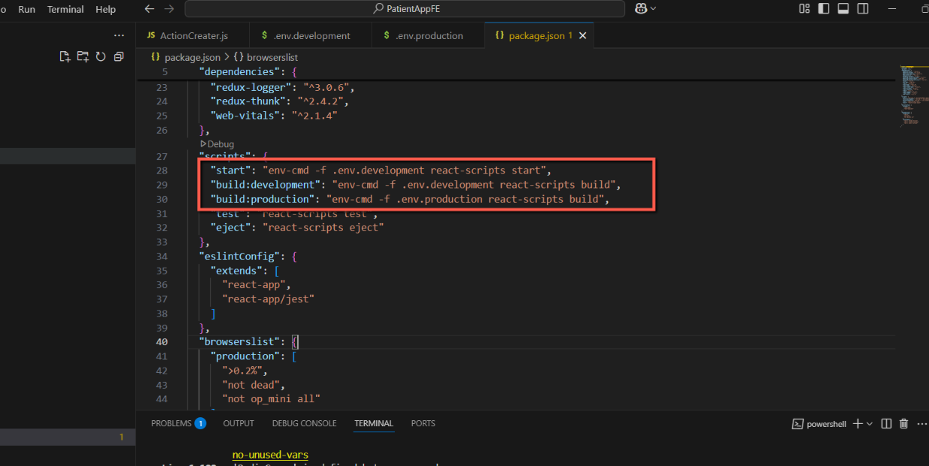

## Steps to up and run the project:

**Backend:**

1. Restore the **PatientApp.bak** in database.
2. Update Server name in connection string in the **appsettings.json** to align with your local db server.
3. Set **PatientApp.WebApi** as Start up project if not already.

Front End:

1. Ensure latest version of node is installed on machine.
2. Open project in VS code.
3. Run **npm i** on terminal
4. Once completed, run **npm start** to run the application.