**CHAPTER 4**

**DESIGN MODULES**

For better understanding purpose we have broken down / sorted our project into 3 modules namely “Login Module”, “Update Module”, “View Module”. Let’s go through these modules now.

**4.1 Login Module**

Let’s begin with an image for a quicker grasp.

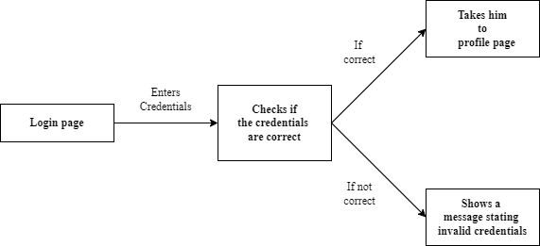

Figure 4.1: Login Module

1. In the login page the user is requested to enter 2 credentials which will be given by us to the user. The 2 required credentials are namely: “Username” and “Password”.
2. Once the required credentials and entered and the “LOGIN” button in hit the program smartly checks the entered credentials.
3. If the credentials are matched, then the user is taken to a profile page with a welcome message and then the user can go to “Update” and “View” pages.
4. If the credentials do not match, an error message stating, “Please check your details and try again.” is shown to the user.
   1. **Update Module**

The picture below shows how the Update module functions

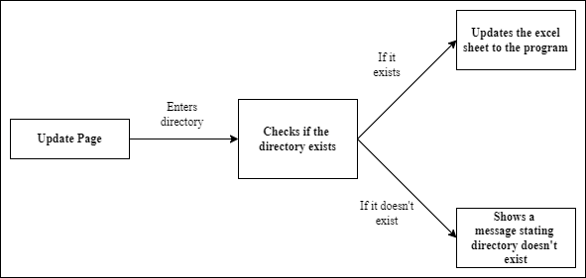

Figure 4.1: Update Module

1. In the update page the user is asked to enter the directory of the excel sheet he wanted to upload.
2. The computer again smartly checks if the entered directory exists and if it is an excel sheet.
3. If the sheet exists in the specified directory, then the excel sheet is uploaded to a local variable and now the data can be viewed in the way we want.
4. If the directory specified is wrong or if it doesn’t exist, then an error message is shown to the user stating, “invalid file try again!!” within the Update page. So, the user can enter the directory again and try.
   1. **View Module**

So, unlike the other 2 modules here we have 2 options given to the user depending on the output he wants/expects. Let’s look at a picture for better understanding.

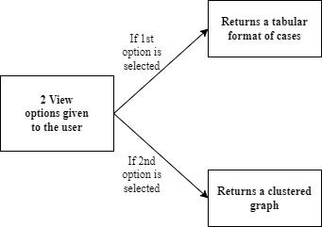

Figure 4.3: View Module

1. In the View page the user is given two options: “based on latitude and longitude” and “based on time limit and type of case”.
2. The first option shows all cases occurred at a particular point in a tabular format whose latitude and longitude are given by the user as input.
3. The second option shows all cases that occurred within a given time limit and belong to a particular type of crime (e.g., Murder, Dispute etc) which are given as inputs by the user, the output in this option is shown to the user in clustered format. The clustering is done based on the density of the cases and gives a colour for each to differentiate.
4. Once the required output is shown to the user the webpage comebacks to the “profile page” from where the user is allowed to either update more crimes or view crimes in other formats he wanted.