INF222 - Practical Work Submission

Name : TCHUENCHE KAMDEM SAMUEL YEDIDYA
Matricule : 23U2987

INF2222 : Backend Development

Exercice_0 : Setting up development enviroment :

I am using Ubuntu 20.04.6 LTS for this project, leveraging its robust environment for backend development

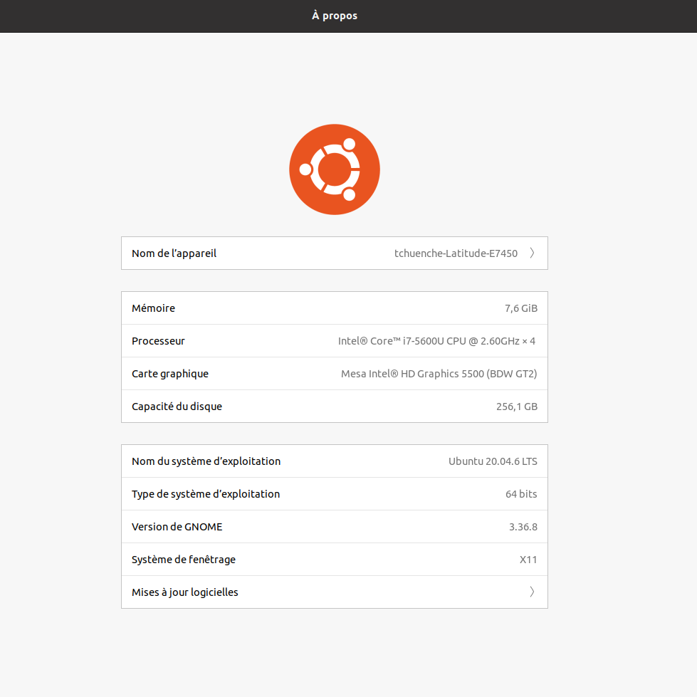

2-

Technology/Tool | Programming Language | Purpose | Specific Version/Proposed Tool
Backend Language | Python | As the main programming language | python:3.8-slim
Web Framework | Flask | For the backend development of the application | flask==3.0.3
Database System | PostgreSQL | To manage the database of the app | postgres:13-alpine
Code Editor/IDE | VS code | My development enviroment where the app is developed | Vs code 1.101
Docker | Docker io | The Docker where the app is Dockerise for deployement | Docker version 24.0.5
Version Control | Git | To manege my versions | git 2.49.0

3- Install the development environment

- python3 : sudo apt install python3 python3-pip
- Flask : pip install flask flask-sqlalchemy psycopg2-binary
- PostgreSQL : sudo apt install postgresql postgresql-contrib
- Docker : sudo apt install docker.io docker-compose

Exercice_1 : Data collection.

1- I downloaded differnt data images and store it in my FOOD_APP/static which i can acces easily

2- I proposed a complete and robust UML diagram for my food app.

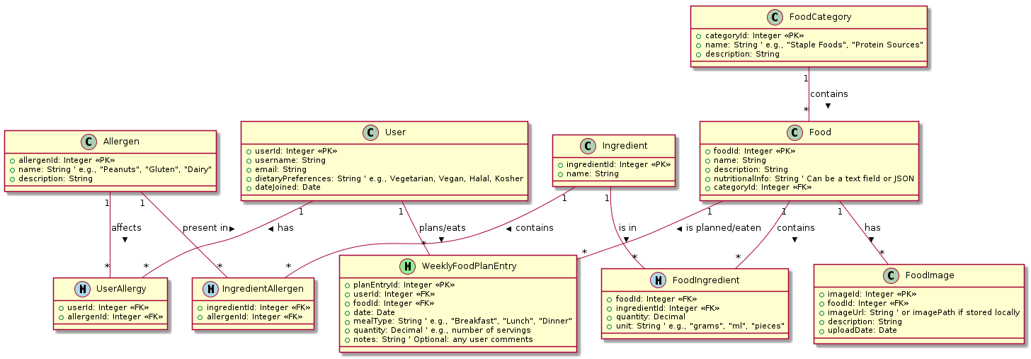
Exercice_2 : In this exercice, i implemented the DAO modules using psycopg2
as my connectivity API and later on i used sqlalchemy
for the ORM approach. Where i build and populated my databases.

Exercice_3 : Business logic implementation
The business module encompasses the core functionalities and entities that define the application's domain.
a) Module for Weekly Food Planning
This module is designed to empower users to organize and schedule their food consumption on a weekly basis, linking specific food items to particular dates
and meal types. Definition of a WeeklyFoodPlanEntrySchema using ma.SQLAlchemyAutoSchema for data serialization/deserialization.

b) Module for Managing a Buffet in the Case of a Ceremony
This module is conceptually designed to assist in the management of food items for events or buffets, facilitating tracking of food prepared and consumed.

Exercice_5 : Deployment, Design and Implementation of the API Endpoint
Here, i used the Docker technologies to Dockerise my backend application. Secondly i did a file that contains all my API endpoints for all the services my app provide. (the file is in the same folder as this one named : « API_ENDPOINT.pdf» )

