**Blight & Housing Conditions Analysis Report**

**City of Jackson – Data Insights & Policy Recommendations**

1. **Introduction**

The purpose of this report is to analyze housing conditions in Jackson, Mississippi, focusing on blight, property values, and neighborhood trends. Using simulated housing data, we identify key insights that can inform policy interventions to improve housing quality and economic growth in affected areas.

The dataset consists of 500 properties, categorized by neighborhood, housing condition, property value, age of home, median income, flood risk, and heat vulnerability. Data visualizations help highlight housing trends and identify potential problem areas.

2. **Key Findings**

**Blight Distribution Across Neighborhoods**

- **Downtown has the best housing conditions**, with most homes classified as "Good."

- **East Jackson has the highest concentration of blighted homes** and properties needing repair.

- **South Jackson, West Jackson, and Midtown show mixed housing conditions**, with a significant number of homes requiring repair.

📊 *See visualization: Blight Distribution Across Neighborhoods*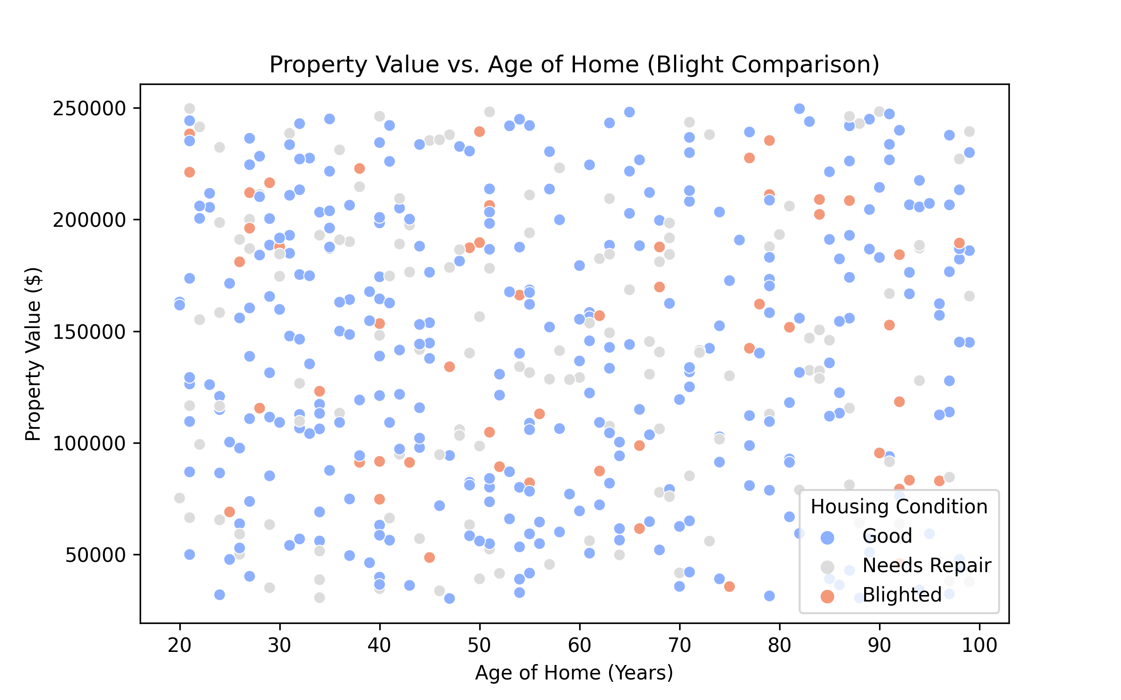

**Property Value Trends**

- There is **no clear correlation between home age and property value**.

- Some older homes retain high property values, while some newer homes are undervalued.

- This suggests **factors other than home age influence property values**, such as location, neighborhood development, and infrastructure quality.

📊 *See visualization: Property Value vs. Age of Home*

**Neighborhood-Level Housing Conditions**

- **Downtown properties have the highest median property values**.

- **East Jackson has the highest percentage of homes needing repairs.**

- **Blight appears to be linked to economic disparities**, with lower-income neighborhoods showing higher rates of blighted homes.

3. **Insights & Interpretation**

1️⃣ **Downtown's strong housing conditions** suggest that urban investment and infrastructure maintenance contribute to stable property values.

2️⃣ **East Jackson's high repair needs indicate a need for targeted revitalization programs**, including housing grants and private investment incentives.

3️⃣ **The lack of correlation between home age and property value** suggests that neighborhood conditions, local policies, and economic opportunities play a bigger role in property valuation than the physical age of a home.

4. Policy & Community Recommendations

🏠 **Targeted Housing Revitalization Programs**

- Establish **home repair assistance grants** for low-income residents.

- Partner with developers to **revitalize abandoned or blighted homes**.

- Introduce t**ax incentives** for property owners to maintain housing conditions.

📈 **Incentives for Property Investment**

- Provide **low-interest loans for home renovations** in East Jackson.

- Encourage **public-private partnerships** to stimulate affordable housing development.

- Develop programs to **attract first-time homebuyers** to revitalizing areas.

🏙️ **Public Infrastructure & Community Development Strategies**

- Improve public infrastructure (roads, lighting, parks) to **increase property values**.

- Support local businesses and amenities to **encourage neighborhood growth**.

- Implement **smart zoning laws** that encourage mixed-use development.

5. **Conclusion & Next Steps**

This analysis provides a foundation for **data-driven urban planning and housing policy improvements** Future work should:

✅ **Incorporate real housing and economic data** for validation.

✅ **Expand the analysis to include crime rates, education access, and employment opportunities**.

✅ **Develop predictive models to assess the impact of revitalization programs over time.**

By leveraging data insights, Jackson can implement **strategic interventions** to reduce blight, improve housing conditions, and stimulate long-term economic growth.

📌 **Next Steps:** Engage policymakers, community stakeholders, and real estate developers to discuss implementation strategies.

📊 **Report prepared using data visualizations and insights from Kaggle analysis.**