Lab
- Create an entity (company) with primary field (company name) and contain below fields:
- Address (single line of text)
- Organization type (option set with values: Local, National, International)
- Business phone (Single line of text): Accepts numbers only
- Fax (Single Line of text)
- Email (Single Line of text) with email format
- Number of Employees (whole Number): Locked, used to count all employees inside the company
- Create Button Called (Add Employee) that open the employee main form to add new record
- Create Subgrid for employee entity and hide (+) button of the subgrid.
- Adjust the company main form to be similar as below:

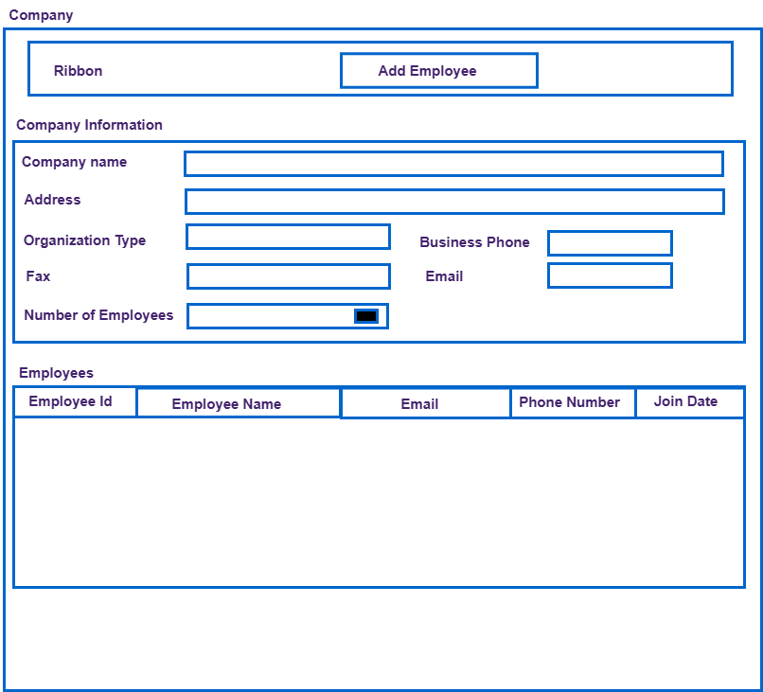

- Create another entity called (Employee) with a primary field (Employee name) and contains below fields
- Employee code (Single line of text)
- Company Name lockup field
- Email (Single Line of Text) with email format
- Mobile number (single line of text): accept numbers only
- Join Date: accept only current date or date in the future, lock after record creation
- Add section called “medical insurance” contains:
- Medical Id (Single line of text)
- Spouse name (Single line of text)
- Have children? Two options
- No of children (whole number)
- Marital status (option set with values: Single, married, divorced) with the below specifications using business rule:
- If the user selects “married”: show “spouse Name” & “have children?” and make fields required
- If the user selects “Divorced”: show “have children?” and make field required
- If the user selects “Yes” for “have children?” show “No of children” and make it required

- Activate employee: A button to change record status from inactive to active and display only when record is inactive (call an action on a button)
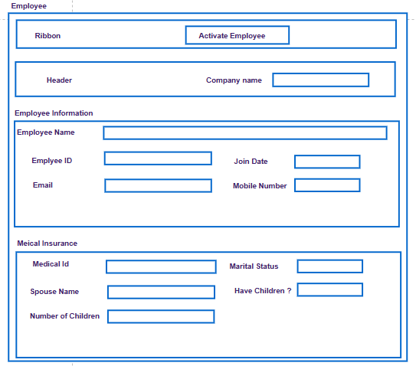

- Create SLA Timer at Certification Entity
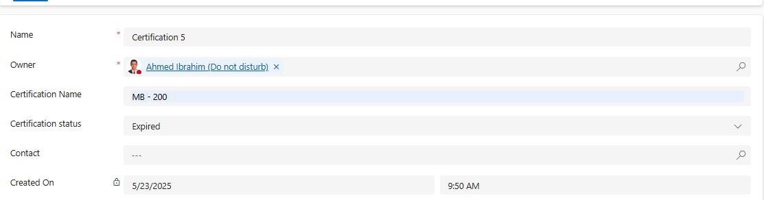
- Create and publish a duplicate detection rule to prevent users from creating duplicate Employee
records based on email address and Employee name.
- Create workflow to assign contact record when record is created to your user and send email to user same as presentation
- Create payment entity and make it as activity entity

- Download import data template for employee entity and try to import it again to system after filling employees data
- Employee Status by Company Chart Type: Stacked Bar Chart
Description: Number of employees per company grouped by status (e.g., Active, On Leave, Terminated)

- Company Size Categories Chart Type: Pie Chart / Donut Chart
Description: Categorize companies based on employee count (e.g., Small: <50, Medium: 50–200, Large: >200).
And display charts in dashboard called “Company Statistics”

