بسم الله الرحمن الرحيم

GCC Cybersecurity Threat & Risk Assessment ( TRA )

By: Kamel Nuri

Content:

1. Introduction.
2. Regional Cybersecurity Context
3. Regulatory Environment
4. Threat Actor Landscape
5. Human & Cultural Factors
6. Emerging/Future Threats
7. Risk Statements
8. Proof of Concept (POC)
9. Mitigation & Recommendations
10. Conclusions
11. About the Writer

Notes :

* This report was done using Google Search & ChatGPT Ai tool , based on my ideas & research and for better explanation of the risk types and cultures
* Cisco Ethical Hacking course at Netacad.com helped me a lot in understanding what does SOC analyst do.
* This is not a cybersecurity expert opinion report , but instead this is my 101 homework report understanding step by step what SOC is , and it’s only for Education purposes .
* \*\* Very Important to me \*\* : Kindly ill attach with this report an empty TRA sectioned papers showing two sections (Pros - Cons) for you to fill . Please honor me with your expert opinion about this report . Leave the paper with the security reception office outside ill come to collected again within one week . anonymously no name needed on paper.

Introduction to Threats:

As we all know , technology evolve rapidly and very fast compared to what we know and can comprehend or understand . In this modern day and age we need to create more IT schools compared to soldiers numbers on the ground, because as technology evolve they are our first line of defense . Today I’d love to focus on:

Rapid digital transformation in GCC areas (Banks ,Oil & Gas , Smart Cities uses IoT connectivity )

Rising cybersecurity Threats from regional conflicts, fraud and global APTs

Gaps in fraud analytics, regulatory consistency and cross boards incident response

Regional Cybersecurity Context:

* As technology industry growing, so is the businesses in GCC area , which attract more divers companies and labors . This positive sign can also be an opening for frauds and social engineering risk.
* The heavy dependency on energy sector & investment wealth companies demand more cybersecurity analysis teams and personal .
* Lack of sharing fraud information between banks at the same country, then cross boarders holding the fraud mitigation efforts behind.
* Smart cities like (Neom , Lusial) attract massive IoT attack . [Comment: Phrase is overstated; suggest 'increase the IoT attack surface'.]

Regulatory Environment:

* Each GCC country has it’s own regulation agency like NCA – Saudi , Q-Cert Qatar but still working to unify regulation and efforts like GCC-CERT harmonization
* Data protection laws is evolving compared to a long standing US/EU laws.
* Financial sector regulations is improving day by day , but fraud analysis still not strongly enforced , some GCC banks use advanced fraud analytics but still less mature and uneven adoption compared to US/EU.

Threat Actor landscape:

* Wealth always attract cybercriminals, so do wealthy nations always
* Targeted by organized cybercrimes for like mobile banking frauds ,Ransomware attacks , crypto stealing and financial institution records & database everyday attacks , Airports & Airline infrastructure attacks which can delay all flights [Comment: Evidence of \*all flights\* being delayed by cyberattack is lacking; consider softening.].
* State sponsored attacks ( Israel , Iran , Russia, North Korea – some standalone hacktivist groups in some countries like ( anonymous US or anonymous Sudan or Yamen hacktivist or Palestine hackers )
* Insider threats like outsider third party O&G temporary contractor who doesn’t fallow restrict data protections laws and regulations . [Comment: Too absolute; reframe as a potential risk rather than a certainty.]

Cultural & Humans Factor:

* Overly depending on an expat IT teams, risk insider threats
* Language specific phishing attacks like spoofing in Hindu , Arabic or Tagalog targeting locals and expats
* (Wasta) or extra trust based hiring, if the employee doesn’t exactly know what he/she doing with the company employees record or the customer’s records can be extremely damaging and can cause high risk of attacks .

Emerging/Future Threats :

Ai misuse Threats : creating phishing emails, voice cloning, generate malware , chatbot exploitation , carry out influence campaigns , bypass safety filters or maybe automate large scale AI cyberattack like DDoS targeting many infrastructures servers at the same time

Top 3 Critical Disruption Risks for GCC Smart Cities:

1. Mass Traffic Control Outage (High Likelihood / High Impact) :

Why critical: GCC cities rely heavily on smart traffic management due to dense urbanization, high car usage, and mega-events (e.g., World Cup, Expo). Coordinated disruption could paralyze mobility, delay emergency response, and cause secondary accidents.

Justification: High attacker ROI, simple tools (jammers/deauth floods), and cascading economic + safety damage make this the #1 disruption risk.

Priority Controls: Citywide spectrum monitoring, redundant backhaul for controllers, manual override centers with law enforcement integration

1. Hospital IoT Disruption (High Likelihood / Medium Impact → safety critical) :

Why critical: Hospitals increasingly use Wi-Fi/IoT for patient monitoring, infusion pumps, and emergency coordination. A disruption directly risks human lives, with reputational and regulatory fallout.

Justification: Even a single patient fatality elevates this to critical risk. Hospitals are often soft targets with weak RF monitoring.

Priority Controls: Dedicated IoMT networks, signed firmware, local alarms/failsafes, staff training for manual override

3) Port Logistics IoT Outage (Medium Likelihood / Medium Impact)

Why critical: GCC ports (Jebel Ali, Hamad, Dammam) are economic lifelines for oil, LNG, and container trade. Disrupting wireless scanners and yard sensors can stall shipments, cause customs bottlenecks, and ripple into regional/global trade.

Justification: Even medium likelihood is unacceptable due to strategic importance. Economic + geopolitical stakes make this a priority risk. Priority Controls: Private spectrum for logistics IoT, redundant scanning systems, RF monitoring, joint port–telecom SOC capabilities

Endpoint Wireless devices (Traffic Control):

* Threat Description :

An adversary (or environmental factor) disrupts, denies, or degrades wireless communications between endpoints and their controllers. This can be achieved through jamming, protocol abuse (e.g., Wi-Fi deauthentication), malicious firmware updates, physical sabotage, or backhaul disruption. Unlike interception threats, disruption attacks primarily target availability, which is critical in GCC smart-city, OT, and IoT-heavy environments.

* Attack Vectors:

RF jamming or interference (cheap SDR tools, high-power transmitters).

Wi-Fi deauthentication/disassociation floods.

Malicious or corrupted firmware updates (supply chain).

Backhaul disruptions (DDoS, fiber cuts, BGP manipulation).

Battery drain attacks on endpoints.

Physical sabotage of antennas, gateways, or power supply.

Unintentional interference (e.g., from events, misconfigured devices).

* Impact:

Safety incidents: outages in traffic control, flood monitoring, or medical devices.

Service availability: large-scale IoT device failures, service degradation for smart meters, parking, logistics.

Economic/reputational loss: congestion, outages, fines, brand trust erosion.

Cascading effects: failure of one gateway can affect hundreds of devices.

Likelihood Drivers carried out attack :

Low-cost equipment (SDRs, jammers) widely available.

High density of wireless devices in GCC smart-city projects.

Large public events increase attacker ROI.

Weak regulatory enforcement on RF spectrum misuse.

* Detection Indicators:

Sudden unexplained spikes in packet loss, latency, or retransmissions.

Abnormal levels of deauth/disassoc frames.

Unexpected RSSI floor increases or spectrum noise.

Simultaneous failures across many devices/gateways.

Abnormal device reboot cycles or rapid battery depletion.

Existing & Recommended Controls

Segmentation of wireless OT from IT traffic.

Redundancy & diversity (wired + cellular + LoRa).

Spectrum monitoring sensors for RF anomalies.

Protected management frames (802.11w) against deauth floods.

Fail-safe design (graceful fallback, manual override).

Physical hardening of gateways and antennas.

Secure firmware supply chain (signed updates, vendor vetting).

Operational exercises (failover drills with national regulators).

* Risk Statement:

Risk: Deliberate or accidental wireless endpoint disruption causes prolonged service outages, leading to safety incidents, operational downtime, and financial/reputational loss in critical GCC infrastructure.

Likelihood: Medium–High (due to low-cost attack tools).

Impact: High (safety + cascading disruption). Residual Risk: Medium.

Priority Remediation:

Deploy spectrum monitoring, enforce firmware integrity, and guarantee alternate backhaul connectivity for critical services within 90 days.

Proof of Concept (PoC) – Demonstrations :

Purpose: This section demonstrates practical, safe, and controlled simulations that validate the key risks identified in this TRA. All PoC activities MUST be conducted in an isolated test environment, using dummy data and systems, with authorization from stakeholders.

Overview: The PoC is designed to show feasibility (not to exploit live systems) and to provide evidence that informs remediation priorities.

PoC 1 — Smart City: Wireless Traffic Control Disruption

Objective: Show how a low-cost attacker could disrupt IoT-based traffic lights in a simulated environment.

Environment Setup: Raspberry Pi or VM + Software Defined Radio (SDR); traffic light IoT simulation (e.g., MQTT broker with virtual sensors).

PoC Action: Use controlled Wi‑Fi deauthentication/emulation tools (e.g., aireplay-ng in a lab, or scripted MQTT spoofing) to simulate loss of connectivity.

Expected Result: Devices lose connectivity or receive spoofed commands in a testbed, demonstrating availability impact and cascading failure modes.

PoC 2 — Hospital IoT Device Tampering

Objective: Highlight risks to wireless medical device telemetry and command channels using simulation.

Environment Setup: Virtual patient monitor (IoMT simulator), isolated network, rogue AP and packet capture tools (Wireshark).

PoC Action: Capture simulated telemetry and demonstrate where lack of encryption or authentication could expose or allow tampering with readings.

Expected Result: Proof that unprotected telemetry can be observed or altered in test environments, underlining patient-safety risk.

PoC 3 — Port Logistics IoT Outage

Objective: Show how disruption of RFID/Scanner systems can delay logistics operations in simulation.

Environment Setup: RFID/scanner simulator, container manifest DB, isolated test network, optional SDR jammer in a lab range.

PoC Action: Introduce RF interference in a controlled range or simulate scanner failures and measure process delays in the simulator.

Expected Result: Simulated delays and backlog in container processing workflows, demonstrating operational and economic impact.

PoC 4 — AI-Generated Phishing (GCC Context)

Objective: Demonstrate how AI can craft convincing spear-phishing content targeted to local languages and cultural cues.

Environment Setup: LLM or template generator (offline or private instance), dummy domain and logos (do NOT impersonate real organizations).

PoC Action: Generate sample phishing emails in Arabic and English, and test them against benign spam-filter sandbox tools using dummy accounts.

Expected Result: Highly convincing simulated phishing messages that inform training and technical controls needed to mitigate social engineering risk.

Deliverables: For each PoC include:

- Network/architecture diagram of the testbed.

- Terminal/screenshots of commands and tools used (sanitized of secrets).

- Packet captures or logs demonstrating the effect.

- A short impact analysis linking the PoC to the TRA risk statements and recommended mitigations.

Safety & Ethics: All PoC steps must be approved by the owning organization. Tests must not target production systems, public networks, or real user data. Use isolated lab networks, synthetic datasets, and follow legal and ethical rules.

Appendix: Templates and checklists for running the PoC safely (authorization form, test-plan checklist, rollback procedures, and evidence capture template) should be attached when the PoC is executed.

🎯 TRA Recommendation Summary

For GCC smart cities, your TRA should highlight availability-focused disruption threats as top priorities.

Safety-critical risk: Hospital IoT disruption (life-threatening).

Operational-critical risk: Mass traffic control outage (city paralysis).

Economic-critical risk: Port logistics outage (trade disruption).

Together, these represent the three most strategic disruption risks to smart city resilience in the GCC.

Risk scenarios: (Enlarge the page )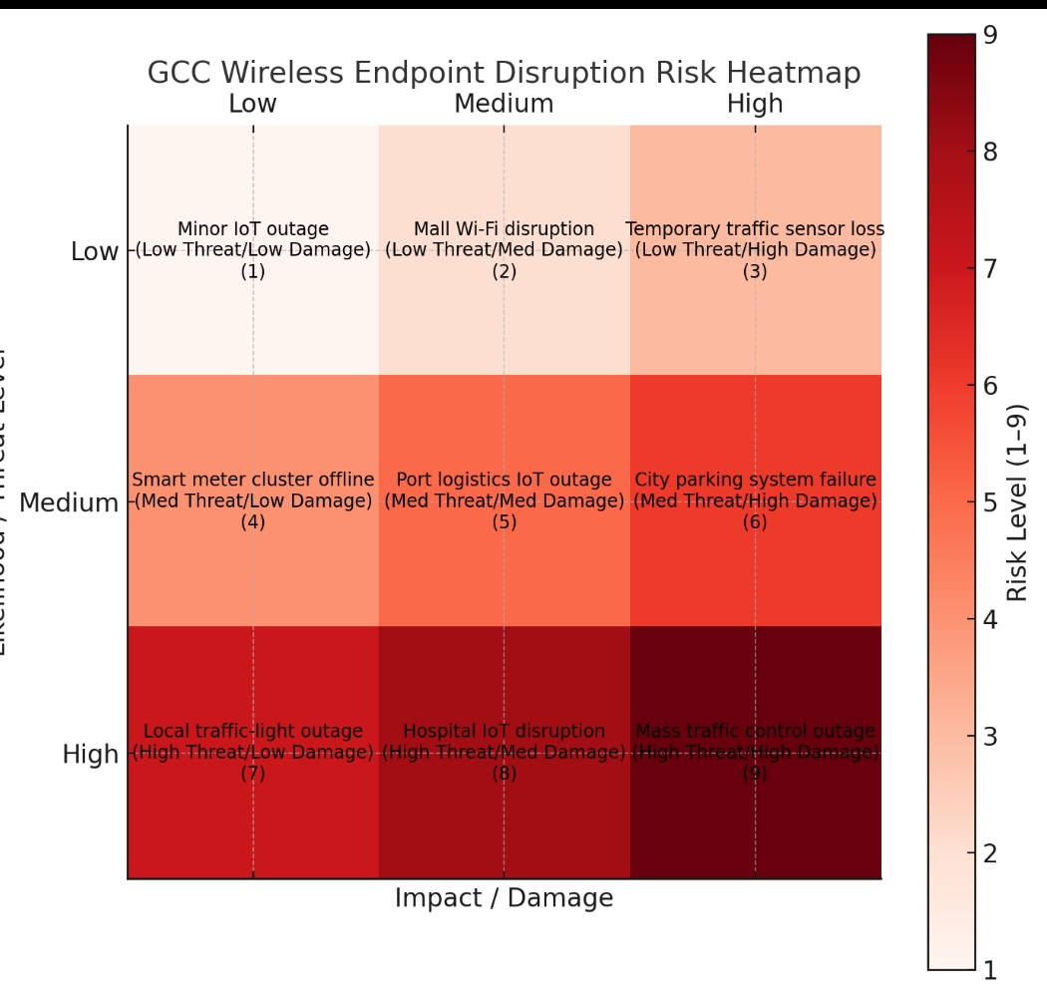

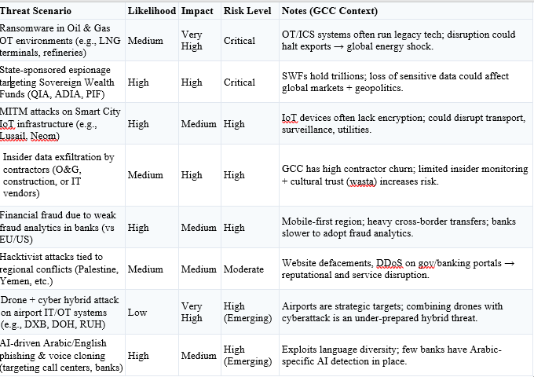

Mitigation & Recommendations:

Regional bush for wide GCC CERT collaboration, unified incident disclosure framework , or in other terms shared cyber threat info between the GCC group .

Expat IT Teams must go under random security check and sign NDA with the employer.

Pen testing and System backups must be done regularly

AI Tools must be embedded to the cybersecurity system to help analyze and detects fraud attempts, bankcards spoofing ……. etc

Conclusion :

* The GCC region is undergoing rapid digital transformation, with smart cities, critical energy infrastructure, and financial systems increasingly dependent on connected technologies. This transformation brings clear opportunities for economic growth and innovation, but also exposes the region to significant cybersecurity threats that are global in nature yet amplified by local factors such as regulatory fragmentation, reliance on expatriate IT expertise, and uneven fraud analytics adoption.
* This Threat and Risk Assessment highlights three disruption scenarios as particularly strategic for the GCC: traffic management outages, hospital IoT disruptions, and port logistics failures. These risks are not theoretical — they are technically feasible with relatively low-cost tools and, if realized, would have cascading safety, economic, and reputational impacts across the region.
* At the same time, the analysis shows that these risks can be mitigated with proactive measures: spectrum monitoring, stronger IoT/OT segmentation, regional CERT collaboration, enhanced fraud analytics, and AI-driven detection capabilities. More importantly, building a culture of cybersecurity awareness, supported by unified regional frameworks and rigorous contractor oversight, will be essential to strengthening resilience.
* In summary, the GCC faces a critical juncture: by prioritizing availability, safety, and information-sharing, the region can not only protect its vital assets but also position itself as a global leader in secure digital transformation. The risks are real and pressing, but with strategic investment and collaboration, they are manageable.

About the Writer:

Kamel Nuri is a Cybersecurity enthusiast.

Thank you very much for your valuable time reading this report .

I am looking forward to your expert insights & comments on this .