

**Department of Computer Science and Engineering**

**Lab Report**

**Course Code:** CSE-454

**Course Title:** Wireless Networks Laboratory

**Submitted By-**

**Name :** Kamelia Zaman Moon

**Exam Roll :** 180657

**Class Roll :** 299

**Session :** 2017-18

**Semester :** 4th year 2nd semester

**Submitted To-**

Nadia Afrin Ritu

Lecturer

Dept. of CSE, JU

Sarnali Basak

Associate Professor

Dept. of CSE, JU



**Department of Computer Science and Engineering**

**Experiment No:** 01

**Experiment Title:** Determination of offered traffic

**Course Code:** CSE-454

**Course Title:** Wireless Networks Laboratory

**Submitted By-**

**Name :** Kamelia Zaman Moon

**Exam Roll :** 180657

**Class Roll :** 299

**Session :** 2017-18

**Semester :** 4th year 2nd semester

**Date of Performance :** 29-11-2022

**Date of Submission :** 12-03-2023

**Objective:** Traffic analysis used to provide a method for determining the cost-effectiveness of various sizes and configurations of networks.

Traffic Parameters of a network:

Average call or packet arrival rate (λ calls/min)

Average call or packet duration (th min)

Offered traffic (or traffic intensity) (A= λth Erlangs)

Number of channels (n)

Blocking probability or QoS (B)

Length of queue

Mean delay

Blocking probability: If Offered traffic (A Erlangs), Number of channels (n),

Blocking probability B and A= λth

**Problem Setup:**

* In communication systems, traffic intensity of an user's or resource's average occupancy over a given period of time.
* Offered traffic (A) represents the total amount of traffic can be moved at a given point of time.
* Penetration rate is an estimation of how many active mobile phone users among 100 peopl in a population.
* GoS(grade of service) means the portion of calls that are lost due to congestion in the busy hour.

GoS = No. of blocked calls/No. of offered calls Blocking probability.

* The likelihood of packet loss of an already accepted call, as well as the probability of approval or rejection of an incoming call, is represented by QoS (quality of service).

**Matlab Code:**

**Ques1:** Determine B(n,A) using Erlang’s formula taking A=12 Erls and n=15

**Code:**

%Ques1: Determine B(n,A) using Erlang’s formula taking A=12 Erls and n=15

A=12;

n=15;

s=1;

for i=1:n

s=s+(A^i)/factorial(i);

end

B=((A^n)./factorial(n))/s;

fprintf("B(n,A) is: \n")

disp(B)

**Output:** B(n,A) is: 0.0857

**RECURRENCE RELATION**

**Ques2:** Proof this using recurrence relation

**Code:**

%RECURRENCE RELATION

%Ques2: proof this using recurrence relation

clc;

clear all

close all

A=12;

n=15;

BO=1;

B(1)=(A*BO)/(1+A*BO);

for i=2:n

B(i)=(A*B(i-1))/(i+A*B(i-1));

end

B(n)

plot(1:n,B,'--ob','LineWidth',3);

xlabel('n');

ylabel('B');

grid on;

title("B vs n Plot Using Recurrence Relation")

**Output:**

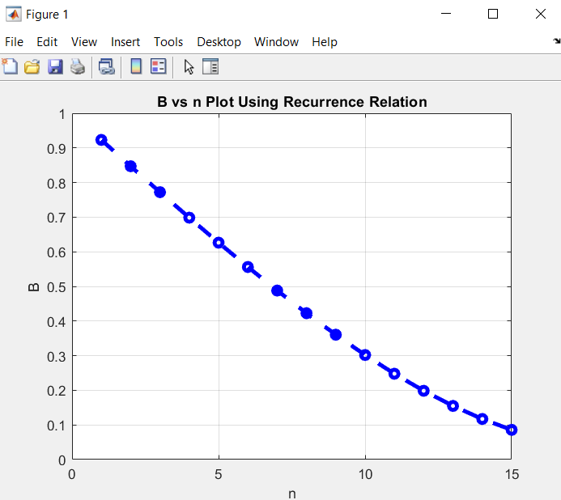

**Ques 3:** Determine offered traffic A taking n=15 and B=0.05

**Code:**

%Ques 3: Determine offered traffic A taking n=15 and B=0.05

clc

clear all

close all

n=15;

Bexp=0.05;

A=8;

e=2;

while e>0.0001

s=1;

for i=1:n;

s=s+(A^i)/factorial(i);

end

B=((A^n)./factorial(n))/s;

e=abs(B-Bexp);

A=A+0.001;

fprintf("%.4f\n", A)

end

**Ques 4:** Probability states before normalization in matrix form.

**Code:**

A1=1;

A2=2;

x1=2;

x2=3;

BW = 9;

M =ceil(BW/x1); %size of the matrix is M by M

for i=1:M

for j=1:M

e = (i-1)*x1+(j-1)*x2;

if e <= 9

S(i, j)= ((A1^(i-1))/factorial(i-1))* ((A2^(j-1))/factorial(j-1));

else

S(i, j)=0;

end

end

end

% rows should be made reversed to cope with Cartesian co-ordinate system

for i=1:M

for j=1:M

k=M-i+1;

S1(i, j)=S(k, j); %states are now S1(x,y)

end

end

T=sum(sum(S1));

Sn=S1/T;

B2 = 0;

for i =1:M

for j =1:M

k=j+1;

if Sn(i, j) > 0 && Sn(i, k)==0

B2 = B2+Sn(i, j);

end

end

end

% open states of roof

B1= 0;

for i = 2:M %start with 2nd row

for j=1:M

k=i-1;

if Sn(i, j)>0 && Sn(k, j)==0

B1= B1+Sn(i, j);

end

end

end

B1=B1+Sn(1,1);

**Output:**

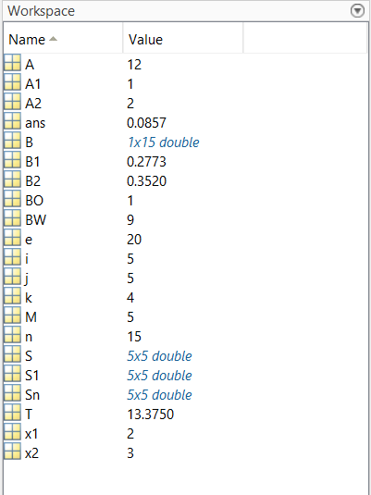

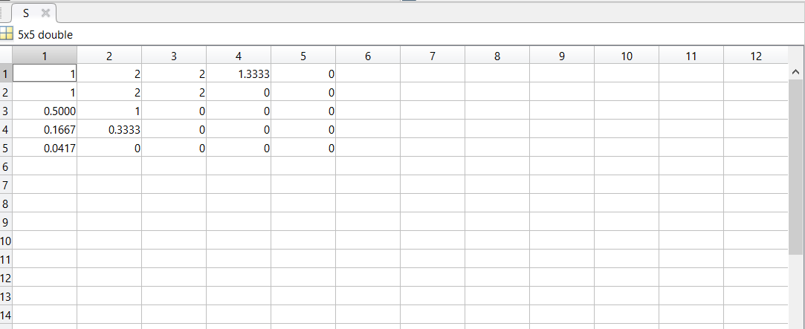

**Conclusion:** This experiment works with both 1D and 2D offered traffics. Also works with bandwidth given.



**Department of Computer Science and Engineering**

**Experiment No:** 02

**Experiment Title:** Simulation of Cognitive Radio Network (CRN)

**Course Code:** CSE-454

**Course Title:** Wireless Networks Laboratory

**Submitted By-**

**Name :** Kamelia Zaman Moon

**Exam Roll :** 180657

**Class Roll :** 299

**Session :** 2017-18

**Semester :** 4th year 2nd semester

**Date of Performance :** 06-12-2022

**Date of Submission :** 12-03-2022

**Objective:** Cognitive Radio Networks (CRNs) are gathering steam as a way to increase spectrum utilization in radio environments by utilizing idle or underutilized airwaves. In this experiment we aim to

* Simulate CRN to ensure maximum utilization of the frequency spectrum
* Increase the efficiency of a frequency spectrum.

**Problem Setup:** Cognitive radio (CR) is a form of wireless communication in which a transceiver can intelligently detect which communication channels are in use and which are not, and instantly move into vacant channels while avoiding occupied ones. This optimizes the use of available radio-frequency (RF) spectrum while minimizing interference to other users. In cognitive radio network there are two types of users:

1. Primary users (licensed user)

2. Secondary users (unlicensed user)

The spectrum sensing of SU are analyzed using two hypothesis like below,

H0: PU does not exist

H1: PU does exist

The received signal for the i-th SU can be expressed as follows:

The false alarm and detection for the i-th SU are, respectively, given as,

Under presence of a PU on physical channel, if the received signal strength is lower than the threshold value, then the phenomenon is called misdetection.

To determine the detection performance, we first note that the test statistics T(x) as,

The probability of false alarm,

Next the probability of detection,

**Matlab Code:**

**Simulation of probability of false alarm and probability of detection**

%# for H0

clc;

clear all;

close all;

%%

var =5;

N=10;

M=100;

T= zeros(M,1);

for i=1:M

x=sqrt(var)*randn(N,1);

T(i)=mean(x);

end

gamma=0:0.25:6;

P=zeros(length(gamma),1);

for i=1:length(gamma)

clear Mgain;

Mgam=find(T>gamma(i));

PFA_sim(i)=length(Mgam)/M;

end

PFA_th=qfunc(gamma/(sqrt(var/N)));

figure(1)

plot(gamma,PFA_sim,'--*r',gamma,PFA_th,':bd')

xlabel("Gamma")

ylabel("Probablility of False Alarm(PFA)")

grid on

title("Comparison of Experimental PFA & Theoretical PFA")

%%

%# for H1

A=2;

T= zeros(M,1);

for i=1:M

x=sqrt(var)*randn(N,1)+A;

T(i)=mean(x);

end

P=zeros(length(gamma),1);

for i=1:length(gamma)

clear Mgain;

Mgam=find(T>gamma(i));

PD_sim(i)=length(Mgam)/M;

end

PD_th=qfunc((gamma-A)/(sqrt(var/N)));

figure(2)

plot(gamma,PD_sim,'--r*',gamma,PD_th,':bd')

xlabel("Gamma")

ylabel("Probability of Detection(PD)")

grid on

title("Comparison of Experimental PD & Theoretical PD")

%%

figure(3)

plot(gamma,PD_sim,'--r*',gamma,PD_th,':bd',gamma,PFA_sim,'--gp',gamma,PFA_th,':mh')

legend('Simulation PD','Analytical PD','Simulation PF','Analytical PF')

xlabel('gamma')

ylabel('PF and PD')

title("Comparison Between PF and PD")

grid on

**Output:**

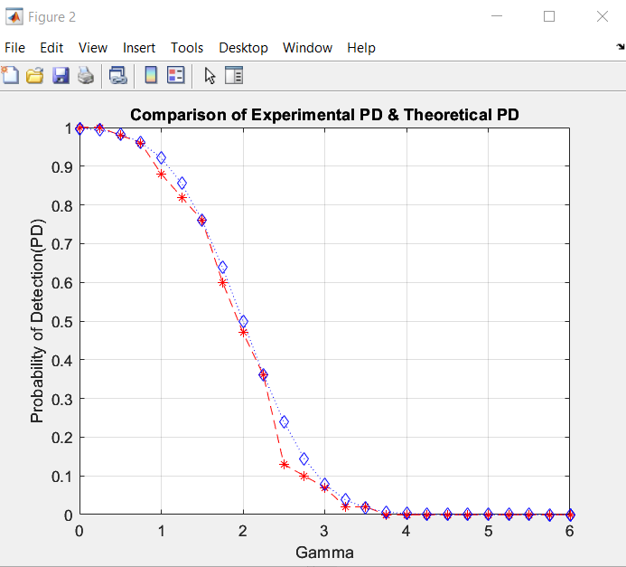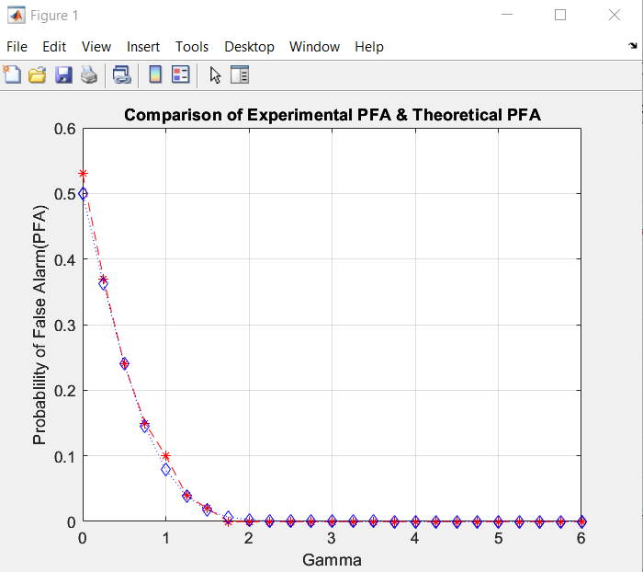

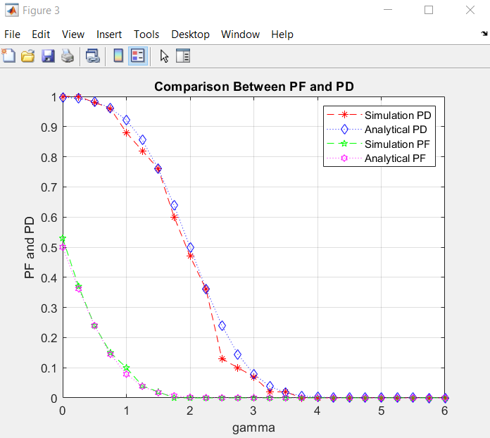

**Conclusion:** The simulation of probability of detection does not match the analytical PD, as evidenced by the output graph of PF and PD versus gamma. Similarly, the analytical curve of the probability of false alarm detection with the data size M=100 does not match the simulation of the likelihood of false alarm detection.



**Department of Computer Science and Engineering**

**Experiment No:** 03

**Experiment Title:** Simulation of on-off Binary Transmission

**Course Code:** CSE-454

**Course Title:** Wireless Networks Laboratory

**Submitted By-**

**Name :** Kamelia Zaman Moon

**Exam Roll :** 180657

**Class Roll :** 299

**Session :** 2017-18

**Semester :** 4th year 2nd semester

**Date of Performance :** 13-12-2022

**Date of Submission :** 12-03-2022

**Objective:** Binary means "two states." The two states are sometimes called "1" and "0", or called "true" and "false", or called "on" and "off", (or other names.) In this experiment, we are doing the simulation of on-off binary signal transmission using MATLAB code for the following:

* To learn and implement probability density function.
* To learn and implement cumulative distribution function.
* Implementation of On-Off Binary Signal Transmission.

**Problem Setup:** We need a carrier frequency and a binary sequence signal to do amplitude shift keying. On-Off keying is yet another name for it. This is because the carrier waves alternate between 0 and 1 based on input signal's high and low levels. Cumulative distribution function (cdf) is measured for discrete probability density function.

For continuous probability density function, Cumulative distribution function (cdf) is measured as

**On-Off Binary Signal Transmission:**

The value of cdf, FX (x) lies [0, 1]

Here, the received waveform,

r(t)=𝑛(𝑡), when 0 is transmitted or 𝑟(𝑡) = 𝑠(𝑡) + 𝑛(𝑡) ,when 1 is transmitted

The input at the detector when 0 is transmitted, the output of the correlator or the input of the detector when 1 is transmitted.

**Matlab Code:**

**Example-1:** Plot PDF of exponential distribution with λ=0.5

**Code:**

%Plot PDF of exponential distribution with λ=0.5

t = 0:0.01:10;

Lambda=0.5;

x = exppdf(t,1/Lambda);

plot(t,x)

xlabel('t')

ylabel('f(t)')

title('Exponential PDF')

**Result:**

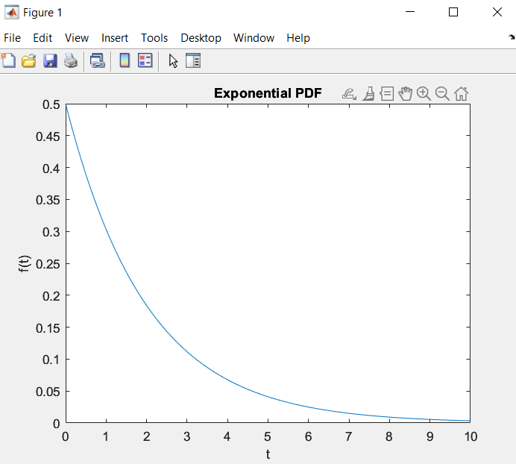

**Example-2:** Plot CDF of exponential distribution with λ=0.5

**Code:**

%Plot CDF of exponential distribution with λ=0.5

t = 0:0.001:10;

Lambda=0.5;

P = expcdf(t,1/Lambda);

plot(t,P)

xlabel('t')

ylabel('F(t)')

title('Exponential CDF')

**Result:**

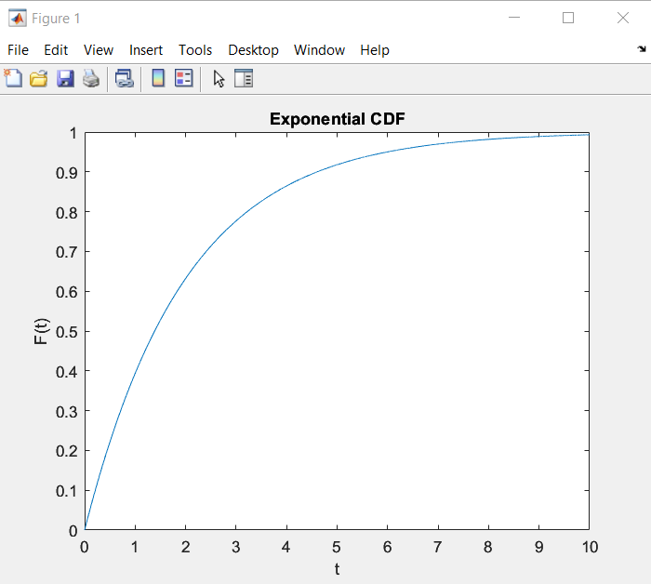

M=200000; %Number of bits used for simulation against each SNR

for k=1:8 % loop for SNR

SNR=2+k*2; %The value of SNR in dB

tx=randi(2, M, 1)-1; %Sequence of 0 and 1

rx=awgn(tx,SNR);

e(k)=0; %initialization of error

for i=1:M %for loop of error

if tx(i)==1

if rx(i)<=0.5

e(k)=e(k)+1;

end

end

if tx(i)==0

if rx (i)>=0.5

e(k)=e(k)+1;

end

end

end %for loop of error

end %loop for SNR

pe=e/M; %probability of error

SNR=4:2:18;

SNR_a=10.^(SNR/10); %absolute value of SNR

pb=qfunc(sqrt(SNR_a/4)); %Theoretical Pb

plot(SNR,pe,'r>:',SNR,pb,'bs:')

legend('simulation','theory')

xlabel('SNR')

ylabel('Pe\Pb')

disp('Error between simulation & theory: ')

disp(abs((pe-pb)/pb)*100)

grid on;

**Result:**

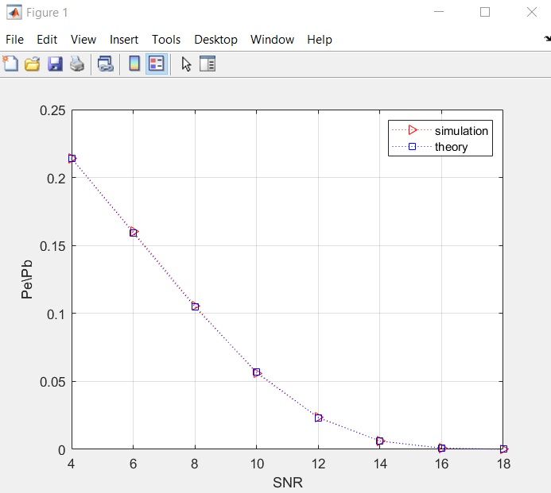

**Conclusion:** We can see in this test that as M rises, the difference between simulation and theory value declines, and as M reduces, the gap between simulation and theory value increases. So, in on-off binary communication systems, when 0 is transmitted, we receive noise in the waveform, and when 1 is relayed, we receive a combination of noise and signal in the waveform.



**Department of Computer Science and Engineering**

**Experiment No:** 04

**Experiment Title:** Simulation of Wireless link under Rayleigh Fading

**Course Code:** CSE-454

**Course Title:** Wireless Networks Laboratory

**Submitted By-**

**Name :** Kamelia Zaman Moon

**Exam Roll :** 180657

**Class Roll :** 299

**Session :** 2017-18

**Semester :** 4th year 2nd semester

**Date of Performance :** 20-12-2022

**Date of Submission :** 12-03-2023

**Objective:** This lab aims to

* Calculating PDF CDF and how wireless links are simulated under Rayleigh fading.
* Observe random distribution of data if they follow Rayleigh.
* Calculate PDF and CDF for that.
* Probability of error is calculated using Rayleigh fading model.

**Problem Setup:** When there are several things in the surroundings scattering the radio signal before it reaches the receiver, Rayleigh fading is a plausible model. The central limit theorem states that if there is enough scatter, the channel impulse response can be well-modeled as a Gaussian process, regardless of the individual component distribution. If the scatter has no dominant component, the process will have a zero mean and a phase distribution that is uniformly distributed between 0 and 2 radians. As a result, the channel response's envelope will be Rayleigh dispersed.

If x is a random variable follows Rayleigh then its pdf expressed as,

The cdf of the random variable x becomes,

, where

Solving the equation of cdf,



where U(x) = rand()

**Matlab Code:**

**Question:** Rayleigh PDF

**Code:**

%Rayleigh PDF

clc;

clear all;

close all;

N=200000; x=0:0.1:5; sigma=1; u=rand(1,N);

r=sigma*sqrt(-2*log(u)); %Rayleigh distributed random data

pdf=(x/sigma^2).*exp(-(x/sigma).^2/2); %Theoretical pdf

figure(1)

subplot(2,1,1)

z=hist(r, x);

zn=z/sum(z);

stem(x, zn, 'b')

grid on

title('Simulation')

subplot(2,1,2)

stem(x,pdf/sum(pdf))

grid on

title('Theoritical')

**Result:**

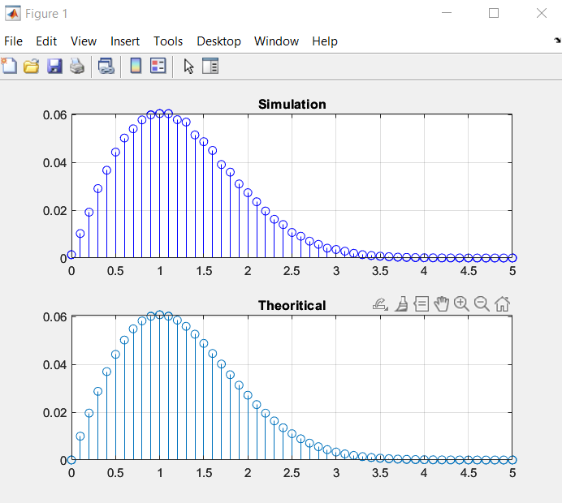

**Question:** Comparison of Theoretical and analytical BER vs SNR

**Code:**

%Comparison of Theoretical and analytical BER vs SNR

%Initialization of parameters

clc

clear all

close all

Eb=1; %energy per bit

Eb_N0_dB=0:1:20; %range of Eb/N0

N0=Eb*10.^(-Eb_N0_dB/10);

%The range of N0

sigma=1;

BER=zeros(1,length(Eb_N0_dB));

%initialization of array

for i=1:length(Eb_N0_dB);

no_error=0; no_bit=0;

%taking m = 0 i.e. all 0s are transmitted

while no_error<=100

u=rand; x=sigma*sqrt(-2*log(u));

noise=sqrt(N0(i))*randn;

%normal pdf with var of No

y=x*sqrt(Eb)+noise;

if y<=0

y_d=1;

else

y_d=0;

end %end of if statement

no_bit=no_bit+1;

no_error=no_error+y_d;

end %end of while loop

BER(i)=no_error/no_bit;

end %end of for loop

rho=(Eb./N0)* sigma*sigma;

Pb=0.5*(1-sqrt(rho./(1+rho)));

semilogy(Eb_N0_dB, BER, '--b*',Eb_N0_dB, Pb, ':rp')

legend('Simulation','Analytical')

xlabel('Eb/N0')

ylabel('BER')

title("Comparison of Experimental & Theoretical BER vs SNR")

grid on

**Result:**

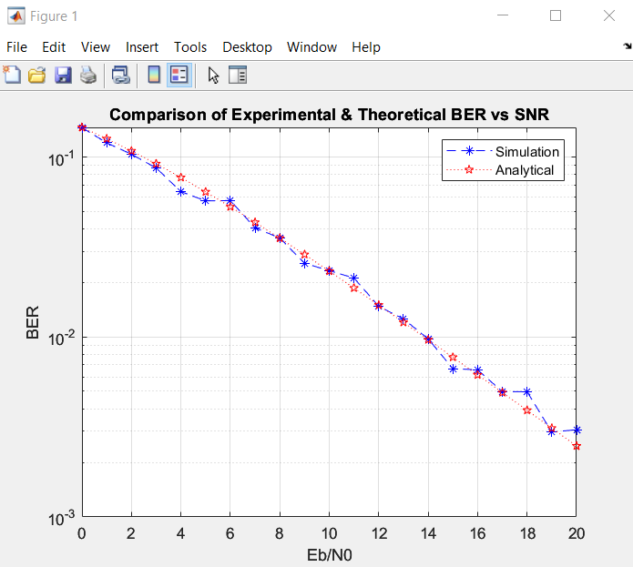

**Conclusion:** In this experiment, the output figure compares the simulated BER for a range of EbNo values



**Department of Computer Science and Engineering**

**Experiment No:** 05

**Experiment Title:** Simulation of a QAM Digital Communication System under AWGN

**Course Code:** CSE-454

**Course Title:** Wireless Networks Laboratory

**Submitted By-**

**Name :** Kamelia Zaman Moon

**Exam Roll :** 180657

**Class Roll :** 299

**Session :** 2017-18

**Semester :** 4th year 2nd semester

**Date of Performance :** 27-12-2022

**Date of Submission :** 12-03-2023

**Objective:** This labwould be to evaluate the performance of a QAM-based wireless communication system in a real-world scenario, where the wireless channel is subject to various types of interference, attenuation, and fading effects. The lab would involve designing and simulating a QAM communication system, which includes selecting the appropriate modulation scheme, designing an error correction coding scheme, and implementing a receiver that can accurately recover the transmitted data in the presence of noise and other types of interference.

**Problem Setup:** In QAM both amplitude and phase of the carrier are modulated to enhance bandwidth efficiency. For M-QAM the ith symbol wave is expressed as,

Si(t) = Ai cos(2πfct +θi ); i = 1, 2, 3…M ,where 0 ≤ t ≤ T

The peak amplitude of Si(t) is Ai and initial phase angle is θi

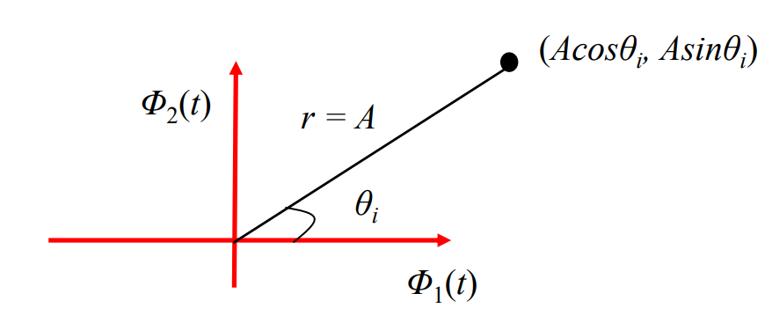

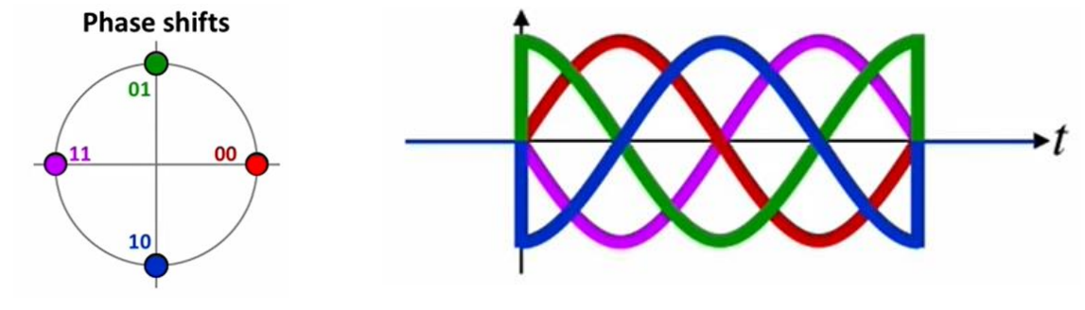

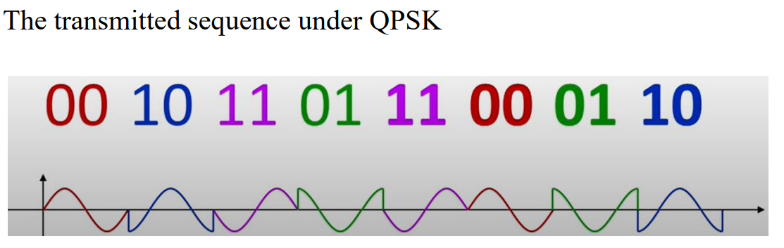

The eye diagram is an oscilloscope representation on a time domain signal, in which waveforms for every T sec. interval are superposed. Waveform that represent a data signal in the interval [0,T] is superposed with the waveform for the interval [T, 2T], with the waveform for the interval [2T, 3T] and so on. Eye diagram is a means of evaluating the quality of a received “digital waveform”.

**Matlab Code:**

%QAM Digital Communication System under AWGN

M = 16; %M=16 is taken for 16-QAM modulator

Fd = 1; %symbol rate

Fs = 10; %sampling rate

D = 1000; % Number random data [0, 15]

msg_d = randi([0 M-1],D,1); % Random signal

% Modulate using 16 points constellation QASK method.

msg_a = qammod(msg_d,M);

N = Fs/Fd; %number of sample per trace, N>=1

W=0.5; %transition BW of the filter

period=1/Fd; %Range of horizontal axis

delay = 3; % Delay of the raised cosine filter

offset = 0;

rcv = rcosflt(msg_a,Fd,Fs,'fir/normal',W,delay);

%received signal

%communication channel is equivalent to a rising cosine filter

h1 = eyediagram(rcv, N, period, offset);%eye diagram

h2 = scatterplot(rcv, N, offset, 'k*');%scattered plot

%let us add some noise with signal

rcv1=awgn(rcv, 4); % 4 dB AWGN noise with rcv

h3 = eyediagram(rcv1, N,period, offset);

h4 = scatterplot(rcv1, N, offset, 'k*');

%Detection of symbol Error

Re= qamdemod(rcv1,M);

k=1;

L=length(rcv1)/N;

%here N = 10 samples per rcv symbols are used so

%length is reduced by N

for j=1:L

Re_s(j) = Re(k);

%every 10th or Nth sample is considered as the

%received symbol

k = k+N;

end

%similariry is found from 7th symbol of Re_s and 4th

%symbol of msg_d

e = symerr(Re_s(7:1003), msg_d(4:1000)');

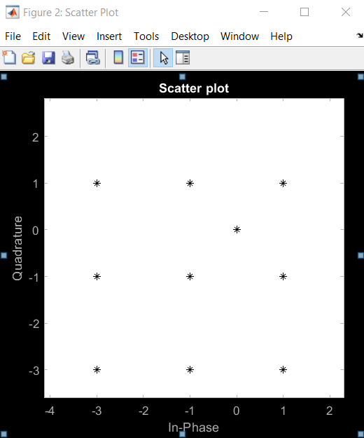**Output:**

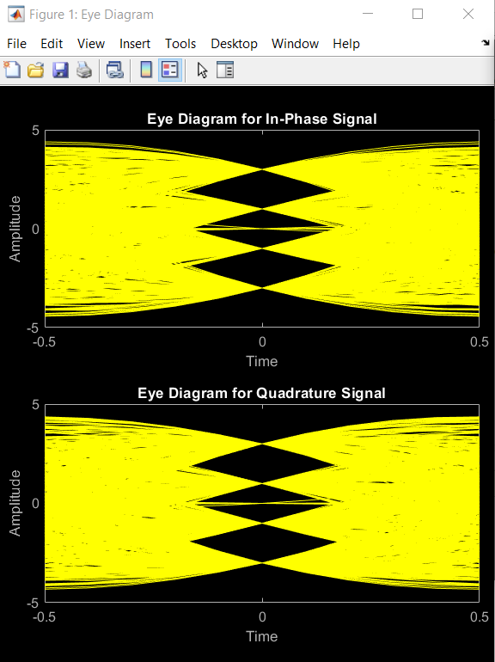

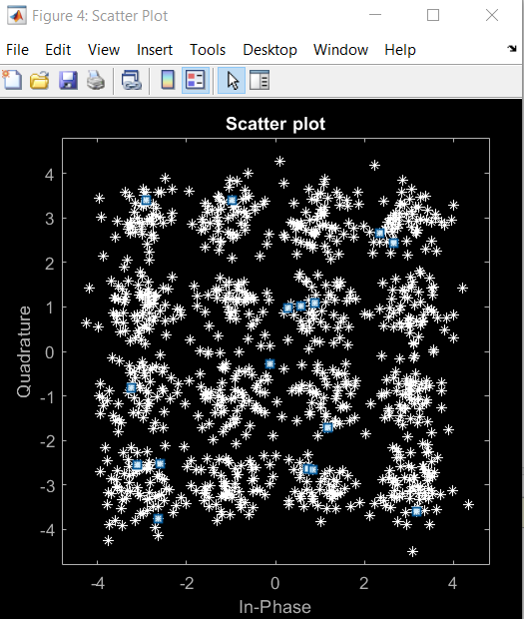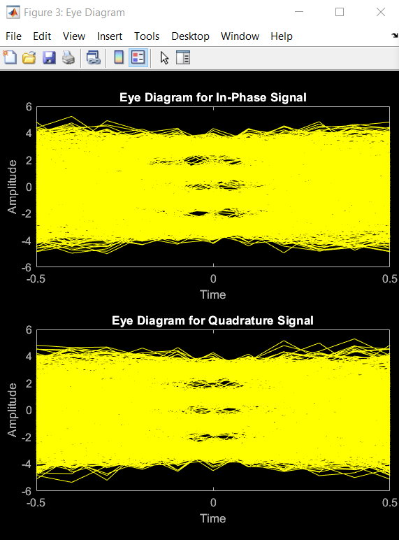

**Conclusion:** Due to the use of many antennas, MIMO wireless technology can dramatically increase a channel's capacity while still conforming to Shannon's rule. The channel throughput can be raised linearly when additional pair of antennas is added to the system.



**Department of Computer Science and Engineering**

**Experiment No:** 06

**Experiment Title:** Multiple Input Multiple Output (MIMO) System

**Course Code:** CSE-454

**Course Title:** Wireless Networks Laboratory

**Submitted By-**

**Name :** Kamelia Zaman Moon

**Exam Roll :** 180657

**Class Roll :** 299

**Session :** 2017-18

**Semester :** 4th year 2nd semester

**Date of Performance :** 03-01-2023

**Date of Submission :** 12-03-2023

**Objective:** This Laboratory work aids to

* Change a one-to-one relationship between transmitter and receiver in wireless communication into a many-to-many relationship in this experiment.
* Fading can affect the signal-to-noise ratio of a channel.

**Problem Setup:** In wireless communication systems, the Multiple Input Multiple Output (MIMO) system provides benefits of spatial diversity with additional channel capacity without increasing the required bandwidth of the communication system.

The channel of this system is defined by nR×nT , which is denoted by H as a complex matrix. The transmitted signal is represented by nT ×1 column matrix, denoted by symbol x, whereas the received signal is represented nR × 1 column matrix, denoted by symbol r.

The distance between two adjacent antenna elements is usually limited to half of a wavelength or slightly more. Let us consider a MIMO system of nT transmit antenna elements and nR received antenna elements. The relation is many-to-many.

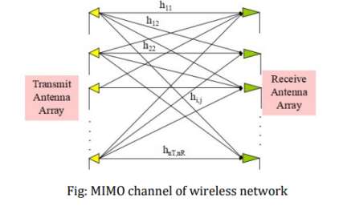

The transmission of antenna element 1 is shown below as the one to all.

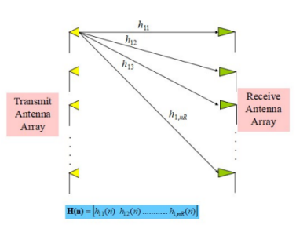

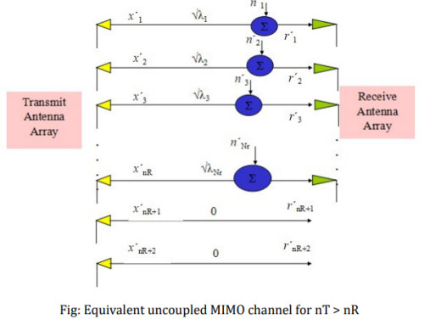

**Matlab Code:**

**Task-1:**

%Task1

clc;

clear all;

close all;

A=[-1 0 0; 1 -2 3; 0 2 -3];

Q=A*A'

[U, D] = eigs(Q);

U*D*U'

**Output:**

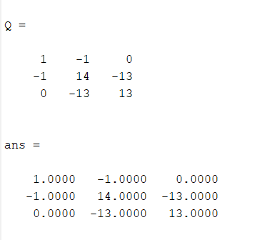

**Task-2:**

%Task2

clc;

clear all;

close all;

x=[0.2+0.4i; 1.1-0.6i; 0.45-0.34i; 1.2+1.4i];

n=[0.001+0.02i; 0.003-0.005i; 0.04-0.003i; 0.0012-0.003i];

H=[0.23-0.12i -0.612+0.09i -0.71+0.12i 0.32+0.11i;

0.112-0.098i 0.16+0.23i 0.154-0.22i 0.32-0.23i;

-0.53-0.12i 0.321-0.25i 0.56-0.076i 0.71-0.22i;

0.86-0.23i -0.887-0.099i 0.23+.76i 0.45-0.42i];

r=H*x+n; %Received signal vector

Q1=H*ctranspose(H); %HHH matrix

[U, D1]=eigs(Q1);

D=sqrt(D1);

np= ctranspose(U)*n; %ń=U^Hn

xp= ctranspose(U)*x; % x=U^Hx;

disp("Value of rp :")

rp= D*xp +np

**Output:**

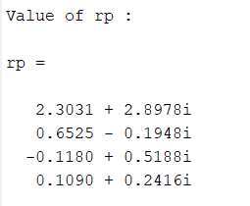

**Task-3:**

%Task3

% Channel capacity of four antenna case

clc;

clear all;

close all;

nT=4;

H4=[0.23-0.12i -0.612+0.09i -0.71+0.12i 0.32+0.11i;

0.112-0.098i 0.16+0.23i 0.154-0.22i 0.32-0.23i;

-0.53-0.12i 0.321-0.25i 0.56-0.076i 0.71-0.22i;

0.86-0.23i -0.887-0.099i 0.23+.76i 0.45-0.42i];

Q4 = H4*ctranspose(H4);

for i=1:10

SNR(i)=1+3*i;

Im4 = [1 0 0 0; 0 1 0 0; 0 0 1 0;0 0 0 1];

CW4(i) = log2(det(Im4+(Q4/nT)*SNR(i)));

CW(i) = log2(1+SNR(i));

end

plot(SNR,CW4, ':r*', SNR,CW, '--bp');

hold on

xlabel('SNR')

ylabel('Channel Capacity/Hz')

title('Channel Capacity of MIMO Link')

grid on

legend('MIMO', 'Single Antenna')

**Result:**

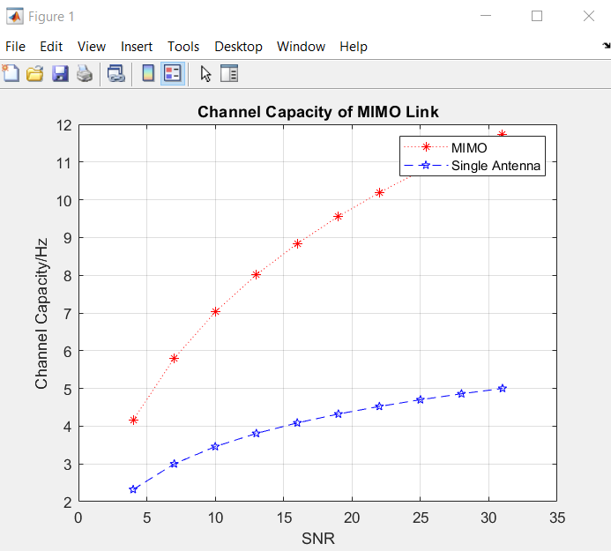

**Conclusion:** Due to the use of many antennas, MIMO wireless technology can dramatically increase a channel's capacity while still conforming to Shannon's rule. The channel throughput can be raised linearly when additional pair of antennas is added to the system.