**Testbirds**

**Level up your testing skills before joining our community! - V4**

**Click on the orange “Edit” button to begin writing your report** (on the page footer).

The website you need to test is:

[**http://www.benjerry.co.uk/**](http://www.benjerry.co.uk/)

UC 1: You want to learn about Ben and Jerry's commitment to climate protection. Show your results by uploading ONE screenshot of a specific page that provided you with this information – show your whole screen including URL and taskbar. You MUST be using the https://www.benjerry.co.uk/ version of the website.

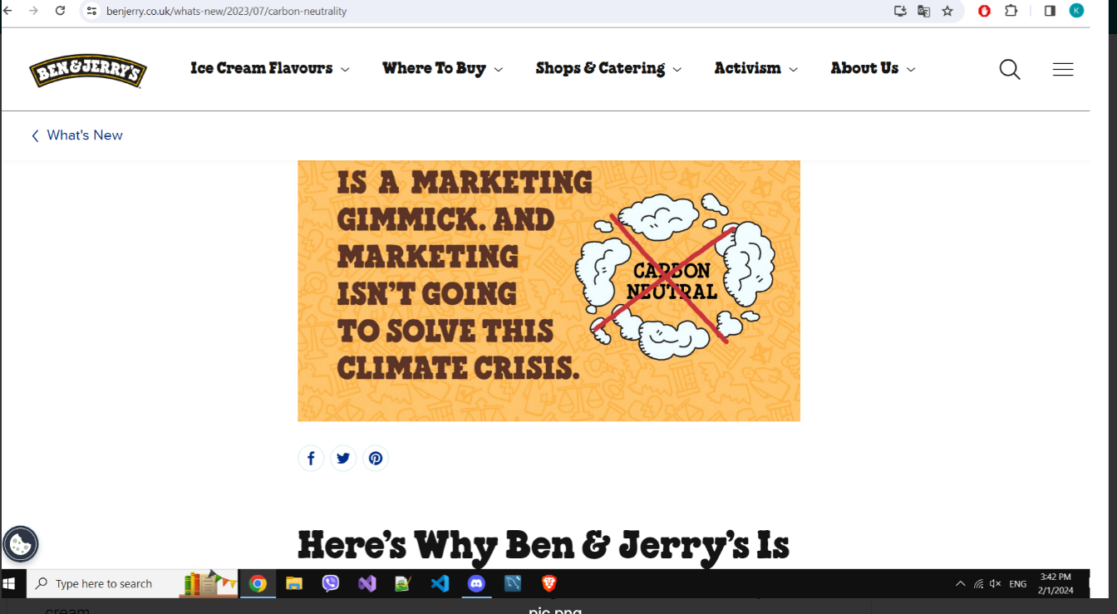

**UC 2: Now, you want to find the Ingredients and Nutrition Facts for a specific Ben and Jerry's product. Please use the search bar or the filter tool on the Flavours page. Find the ingredients information about a specific ice cream product and list your steps here.**

**Checklist**

* **List ALL your actions, step-by-step in a numbered list.**
* **Don't include any feedback here.**Any comments about what you liked/disliked should go in the Open Questions section only (later in the report).
* Tell us **WHERE**you clicked - ensure that you include any: tab headers, page names, hyperlink labels, article titles, button names or image/textbox labels etc.
* Make sure that you include an **‘action’ word** in each of your steps e.g. clicked on, scrolled to, hovered over, selected, tapped, opened, typed etc.

**Use Case 2**

1. I went to the search cursor and typed flavors.

2. I chose an ice cream "Baked Alaska".

3. I Scrolled down and saw that its packaging and composition are biodegradable.

4. Also there were Certifications and Review and Ratings, as well as a brief explanation of how it was stored.

**UC 3: You want to learn more about the company’s history. Try to find the year the first Ben and Jerry’s ice cream shop was opened. How did you find this information? List your steps.**

**Use Case 3**

1. I loaded the site URL and scrolled down.

2. I marked with the mouse "About Us".

3. All the information about the creation of ice cream came out.

4. By two guys Ben and Jerry in 1978.

**UC 4: You want to find the contact information for Ben and Jerry's. Please explore the site and find the contact details of Ben and Jerry's. Describe how you can find this information. Please do not contact the company - it's only about finding the contact information!**

**Use Case 4**

1. I loaded the site URL and scrolled down.

2. I marked with the mouse "Send Us Feedback" in the column "Connect With Us".

3. Loaded my Contact Us with four departments: "Consumer Support", "Press & Media", "Call Us" and "Write To Us".

4. I also saw that there is another "Contact Us" button that loads the same information for Ben and Jerry's.

P.S. but I would like an ice cream ;)

**UC 5: Explore two sections of the website that interest you and you haven't been to in any of the other Use Cases (e.g. Movies, What’s New, etc.). Don't forget to list your steps and include an action word in each step (e.g. scrolled/tapped/clicked).**

**Reminder:**Have you **saved**your report recently? Don't forget during the next Use Case (UC 5) to take screenshots as you explore the test site - you will be asked to upload screenshots in the following task!

**Use Case 5**

Section 1

1. I hovered over Shops & Catering on the top navigation bar

2. I chose an Ice Cream Cakes to order for a birthday.

3. Two fields appear where the city or zip code can be entered. The other field is for which country it should be.

Section 2

1. I hovered over About Us on the top navigation bar

2. I chose "Where We Do Business"

3. And from this section it is understood that they have opened stores all over the world.

[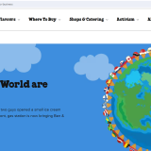](https://media-production.obs.eu-de.otc.t-systems.com/files/9f97012d8c44417896b785514312b3c7)[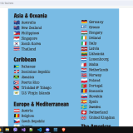](https://media-production.obs.eu-de.otc.t-systems.com/files/1f87f9ae5e2649d2ac169eff14120823)[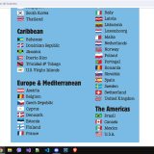](https://media-production.obs.eu-de.otc.t-systems.com/files/790d3aab86fc46b79b840b5352f38a87)[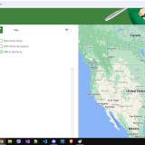](https://media-production.obs.eu-de.otc.t-systems.com/files/ec0df63b00844dad8c70211b2e4ab852)[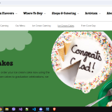](https://media-production.obs.eu-de.otc.t-systems.com/files/b4b25b21e92040bd86c3c2dc118e2600)

**Q1: What was your first impression of the Ben and Jerry's website?**

At first glance, everything is very patterned, in my opinion, the photos should be made one idea smaller. The same can change the font of the text, to make it easier to read.

**Q2: Which features/elements of the website did you like? And why (with details and examples)? Minimum of 3 different points.**

1. I liked their mission, with care for the environment and how they have a variety of articles in this area and most of all that there is action on things.

2. I also liked that they have a large assortment of products and especially healthy Vegan ice creams, because few people think about this direction.

3. And the other thing I liked is that it can be easily found on social media, as well as phone and address. Other sites mostly leave only the phone, but this is a big plus for Ben and Jerry's.

**Q3: Which features/elements of the website did you dislike and why (with details and examples)? It could help to think about what you might change/improve if you were in charge of the Ben and Jerry's website. Minimum of 3 different points.**

1. I didn't like that the taskbar has a lot of listings under the tab. Example, I go to Activism and there are five more tagging and information departments.

2. And at the top right, the sign with the three lines, I think is redundant, because when we scroll at the bottom, there is already contact with them.

3. Another thing I didn't like, the site language changer, can't be placed at the bottom left. It should be at the top next to the magnifying glass, for example.

4. Overall, I would say that the site at first glance is quite messy and it is difficult to find information that is up-to-date.