

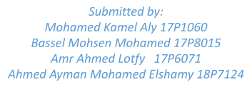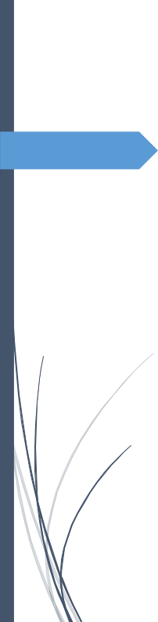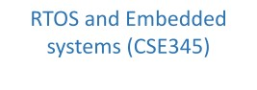

RTOS Project 2021

Contents

flow chart 2 2

Explaination video 2

individual contribution 3

# flow chart

start

start

start

Define the LCD interface

Get time

Config UART

Wait until new time is received

Increment time

Read current time at London.

Display the city names

Extract required city name

Set required city

Extract time difference

Get current time

Calc time in required city

Display city name at first row

Display time at second row

# Explaination video

https://drive.google.com/drive/folders/1_QmqLJ3vLAVMu7_zMF-4f2oJ20sIVYmY?usp=sharing

# individual contribution

|  |  |
| --- | --- |
| Mohamed Kamel Aly 17P1060 | LCD init, LCD cursors,video, Uart controller in city times |
| Bassel Mohsen Mohamed 17P8015 | UART init and print char, LCD controller in citytimes |
| Amr Ahmed Lotfy 17P6071 | Flowchart, LCD printchar, hardware connection, time controller in citytimes |
| Ahmed Ayman Mohamed Elshamy 18P7124 | LCD cursor set and lcd commands ,queues and structs for task comm. |

Most of the functions were contributed on from multiple individuals as there were lots of bugs and each of us used help from others.