Mastering Embedded System

Online Diploma

[www.learn-in-depth.com](http://www.learn-in-depth.com)

First Term Project 1

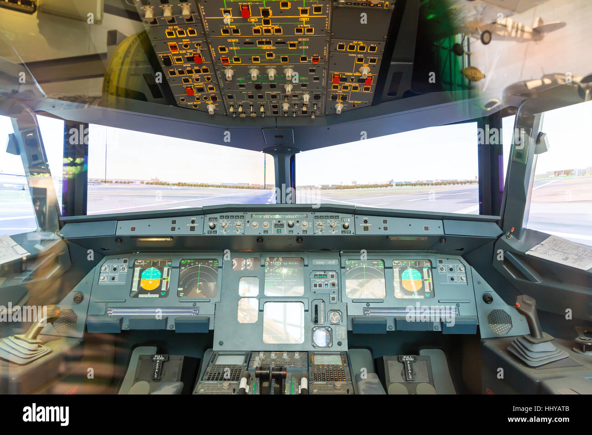High Pressure Detection System

BY :

Eng. Mohamed Kamel Aly

My Profile : No progess page created,

Email: mohamed.kamel.m73@gmail.com

Contents

Business Analysis (Case Study) 3

Methodology 3

Requirements 4

System Analysis 5

Use Case Diagram 5

Activity Diagram 5

Sequence Diagram 6

System Design 6

Block Diagram 6

Pressure Sensor State Machine 7

Alarm Monitor State Machine 7

Main Algorithm State Machine 8

Alarm State Machine 8

State Machines’ Simulation 9

Proteus Simulation 10

Code Analysis 11

Symbol Table 11

Relocatable code Sections 12

Full Code Sections 14

Map File Sample: 15

# Business Analysis (Case Study)

This case study describes a pressure detection system which lights an LED alarm when triggered:

1. A pressure sensor reads pressure values each 60 seconds
2. The system checks if the pressure is above a threshold of 20
3. If the pressure is above the threshold, an LED alarm is turned on
4. The alarm duration equals 60 seconds
5. Optional: the system keeps track of the measured pressure values.

# Methodology

Agile methodology is an iterative and incremental approach to software development that prioritizes flexibility, collaboration, and customer satisfaction. It emerged as a response to the shortcomings of traditional waterfall methodologies, which often resulted in lengthy development cycles and a lack of adaptability to changing requirements.

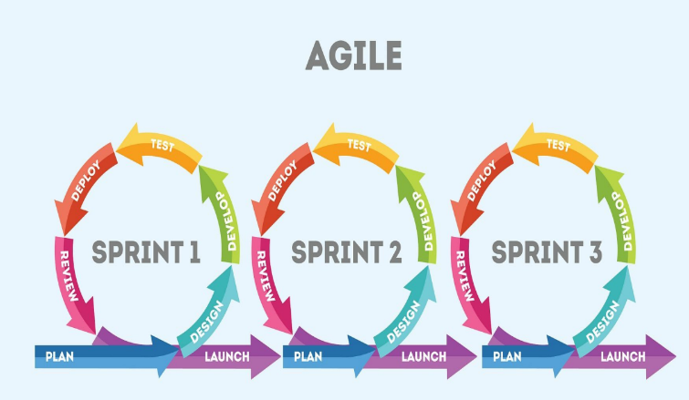

# Requirements

A ”client” expects to deliver the software of the following system

specification (from the client) A pressure controller informs the crew of a

cabin with an alarm when the pressure exceeds 20 bars in the cabin the

alarm duration equals 60 seconds.

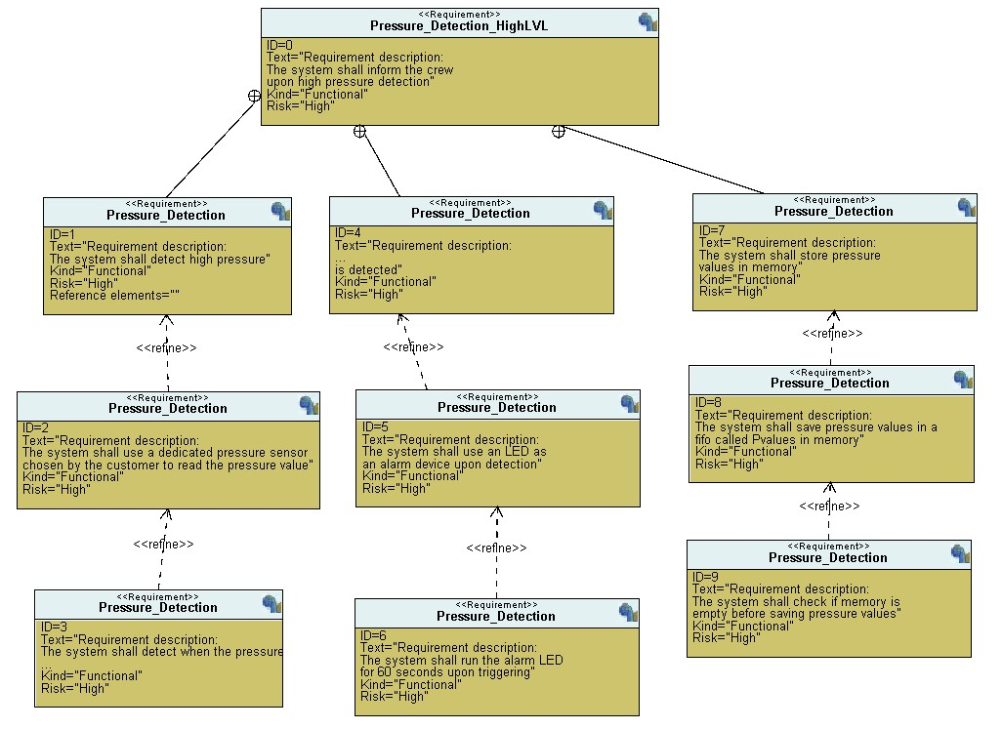

# System Analysis

## Use Case Diagram

## Activity Diagram

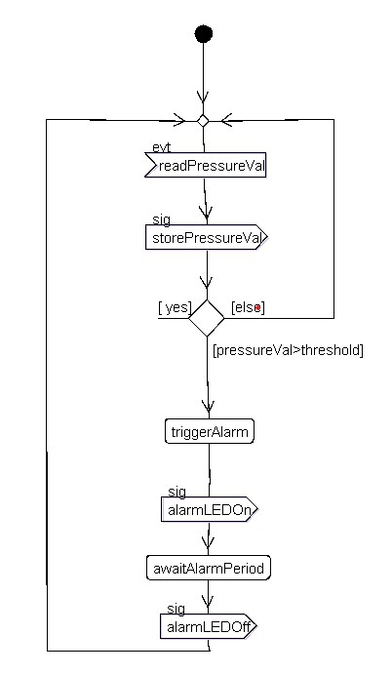

## Sequence Diagram

# System Design

## Block Diagram

## Pressure Sensor State Machine

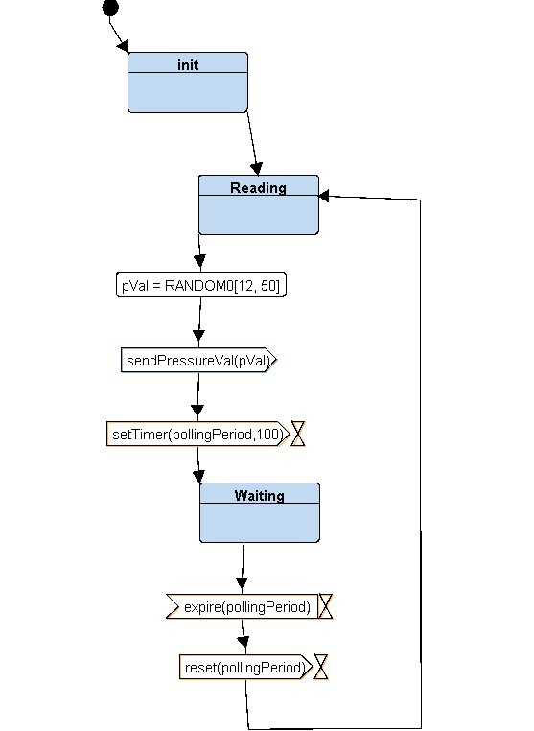

## Alarm Monitor State Machine

## Main Algorithm State Machine

## Alarm State Machine

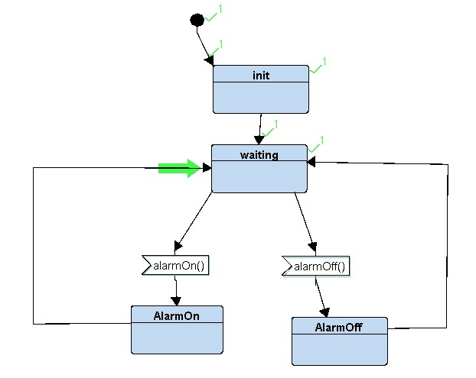

# State Machines’ Simulation

# Proteus Simulation

Test Cases:

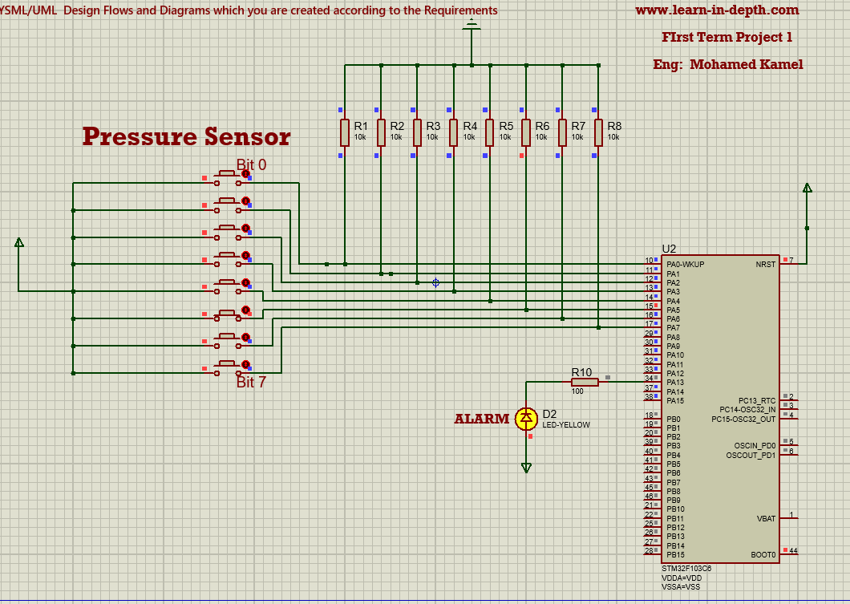Pressure Input Value:32

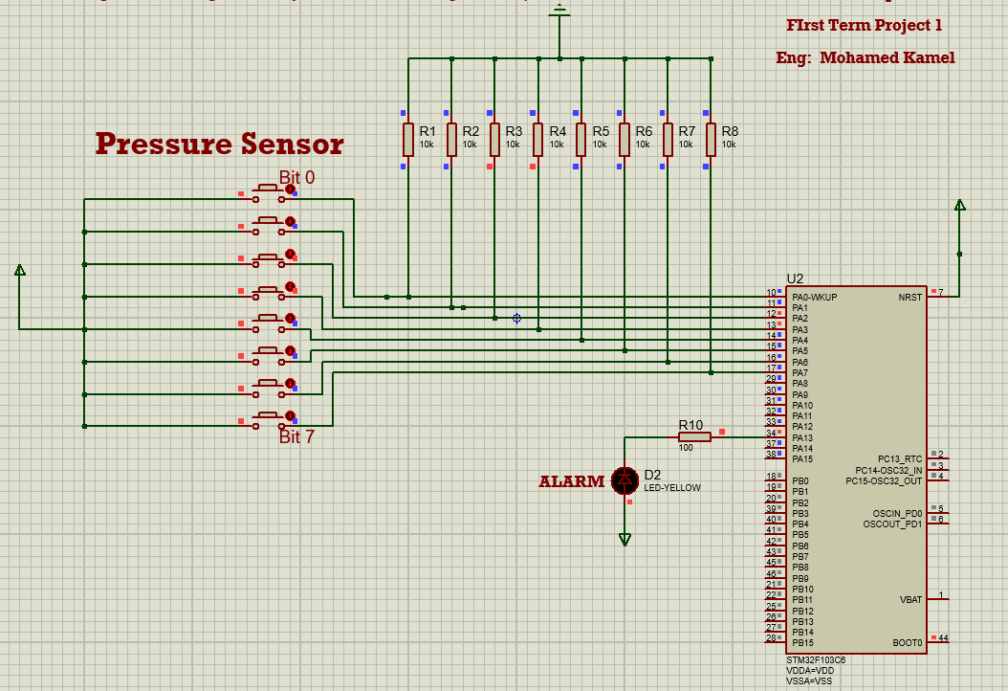Pressure Input Value:12

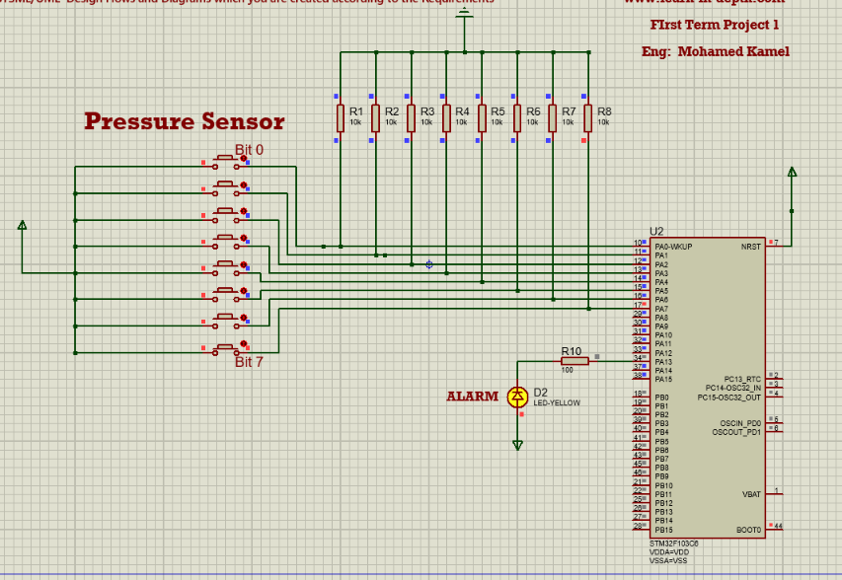Pressure Input Value:128

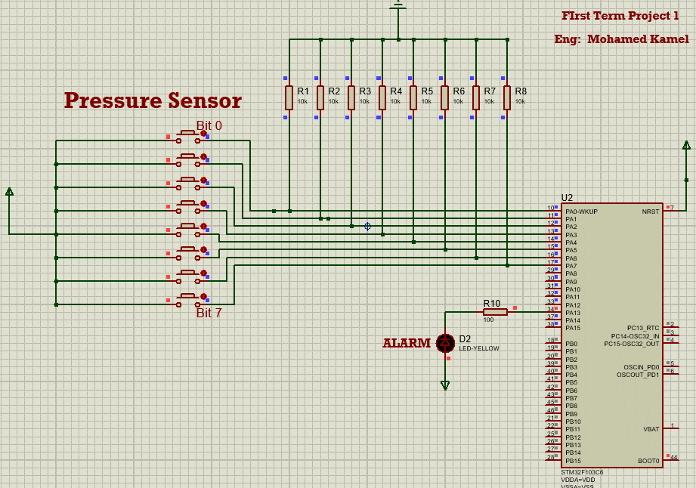Pressure Input Value:0

# Code Analysis

Repo:

<https://github.com/Kamelz70/LID_Diploma/tree/main/First_Term_Projects/Project_1>

## Symbol Table

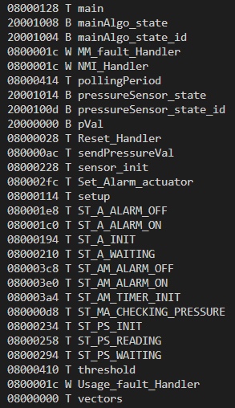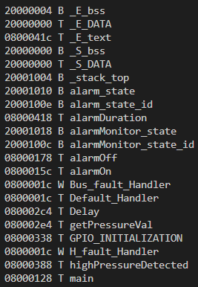

## Relocatable code Sections

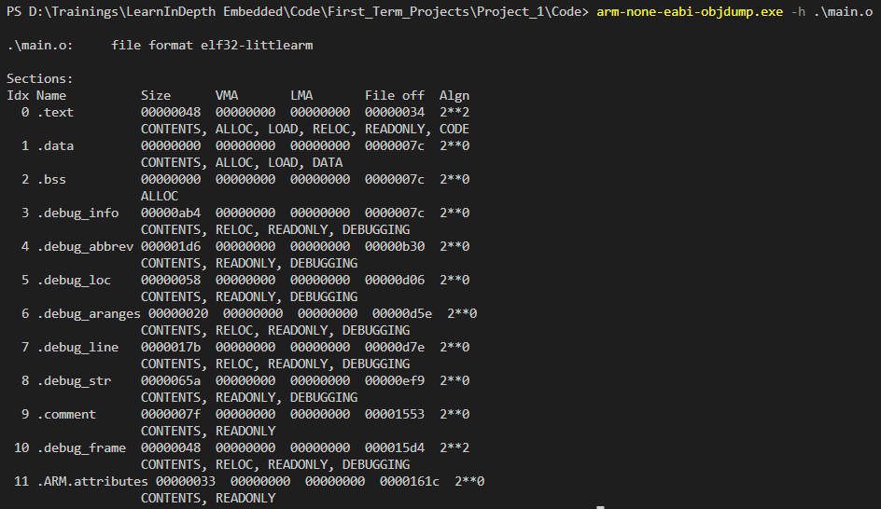main:

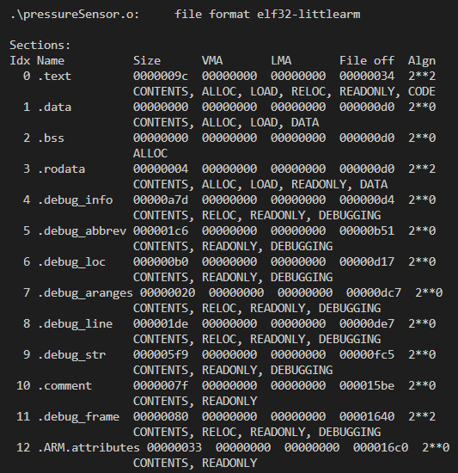pressureSensor.o:

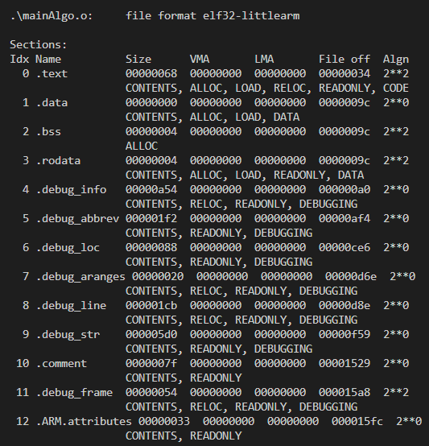mainAlgo.o:

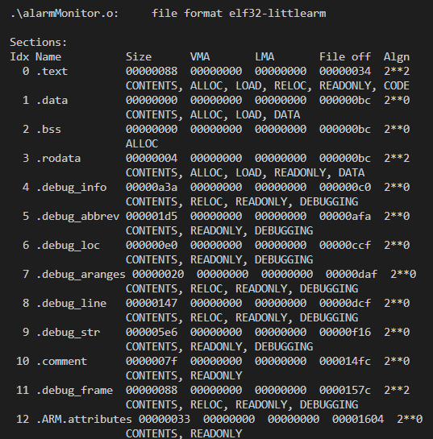alarmMonitor.o:

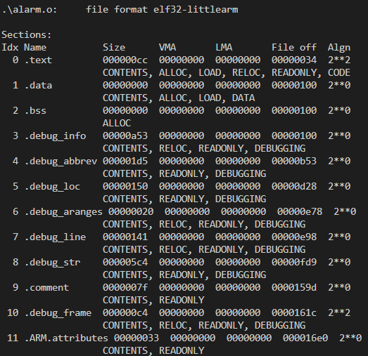alarm.o:

## Full Code Sections

## Map File Sample:

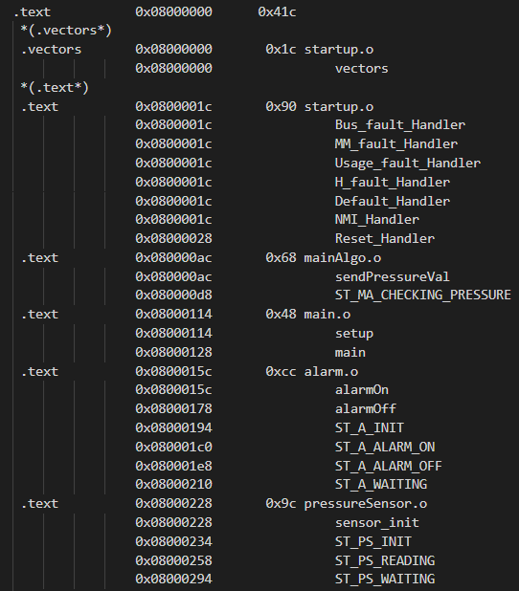This is a map file sample showing section/symbol locations in memory