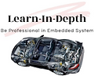Mastering Embedded System

Online Diploma

[www.learn-in-depth.com](http://www.learn-in-depth.com)

First Term Project 1 :-

High Pressure Detection System

BY :

Eng. Mohamed Kamel Aly

My Profile :

Contents

Requirements Diagram 3

Methodology 3

System Analysis 4

Use Case Diagram 4

Activity Diagram 4

Sequence Diagram 5

System Design 5

Block Diagram 5

Pressure Sensor State Machine 6

Pressure Monitor State Machine 6

Main Algorithm State Machine 7

Alarm State Machine 7

# Methodology

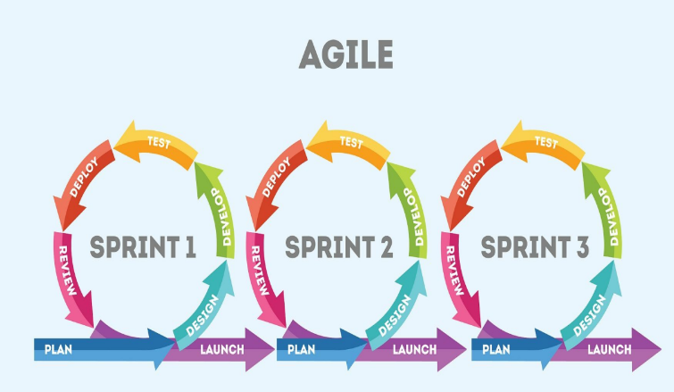Agile methodology is an iterative and incremental approach to software development that prioritizes flexibility, collaboration, and customer satisfaction. It emerged as a response to the shortcomings of traditional waterfall methodologies, which often resulted in lengthy development cycles and a lack of adaptability to changing requirements.

# Requirements

A ”client” expects to deliver the software of the following system

specification (from the client) A pressure controller informs the crew of a

cabin with an alarm when the pressure exceeds 20 bars in the cabin the

alarm duration equals 60 seconds.

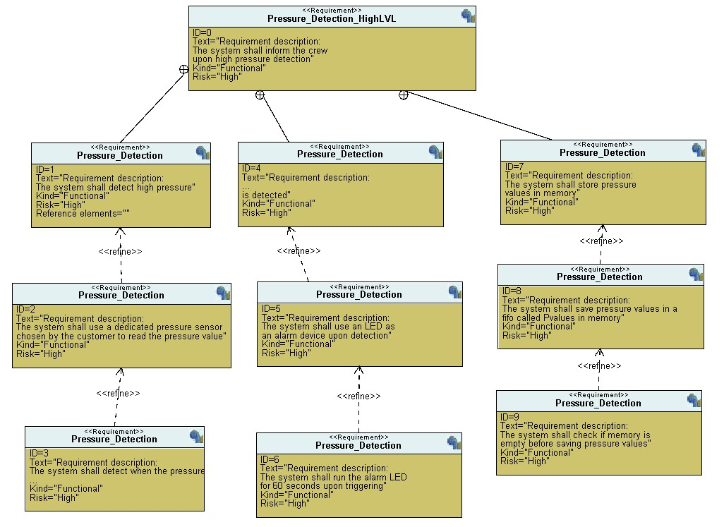

# System Analysis

## Use Case Diagram

## Activity Diagram

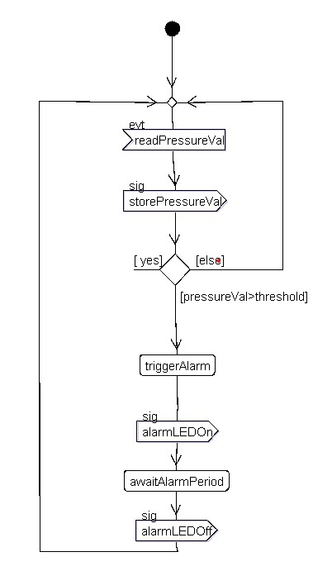

## Sequence Diagram

# System Design

## Block Diagram

## Pressure Sensor State Machine

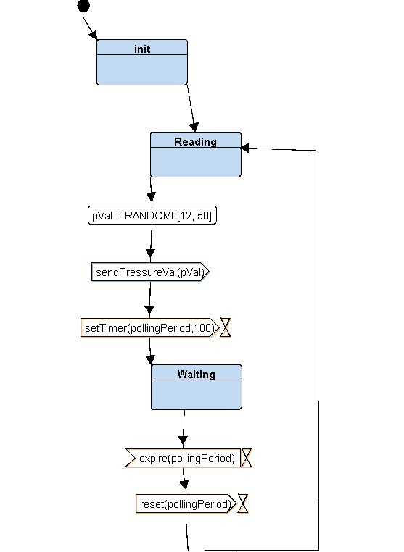

## Alarm Monitor State Machine

## Main Algorithm State Machine

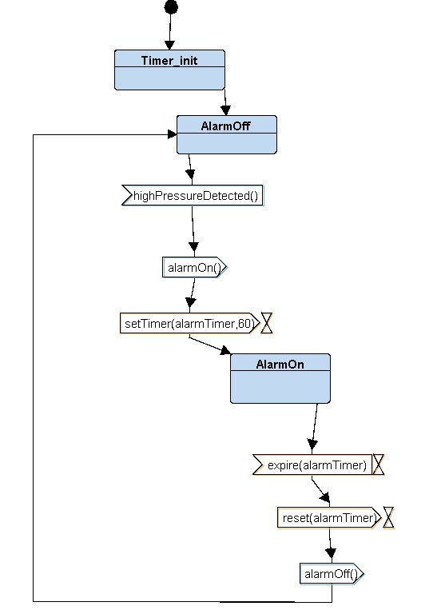

## Alarm State Machine

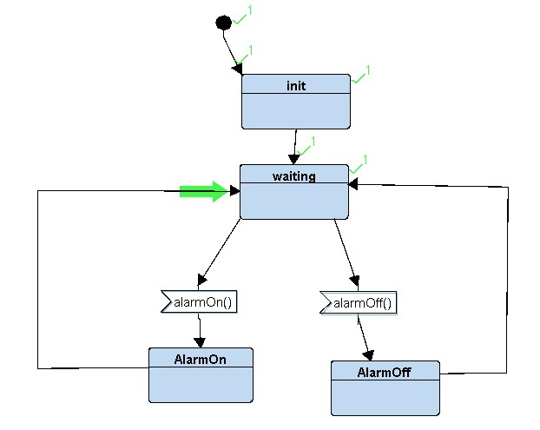

# Simulation

# Code