Mastering Embedded System

Online Diploma

[www.learn-in-depth.com](http://www.learn-in-depth.com)

First Term Project 2

Student Database System

BY :

Eng. Mohamed Kamel Aly

My Profile : No progess page created,

Email: [mohamed.kamel.m73@gmail.com](mailto:mohamed.kamel.m73@gmail.com)

Github Code: [https://github.com/Kamelz70/LID_Diploma/tree/main/First_Term_Projects/Project_2](%20https:/github.com/Kamelz70/LID_Diploma/tree/main/First_Term_Projects/Project_2)

Contents

Problem Statement 3

Approach 3

Configuration 3

Code APIs And Helper Methods 4

APIs 4

addManually 4

addFromFile 4

printStudentByID 4

printByFirstName 4

printCourseStudents 4

printAll 4

deleteByID 4

updateByID 4

countStudents 5

HelperMethods’ 5

isUniqueID 5

getStudentByID 5

printStudentInfo 5

FIFO_validator 5

enterStudentInfo 5

Tests 5

Add students from file: 6

Print All Students 7

Add Student Manually 7

Print Student by ID 8

Print Student By First Name 8

Print Students In Course 9

Delete Student By ID 10

Update Student By ID 10

Get Total Number Of Students 11

# Problem Statement

Write a program to build a simple Software for Student Information Management

System which can perform the following operations:

● Store the First name of the student.

● Store the Last name of the student.

● Store the unique Roll number for every student.

● Store the GPA of every student.

● Store the courses registered by the student.

# Approach

The idea is to form an individual functions for every operation. All the functions are

unified together to form software.

● Add Student Details From File

● Add Student Details Manually

● Find the student by the given roll number

● Find the student by the given first name

● Find the students registered in a course

● Count of students

● Delete a student

● Update Student

# Configuration

In students.h, there are some config options to se

// //////////////////////////////////////////

// Configuration

// //////////////////////////////////////////

#define BUFFER_LENGTH 50

#define MAX_NUM_OF_COURSES 10

#define MAX_NAME_CHARACTERS 50

#define FILENAME "studentsDB.txt"

BUFFER_LENGTH:

Sets the maximum number of students to save in the DB

MAX_NUM_OF_COURSES:

Sets the maximum No. of courses each single student can take

MAX_NAME_CHARACTERS:

Sets the maximum first/last name No. of characters

# Code APIs And Helper Methods

Github Code: [https://github.com/Kamelz70/LID_Diploma/tree/main/First_Term_Projects/Project_2](%20https:/github.com/Kamelz70/LID_Diploma/tree/main/First_Term_Projects/Project_2)

## APIs

These are the main APIs used to provide functionality

### addManually

void addManually(FIFO_Buf_t *S_FIFO);

This API adds a student manually, it uses helper methods of **FIFO_validator,** **enterStudentInfo,** **countStudents**

### addFromFile

void addFromFile(FIFO_Buf_t *S_FIFO);

This API adds students from an existing text file, it uses helper methods of **FIFO_validator** **,isUniqueID**

### printStudentByID

void printStudentByID(FIFO_Buf_t *S_FIFO);

This API prints a student by ID, it uses helper methods of **FIFO_validator,** **getStudentByID,** **printStudentInfo**

### printByFirstName

void printByFirstName(FIFO_Buf_t *S_FIFO);

This API prints a student by ID, it uses helper methods of **FIFO_validator,** **printStudentInfo**

### printCourseStudents

void printCourseStudents(FIFO_Buf_t *S_FIFO);

This API prints students taking a certain course ID, it uses helper methods of **FIFO_validator,** **printStudentInfo**

### printAll

void printAll(FIFO_Buf_t *S_FIFO);

This API prints All students, it uses helper methods of **FIFO_validator,** **printStudentInfo**

### deleteByID

void deleteByID(FIFO_Buf_t *S_FIFO);

This API deletes a student by ID, it uses helper methods of **FIFO_validator,** **printStudentInfo,** **getStudentByID**

### updateByID

void updateByID(FIFO_Buf_t *S_FIFO);

This API updates a student by ID, it uses helper methods of **FIFO_validato,** **getStudentByID,** **enterStudentInfo**

### countStudents

void countStudents(FIFO_Buf_t *S_FIFO);

This API counts all students, it uses the helper method **FIFO_validator**

## HelperMethods

These are the helper methods used by the main APIs to enhance code readability/maintainability

### isUniqueID

bool isUniqueID(FIFO_Buf_t *S_FIFO, uint32 ID);

This method is called to check if a given ID input is unique or not, it uses the helper method **getStudentByID**

### getStudentByID

Student *getStudentByID(FIFO_Buf_t *S_FIFO, uint32 ID, int *studentListingNumP);

This method iterates on student IDs to return a pointer to the student with the ID, if not found, it returns NULL, it uses the helper method **FIFO_validator**

### printStudentInfo

void printStudentInfo(Student *s);

This method prints a given student’s information

### FIFO_validator

bool FIFO_validator(FIFO_Buf_t *S_FIFO, bool isEmptyValidate, bool isFullValidate);

This method is used to validate the FIFO buffer and its’ data to check if it’s invalid, empty, or full

### enterStudentInfo

void enterStudentInfo(FIFO_Buf_t *S_FIFO, Student *targetStudent, uint8 choice);

This method is used to enter student data and save it the student pointer

# Tests

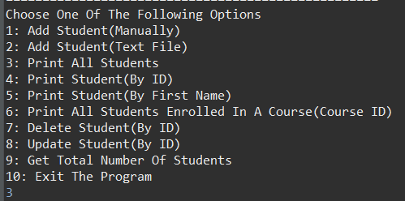These are the options which are presented to the user upon starting the program

## Add students from file:

While reading each line, any non-unique ID entry is skipped and the program continues saving from the next line

## Print All Students

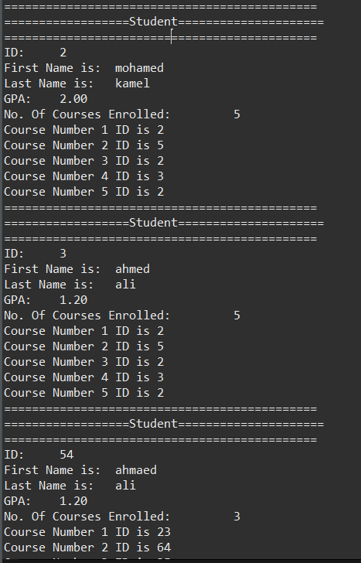

The Students added from the previous file are present when choosing option 3 (PrintAll)

## Add Student Manually

The left screenshot show the process of adding the student

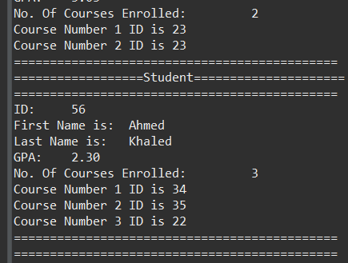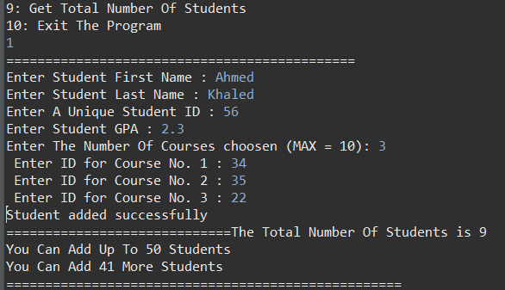, and the right one shows it’s been added by printing all students

## Print Student by ID

From the above added students, searching for a student with an ID prints the target correctly

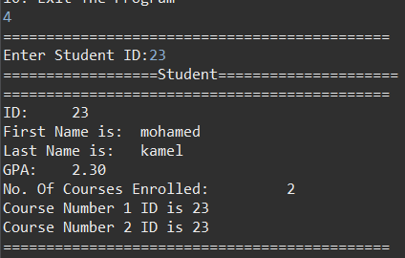

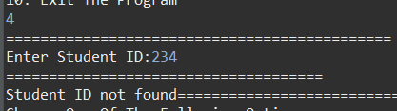Non-existing IDs print the following

## Print Student By First Name

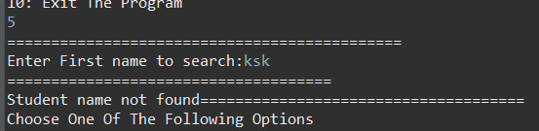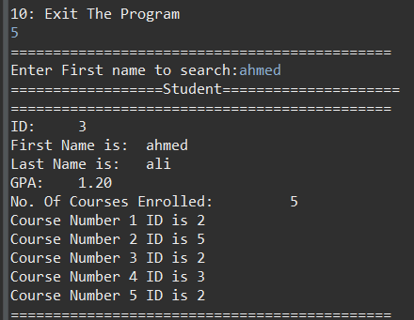This also works by entering the name, then the found student is printed, entering a non-existing name is shown in the right screenshot

## Print Students In Course

The students taking course No 33 are all printed as intended

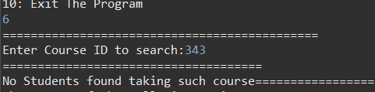Entering a non-existing course will print the following message:

## Delete Student By ID

In this test, we delete the student with the ID 132, the lower screenshots show the DB before and after the deletion

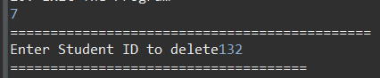

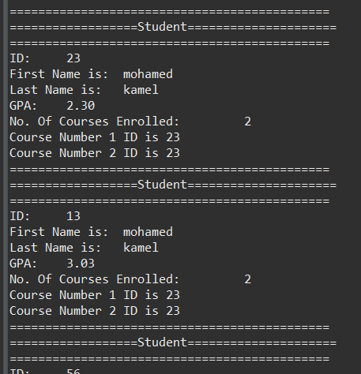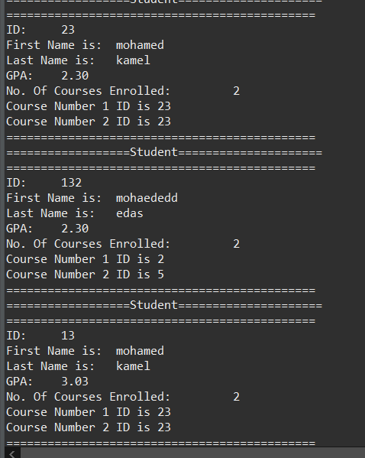

## Update Student By ID

The left-most Screen shows a student we will update, upon entering student ID, we choose what we want to update, the right-most screen shows that the student has been updated successfully

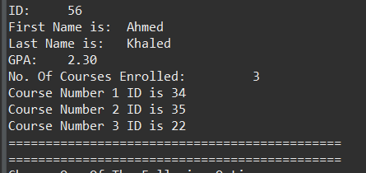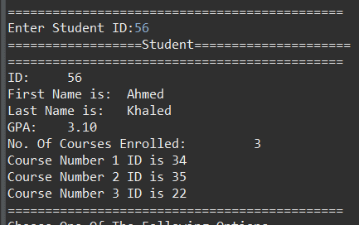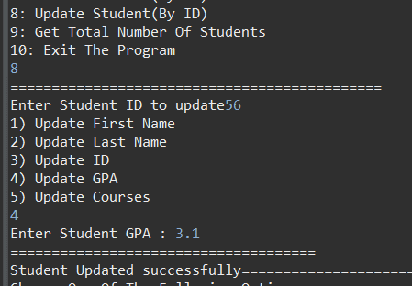

## Get Total Number Of Students

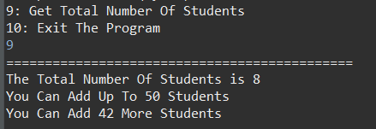This functionality shows the number of students in our database