Edmonds Tree Canopy Assessment
Science report to the board · 9 September 2026 · Kameron Eck
This report presents what the research has established about Edmonds' tree canopy, why a canopy percentage from any single aerial survey cannot be taken at face value, what governs how well a model can see trees in a given survey, and the work under way to make every year of the archive comparable.

1. The result we can defend: 2016 to 2024
Between 2016 and 2024 Edmonds lost a net 2.2 percentage points of its land area in tree canopy, with a 95% confidence interval of ±1.1 points. This comes from 1,250 paired points across the city, each read by a person against the 2016 and 2024 photographs, using a standard paired-sample design. It does not depend on the model. Two checks are recorded beside it: a repeat-reading disagreement of 2 of 28 duplicates, above the design's own target, and a worst-case misalignment test that bounds a bias of up to 1.0 point which would shrink the decline. Even under that bound the loss stays negative.
This is the number to quote. Direction is not in doubt; the size is best stated as about two points with the interval attached.

2. The annual canopy estimate, survey by survey
The model produces a canopy percentage for every survey in the archive. Figure 1 shows eight surveys from 2009 to 2024, all processed by one model with one recipe, at two operating points: each survey at its own best cut, which is how a single-year contractor would deliver it, and a cut matched across surveys so that precision is held at 75% for all of them.
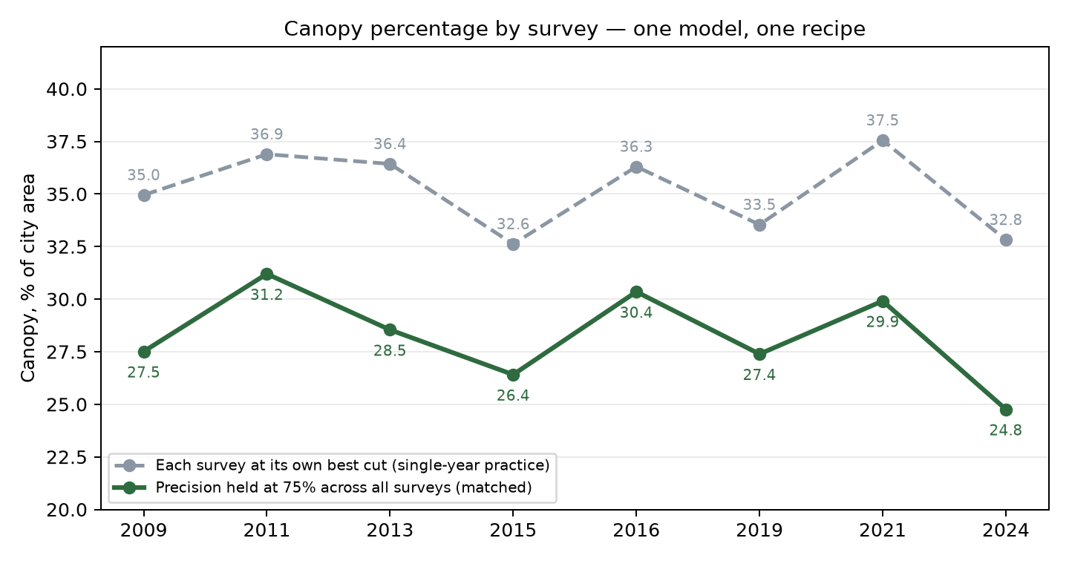
Figure 1. Canopy percentage by survey. Grey: each survey at its own best threshold. Green: precision held at 75% across all surveys. Same city, same model, same recipe.
Read either line as a trend and the city appears to gain and lose five points of canopy every two or three years. It does not: the paired-point panel measured a two-point decline over the whole 2016 to 2024 span, smaller than the model's swing between consecutive surveys. The swing is the surveys, not the trees. This is why canopy percentages produced by different contractors on different years' imagery cannot be lined up as a trend. Each was made on one survey, with its own labels and its own threshold, and none was adjusted for how visible trees were in that survey. The adjustment is the science: one model, one recipe, one held operating point, and a measured correction for each survey's sensitivity.
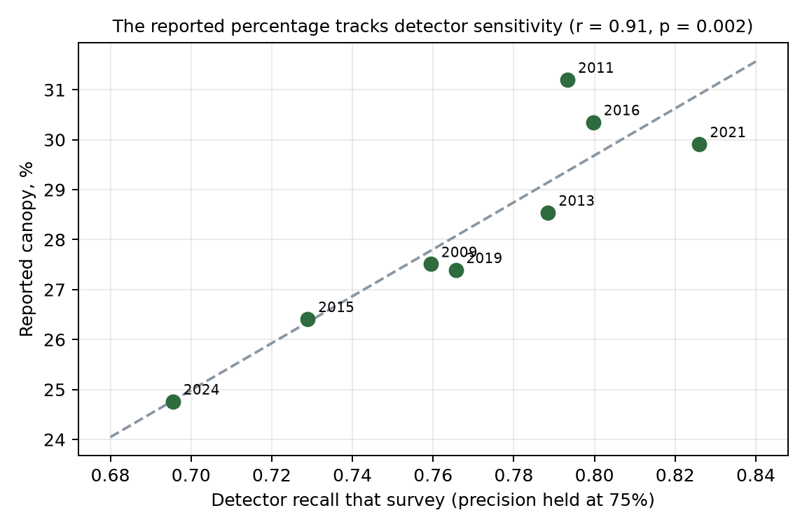
Figure 2. The reported percentage rises and falls with how much of the reference canopy the detector recovered that survey (r = 0.91, exact permutation p = 0.002 over all 40,320 orderings). The instrument is moving, not the forest.
The defensible statement today is therefore a band, the mid-twenties to about thirty percent of city area across 2009 to 2024, together with the measured two-point decline since 2016. A per-year percentage with its own error bar is the next measurement and requires the ground-truth points described in section 5.

3. What governs whether a model can see a tree
Every survey in the archive was flown for a different purpose by a different agency, and each of the following changes what a tree looks like in the pixels. The model inherits all of it.
- Camera sensor and lens. Four sources (City of Edmonds, King County, Snohomish County, USDA NAIP) with different sensors, band sets and radiometric processing. Three of the fifteen mapped surveys carry a near-infrared band; the rest are true colour only.
- Altitude and resolution. Ground resolution spans 5 cm to 1 m. At 5 cm a crown is thousands of pixels; at 1 m it is a few. Nominal resolution also lies: the 2005 survey is catalogued at 20 cm and measures at 81 cm.
- Time of day and sun angle. Shadow length and direction change the appearance of crowns and of the ground beside them; a shadowed lawn can resemble understorey.
- Weather and haze. Contrast and colour balance differ between flights; some surveys are visibly hazier.
- Leaf presentation. The archive spans February to October. Every label the model learned from comes from an April to July 2020 flight, so leaf-off surveys carry a systematic, species-correlated error rather than random noise.
- Post-processing. Orthorectification, mosaicking, colour balancing and compression differ by vendor; the same flight delivered two ways agrees with itself only at an intersection-over-union of 0.74, which sets a floor no algorithm can remove.
- Registration. Surveys do not sit on top of one another perfectly; the measured inter-year offsets are small but real, and a change map is sensitive to them.
Figure 3 shows the consequence: at a held 75% precision, the share of reference canopy the model recovers ranges from 0.68 to 0.82 across the surveys, with the harder surveys (2015, 2020, 2024) at the low end.
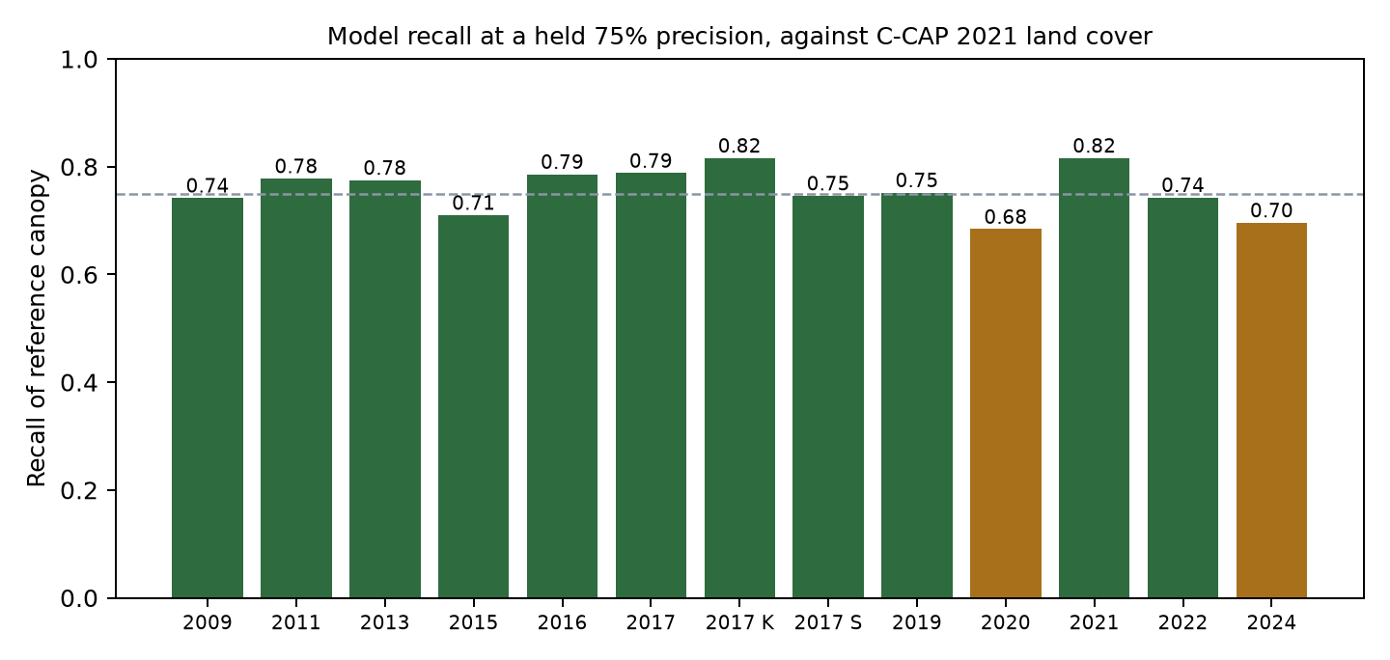
Figure 3. Model recall at a held 75% precision, scored against an independent national land-cover product (C-CAP 2021). These are agreement figures with a reference that over-calls shrubs and skips isolated trees, not ground truth. Amber bars sit on a steep part of their survey's curve and are best read as ranges.

4. The model on three surveys, same block
Figures 4 to 6 show one 180 m residential block in central Edmonds as photographed in three surveys of different resolution, with the model's canopy in green beside each. The same trees, seen through three different instruments.
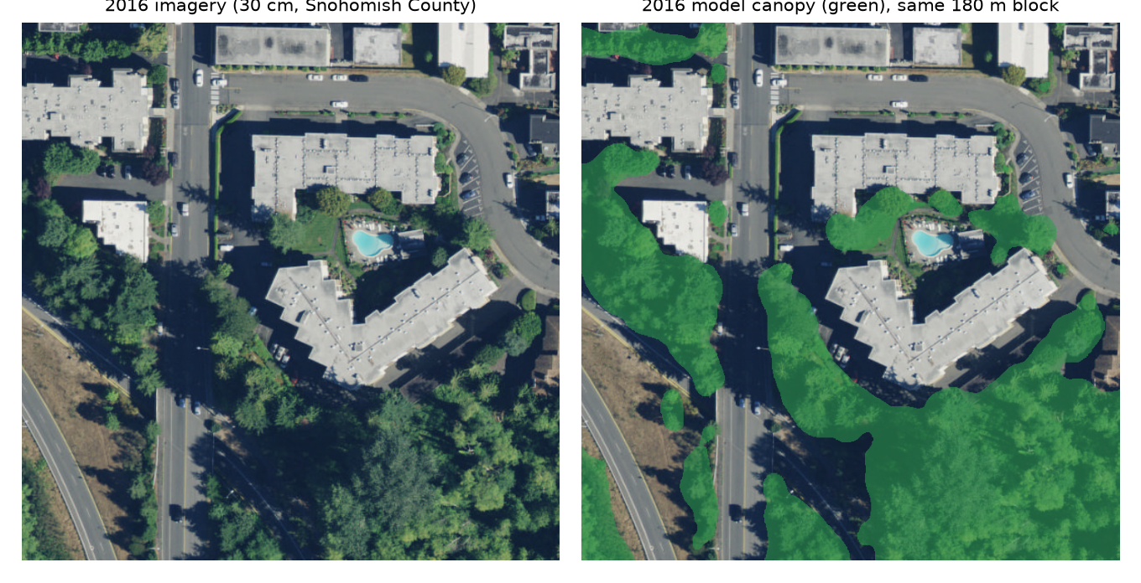
Figure 4. 2016 survey, 30 cm, Snohomish County. Left: the photograph. Right: the model's canopy mask over it.
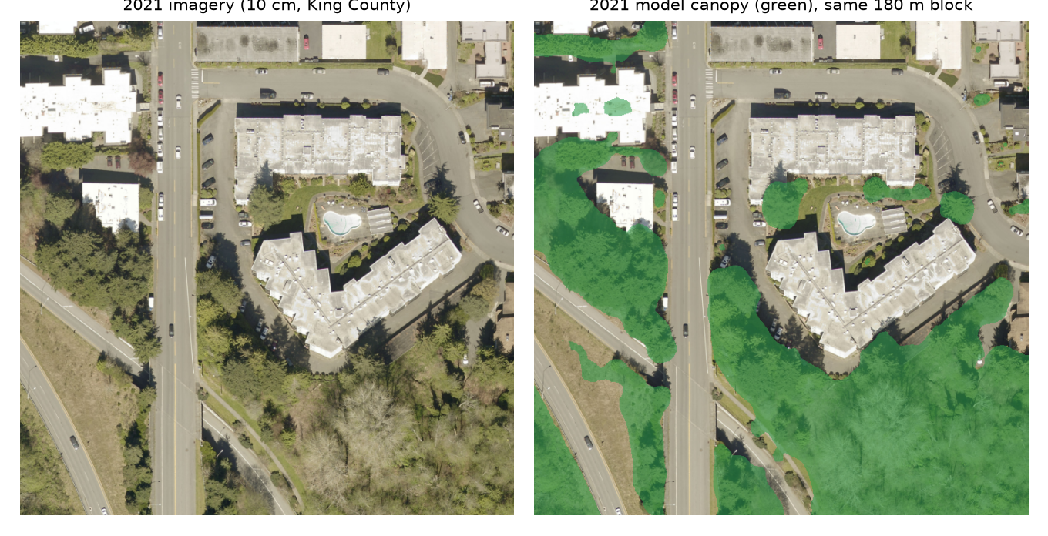
Figure 5. 2021 survey, 10 cm, King County. Left: the photograph. Right: the model's canopy mask over it.
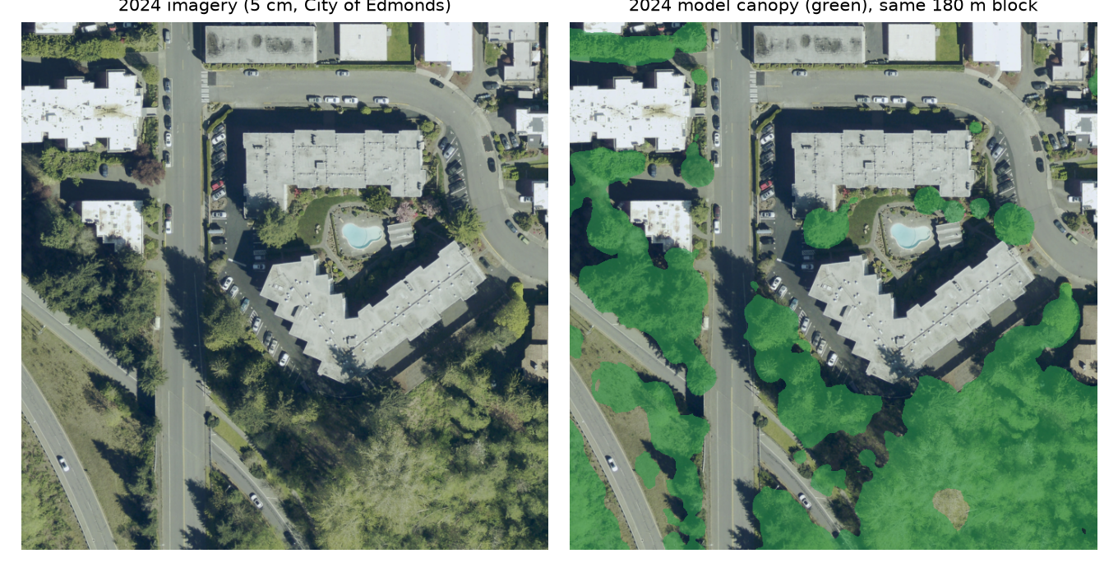
Figure 6. 2024 survey, 5 cm, City of Edmonds. Left: the photograph. Right: the model's canopy mask over it.

5. Work in progress: making the years comparable
Sensitivity correction. Holding precision fixed across surveys removes the largest part of the year-to-year swing and is what makes the 2016 to 2024 decline readable. The residual is the per-survey sensitivity correction, which is being measured rather than assumed.
Photo-point interpretation. The only way to measure each survey's error directly is for a person to read points. The paired panel behind section 1 is 1,250 such points. A further 250 points per survey are drawn, stratified across the city, and await reading; those readings turn the agreement figures in Figure 3 into ground-truth accuracy with confidence intervals, survey by survey. Points read inside the experiment's test blocks additionally let every method experiment be scored against a person rather than against the model's own past output.
The healing tool. A method to fill gaps where the model misses a tree in one survey that it finds in the surveys before and after. It was built and tested this month against ten fields of prior literature and a plain morphological baseline; on the current eight-survey stack it performs no better than the simple baseline, and its main effect is a size floor. It is paused, with its test sample drawn, until the record-keeping around it was hardened. It will resume with a denser stack of surveys, where it has more to work with.

6. Computational efficiency: faster experiments, more hypotheses
Every hypothesis about how to improve the annual estimates needs a trained model to test it, and the current model is large. This week two lighter models were trained on the same 748 hand-labelled tiles the current model learned from and scored on the same 150 held-out tiles. They come within one to two percent of the current model on intersection-over-union and average precision (Figure 7), while training in roughly an hour or less. A fair comparison on the standard experiment set is running now from these trained starting points. If it holds, every experiment runs two to three times cheaper, which means more hypotheses tested per month on the road to a credible annual product.
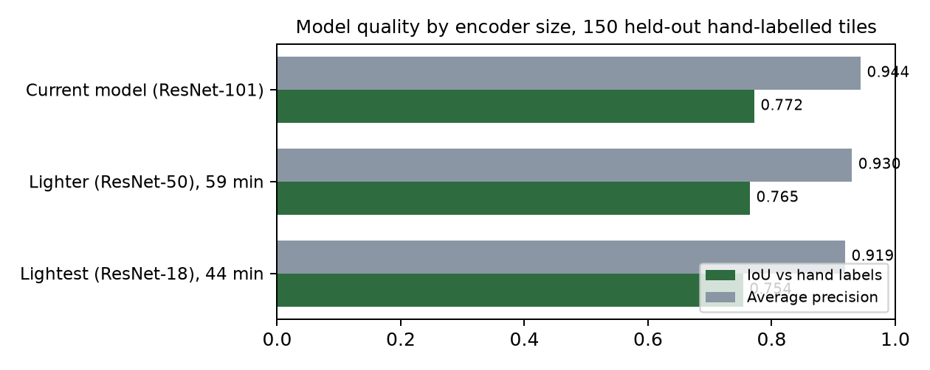
Figure 7. Model quality by encoder size on the held-out hand-labelled tiles. The current model also started from an earlier pretrained head start the lighter ones cannot use, so the gap is an upper bound on what they give up.

7. Why this is hard, and why it matters
- Only one year has hand labels. Every other survey is supervised by projecting the 2020 labels onto it, so growth, removal and the season of the flight all enter as label error. Measuring that error is the core of the work.
- An archive that spans February to October and five centimetres to one metre is not comparable by assumption. Comparability has to be measured in.
- A change estimate needs a matched operating point and a per-survey correction. Without them, any two years can be made to show a gain or a loss by the choice of threshold.
- What the city gets: a canopy record built on one method across fifteen years, with every number tied to the file that produced it and re-checked automatically, instead of a set of one-off percentages that cannot be compared or defended.
Sources: Panel A paired-point estimate; the arm-metrics table at the matched 0.75-precision cut against C-CAP 2021 high-resolution land cover; trend-series policy cuts, harmonized fractions and sensitivity table; encoder-base evaluate logs of 9 September 2026. All figures trace to tracked files in the project record.

