About application to image recognition.

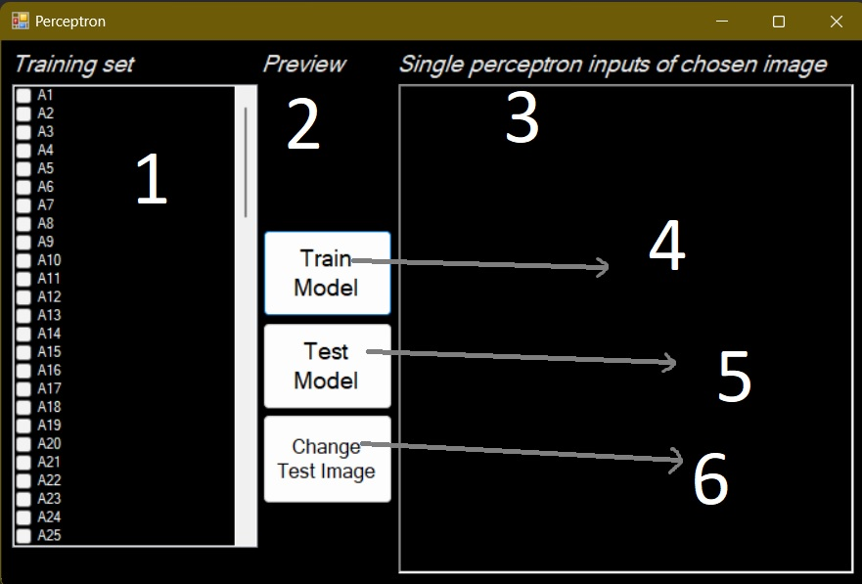

Pic.1. Main view of application.

The numbers means:

1. There user can check the training set.
2. Place where is the picture of trianing/test set.
3. User can see the simplified trained model/input as 0 and 1 ( what is put into inputs of perceptron)/ Actually chosen test image.
4. Button, that train model with dataset.
5. Should be chosen after Training model and after (6).
6. Allow to change an image that will be tested.

!!!

There is no need to select any image from (1),

User can test picture after -> TRAIN MODEL -> CHANGE TEST IMAGE -> TEST MODEL

User can test image after image, example:

TRAIN MODEL -> CHANGE TEST IMAGE -> TEST MODEL -> (read result) -> CHANGE TEST IMAGE-> TEST MODEL -> (read result ).

After training model there is no possibility to show images from Training set

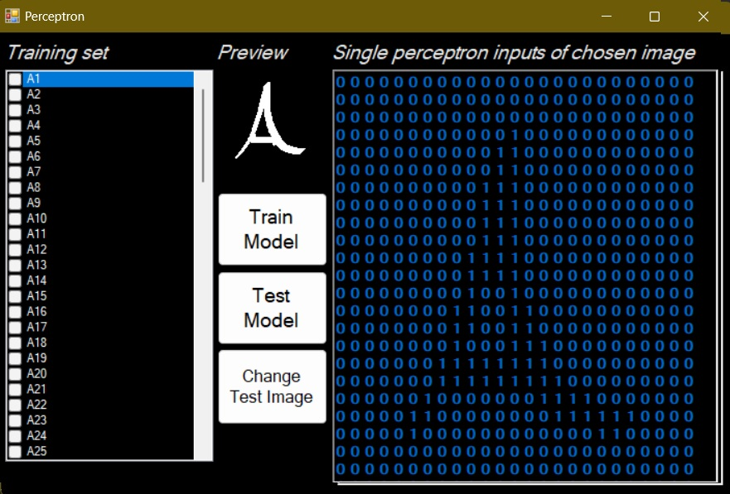

Pic.2. View seen after choose an image from dataset

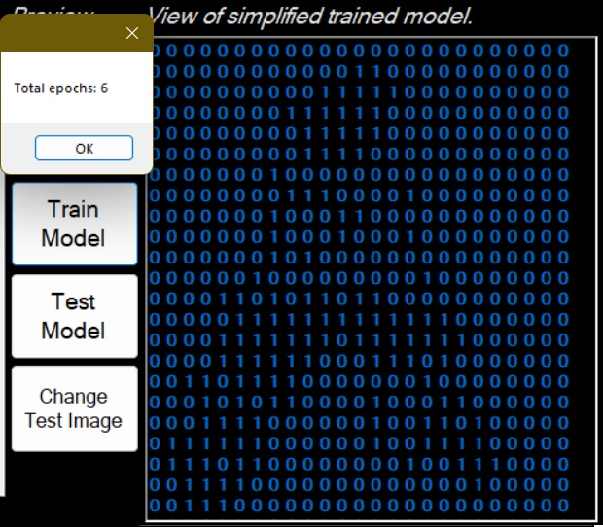

Pic.3. View after training model. Model is trained after one click.

Pic.4. View after choose „Change Test Image”. There is possible to select next image after choosing again „Change Test Image”

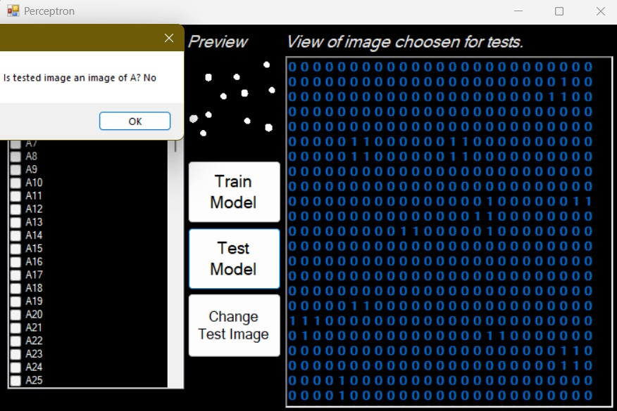

Pic.5.View After testing if the chosen image is ‘A’ like’ish.

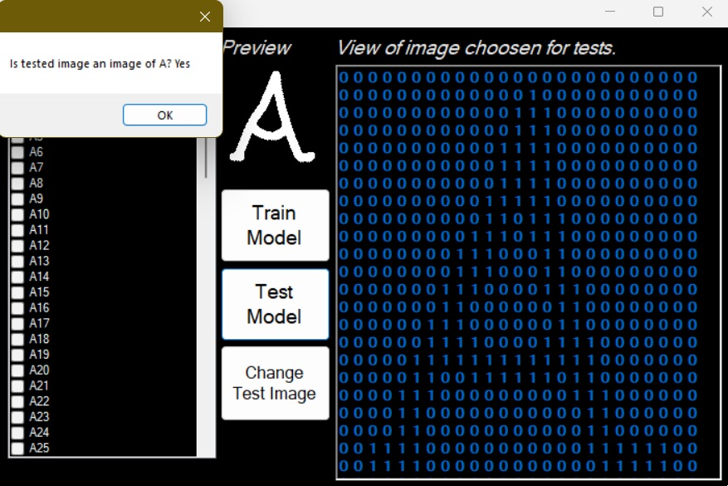

Pic.6.View After testing if the chosen image is ‘A’ like’ish.