COOKBOOK: YOUR VIRTUAL KITCHEN

**ASSISTANT NAANMUDHALVAN PROJECT REPORT**

Submitted by

### TEAM LEADER

**B.KAMESH (222209502)** [**Kamesh2002@gmail.com**](mailto:Kamesh2002@gmail.com)

**TEAM MEMBERS**

**D.SAKTHIVEL (222209508) dossamul2@gmail.com**

**M.GUNAL (222209499) mguna262003@gmail.com**

**R.HEMANATHAN (222209501) rhemanathan58@gmail.com**

# DEPARTMENT OF COMPUTER SCIENCE



**TAGORE COLLEGE OF ARTS AND SCIENCE**

(Affiliated to the University of Madras)

CLC WORKS ROAD, CHROMPET, CHENNAI – 600 044

**MARCH - 2025**

# 

# TITLE

|  |  |  |
| --- | --- | --- |
| **S.NO** | **CONTENTS** | **PAGE NO** |

|  |  |  |
| --- | --- | --- |
| **1.** | **INTRODUCTION ABSTRACT**   * 1. OVERVIEW OF COOKBOOK   2. PURPOSE AND VISION   3. TARGET AUDIENCE |  |
| **2.** | **PROJECT DESCRIPTION**   * 1. FEATURES AND FUNCTIONALITIES   2. SCENARIO-BASED USE CASE |  |
| **3.** | **TECHNICAL ARCHITECTURE**   * 1. FRONTEND TECHNOLOGIES   2. API INTEGRATION (MEALSDB & RAPID API)   3. BACKEND & DATABASE STRUCTURE |  |
| **4.** | **PROJECT GOALS AND OBJECTIVES**   * 1. USER-FRIENDLY EXPERIENCE   2. COMPREHENSIVE RECIPE MANAGEMENT   3. ADVANCED SEARCH AND FILTERING |  |
| **5.** | **FEATURES OF COOKBOOK**   * 1. RECIPE BROWSING & SEARCH   2. VISUAL RECIPE DISPLAY   3. USER-FRIENDLY UI & NAVIGATION   4. INTEGRATION WITH EXTERNAL APIS |  |

|  |  |  |
| --- | --- | --- |
| **6.** | **PREREQUISITES**  6.1. SOFTWARE & TOOLS REQUIRED |  |

|  |  |  |
| --- | --- | --- |
| **7.** | **PROJECT STRUCTURE**   * 1. FOLDER & FILE ORGANIZATION   2. EXPLANATION OF COMPONENTS |  |
| **8.** | **PROJECT DEVELOPMENT MILESTONES**   * 1. MILESTONE 1: SETTING UP THE PROJECT   2. MILESTONE 2: IMPLEMENTING CORE FEATURES   3. NAVBAR AND HERO COMPONENTS   4. FETCHING CATEGORIES AND DISHES (MEAL SDB API)   5. TRENDING DISHES & CATEGORY PAGES   6. RECIPE PAGE (DETAILS, INGREDIENTS, INSTRUCTIONS,   VIDEO)   * 1. IMPORTANT CODE SNIPPETS |  |
| **9.** | **USER INTERFACE COMPONENTS**   * 1. HERO SECTION   2. POPULAR CATEGORIES   3. TRENDING DISHES   4. NEWSLETTER SUBSCRIPTION   5. CATEGORY & RECIPE PAGES |  |
| **10.** | **CONCLUSION** |  |

**ABSTRACT**

CookBook is a modern web application designed to enhance the recipe discovery and management experience for cooking enthusiasts and professional chefs. Built using React.js, it offers a seamless and interactive platform where users can search, explore,

and organize recipes efficiently. By integrating TheMealsDB API via Rapid API, the application provides users with real-time access to a diverse collection of recipes, ensuring an engaging and ever-expanding culinary experience.

The platform includes key features such as advanced search functionality, trending dish highlights, category-based browsing, and detailed recipe pages. Each recipe page provides ingredient lists, step-by-step cooking instructions, and embedded video tutorials, helping users cook with ease. The user-friendly interface, designed with Tailwind CSS or Bootstrap, ensures smooth navigation and responsiveness across different devices.

From a technical perspective, CookBook leverages React Router for navigation, Axios for efficient API calls, and modular UI components for scalability. The integration of third-party APIs eliminates the need for a dedicated backend, making the application lightweight, fast, and efficient. The structured component-based architecture ensures easy maintenance and future scalability.

Beyond being a digital cookbook, CookBook aims to build a community of culinary enthusiasts, allowing users to explore new dishes and cooking techniques effortlessly. With its intuitive design and powerful features, the platform makes the cooking experience more accessible, interactive, and enjoyable for users worldwide.

# INTRODUCTION

## OVERVIEW OF COOKBOOK :

CookBook is a web-based recipe management application designed to enhance the way users discover, organize, and create recipes. It provides an intuitive and userfriendly interface, making it an ideal platform for both home cooks and professional chefs.

The platform integrates TheMealsDB API via Rapid API, allowing users to explore a vast collection of categorized recipes. It offers key features such as search functionality, visual recipe browsing, and trending dish recommendations, making it easy to find and save favorite recipes. Each recipe page includes detailed ingredient lists, step-by-step instructions, and tutorial videos, ensuring a seamless cooking experience.

Built with modern web technologies like React.js, React Router, Axios, Bootstrap, and Tailwind CSS, CookBook provides a smooth, responsive, and scalable architecture. It follows a modular project structure, ensuring efficient data fetching and component-based development.

By simplifying recipe discovery and organization, CookBook serves as both a personalized digital cookbook and a community-driven platform that encourages users to explore and share their culinary experiences. It bridges the gap between traditional

cooking methods and digital convenience, offering an engaging and interactive cooking experience.

## PURPOSE AND VISION :

#### PURPOSE :

The primary purpose of CookBook is to provide a digital recipe management platform that simplifies the process of discovering, organizing, and creating recipes. It is designed to cater to both home cooks and professional chefs, offering an easy-to-use interface with a wide range of categorized recipes. By integrating with TheMealsDB API via Rapid API, CookBook ensures users have access to diverse and dynamic recipes from various cuisines. The platform aims to enhance the cooking experience by offering features such as advanced search, trending dishes, detailed ingredient lists, cooking instructions, and tutorial videos.

#### VISION :

The vision of CookBook is to become a go-to digital culinary platform, making cooking more accessible, organized, and interactive. It aims to bridge traditional cooking methods with modern technology, providing a seamless experience for food enthusiasts worldwide. With its intuitive design, robust functionality, and scalable architecture, CookBook aspires to create a vibrant culinary community, where users can explore, experiment, and share their cooking experiences effortlessly

## TARGET AUDIENCE :

The CookBook application is designed to cater to a wide range of users who are passionate about cooking, recipe exploration, and digital convenience. The primary target audience includes:

* + - Home Cooks & Food Enthusiasts – Individuals who enjoy

experimenting with new recipes and want a personalized digital cookbook for easy recipe discovery and organization.

* + - Professional Chefs & Culinary Experts – Chefs looking for inspiration from global cuisines and a platform to organize and manage their recipes efficiently.
    - Students & Beginners in Cooking – People who are learning to cook and need step-by-step instructions, ingredient lists, and video tutorials to

guide them.

* + - Health-Conscious Individuals – Users who focus on diet-specific recipes such as vegan, keto, gluten-free, or low-carb meals.
    - Food Bloggers & Content Creators – Individuals who want a platform to explore and curate recipes, share culinary insights, and enhance their food blogging experience.
    - Busy Professionals & Families – Those looking for quick and easy meal options to save time while ensuring healthy and delicious meals for their families.

By catering to these diverse user groups, CookBook aims to be a comprehensive and accessible platform for anyone interested in cooking and recipe management.

# PROJECT DESCRIPTION

## FEATURES AND FUNCTIONALITIES :

#### RECIPE DISCOVERY & BROWSING :

* Access a vast collection of recipes from different cuisines.
* Browse recipes by category, ingredients, or meal type (e.g., breakfast, lunch, dinner).
* View trending and popular dishes based on user preferences.

#### SEARCH & FILTER OPTIONS :

* Keyword-based search to find specific recipes quickly.
* Filter recipes by cuisine, ingredients, dietary preferences (e.g., vegetarian, keto, gluten-free).

#### DETAILED RECIPE PAGES :

* Step-by-step cooking instructions for each recipe.
* Ingredient lists with precise measurements.
* Embedded tutorial videos for easy learning.
* High-quality images of dishes to visualize the final outcome.

#### USER-FRIENDLY INTERFACE :

* Clean and intuitive UI designed with React.js and Tailwind CSS.
* Responsive layout for seamless browsing on desktops, tablets, and mobile devices.

#### API INTEGRATION :

* Fetches real-time recipe data from TheMealsDB API via Rapid API.
* Efficient data handling using Axios for API calls.

#### FAST PERFORMANCE & SCALABILITY :

* Uses React.js for frontend development ensuring smooth navigation.
* Modular component structure for easy scalability and maintenance.
* Optimized performance with React Router for dynamic page transitions.

## SCENARIO-BASED USE CASE :

Scenario: A Busy Parent Looking for a Quick Dinner Recipe

Sarah, a working mother, comes home after a long day at work. She wants to prepare a quick and healthy dinner for her teenage son, Ethan, but she is unsure of what to cook with the available ingredients in her kitchen.

#### DISCOVERING COOKBOOK

* Remembering a friend’s recommendation, Sarah visits the CookBook web application.
* She is greeted by a clean and intuitive interface, with trending recipes displayed on the homepage.

#### SEARCHING FOR A RECIPE

* Sarah uses the search bar to look for “quick chicken recipes.”
* She filters the results by selecting “under 30 minutes” and “healthy options”.
* CookBook instantly suggests a Grilled Lemon Garlic Chicken recipe that fits her needs.

#### EXPLORING THE RECIPE PAGE

* She clicks on the recipe and finds:
* A step-by-step guide on how to prepare the dish.
* A list of required ingredients, most of which she already has.
* A short video tutorial demonstrating the cooking process.

#### COOKING MADE EASY

* Sarah follows the instructions and watches the video for guidance.
* With the clear measurements and cooking steps, she prepares the dish without hassle.

#### FAMILY DINNER & SAVING FAVORITES

* Ethan enjoys the meal, and Sarah is pleased with how easy it was to make.
* She saves the recipe to her favorites for future reference.
* She also subscribes to the newsletter to receive more quick meal ideas.

# TECHNICAL ARCHITECTURE

## FRONTEND TECHNOLOGIES :

The CookBook web application is built using a modern frontend framework like React.js or Vue.js, ensuring a single-page application (SPA) experience. This architecture enables fast and interactive navigation, providing users with a seamless browsing experience while exploring recipes. The UI of the application is designed for efficiency and responsiveness, allowing smooth interactions with various features like recipe search, filtering, and viewing detailed cooking instructions.

## API INTEGRATION (MEALSDB & RAPID API) :

A key component of the CookBook architecture is the integration of Rapid API, which facilitates communication with external APIs, such as TheMealsDB API. These APIs allow the application to fetch real-time recipe data, including ingredient lists, cooking instructions, and images, without the need for an extensive backend. This approach eliminates the need to build a database from scratch, making CookBook more scalable and efficient. The API client in the architecture serves as a bridge between the frontend and external data sources, ensuring smooth data retrieval and display.

## BACKEND & DATABASE STRUCTURE :

Since CookBook relies on third-party APIs for data retrieval, there is no need for a traditional backend with a dedicated database. Instead, all recipe-related information is fetched dynamically from TheMealsDB API via Rapid API. However, if additional backend functionalities were required in the future (such as user authentication, personalized recipe saving, or custom recipe uploads), a backend using Node.js with Express and a database like MongoDB or Firebase could be implemented to store user preferences and custom content.

# PROJECT GOALS AND OBJECTIVES

## USER-FRIENDLY EXPERIENCE :

The CookBook web application is designed with a user-friendly interface, ensuring an engaging and seamless experience for users of all skill levels. Built using React.js and Tailwind CSS, the platform provides a clean, intuitive, and responsive design, making it easy to navigate on desktops, tablets, and mobile devices.

Key elements that enhance the user experience include:

* + - Simple & Intuitive Navigation – Users can effortlessly browse through categories, search for recipes, and access trending dishes with an easy- touse menu.
    - Fast & Interactive UI – The single-page application (SPA) architecture ensures quick page loads and smooth transitions without constant reloading.
    - Advanced Search & Filtering – Users can search by keywords and filter recipes based on cuisine, ingredients, or dietary preferences to find the perfect dish.
    - Detailed & Engaging Recipe Pages – Each recipe page includes step- bystep instructions, ingredient lists, high-quality images, and tutorial videos, making cooking simple and enjoyable.
    - Responsive Design – Optimized for all screen sizes, ensuring a consistent experience across different devices.
    - API-Driven Real-Time Data – Integration with TheMealsDB API via Rapid API ensures that users receive up-to-date and diverse recipe options.

Overall, CookBook prioritizes accessibility, efficiency, and engagement, making it a reliable digital companion for food lovers, home cooks, and professional chefs alike.

## COMPREHENSIVE RECIPE MANAGEMENT :

The CookBook web application offers a robust and efficient recipe management system, allowing users to discover, organize, and access a vast collection of recipes with ease. The platform integrates modern web technologies and API-driven data fetching to create a seamless and dynamic culinary experience.

Key Aspects of Recipe Management:

* + - Recipe Discovery & Categorization – Users can explore a diverse collection of recipes from various cuisines, categorized for easy navigation. They can browse by meal type (breakfast, lunch, dinner), ingredients, or dietary preferences (vegetarian, keto, gluten-free, etc.).
    - Advanced Search & Filtering – An intelligent search bar and filtering options enable users to quickly find recipes based on specific ingredients, cooking time, difficulty level, or cuisine type.
    - Detailed Recipe Information – Each recipe page provides step-by-step instructions, ingredient lists with measurements, high-quality images, and embedded tutorial videos, ensuring a comprehensive cooking guide.
    - Real-Time Data Integration – CookBook leverages TheMealsDB API via Rapid API, allowing users to access live recipe updates without needing a dedicated backend. This ensures a constantly growing and up-to-date recipe collection.
    - User-Friendly Experience – A clean and interactive UI ensures that users can easily save, share, and revisit their favorite recipes. Future enhancements could include user authentication for personalized recipe collections.
    - Scalability & Performance – Built with React.js and optimized with Tailwind CSS, CookBook ensures a smooth and fast browsing experience, whether on desktop or mobile devices.

With its comprehensive recipe management system, CookBook serves as the ultimate digital cookbook, making cooking, meal planning, and recipe discovery both effortless and enjoyable.

## ADVANCED SEARCH AND FILTERING :

The CookBook web application provides an intelligent and efficient search and filtering system, ensuring users can quickly and easily find recipes based on their specific needs. This feature enhances the usability and accessibility of the platform, making recipe discovery seamless and personalized.

Key Features of Advanced Search & Filtering:

* + - Keyword-Based Search – Users can enter dish names, ingredients, or cuisine types to find relevant recipes instantly.
    - Ingredient-Based Filtering – Users can search for recipes based on available ingredients, helping them reduce food waste and make the most of what they have in their kitchen.
    - Cuisine & Category Filters – Recipes are categorized by cuisine types (Italian, Indian, Chinese, etc.) and meal types (breakfast, lunch, dinner, desserts, etc.), making it easy to explore diverse options.
    - Dietary Preferences & Restrictions – Filters allow users to find recipes that match specific dietary needs, such as vegetarian, vegan, keto, glutenfree, and low-calorie options.
    - Cooking Time & Difficulty Level – Users can filter recipes based on preparation time (e.g., under 30 minutes) and skill level (easy, intermediate, advanced), making it convenient for both beginners and experienced chefs.
    - Trending & Popular Recipes – A sorting feature highlights trending, highly-rated, or most-viewed recipes, ensuring users get access to the best-rated dishes.

The advanced search and filtering system in CookBook ensures a personalized and efficient user experience, allowing users to discover the perfect recipe with minimal effort.

# FEATURES OF COOKBOOK

* 1. **RECIPE BROWSING & SEARCH :**

The CookBook web application offers a seamless and intuitive recipe browsing and search experience, allowing users to explore, discover, and access recipes efficiently. With a well-structured user interface and API-driven data fetching, the platform ensures that users can find the perfect recipe with minimal effort.

Key Features of Recipe Browsing & Search:

* + - Intuitive Recipe Browsing – Users can explore a wide range of recipes through well-organized categories such as meal type (breakfast, lunch, dinner), cuisine (Italian, Indian, Mexican), and trending dishes.
    - Search Bar with Smart Suggestions – A powerful search bar allows users to quickly find recipes by entering dish names, ingredients, or keywords. Smart suggestions help refine search results, ensuring users find relevant recipes.
    - Ingredient-Based Search – Users can search for recipes using specific ingredients they have available, helping them reduce food waste and optimize meal planning.
    - Filtered & Advanced Search Options – Users can refine their search results based on cooking time, difficulty level, dietary preferences (vegetarian, vegan, keto, gluten-free), and trending recipes.
    - Dynamic & Real-Time Data Fetching – Integrated with TheMealsDB API via Rapid API, CookBook ensures that users always have access to the latest and most diverse recipe collection.
    - User-Friendly Navigation & Responsive Design – A clean and visually appealing UI ensures users can browse recipes smoothly across different devices, including desktops, tablets, and smartphones.

With its advanced search capabilities and seamless browsing experience, CookBook provides a fast, interactive, and user-friendly platform for discovering and managing recipes effortlessly.

## VISUAL RECIPE DISPLAY :

The CookBook web application enhances the user experience by incorporating a visually rich and interactive recipe display, making cooking more intuitive and engaging.

Each recipe is presented with high-quality images that allow users to visualize the final dish before they start preparing it. Additionally, the platform provides step-bystep visual instructions, sometimes accompanied by GIFs or images to illustrate key cooking techniques. To further enrich the experience, embedded video tutorials sourced from TheMealsDB API via Rapid API help users follow along with cooking demonstrations.

The ingredient lists are also designed for clarity, displaying well-organized ingredients with corresponding images and precise measurements, ensuring ease of understanding. The overall layout follows a grid-based responsive design, making it visually appealing and easily accessible across various devices, including desktops, tablets, and mobile phones. By combining visual appeal with structured content, CookBook transforms the way users explore and prepare recipes, making cooking an engaging and effortless experience.

## USER-FRIENDLY UI & NAVIGATION :

The CookBook web application is designed with a clean, intuitive, and responsive user interface, ensuring a seamless and enjoyable browsing experience for users. Built using React.js and Tailwind CSS, the platform provides fast and interactive navigation, allowing users to explore recipes effortlessly. The single-page application (SPA) architecture ensures that transitions between pages are smooth and quick, eliminating the need for constant reloading. A well-organized menu and category-based navigation system helps users easily browse different cuisines, meal types, and trending recipes. The advanced search and filtering options further enhance usability by enabling users to find recipes based on ingredients, cooking time, difficulty level, and dietary preferences. With responsive design optimized for both desktop and mobile devices, CookBook ensures a consistent and engaging experience across all screen sizes, making recipe discovery and management more accessible than ever.

## INTEGRATION WITH EXTERNAL APIS :

The CookBook web application seamlessly integrates with external APIs to provide a rich and dynamic recipe discovery experience. The platform utilizes TheMealsDB API via Rapid API, allowing real-time access to a vast collection of recipes, ingredients, and cooking instructions without requiring a dedicated backend. This integration enables CookBook to fetch and display diverse recipes, ensuring users always have access to new and updated culinary content. By leveraging APIs, the application can dynamically retrieve detailed recipe data, high-quality images, ingredient lists, and even tutorial videos, enhancing the user experience. Additionally, the API client acts as a bridge between the frontend and external data sources, ensuring smooth data flow, fast retrieval, and scalability. The use of external APIs eliminates the need to store large recipe databases, making the application lightweight, efficient, and easy to maintain.

# PREREQUISITES

Prerequisites refer to the essential requirements or conditions that must be met before starting a task, project, or process. In the context of software development, prerequisites include the necessary tools, technologies, and knowledge needed to build and run an application successfully. These may involve installing specific software, frameworks, libraries, or dependencies required for development. Additionally, having a basic understanding of programming concepts, database management, and API integration can be crucial for efficiently working on a project. Ensuring all prerequisites are met helps in avoiding compatibility issues, streamlining development, and ensuring a smooth workflow.

## SOFTWARE & TOOLS REQUIRED :

To develop and run the CookBook web application efficiently, the following software and tools are required:

#### FRONTEND DEVELOPMENT:

* + React.js – For building a dynamic, interactive, and responsive user interface.
  + React Router – For enabling seamless navigation between pages in the single-page application (SPA).
  + Tailwind CSS / Bootstrap – For designing a visually appealing and responsive UI.
  + Axios – For handling API requests and fetching recipe data from external sources.

#### API INTEGRATION & DATA FETCHING:

* + Rapid API – For connecting with external APIs like TheMealsDB to fetch real-time recipe data.
  + TheMealsDB API – Provides a vast collection of recipes, ingredients, and cooking instructions.

#### DEVELOPMENT ENVIRONMENT & CODE MANAGEMENT:

* + Visual Studio Code (VS Code) – The preferred code editor for writing and managing project files.
  + Node.js & npm (Node Package Manager) – Required for running the React.js environment and managing dependencies.
  + Git & GitHub – For version control, collaboration, and storing project code.

# PROJECT STRUCTURE

## FOLDER & FILE ORGANIZATION :

The CookBook web application follows a well-structured folder and file organization to maintain code readability, scalability, and efficiency. The project is typically organized into separate directories for components, pages, assets, and styles, ensuring a clean and maintainable architecture. The main folders include src/, where all the core functionalities reside, along with subdirectories like components/ (UI elements), pages/ (individual screens), and styles/ (CSS or Tailwind configurations). This modular structure enables efficient code management, easy debugging, and seamless collaboration among developers.

## EXPLANATION OF COMPONENTS :

The components in CookBook represent reusable UI elements that enhance code efficiency and maintainability. These may include elements like Navbar, Footer, SearchBar, RecipeCard, and FilterOptions, which are used across multiple pages. By breaking the UI into smaller, reusable components, the application achieves a consistent design and improved performance. Components are stored in the components/ folder and are imported into various pages as needed.

#### EXPLANATION OF PAGES :

The pages directory contains different screens of the application, which define the user’s navigation experience. Each page is responsible for rendering a specific section of the application, such as:

* + HomePage.jsx – Displays featured and trending recipes.
  + RecipeDetail.jsx – Shows detailed information about a selected recipe.
    - SearchResults.jsx – Presents recipes based on user queries.
      * Favorites.jsx – Stores user-saved or bookmarked recipes.

By keeping page components separate, the application maintains better routing and structured navigation, ensuring a smooth user experience.

#### EXPLANATION OF STYLES :

The styles directory contains all CSS files or Tailwind configurations that define the visual appearance of the application. The application may use global stylesheets (styles.css) for overall design consistency and module-based styles for individual components to prevent conflicts. If using Tailwind CSS, styling is applied directly within component files using utility classes, ensuring lightweight and efficient styling. This approach enhances the responsiveness and maintainability of the application’s user interface.

# PROJECT DEVELOPMENT MILESTONES

## MILESTONE 1: SETTING UP THE PROJECT :

The first milestone in the CookBook web application development is

establishing a well-structured project environment to ensure smooth development. This begins with initializing the project using React.js, either through Create React App (CRA) or Vite, to set up a fast and optimized framework. Once the project is created, essential dependencies such as React Router for navigation, Axios for API

requests, and Tailwind CSS for styling are installed. Organizing the folder structure is crucial at this stage, where directories like components, pages, and styles are

structured to maintain clarity and reusability in code. If Tailwind CSS is used, it is configured for styling flexibility. Additionally, setting up React Router allows

seamless navigation between pages such as the home page, recipe details, and search results. Finally, the setup is tested by running the development server to ensure all configurations work correctly. Completing this milestone establishes a solid

foundation for further development, enabling the implementation of components, API integration, and advanced functionalities in later stages.

## MILESTONE 2: IMPLEMENTING CORE FEATURES :

The second milestone in the CookBook web application focuses on integrating the essential functionalities that define the platform’s user experience. This includes developing key features such as recipe search, detailed recipe views, and user

interaction elements. The search functionality is implemented using Axios to fetch data from TheMealsDB API via Rapid API, ensuring real-time access to a vast

collection of recipes. Users can browse through categorized recipes, view trending dishes, and access comprehensive details such as ingredients, step-by-step

instructions, and tutorial videos. To enhance the interface, reusable components like RecipeCard, SearchBar, and FilterOptions are created, improving modularity and code reusability. Navigation between different sections is managed through React Router,

allowing seamless transitions between the home page, search results, and detailed

recipe pages. Additionally, state management techniques, such as React's useState and useEffect hooks, are utilized to efficiently handle API responses and update the UI

dynamically. By the end of this milestone, the core functionalities of the CookBook application are established, ensuring a responsive, user-friendly, and engaging

cooking experience for users.

## NAVBAR AND HERO COMPONENTS :

The Navbar and Hero components play a crucial role in the CookBook web application by enhancing navigation and user engagement. The Navbar serves as the primary navigation bar, allowing users to easily access different sections such as Home, Search, Categories, and Favorites. It is designed to be responsive and intuitive, ensuring

smooth navigation across devices. The Navbar may also include a search bar for quick recipe lookups and a dark/light mode toggle for an improved user experience.

The Hero component acts as the main visual introduction of the application, typically appearing at the top of the homepage. It features a bold heading, a catchy tagline, and an eye-catching background image or animation that sets the theme for the platform. This section is designed to grab user attention, often including a call-to-action button that directs users to explore trending or featured recipes. Together, the Navbar and Hero components establish a strong first impression, ensuring an engaging and seamless navigation experience for users interacting with the CookBook application.

## FETCHING CATEGORIES AND DISHES (MEALS DB API) :

The CookBook web application integrates TheMealsDB API via Rapid API to dynamically fetch recipe categories and dishes, providing users with a diverse collection of meals. The application sends API requests using Axios to retrieve structured data, including meal names, images, ingredient lists, and preparation instructions. Initially, the app fetches a list of meal categories, such as Seafood, Vegetarian, Dessert, and Chicken, allowing users to explore recipes based on their preferences. Upon selecting a category, another API call is made to retrieve all the dishes within that category, ensuring a seamless browsing experience. The fetched data is displayed using reusable components like CategoryCard and RecipeCard, enhancing visual appeal and modularity. Additionally, React’s useState and useEffect hooks are used to manage and update the UI dynamically based on user interactions. This efficient API integration ensures that users have real-time access to an extensive and ever-growing collection of recipes, making the cooking experience both convenient and engaging.

## TRENDING DISHES & CATEGORY PAGES:

The Trending Dishes and Category Pages in the CookBook web application enhance user engagement by offering a well-organized and visually appealing way to explore recipes. The Trending Dishes section highlights the most popular and highlyrated recipes, dynamically fetched from TheMealsDB API via Rapid API. This section updates regularly to display trending meals based on popularity, seasonality, or user interactions, ensuring that users always discover exciting new dishes.

The Category Pages provide a structured way for users to browse recipes based on their preferred cuisine or dish type. When a user selects a category—such as Seafood, Vegetarian, or Desserts—an API request fetches all related meals, displaying them in an organized grid format. Each recipe card includes an image, dish name, and a quick preview, allowing users to easily explore and select meals of interest. With the help of React Router, navigation between categories is seamless, and users can instantly access relevant content without page reloads. These features make CookBook an interactive

and user-friendly platform for discovering and exploring a vast collection of recipes effortlessly.

## RECIPE PAGE (DETAILS, INGREDIENTS, INSTRUCTIONS, VIDEO) :

The Recipe Page in the CookBook web application provides users with a detailed view of selected meals, offering a comprehensive cooking guide. When a user clicks on a Recipe Card, the page dynamically fetches and displays recipe details, including the dish name, an image, and category information. A dedicated Ingredients Section lists all required ingredients along with their measurements, ensuring users have everything needed for preparation. The Instructions Section provides clear, step-by-step cooking directions, making the recipe easy to follow. To enhance the cooking experience, an embedded video tutorial from TheMealsDB API offers visual guidance on meal preparation. With its structured layout and engaging multimedia integration, the Recipe Page ensures an interactive and informative experience, helping users cook with confidence.

## IMPORTANT CODE SNIPPET :

The RecipeDetails component fetches and displays detailed recipe information from TheMealsDB API using React Hooks (useState, useEffect). It retrieves the recipe ID from the URL via useParams(), then makes an API request to get the meal name, image, ingredients, instructions, and a YouTube video tutorial. The ingredients are dynamically listed, and the video tutorial is embedded for an interactive cooking guide. Styled with Tailwind CSS, this component ensures a clean, responsive, and user-friendly design, enhancing the recipe exploration experience.

# USER INTERFACE COMPONENTS

The CookBook web application is built with a collection of well-structured User Interface (UI) components to enhance user experience, making recipe exploration seamless and interactive. The Navbar serves as the main navigation tool, allowing users to access sections like Home, Categories, and Favorites, while also integrating a search bar for quick meal lookups. The Hero Section, positioned at the top of the homepage, features a visually engaging design with a catchy tagline and a call-to-action button, encouraging users to explore trending or featured recipes.

The Recipe Card displays meals from TheMealsDB API with images, names, and descriptions for easy browsing. Category Filters allow users to explore recipes by cuisine or meal type, updating dynamically. The Search Bar Component enhances efficiency with real-time search results, making meal discovery quick and convenient.

CookBook's UI components are built using React.js for modularity and reusability, ensuring seamless application across multiple pages. Styled with Tailwind CSS or Bootstrap, the design remains responsive and modern, adapting to various screen sizes. Additional elements like buttons, modals, and loading indicators enhance user experience, making CookBook a visually appealing and efficient recipe management platform.

## HERO SECTION :

The Hero Section is the first element users see on the homepage, designed to grab attention with a high-quality background image, a catchy tagline, and a call- toaction button. It serves as an entry point to the application, guiding users toward exploring trending recipes or searching for meals. Styled with Tailwind CSS or Bootstrap, the Hero Section ensures a visually appealing and responsive design

## POPULAR CATEGORIES :

The Popular Categories section allows users to browse recipes based on different cuisines or meal types such as Desserts, Italian, Asian, or Vegan dishes. It dynamically fetches category data from TheMealsDB API, displaying each category with an image and title. Clicking on a category redirects users to a dedicated page showing all relevant recipes, improving accessibility and ease of navigation.

## TRENDING DISHES :

The Trending Dishes section highlights the most popular or newly added recipes, helping users discover exciting meal options. It showcases recipe cards with dish images, names, and short descriptions. Fetching real-time data through TheMealsDB API, this section ensures users always have fresh content. Clicking on a trending dish

leads to a detailed recipe page, where users can view ingredients, cooking instructions, and video tutorials.

## NEWSLETTER SUBSCRIPTION :

The Newsletter Subscription feature allows users to subscribe to regular updates on new recipes, cooking tips, and special promotions. It includes a simple form where users enter their email addresses, ensuring engagement with the platform. This feature helps build a community of food enthusiasts and enhances user retention by keeping them informed about the latest additions to the recipe collection.

## CATEGORY & RECIPE PAGES :

The Category Pages display recipes sorted by their respective categories, making it easier for users to find specific meal types. Each page lists multiple recipe cards with images and brief details. The Recipe Pages provide a detailed view of selected meals, including dish name, ingredients, cooking instructions, and an embedded YouTube video tutorial. These pages ensure a smooth browsing experience and help users cook with confidence.

### 10.CONCLUSION:

The **Cookbook** project successfully provides a user-friendly platform for exploring and managing recipes. By integrating the **MealsDB API**, the app offers a vast collection of dishes with detailed instructions and images, making it easier for users to discover new

recipes. The intuitive design, search functionality, and visual browsing experience enhance usability, ensuring a seamless cooking journey.

Through this project, we have demonstrated the power of **React** in building interactive and dynamic web applications. Future improvements could include **user authentication, personalized recipe collections, and a meal planner** to further enhance the app's functionality.

Beyond its technical aspects, this project highlights the importance of **technology in modern-day cooking and meal planning**. With a growing interest in home-cooked meals, having a digital cookbook enables users to explore new cuisines, experiment with recipes, and organize their favorite dishes conveniently.

Overall, the Cookbook project is a valuable resource for food enthusiasts, offering a well-organized and engaging way to explore culinary delights.

SCREENSHOTS :

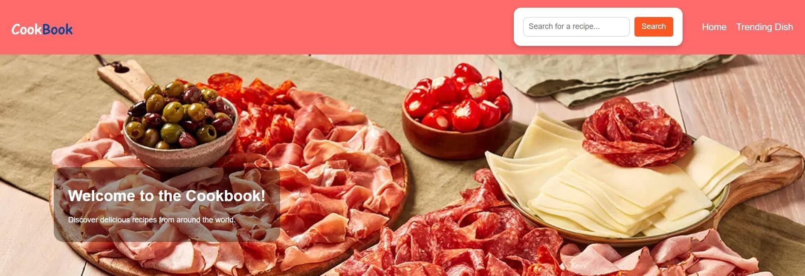

Figure: Welcome Cookbook Home Page

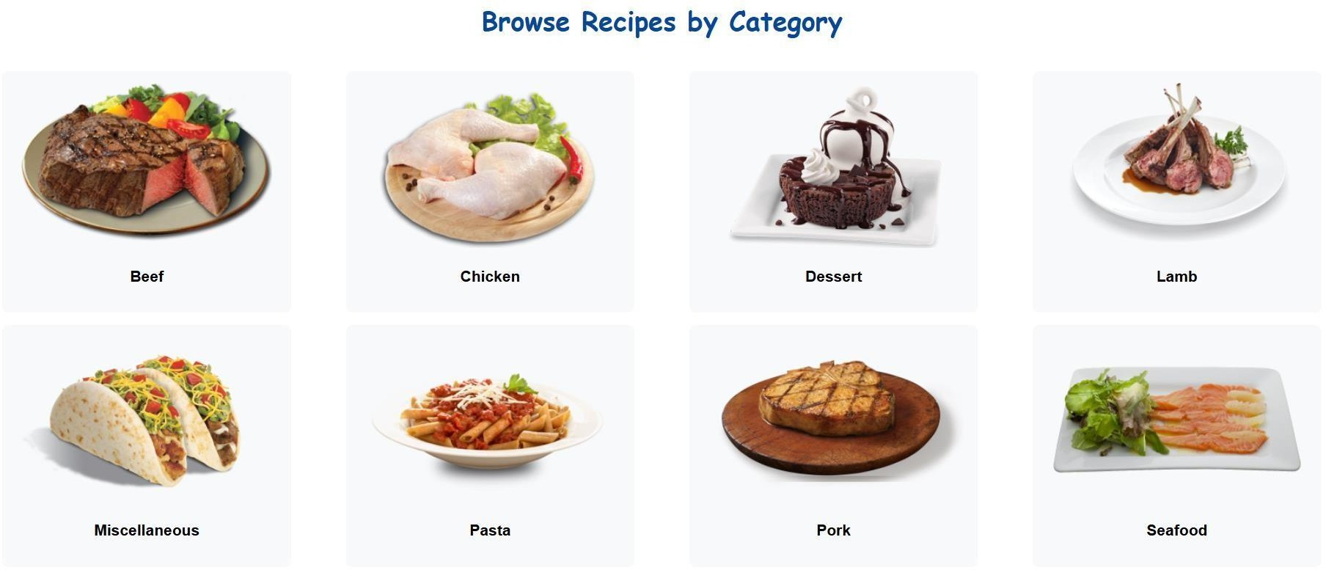

Figure: Category Page

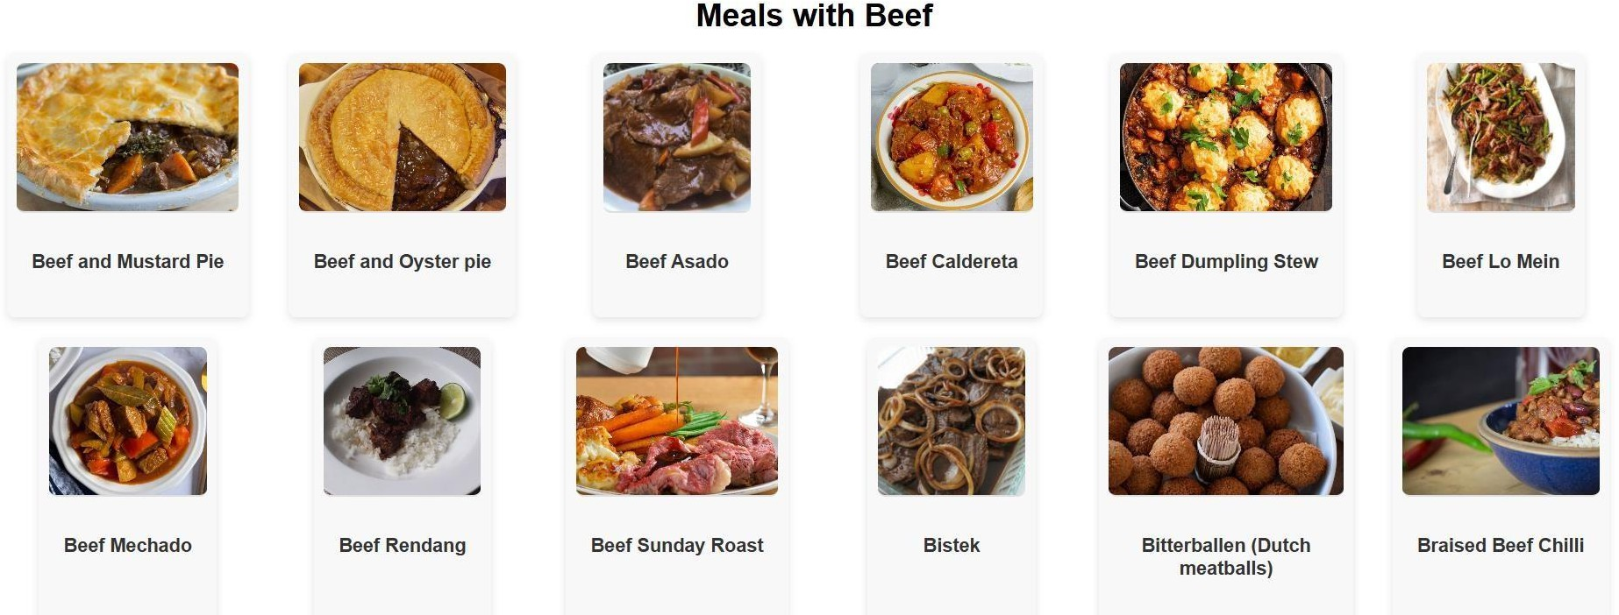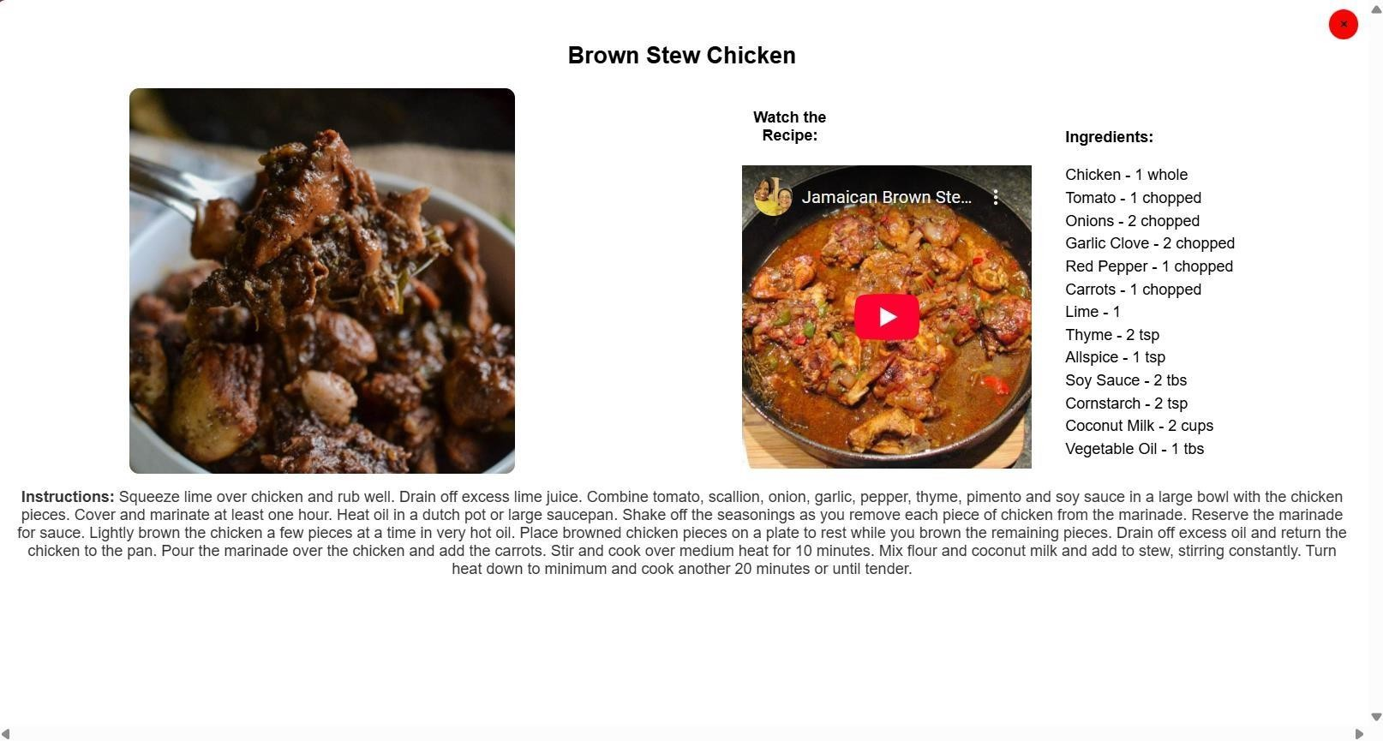

Figure: Types Of Category With Meals Page Figure: Make Dish Ingredients Page

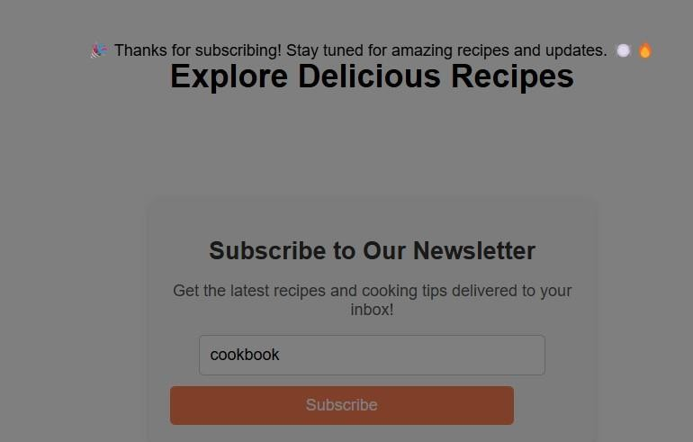

Figure: News Letter Page

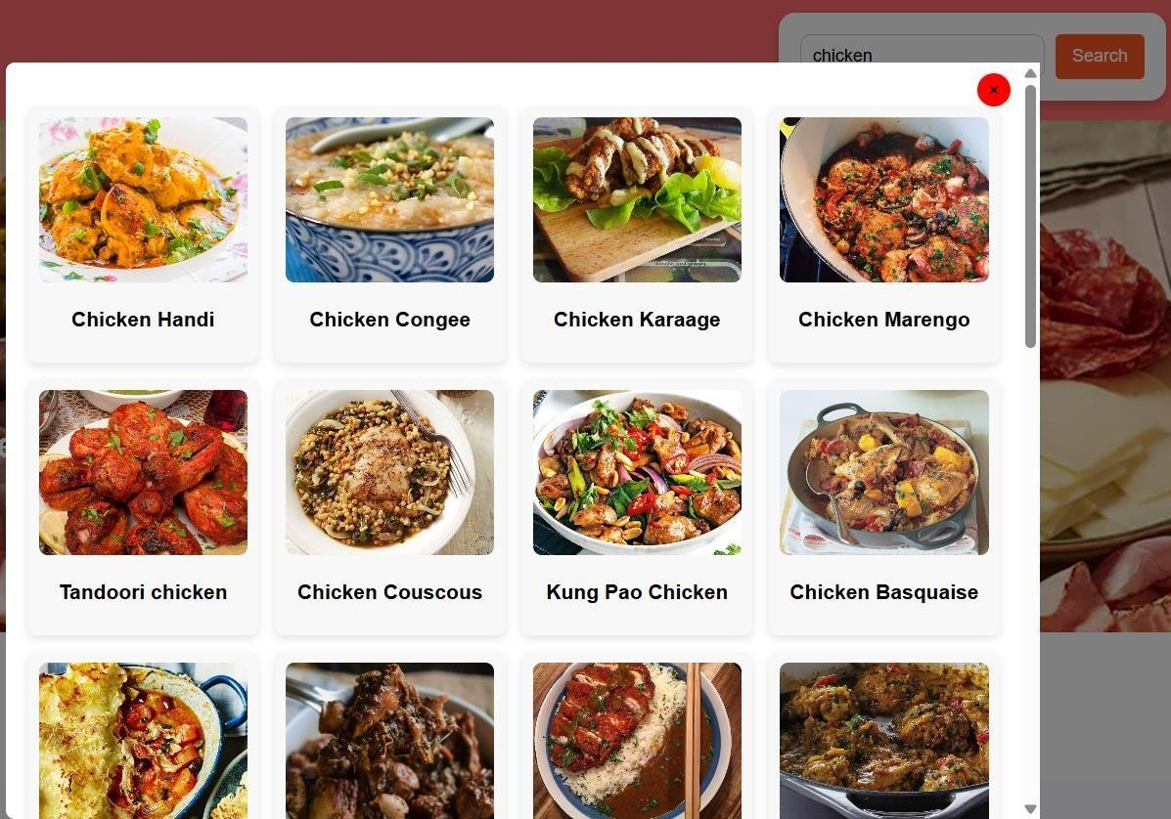

Figure : Search Page

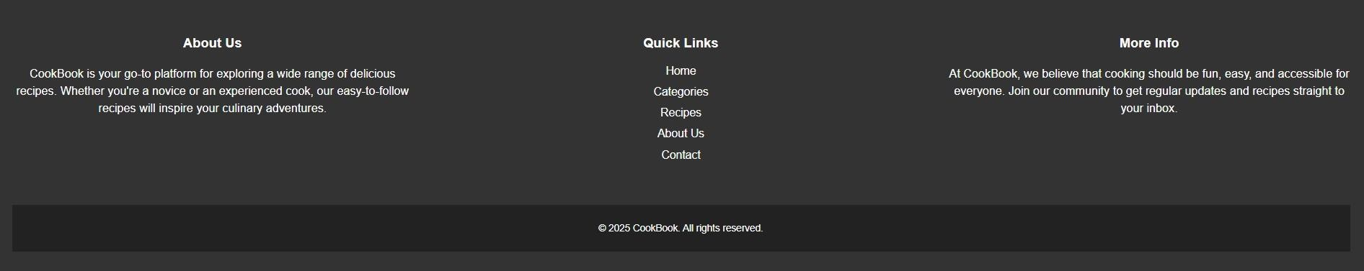

Figure: Footer Page