**ASSIGNMENT(13-09-2023)**

**NAME:** k.kamesh

**BATCH:** July A2

**Arrays built-in functions:**

It provides a set of built-in functions(also called methods) that allow you to perform various operations on arrays.

**Java.util.Arrays :**

These built in functions are part of the “ java.util.Arrays “ class, and they are provide convenient and efficient ways to work with arrays.

Here are some commonly used built-in functions for arrays in java:

* **Arrays.toString() :**

The Arrays.toString() method in java is particularly helpful for debugging and printing the contents of an array to the console and also including it in log messages.

Here’s the example of this array method is shown below,

**CODE:**

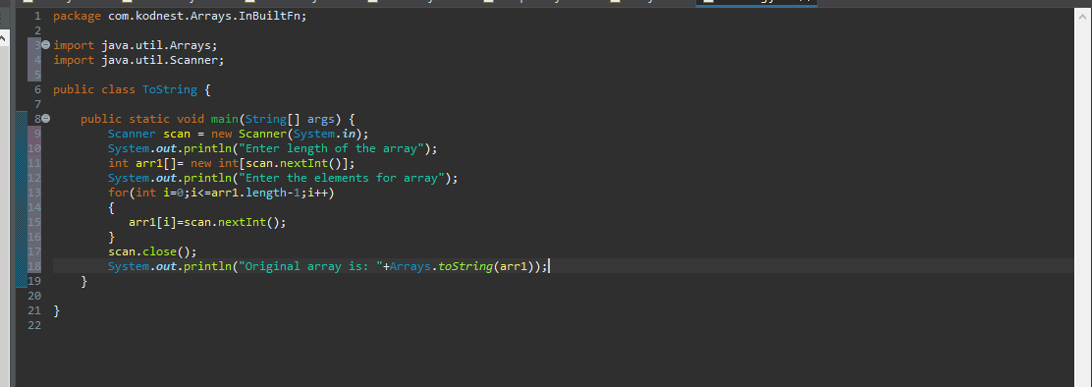

**OUTPUT:**

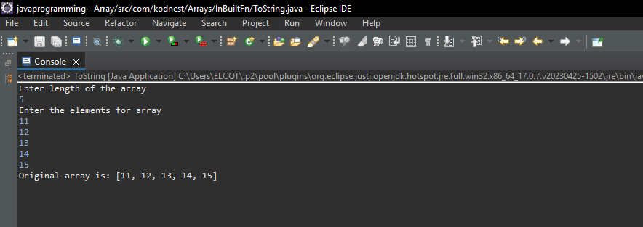

* **Arrays.sort() :**

The Arrays.sort() method in java is used to sort the elements of an array in ascending order. It is part of the “ java.util.Arrarys ” class and provides a convenient way to perform sorting operations on arrays.

Here’s the example of this array method is shown below,

**CODE:**

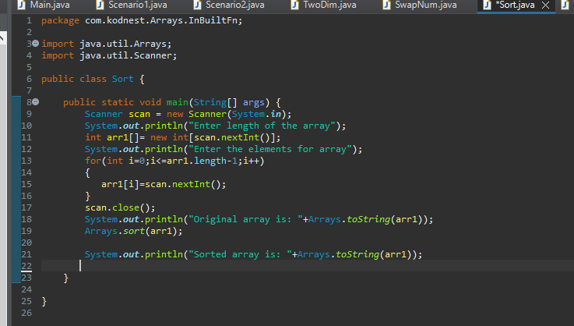

**OUTPUT:**

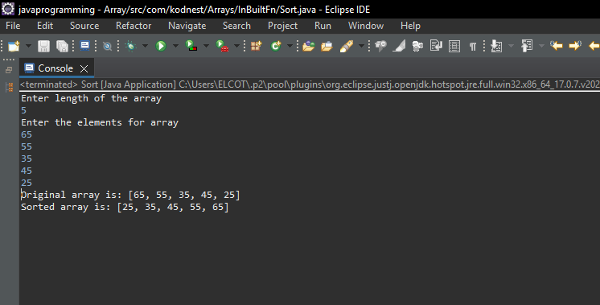

* **Arrays.equals() :**

The Arrays.equals() method in java is used to compare two arrays to determine if they are equal. It checks whether the arrays having the same elements in same order.

This method is especially useful when you need to compare the contents of two arrays to check for equality.

Here’s the example of this array method is shown below,

**CODE:**

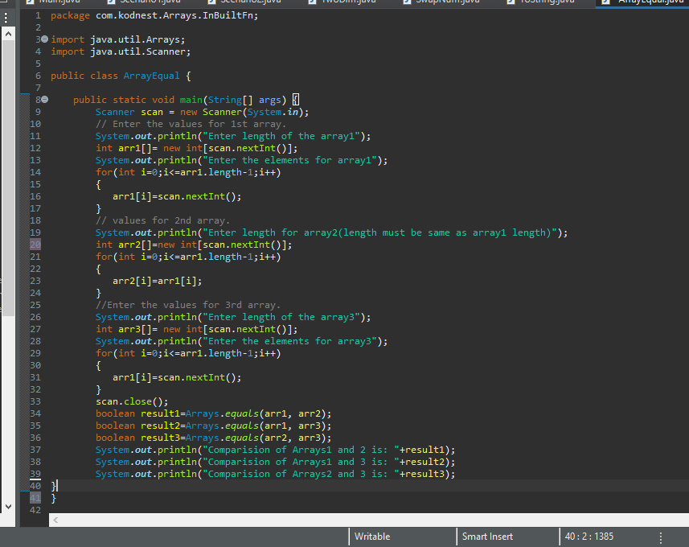

**OUTPUT:**

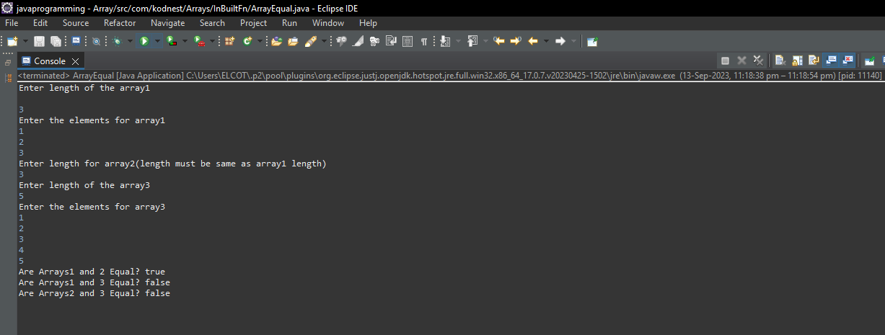

* **Arrays.asList() :**

The Arrays.asList() method is a utility function in Java that allows you to convert an array into a List. This method is part of the ‘java.util.Arrays’ class

The primary purpose of Arrays.asList() is to convert an array (of any type) into a List.

It creates a List view of the specified array, which means that changes made to the list will affect the underlying array, and vice versa.

It doesn't create a new list or copy the elements from the array; it merely provides a List interface to the array.

Here’s the example of this array method is shown below,

**CODE:**

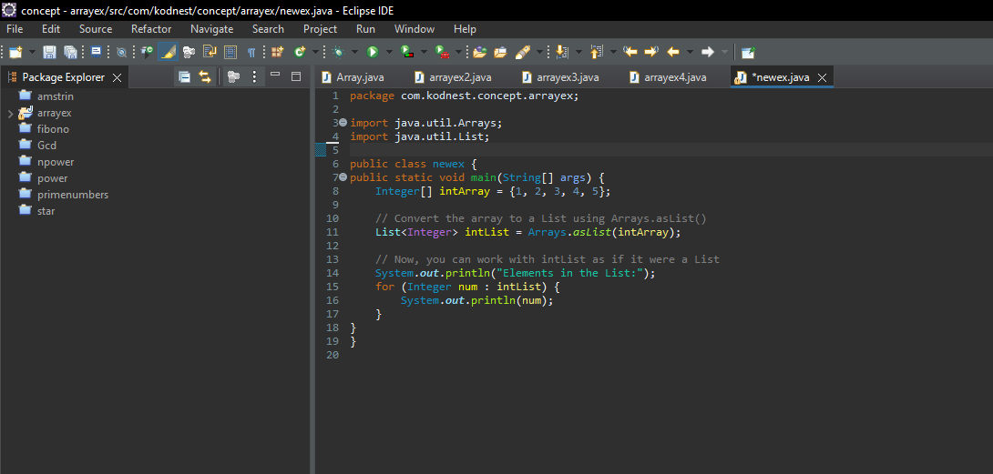

**OUTPUT:**

