ANU LABS
IVF Laboratory Environmental
Monitoring System
System Architecture Document
Version 2.0 | June 2026

Field | Details
Project | IVF Laboratory Environmental Monitoring System
Company | ANU LABS
Prepared By | Sathish Kumar
Version | 2.0
Date | June 2026
Status | Released for Review
Classification | Confidential

1. Executive Summary
The IVF Laboratory Environmental Monitoring System (IVF-EMS) is a dedicated embedded solution designed to maintain the precise environmental conditions required for successful in-vitro fertilisation procedures. Unstable TVOC levels, temperature, or humidity can adversely affect embryo viability; this system provides continuous, automated monitoring with instant alarm response, persistent data logging, and a clinician-friendly touch HMI.

Scope: Continuous real-time monitoring of TVOC, Temperature, and Humidity across one IVF laboratory zone, with local HMI, SD card data logging, alarm management, and a WiFi-ready architecture for future cloud integration.

2. System Objectives
The IVF-EMS shall fulfil the following operational objectives:

- Continuously acquire TVOC index readings from the SGP41 sensor at 1-second intervals with humidity-compensated processing.
- Monitor ambient temperature and relative humidity via the SHT41 precision sensor with ±0.2°C and ±1.8% RH accuracy.
- Render real-time environmental data on a 3.5" 480×320 TFT touch display driven by the LVGL framework at 30 FPS.
- Execute a multi-level alarm engine (Normal / Warning / Critical) with piezo buzzer and relay output, responding within 2 seconds.
- Log all measurements and alarm events to a MicroSD card in CSV format at a configurable interval (default 1 minute).
- Provide 90-day historical trend visualisation directly on the HMI.
- Expose a WiFi interface on the ESP32-S3 for future cloud, OTA, and mobile integration.

3. System Architecture Overview
The system follows a layered, modular embedded architecture. All sensor acquisition, processing, alarm evaluation, data logging, and user interface functions run on a single ESP32-S3 microcontroller. The layers are strictly separated to allow independent testing and future enhancement.

+-------------------------------------------------------+
| IVF-EMS (ESP32-S3 Core) |
+-------------------------------------------------------+
| |
| [ SGP41 TVOC ] [ SHT41 Temp/Hum ] |
| | | |
| +------I2C-------+ |
| | |
| Sensor Acquisition Layer |
| | |
| Environmental Processing Module |
| | |
| +--------+--------+ |
| | | |
| Alarm Engine Data Logger <-- MicroSD (CSV) |
| | | |
| Buzzer/Relay LVGL HMI <-- 3.5" TFT Touch |
| | |
| WiFi Module (ESP32-S3) |
| | |
| (Future: Cloud / OTA) |
+-------------------------------------------------------+

4. Hardware Architecture

4.1 Microcontroller — ESP32-S3
The ESP32-S3 serves as the central processing unit for all system functions.

Attribute | Detail
Core | Dual-core Xtensa LX7, up to 240 MHz
Flash | 8 MB (minimum recommended)
PSRAM | 8 MB (for LVGL frame buffer)
Interfaces Used | I2C (sensors), SPI (TFT display, SD card), GPIO (buzzer, relay)
Wireless | Wi-Fi 802.11 b/g/n (2.4 GHz), Bluetooth 5.0
Operating Voltage | 3.3 V
Key Responsibility | Sensor polling, alarm evaluation, LVGL rendering, SD logging, WiFi

4.2 TVOC Sensor — Sensirion SGP41

Parameter | Value
Measured Output | VOC Index (1–500 scale, TVOC compensated)
Interface | I2C (address 0x59)
Supply Voltage | 1.8 V – 3.3 V
Sampling Rate | 1 sample/second
Humidity Comp. | Requires T/RH input from SHT41 for accurate readings
Signal Conditioning | On-chip MOx signal processing
Long-term Stability | Auto-baseline correction built in

Integration Note: The SGP41 VOC algorithm requires T/RH compensation values from the SHT41. Both sensors must be read in sequence each cycle: SHT41 first, then SGP41 with compensation applied.

4.3 Temperature & Humidity Sensor — Sensirion SHT41

Parameter | Value
Measured Parameters | Temperature, Relative Humidity
Interface | I2C (address 0x44 / 0x45)
Temperature Accuracy | ±0.2°C (typical)
Humidity Accuracy | ±1.8% RH (typical)
Temperature Range | -40°C to +125°C
Humidity Range | 0–100% RH (non-condensing)
Resolution | 16-bit

4.4 Display — 3.5" TFT Touch Panel

Parameter | Value
Resolution | 480 × 320 pixels
Interface | SPI (HSPI bus on ESP32-S3)
Touch Controller | XPT2046 (resistive) or FT6336 (capacitive, variant-dependent)
UI Framework | LVGL v8.x
Refresh Rate | 30 FPS target
Backlight | GPIO-controlled PWM dimming

4.5 Storage — MicroSD Card Module

Parameter | Value
Interface | SPI (VSPI bus on ESP32-S3)
File System | FAT32
Log File Format | CSV (one file per day, e.g. 2026-06-03.csv)
Default Interval | 1 minute (configurable via HMI Settings screen)
Stored Fields | Timestamp, TVOC Index, Temperature (°C), Humidity (% RH), Alarm Status
Minimum Card Size | 2 GB (supports >5 years of 1-minute logs)

4.6 Alarm Output Hardware

Component | Specification | Trigger Condition
Piezo Buzzer | 3.3 V active buzzer on GPIO | Warning or Critical alarm state
Relay Module | 5 V coil, COM/NO/NC output, optoisolated | Critical alarm state only
LED Indicator | Optional RGB LED (GPIO PWM) | Green=Normal, Amber=Warning, Red=Critical

4.7 Hardware Pin Assignment Summary

Signal | ESP32-S3 GPIO | Notes
SDA (I2C) | GPIO 8 | SGP41 + SHT41 shared bus, 4.7kΩ pull-up to 3.3V
SCL (I2C) | GPIO 9 | SGP41 + SHT41 shared bus, 4.7kΩ pull-up to 3.3V
TFT MOSI (SPI) | GPIO 13 | HSPI bus
TFT SCLK (SPI) | GPIO 14 | HSPI bus
TFT CS | GPIO 15 | Active LOW
TFT DC | GPIO 2 | Data/Command select
TFT BL | GPIO 21 | Backlight PWM
Touch CS | GPIO 33 | XPT2046 CS
Touch IRQ | GPIO 36 | Touch interrupt
SD CS | GPIO 5 | VSPI bus
Buzzer | GPIO 41 | Active HIGH
Relay | GPIO 42 | Active HIGH, drives optoisolated relay module

5. Software Architecture
The firmware follows a six-layer architecture. Each layer exposes a clean API to the layer above and has no direct dependencies on non-adjacent layers.

+---------------------------------------------+
| Layer 6: LVGL GUI Layer | Screens: Dashboard, Trend, Alarms, Logs, Settings
+---------------------------------------------+
| Layer 5: Application Layer | Screen manager, event routing, state machine
+---------------------------------------------+
| Layer 4: Alarm Management Layer | Threshold evaluation, buzzer/relay control
+---------------------------------------------+
| Layer 3: Data Logging Layer | SD card CSV writer, circular buffer
+---------------------------------------------+
| Layer 2: Sensor Driver Layer | SGP41 VOC + SHT41 T/RH drivers, I2C HAL
+---------------------------------------------+
| Layer 1: ESP32-S3 Hardware Layer | FreeRTOS tasks, SPI/I2C/GPIO/PWM HAL
+---------------------------------------------+

6. Functional Modules

6.1 Sensor Acquisition Module
Runs as a dedicated FreeRTOS task at 1 Hz. Reads SHT41 first (for T/RH), then passes compensation values into the SGP41 measurement command. Validates CRC on all I2C responses. Publishes results to a shared data structure protected by a FreeRTOS mutex.

Attribute | Detail
Task Priority | High (above LVGL render task)
Update Rate | 1 second
Error Handling | Sensor timeout → flag error, display offline indicator, retry after 5 s
Noise Filtering | Exponential moving average (alpha = 0.3) on TVOC output

6.2 Environmental Processing Module
Consumes raw sensor data and produces derived metrics: rolling 60-second average, 1-minute minimum and maximum, and trend direction (rising/stable/falling) for each parameter. Results feed both the alarm engine and the LVGL dashboard.

6.3 Alarm Management Module
Evaluates all three environmental parameters against configurable thresholds every second. Outputs a three-state alarm level and drives the buzzer and relay accordingly.

Parameter | Normal | Warning | Critical | Buzzer | Relay
TVOC Index | 0 – 150 | 151 – 300 | > 300 | Slow beep | Not triggered
Temperature | 20°C – 25°C | < 20 or > 25°C | < 18 or > 28°C | Slow beep | Not triggered
Humidity | 30% – 60% RH | < 30 or > 60% | < 20 or > 70% | Slow beep | Not triggered
Any Critical | — | — | Any above critical | Fast beep | Triggered

Alarm Response SLA: The system must detect an out-of-range condition and activate the buzzer/relay output within 2 seconds of the condition first occurring. The alarm state is latched until the parameter returns within the Normal band for 30 consecutive seconds.

6.4 Data Logging Module
A FreeRTOS task writes one CSV record per configured interval (default 1 minute) to the MicroSD card. A new file is created each calendar day. If the SD card is absent or write fails, the event is flagged on the HMI and logged to internal flash ring buffer (last 1440 records).

CSV Field | Format | Example
Timestamp | YYYY-MM-DD HH:MM:SS | 2026-06-03 14:32:00
TVOC | Integer (ppb) | 142
Temperature | Float 1dp (°C) | 23.4
Humidity | Integer (% RH) | 47
Alarm Status | String | NORMAL / WARNING / CRITICAL

6.5 LVGL HMI Module — Screen Descriptions

Dashboard Screen

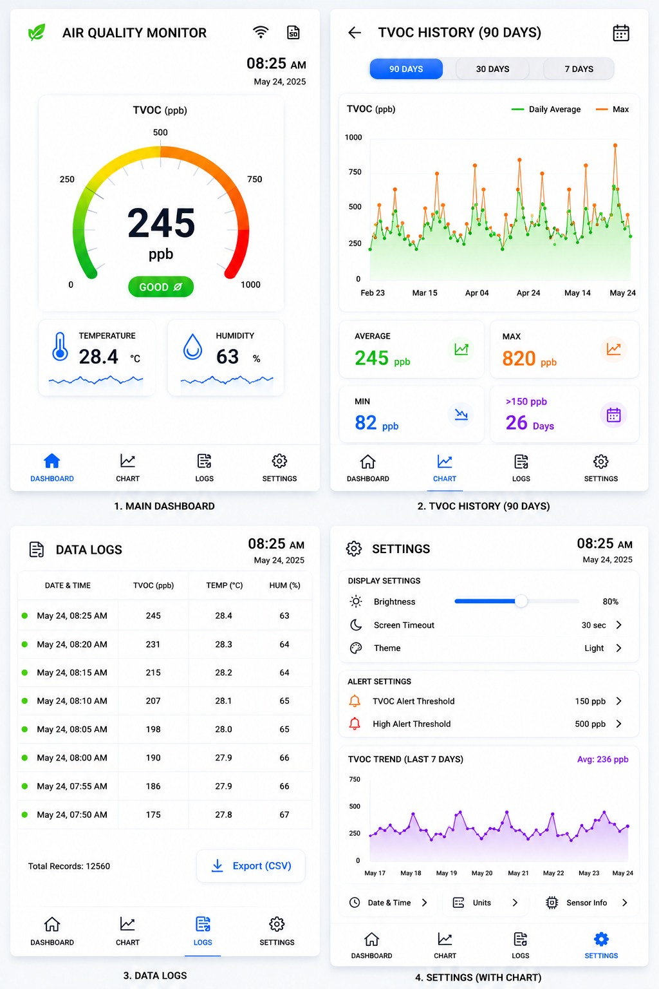
Primary operational view. Displays live TVOC, Temperature, and Humidity in individual sensor cards with colour-coded alarm badges (Green=Normal, Amber=Warning, Red=Critical), a progress bar showing value within range, and a 30-day TVOC mini-chart.

Trend Screen
Displays the full 90-day TVOC history chart with Warning (150) and Critical (300) threshold lines. Summary statistics (Min, Avg, Max, Warning Days, Critical Days) shown above the chart. User can switch between 7D / 30D / 90D views via tab buttons.

Alarms Screen
Shows the current alarm status of each parameter with visual indicators (blinking for active alarms), current measured value, configured limits, and live Buzzer / Relay state.

Data Logs Screen
Scrollable table of the last 30 SD card log entries. Columns: Timestamp, TVOC, Temperature, Humidity, Status. Warning and Critical rows are highlighted with left colour bars.

Settings Screen
Allows the operator to configure: TVOC Warning/Critical thresholds, Temperature Normal band, Humidity Normal band, log interval (1 / 5 / 10 / 30 / 60 min), display backlight level, and time/date. All settings persisted to NVS (ESP32 non-volatile storage).

7. Communication Architecture

7.1 Internal Bus — I2C

Device | I2C Address | Role
Sensirion SGP41 | 0x59 (fixed) | TVOC Index source
Sensirion SHT41 | 0x44 (default) / 0x45 | Temperature & Humidity source

Both devices share a single I2C bus running at 400 kHz (Fast Mode). Pull-up resistors (4.7 kΩ to 3.3 V) are required on SDA and SCL.

7.2 External Communication — WiFi (Phase 2)
The ESP32-S3 WiFi peripheral is reserved for Phase 2. The firmware architecture includes a placeholder WiFi task that is initialised but idle in Phase 1. Planned features:

- MQTT publish to cloud broker (AWS IoT Core / Thingzo Smart platform)
- OTA firmware updates via HTTPS
- REST API for mobile app data queries
- Email / SMS alarm notifications

8. Data Flow Diagram

SHT41 SGP41
| T/RH comp --> |
+--------+-----------+
|
Acquisition Task (1 Hz)
|
Environmental Processing
|
+---------+-----------+----------+
| | |
Alarm Engine Data Logger LVGL HMI
| | |
Buzzer/Relay MicroSD CSV TFT Display
| |
+--------- NVS (settings) -----+
|
WiFi Task (Phase 2)
|
Cloud / OTA

9. Performance Requirements

Parameter | Requirement | Verification Method
Sensor Update Rate | 1 second | FreeRTOS task timing, oscilloscope
Display Refresh Rate | 30 FPS (minimum) | LVGL frame timing log
Alarm Response Time | < 2 seconds | GPIO timing test on simulated threshold cross
Data Log Interval | 1 minute (default) | SD file timestamp diff
System Availability | > 99% | 72-hour soak test, no reboot
I2C Bus Speed | 400 kHz Fast Mode | Logic analyser
Operating Temperature | 10°C – 40°C | Thermal chamber test
Operating Humidity | 10% – 90% RH | Humidity chamber test
SD Write Latency | < 500 ms per record | Firmware log timer
Touch Response | < 100 ms | Stylus + high-speed camera

10. Security & Compliance Considerations
Although Phase 1 is a standalone embedded system with no cloud connectivity, the following considerations apply:

- WiFi credentials (Phase 2) must be stored in ESP32 NVS with flash encryption enabled.
- SD card data is stored in plaintext CSV; physical access control to the laboratory is assumed for Phase 1.
- OTA updates (Phase 2) must use HTTPS with certificate verification to prevent firmware tampering.
- The system should comply with IEC 62133 safety standards for the embedded electronics and IVF laboratory biosafety protocols.
- An audit trail module (Phase 2) will log all settings changes with operator ID and timestamp.

11. Future Enhancements (Phase 2+)

Feature | Priority | Phase
Thingzo Smart Cloud Dashboard | High | Phase 2
OTA Firmware Update | High | Phase 2
Mobile Application (iOS/Android) | Medium | Phase 2
Email & SMS Alarm Notifications | Medium | Phase 2
PDF Compliance Reports | Medium | Phase 3
Multi-Zone / Multi-Lab Monitoring | Medium | Phase 3
Audit Trail System | Low | Phase 3
User Access Control (PIN/RFID) | Low | Phase 3
CO2 / O2 Sensor Integration | Low | Phase 3
AI-based Anomaly Detection | Low | Phase 3

12. Conclusion
The IVF Laboratory Environmental Monitoring System provides a clinically reliable, responsive, and operator-friendly solution for continuous environmental surveillance. The SGP41 + SHT41 sensor combination on an ESP32-S3 platform delivers accurate, compensated measurements; the LVGL HMI presents data intuitively; and the layered firmware architecture ensures maintainability and a clear path to cloud integration via the Thingzo Smart platform.

Next Steps: Proceed to PCB schematic capture (ESP32-S3 + SGP41 + SHT41 + 3.5" TFT + SD card), followed by firmware module scaffolding (FreeRTOS task skeleton, LVGL screen manager, sensor drivers).

