DOM: Document Object Model

<html>

<head>

<title></title>

</head>

<body>

<h1>My Heading</h1>

<form>

<input>

<select> <option>Mumbai</option> </select>

</form>

</body>

</html>

whenever a web page/.html file is loaded into the browser

at the same time browser will create a tree structure of the tags

html

head body

title h1 form

input select

document is an object of the DOM

DOM manipulation: making changes in the DOM

1. we can add new elements in DOM

2. we can remove elements from the DOM

3. we can get the content written inside an element

4. we can change the content written inside an element

5. we can change the style also

6. we can get value of attributes

7. we can change the value of attributes

It will give that h1 tag displayed on console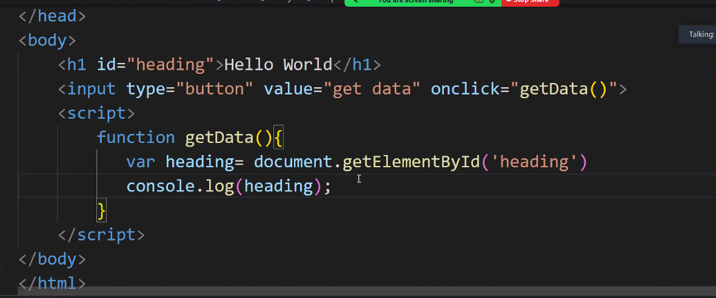

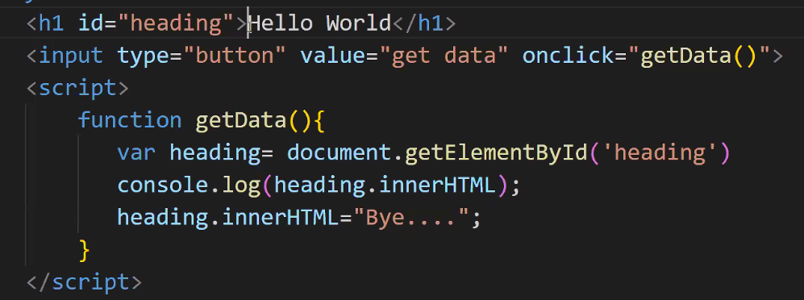

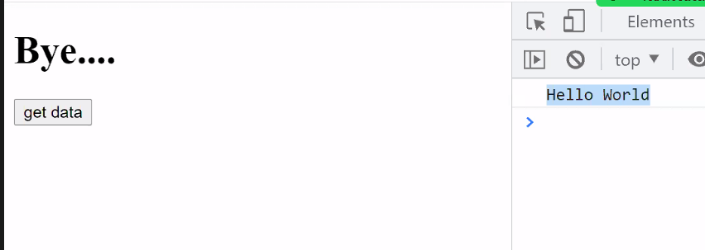

Onclicking, due to innerHTML it will update in h1 temporarily

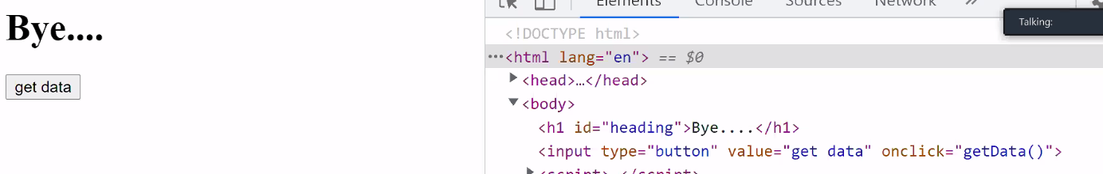

When user will click then we need to change attribute from password to text **dynamically**

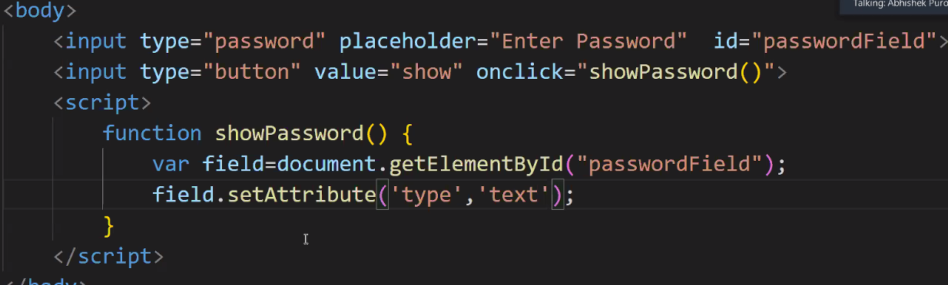

What if button will change from show to hide `

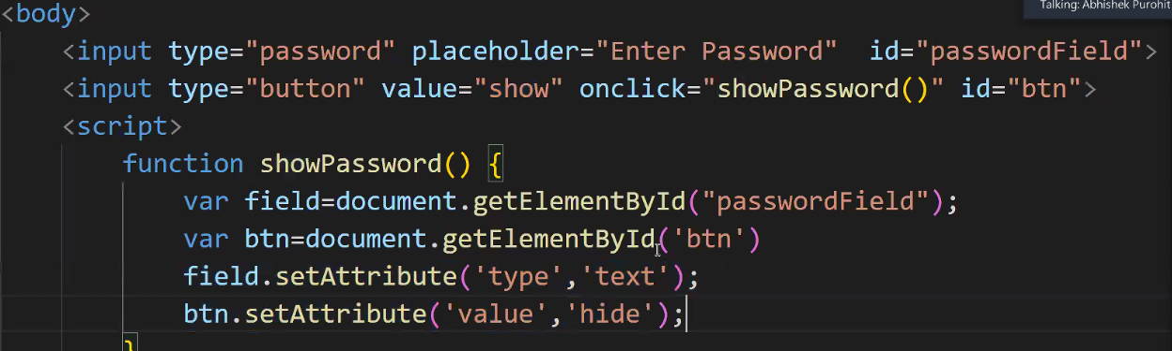



If I want to hide again then use if else

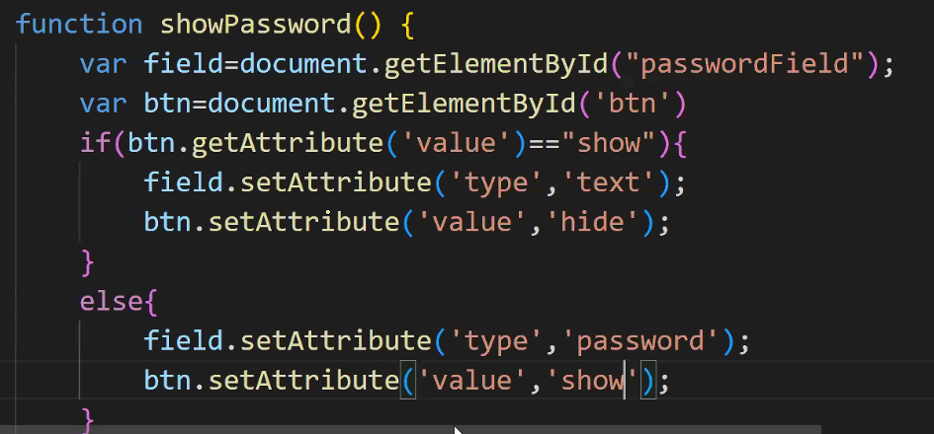

We’re changing the attributes dynamically-🡪DOM

Want to develop news app

Newsapi.org ----documentation--------top headline/heading------it will give API---it will give response in JSON

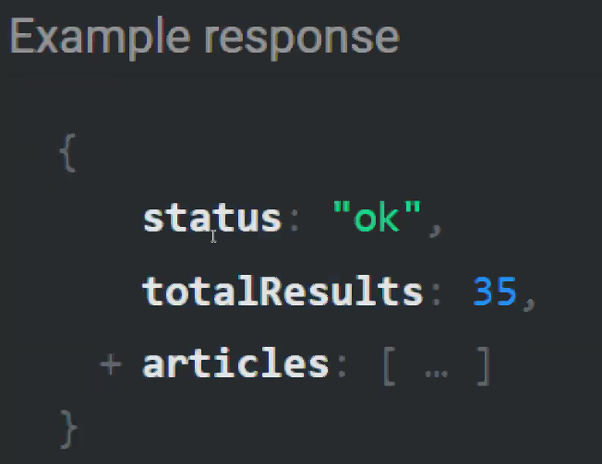it will respond in key-value pairs and article with array of **JSON object**

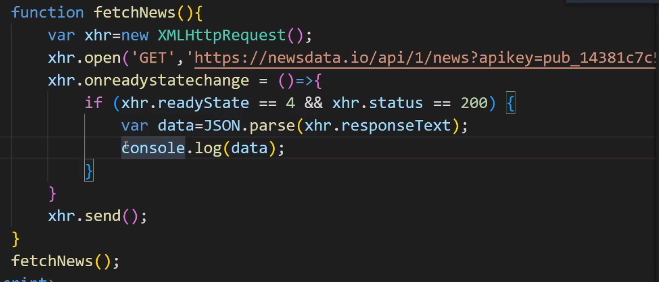



Add &sports it will include only sport news



