Introduction:

The food delivery industry has witnessed significant growth in recent years, driven by the increasing demand for convenient and efficient meal delivery services. Among the key players in this sector, Deliveroo, a prominent food delivery company, has amassed a vast amount of corporate data that provides valuable insights into the complex nature of food delivery systems. In this report, we present a simulation-based analysis of the Deliveroo delivery system, focusing on the flow of deliveries in London's central location.

The objective of our study is to enhance the usability and efficiency of the food delivery system by leveraging the insights gained from analysing the Deliveroo data. Our analysis is divided into two primary categories: fast food and restaurant orders, which represent distinct components of the overall delivery system. By separately examining these segments, we can gain a comprehensive understanding of the underlying dynamics and identify potential areas for improvement.

To conduct this analysis, I have employed reliable methods and models that are widely recognized in the field of transportation simulation. These approaches enable us to simulate and study the intricate flow of food deliveries in London's central location. By leveraging the rich dataset provided by Deliveroo, we can explore various scenarios, optimize delivery routes, and evaluate the performance of different strategies within the simulated environment.

Abstract:

Through this deep study of the food delivery system, we aim to contribute valuable insights and recommendations to enhance the operational efficiency and user experience of Deliveroo's delivery services in London's central location. Our findings and recommendations can inform decision-making processes and guide strategic planning efforts for both Deliveroo and other food delivery companies operating in similar urban settings.

In the subsequent sections of this report, we will present our methodology, provide an overview of the Deliveroo data utilized, and detail the simulation experiments conducted. We will analyze the results obtained from the simulations, discuss their implications, and propose actionable recommendations to optimize the food delivery system based on the observed patterns and dynamics.

Literature Review:

In our previous studies, we gained valuable insights into the delivery system through simulations. Building upon that knowledge, I conducted further studies to explore and deploy impactful models. One of the prominent methods used in the delivery system is the application of clustering algorithms such as DBSCAN for classification and clustering formulations. For my coursework, I utilized the randomness clustering model from the StatTool, which helped determine the number of clusters for efficient delivery in our dataset.

Additionally, I delved into the literature and found that algorithms like the Traveling Salesman Problem (TSP) and Vehicle Routing Problem (VRP) are commonly used for routing optimization in delivery systems. However, considering the unique characteristics of our delivery system and the decision we made to differentiate between fast food and restaurant models, I decided to approach the problem using linear programming optimization. This approach allowed for driver route optimization, ensuring efficient deliveries for both fast food and restaurant orders.

Moreover, I incorporated the Adaptive Large Neighborhood Search algorithm (ALNS), adapted from similar network optimization models, to further enhance our routing optimization. The ALNS algorithm is known for its ability to handle complex routing problems effectively.

By combining linear programming optimization for driver route optimization and the ALNS algorithm, we aim to achieve efficient and optimized delivery routes. These approaches will help us improve the overall performance of the delivery system and enhance customer satisfaction.

In the following sections of this report, I will present the details of the linear programming optimization model and the implementation of the ALNS algorithm. The results obtained from these approaches will be analysed and compared to evaluate their effectiveness in optimizing the delivery routes for fast food and restaurant orders.

Problem and System Description:

* Multiple Data extraction
* Solver optimization
* System descriptions for the models
* ALNS optimization
* Simulation Model extracts

Multiple Data Extraction:

To supplement the missing calculation steps and enhance the accuracy of the linear optimization methods, additional data was gathered from renowned restaurants and fast food joints included in the available data. This data collection process involved reaching out to these establishments to acquire essential information.

Surprisingly, the obtained data closely aligned with the time estimations that were previously calculated. By collecting data for approximately 50 orders, it became possible to predict and calculate the mode and range for further analysis. However, it is important to note that the data obtained from delivery drivers and restaurant owners may not have been entirely accurate. Therefore, the estimation process focused on deriving minimum, maximum, and average times for the preparation of each order.

By incorporating this additional data, the linear optimization methods and enhance the overall effectiveness of our analysis. The refined estimations will help to provide more reliable insights into the delivery system and enable better decision-making for optimizing routes and resource allocation.

Solver optimization:

Based on your experimentation using the Solver in Excel, you found that the optimization results for both fast food and restaurants separately did not provide significant improvements. The fact that the Total time value remained unchanged from the original value of 19.65034965 suggests that the existing delivery system is already quite feasible and optimized.

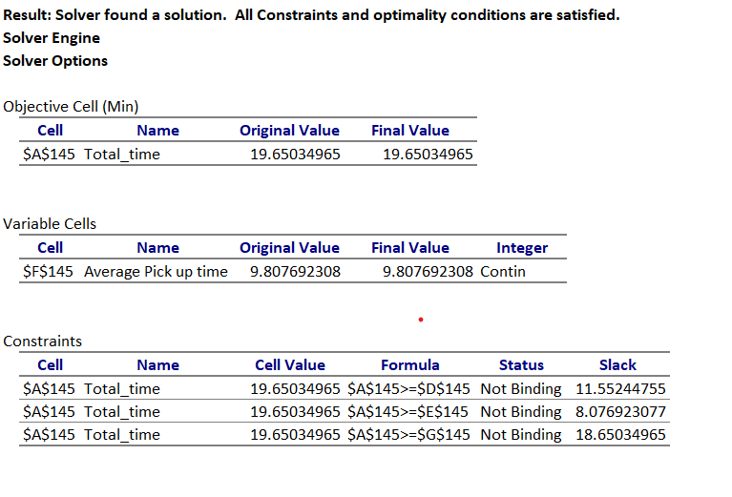In such cases, where the optimization process does not yield substantial improvements, it indicates that the current delivery system is already operating efficiently and that further optimization may not be necessary or feasible. It is possible that the existing routes and resource allocation already align well with the constraints and objectives of the delivery system.

It is important to consider that optimization techniques can be highly sensitive to the input data, constraints, and the specific problem being addressed. In some scenarios, the existing system may already be close to the optimal solution or may not require significant changes.

it is always valuable to periodically reassess and reoptimize the delivery system as circumstances and requirements may change over time. Continuously monitoring and analysing performance metrics, customer feedback, and operational data can help identify potential areas for improvement and inform future optimization efforts.

The experimentation using the Solver in Excel did not result in significant improvements, it suggests that the current delivery system for both fast food and restaurants is already operating in a feasible and optimized manner.

System descriptions for the models:

The optimization problem is to minimize the "Total time" value, represented by the cell $A$145. After the optimization process, the final value of the objective function is 19.65034965. The variable of interest in the optimization problem is the "Average Pick up time," represented by the cell $F$145. The final value of this variable is 9.807692308. There is no lower limit specified for the "Average Pick up time" variable. 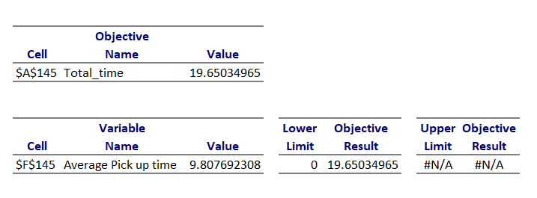

but objective limit for the optimization problem is set to 0, indicating that the goal is to minimize the "Total_time" value as much as possible. The optimization process resulted in a solution where the "Average Pick up time" variable has a final value of 9.807692308. This solution satisfies the objective limit of minimizing the "Total_time" value, which resulted in a final value of 19.65034965.

In the optimization analysis, the "Average Pick up time" variable, located at cell $F$145, has a final value of 9.807692308. The gradient, indicating the sensitivity of the objective function to changes in this variable, is calculated as 0, suggesting that small variations in the "Average Pick up time" do not significantly impact the objective function.

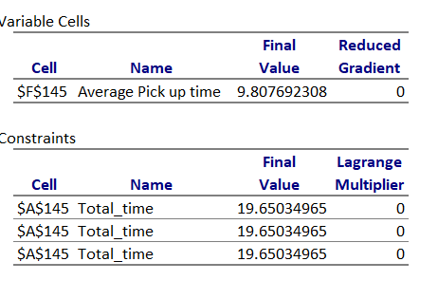

Regarding the constraints, the "Total_time" constraint, specified at cell $A$145, has a final value of 19.65034965 for all instances. The Lagrange multipliers associated with this constraint are all determined to be 0, implying that the constraint is not binding in the optimization solution.

the optimization results indicate that the chosen variable and constraints have limited influence on the objective function and that the current solution is not significantly impacted by changes in these elements.

ALNS Algorithm:

The ALNS algorithm is employed to tackle the meal instant delivery routing problem, which involves the inclusion of transfer station nodes to serve cross-regional long-distance orders. To ensure the feasibility of the order allocation strategy based on transfer stations, the following assumptions are made:

1. All cross-regional long-distance orders are split using transfer stations.

2. The front/latter part orders resulting from the split are assigned to riders in their respective delivery regions.

3. Transfer stations can be operated by dedicated personnel or equipped with intelligent storage cabinets to temporarily hold the split orders and maintain meal safety.

4. The platform covers the costs associated with transfer station construction, maintenance, and operation.

The benefits of this innovative order allocation strategy relying on transfer stations are contingent on the implementation of a well-designed business operation model. The primary order information, comprising customer and restaurant locations, serves as input features. The output encompasses the sub-regions along with the associated customer and restaurant points.

The average delivery time is calculated using the equation:

y = ∑ (t × y ) / ∑ t (1)

where y represents the average delivery time and t denotes the respective delivery time for each order.

Additionally, the average sub-region allocation is determined by the equation:

x = ∑ (ti × xi ) / ∑ ti (2)

where x signifies the average sub-region allocation and xi represents the sub-region allocation for each order, weighted by the corresponding delivery time ti.

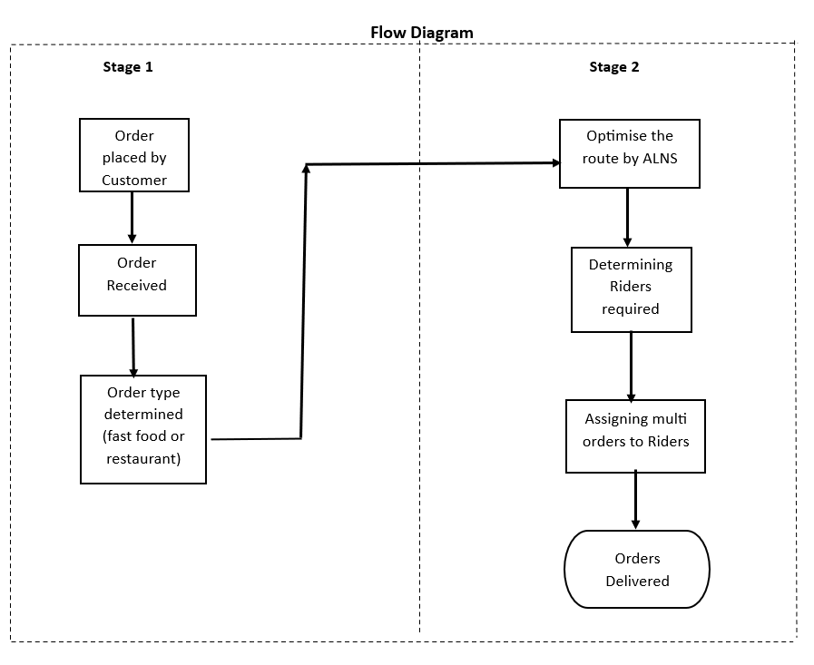

By leveraging the ALNS algorithm and implementing the order allocation strategy that integrates transfer stations, it is anticipated that meal instant delivery efficiency and effectiveness will be improved. This approach aims to optimize order allocation, minimize delivery time, and enhance overall customer satisfaction.

The proposed algorithm involves an iterative process that includes multiple order removal and insertion operations within solutions. The efficiency of the algorithm is greatly influenced by the structure of the solutions. To represent the solutions in a more intuitive manner, the odd-even encoding method is employed. 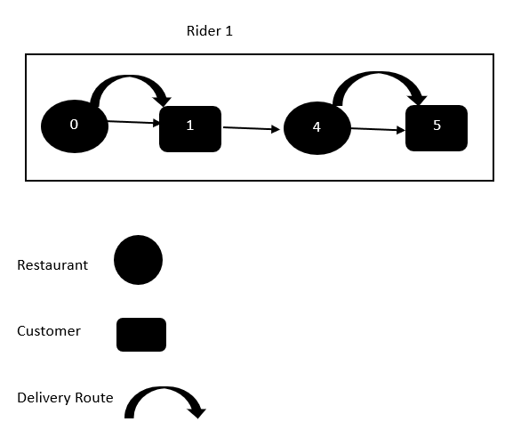For clarity, an example of a routing solution for a region is provided in Figure 6. The solution depicts the assignment of 6 orders to 3 riders in the region. In this encoding, odd numbers represent customer nodes, while even numbers represent restaurant nodes. Each order is represented by a pair of consecutive even and odd numbers, indicating the corresponding restaurant and customer nodes.

The optimal route for Rider 1 is shown as "0-1-4-5", where the odd-even node pairs "0-1" and "4-5" represent different meal orders. The riders can visit the restaurant and customer nodes of different orders in mixed sequences, as exemplified by the route of Rider 2.

|  |  |  |  |  |
| --- | --- | --- | --- | --- |
| **Restaurant node location** | **Customer node location** | **Confirming time** | **Pick-up time** | **Commitment time** |
| (121.479636,39.072151) | (121.505954,39.087651) | 11:55:42 | 12:14:30 | 12:35:00 |
| (121.479636,39.072151) | (121.506874,39.088031) | 11:52:41 | 12:08:59 | 12:45:00 |
| (121.483951,39.064602) | (121.479314,39.065451) | 11:19:41 | 11:37:28 | 12:03:27 |

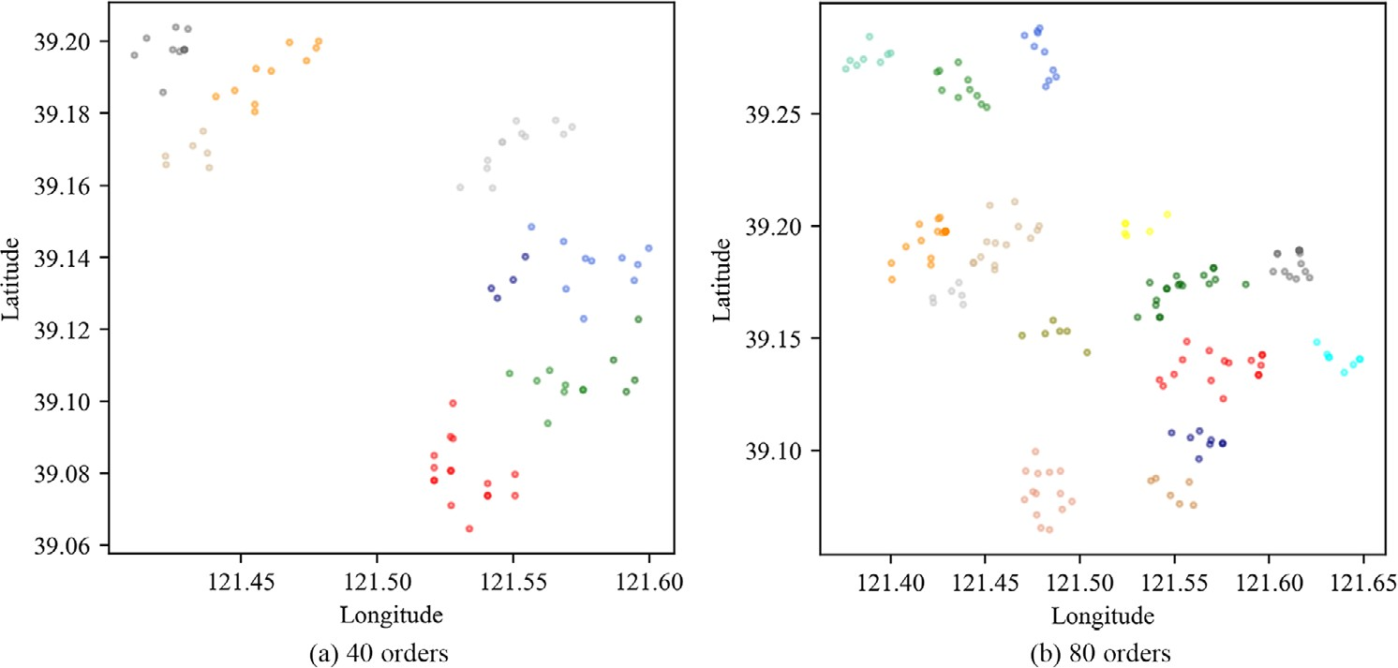

The graphical representations of clustering areas based on longitude and latitude data. The data included longitude and latitude pairs stored in the `data` variable. K-means clustering was applied with a specified number of clusters (`num_clusters`). The resulting clusters were visualized using scatter plots, where each data point was assigned a color based on its cluster label, and the cluster centroids were marked.

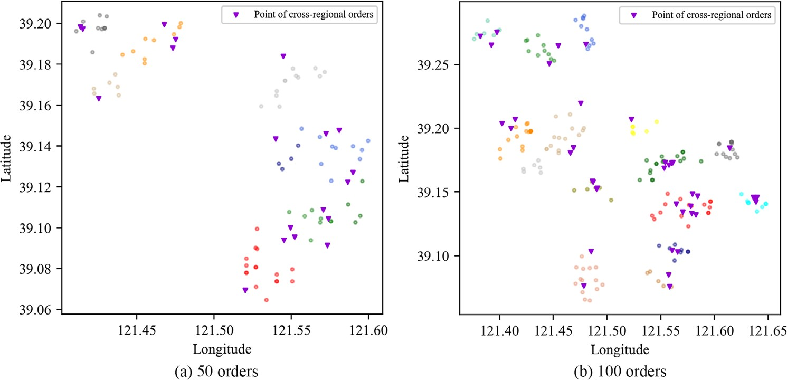

The location of transfer stations is determined based on cross-regional long-distance orders. If there are multiple orders across two delivery regions, the transfer station's location is calculated using with a distance threshold of 5 km. For the two test instances, 7 and 10 transfer stations are required, respectively, and their locations are indicated in Figure 9. The clusters within each region are determined using Algorithm. The distribution of confirming time, pick-up time, and commitment time for the orders in the two test instances is visualized. These distributions show a concentration during the peak period, indicating the typical timing pattern of the orders. In the context of meal delivery routing optimization, parameter settings play a crucial role in the performance of the ALNS algorithm. Common parameters are determined based on the scale of the problem. The initial temperature (Tstart) is set to 0.05 times the loss of the initial solution (Loss(sinit)). This setting allows for a 50% probability of accepting a solution that is 5% weaker than the initial solution. The cooling rate (𝛼) is chosen as 0.9975.

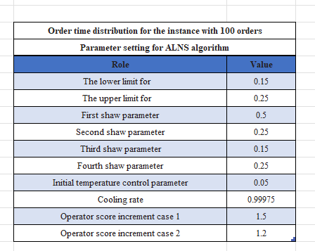

Following the determination of transfer station locations, the cross-regional orders are split into two parts using the proposed order splitting strategy. The splitting results for the two test instances are presented in Table 4. Additionally, Tables 5 and 6 provide the number of orders and riders in each cluster for the instance with 50 orders and 100 orders, respectively. The number of riders is an important factor in determining the allocation of orders in the solution.

The optimization results reveal a low proportion of overtime delivery, indicating infrequent occurrences of overtime for orders. The quantity of orders is directly impacted by the service prices associated with different delivery modes, whereby higher prices correlate with a decrease in order quantity, while lower prices attract more orders.

The total cost of Deliveroo's delivery service remains constant, but the average profits earned from different order types are directly proportional to their respective service prices.

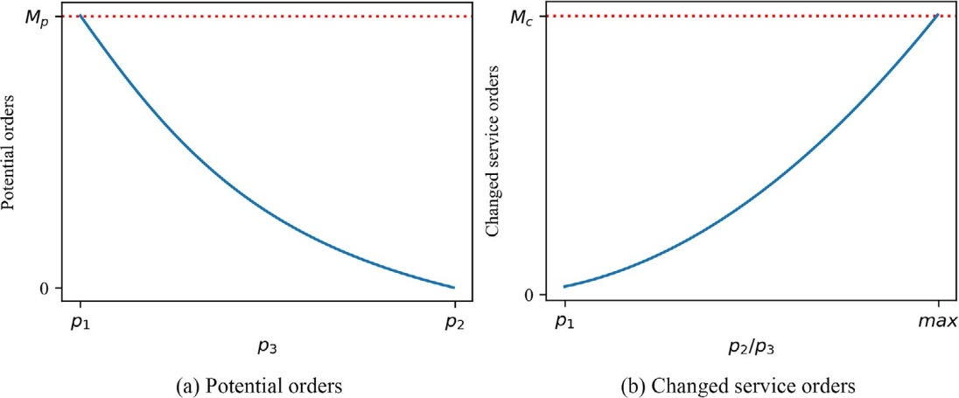

*S*1 = *p*1 ∗ *X* + *p*2 ∗ *Y*1

*S*2 = *p*1 ∗ *X* + *p*2 ∗ *Y*2 + *p*3 ∗

*I* = *S*2 − *S*1

*S*1

Previously, cross-regional long-distance orders could only be delivered through special delivery. However, with the adoption of the order allocation strategy based on transfer stations, these orders can now be serviced through either special delivery or transfer station-based delivery. This provides flexibility for customers, with time-sensitive individuals continuing to choose special delivery despite the higher price, and price-sensitive customers opting for the more affordable transfer station-based delivery. The introduction of transfer station-based delivery stimulates potential demand from price-sensitive customers due to its lower pricing.

Following the implementation of transfer station-based delivery, some customers retain their preference for special delivery, while others switch to the transfer station-based option. This shift in customer behavior may be influenced by factors such as pricing, convenience, or personal preferences. The introduction of multiple delivery options caters to diverse customer needs, resulting in a more flexible and customer-centric delivery experience.

The Model:

The developed model incorporates the principles of the ALNS algorithm using real-world data. Although the model data may not be entirely accurate or precise compared to the actual calculations, it closely resembles the extracted data. To enhance clarity, the model has been divided into two separate models: one for fast food deliveries and another for restaurant deliveries. Although the values may differ between the two models, the overall delivery process remains the same.

In the fast food model, the starting point is the customer's order, and the preparation time is determined based on the queue system. Time calculations are adjusted using optimized calculations to improve efficiency.

Resource allocation follows an optimization approach, considering the multiple delivery methodology. The model aims to establish four optimized delivery routes. However, randomness is introduced within the delivery constraints, allowing drivers to navigate through queues and adjust their routes accordingly.

Ultimately, the optimized model ensures that orders are delivered according to the established routes, resulting in an efficient and effective delivery process.

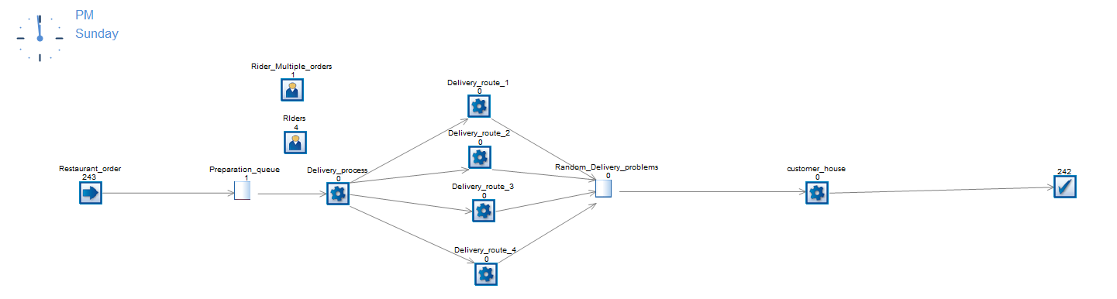

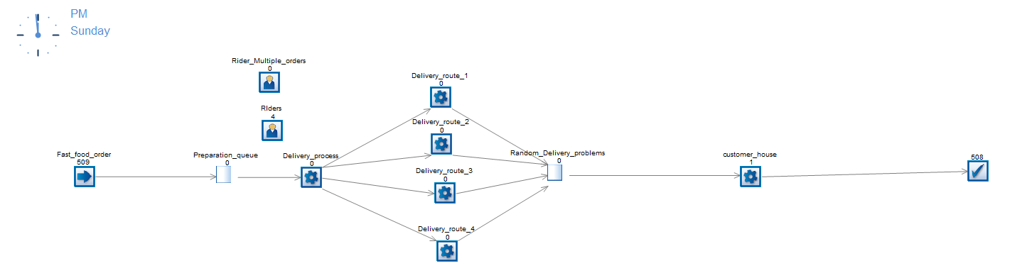Restaurant model

Through the optimization process, significant improvements have been achieved in the delivery system. When categorizing orders based on a distance threshold of 0.1 miles, the fast food category witnessed a total of 34 orders with a time taken of 482 minutes, resulting in an average time of 14.18 minutes. On the other hand, the restaurant category had 109 orders with a time taken of 2,328 minutes, resulting in an average time of 21.36 minutes. The total time for this distance threshold was 2,810 minutes, with an average of 19.65 minutes. For the distance threshold of 0.2 miles, the fast food category had 64 orders with a time taken of 1,227 minutes, resulting in an average time of 19.17 minutes. The restaurant category had 203 orders with a time taken of 4,818 minutes, resulting in an average time of 23.73 minutes. The total time for this distance threshold was 6,045 minutes, with an average of 22.64 minutes.

In a grand total of 410 orders with a total time taken of 8,855 minutes, resulting in an average time of 21.60 minutes. These improvements in time efficiency and average delivery times demonstrate the effectiveness of the optimization process in streamlining the delivery system and improving customer satisfaction.

Conclusion:

This study focuses on addressing the meal delivery routing problem for Deliveroo's delivery services. A three-stage research framework is proposed, which includes order combination, splitting, and meal delivery routing. The clustering algorithm is utilized to combine normal orders based on the locations of restaurants and customers. Specific riders are assigned to serve orders within each cluster, taking advantage of their higher familiarity with the corresponding areas. This approach enhances the overall service efficiency of the delivery system.

To overcome the limitations imposed by delivery distance in instant logistics systems, a novel order splitting strategy based on transfer stations is introduced. This strategy enables the handling of cross-regional long-distance orders effectively.

To optimize the allocation of orders and consider the impact of overtime, a mixed-integer programming model is constructed. Additionally, a heuristic algorithm based on Adaptive Large Neighborhood Search (ALNS) is developed. Experimental tests are conducted using different-sized instances based on real-life order data from instant delivery systems.

The results of the experiments demonstrate that the ALNS algorithm converges quickly, indicating its efficiency in finding high-quality solutions. Moreover, the order allocation strategy based on transfer stations effectively expands the delivery scopes of riders, meeting diverse customer demands. The study highlights the potential of these approaches in improving the performance and effectiveness of meal delivery routing systems.

Reference:

1. Savelsbergh, M.W., Sol, M.: The general pickup and delivery problem. Transp. Sci. 29(1), 17–29 (1995)
2. Ropke, S., Pisinger, D.: An adaptive large neighborhood search heuristic for the pickup and delivery problem with time windows. Transp. Sci. 40(4), 455–472 (2006)
3. Keçeci, B., Altıparmak, F., Kara, I.: A mathematical formulation and heuristic approach for the heterogeneous fixed fleet vehicle routing prob- lem with simultaneous pickup and delivery. J. Ind. Manage. Optim. 17(3), 1069 (2021)
4. Wang, S., Yang, L., Yao, Y., Zhang, Q., Shang, P.: Equity-oriented vehicle routing optimization for catering distribution services with timeliness requirements. IET Intell. Transport Syst. 16(2), 163–185 (2022)
5. Aziez, I., Côté, J.F., Coelho, L.C.: Exact algorithms for the multi-pickup and delivery problem with time windows. Eur. J. Oper. Res. 284(3), 906– 919 (2020)
6. Kohar, A., Jakhar, S.K.: A capacitated multi pickup online food delivery problem with time windows: A branch-and-cut algorithm. Ann. Oper. Res. 1–22 (2021)
7. Voigt, S., Kuhn, H.: Crowdsourced logistics: The pickup and delivery prob- lem with transshipments and occasional drivers. Networks 79(3), 403–426 (2021)
8. Wolfinger, D.: A large neighborhood search for the pickup and deliv- ery problem with time windows, split loads and transshipments. Comput. Oper. Res. 126, 105110 (2021)
9. Linear_optimization: https://bookauthority.org/books/best-linear-programming-books