# Abstract

Given that financial markets inherently consist of historical sequences of equity prices, an increasing number of quantitative researchers and finance professionals are turning to LSTM to model and predict price movements. This project entails a comprehensive machine learning workflow that entails the development of an LSTM model for forecasting stock market prices. The implementation utilizes PyTorch and Alpha Vantage APIs, enabling the exploration of historical data, training of the model, and generating predictions.

# Background

Based on data provided by the Central Bank of Taiwan (Republic of China Central Bank, 2021), over the span of the last twenty years, there has been a significant decline in the average yearly interest rate for fixed deposits, plummeting from 5.02% to a mere 0.77%.

In principle, conventional or "vanilla" RNNs have the ability to capture and retain long-term dependencies within input sequences. However, a practical challenge arises with vanilla RNNs during training using back-propagation, where the gradients that are back-propagated can either diminish (vanish) towards zero or grow uncontrollably (explode), due to finite-precision computations involved in the process.[16] This limitation affects the network's ability to effectively learn and process information.

To address this issue, LSTM (Long Short-Term Memory) units are employed in RNNs, which offer a partial solution to the vanishing gradient problem by allowing gradients to flow without alteration. Despite this improvement, LSTM networks can still encounter the challenge of exploding gradients.[17]

The idea behind the LSTM architecture is to introduce an additional module within the neural network that learns the optimal moments for retaining or discarding relevant information.[15] In simpler terms, the network acquires the ability to identify which information should be remembered for future use in a sequence and when it becomes irrelevant. This capability proves valuable, particularly in natural language processing tasks, where the network can learn and leverage grammatical dependencies.

**Dataset Overview:**

Alpha Vantage is a popular API for accessing financial market data and analytics. With Alpha Vantage, you can easily fetch real-time and historical stock market data, including stock quotes and intraday time series. You can also access technical indicators like moving averages and volume analysis, which are useful for analyzing stock price trends. Alpha Vantage covers a wide range of global equity markets and supports fundamental data such as company information and financial statements. The API is user-friendly and offers easy integration into your project using popular programming languages like Python. While there is a free plan available, they also offer paid subscription plans with higher API rate limits and additional features. With Alpha Vantage, you'll have access to the essential stock market information needed for your project work.

# Process Flow:

1. Retrieve data from the Alpha Vantage API: To obtain relevant financial data from the Alpha Vantage API using appropriate endpoints and parameters.

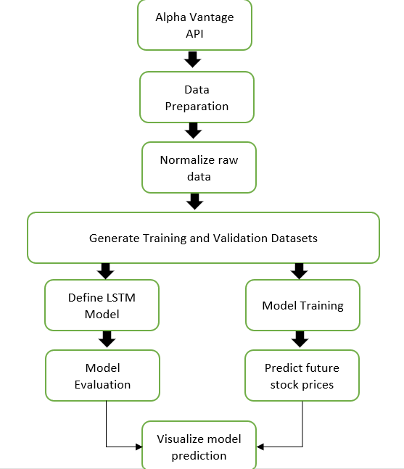

2. Performing data preparation: Cleaning and organizing the retrieved data by removing outliers, handling missing values, and ensuring consistency and quality.

3. Normalize the raw data for consistency: Applying normalization techniques, to standardization and ensure that all data features are on a comparable scale.

4. Generate training and validation datasets: Split the normalized data into separate datasets for training and validation purposes, typically using a suitable ratio.

5. The LSTM model for stock price prediction: Specify the architecture, layers, and activation functions of the LSTM model, which is suitable for sequential data analysis.

6. To Evaluate the model's performance using metrics: such as MSE and MAE TO Measure the accuracy and performance of the trained model by calculating evaluation metrics.

8. Predict future stock prices using the validation dataset: Utilize the trained LSTM model to make predictions on the validation dataset, forecasting future stock prices based on learned patterns.

9. Visualize the model's predictions with Tableau: Tableau to create visual representations of the predicted stock prices, enabling better understanding and interpretation of the model's performance.

# Conclusion:

the project "Predicting Stock Prices with Deep Learning using Alpha Vantage API" provides a comprehensive framework for developing and training a deep learning model to forecast stock prices. By leveraging the power of deep learning, specifically Long Short-Term Memory (LSTM) networks, in conjunction with the Alpha Vantage API, I can access real-time and historical stock market data to build an accurate predictive model. This project equips me with the necessary tools to make informed investment decisions, manage risks effectively, and optimize market timing. By successfully completing this project, I would like to gain valuable insights into the application of deep learning and the utilization of APIs in the financial domain, ultimately enhancing our understanding of stock market dynamics and prediction methodologies.

# Resources

All the resources are already available freely and without any license or ethical issues.

***Software Requirement***

* NumPy
* PyTorch
* Matplotlib
* alpha_vantage API
* SQLlite
* Tableau

***Language:*** Python, SQL, Tableau

# References

[1] National Library : https://www.ncbi.nlm.nih.gov/pmc/articles/PMC7959635/

https://www.xplenty.com/blog/snowflake-schemas-vs-star-schemas-what-are-they-and-how-are-they-different/

[2] Wikipedia https://en.wikipedia.org/wiki/Long_short-term_memory

[3] <https://www.lstmed.ac.uk/news-events/seminars-and-lectures/how-data-visualization-and-predictive-analytics-are-helping-to-map>

[4] https://uk.mathworks.com/campaigns/offers/deep-learning-for-signal-processing-white-paper.html?gclid=CjwKCAjw-IWkBhBTEiwA2exyO2eB9jB8H68HTztnMsRRVN5rqewNVV-jpsRbtUH2hbrDkO9RyMGSXxoCSEAQAvD_BwE&ef_id=CjwKCAjw-IWkBhBTEiwA2exyO2eB9jB8H68HTztnMsRRVN5rqewNVV-jpsRbtUH2hbrDkO9RyMGSXxoCSEAQAvD_BwE:G:s&s_kwcid=AL!8664!3!603945688753!p!!g!!lstm&s_eid=psn_124220404477&q=lstm