**Introduction:**

This article presents a novel approach to maximizing profits for a hypothetical direct marketing campaign by employing goal programming techniques. The proposed methodology identifies customer segments based on the classic RFM model, which analyses customers' recency, frequency, and monetary value profiles. By utilizing historical data, the model selects the most promising customer segments while taking into account the given marketing priorities and budget constraints.

The proposed model groups customers with similar values and creates targeted promotional offers to reach them. For instance, if a particular customer segment displays low values for recency and relatively high values for frequency and monetary value, a "we want you back" marketing strategy is typically used to entice these customers to return. On the other hand, if a customer segment displays a low monetary value and high values for frequency and recency, a more relevant "up-selling" marketing strategy is designed to generate additional sales revenue.

I had to use the data from Kaggle source and other similar Literature study to built the dataset for this approach. By utilizing goal programming techniques, businesses can improve their marketing strategies and maximize their profits while taking into account different priorities and budgetary constraints.

Problem Statement:

The RFM model is a well-established approach used in marketing to select customers based on their recency, frequency, and monetary value profiles. These factors are considered key predictors of future purchase behavior and have been widely adopted due to their effectiveness. In this study, the RFM model is optimized through various options to solve the specific problem of identifying the most promising customer segments for a direct marketing campaign.

To achieve this, a refined dataset is obtained through an enhanced data cleaning process, which includes variables such as customer acceptance of offers in previous campaigns, complaints, enrolment date, education, marital status, household composition, income, and spending behavior. These variables provide a comprehensive understanding of customers' past behaviors and demographic characteristics, which can be used to create targeted marketing strategies.

AcceptedCmp1 – Good for 1st campaign,

AcceptedCmp2 - Good for 2nd campaign,

AcceptedCmp3 - Good for 3rd campaign,

AcceptedCmp4 - Good for 4th campaign,

Response (target) - Good for last campaign,

Complain – Yes if complained in the last 2 years,

DtCustomer - date of customer’s enrolment with the company,

Education – Educationlevel,

Marital - customer’s marital status,

Kidhome - number of small children in customer’s household,

Teenhome - number of teenagers in customer’s household,

Income - customer’s yearly household income,

MntFishProducts - amount spent on fish products in the last 2 years,

MntMeatProducts - amount spent on meat products in the last 2 years,

MntFruits - amount spent on fruits products in the last 2 years,

MntSweetProducts - amount spent on sweet products in the last 2 years,

MntWines - amount spent on wine products in the last 2 years,

MntGoldProds - amount spent on gold products in the last 2 years,

NumDealsPurchases - number of purchases made with discount,

NumCataloLPurchases - number of purchases made using catalogue,

NumStorePurchases - number of purchases made directly in stores,

NumWebPurchases - number of purchases made through company’s web site,

NumWebVisitsMonth - number of visits to company’s web site in the last month,

Recency - number of days since the last purchase.

Frequency – Recent time interval of the purchase and

Monetary – Money value that was spent by the age group.

Using a linear programming model, the researchers formulate the calculation needed to find the best fit of expectation, based on the RFM model's three factors. This allows the identification of customer segments with the highest potential for response to the direct marketing campaign. By utilizing this methodology, businesses can make informed decisions regarding their marketing strategies, ensuring that resources are utilized efficiently and effectively to maximize profits.

Limitations:

The available data on the Kaggle open-source platform is limited for the specific marketing optimization task at hand. Therefore, additional sources of data were utilized to obtain a comprehensive dataset suitable for exploring options for building a core for the 5th campaign. To achieve this, formal methods of analysis and exploration were employed in this coursework to refine and optimize the data.

Direct marketing companies have always recognized the significance of targeting specific customer segments for their campaigns. Although other machine learning techniques and models can be used for prediction, this coursework utilized the traditional method of research optimization to achieve the desired outcome. By adopting this approach, the research aims to contribute to the development of effective and efficient marketing strategies for direct marketing companies.

Linear Programming Formulation:

In this approach, multiple objectives are taken into consideration, and some of them are treated as constraints instead of objectives. The aim is to determine the cut-off points for recency, frequency, and monetary values that would maximize customer profitability within a limited budget for a specific direct marketing campaign.

During the presentation, we discussed the calculation of monetary values, and I would like to elaborate on that. In this approach, the modeler considers each value of recency (R), frequency (F), and monetary value (M) as marketing "goals" and tries to find a solution that comes closest to achieving all of them. However, it may not always be possible to reach all the goals simultaneously. Therefore, the modeler should assign penalties for not reaching each goal, depending on the importance of reaching a particular segment. For example, if the modeler values recency more than frequency and then frequency more than monetary value, the penalties could be denoted as P1, P2, and P3, respectively, where P1>P2>P3>0.

**It is then formulated as:**

Minimize Z = P1s1 + P2s2 + P3s3

**subject to:**

{objective function of the R} + s1 = VR {objective function of the F } + s2 = VF {objective function of the M} + s3 = VM + constraints of original LPs

The objective of this individual is furthermore dived deep to classify and find the calculation for **recency.**

Were the LP formulation is calculated with decision variable 0-1 below:

xi = 1 if customers in recency i are reached through the direct marketing campaign; 0, otherwise. Using the above notations, a 0-1 mixed integer LP formulation is presented:

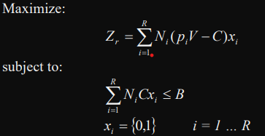

Where,

These are different ways of expressing the same idea:

To indicate if customers in recency i have been targeted in an optimized marketing campaign, we use a binary variable xi that equals 1 if they have been reached and 0 otherwise.

If xi = 1, it means that customers in recency i have been targeted in a direct marketing campaign; otherwise, it is assumed that they have not.

Customers in recency i are considered reached by direct marketing if xi = 1; otherwise, xi = 0.

We assume that xi = 1 when customers in recency i are targeted by the direct marketing campaign, and 0 otherwise.

The value of xi represents whether customers in recency i have been reached through direct marketing. If they have, xi = 1; otherwise, it equals 0.

Direct marketing campaigns target customers in recency i by setting xi = 1; otherwise, it is 0.

If xi is equal to 1, it indicates that the direct marketing campaign has targeted customers in recency i; otherwise, it is 0.

When targeting customers in recency 1 through a direct marketing campaign, xi = 1; otherwise, it is assumed that xi = 0.

Solving the Recency model:

The objective of the direct marketing campaign is to maximize the expected profit (Zr). The probability of a customer in recency I making a purchase is pi, and the probability of not making a purchase is (1-pi). The profit from a customer who makes a purchase is calculated as (V - C), where V is the revenue earned from the customer and C is the cost of marketing to that customer. When a customer does not make a purchase, the expected profit is simply (-C). Therefore, the expected value of profit from a single customer in state i is given by equation, which can be simplified to equation.

Since there are Ni customers in recency i, the expected profit from this group of customers is given by equation. It represents the sum of profits for all groups of customers that are targeted through the marketing campaign (xi=1). Equation ensures that the total cost of the campaign does not exceed the available budget (B). The left-hand side of the equation represents the actual cost of the campaign, which is the sum of the costs for each group i of customers. The decision variables xj are subject to binary constraints.

Hierarchical implementation of Recency:

When Assuming the importance of different priority following Recency as

P1 = 200, then

Maximize Z = 200s1

The formulation is expected to be i=1ΣR =Ni (piV - C)Xi + S1 = VR

**Subject to:**

i=1ΣR NiCxi ≤ B

**Xi = {0,1} i = 1 … R**

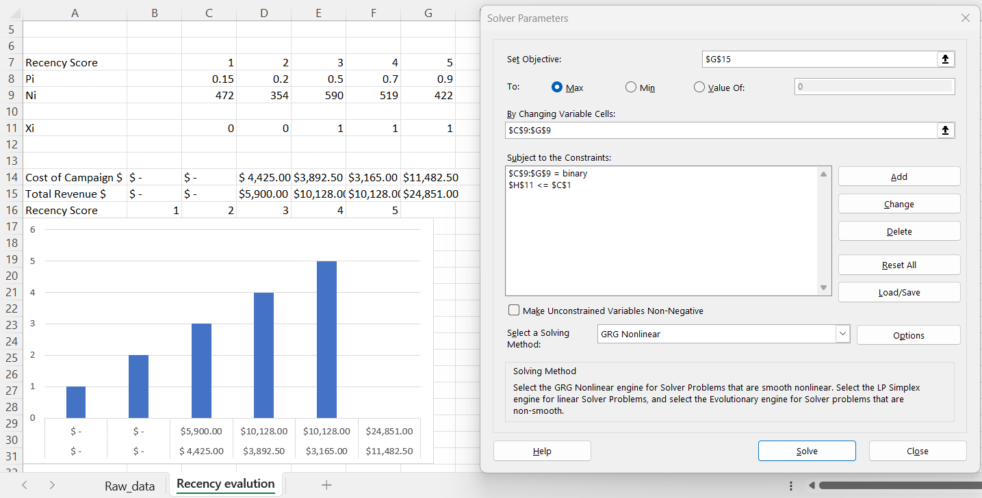

**Solver for recency solution**

It seems that the enhanced solution of the model suggests that a recency value of 5 would be optimal for the direct marketing campaign. In this solution, the highest priority is given to recency, while the lowest priority is given to monetary value. Therefore, the model suggests that no promotional offers should be based solely on monetary value. This conclusion is based on the base model developed by your group during the presentation.

Linear calculation Expectation implication:

The optimal solutions obtained from the different models suggest targeting different customer segments for future promotional efforts. The recency model suggests targeting customers with recency values of 3, 4, and 5, while the frequency model suggests targeting customers with frequency values of 4 and 5. The goal programming approach suggests targeting customers with recency values of 5 and frequency values of 4 and 5.

Based on these results, the firm may want to consider a combination of these targeting strategies to maximize profitability. For example, they could target customers with recency values of 3, 4, and 5, as suggested by the recency model, and among these customers, prioritize those with frequency values of 4 and 5, as suggested by the frequency model and goal programming approach.

Furthermore, the suggestion that no differential marketing action should be based on monetary value indicates that the firm should not allocate additional resources towards targeting customers with higher monetary values, as it may not necessarily lead to increased profitability.

Overall, the optimal solutions obtained from the different models can provide valuable insights for the firm's direct marketing campaign and help them allocate their marketing resources more effectively to maximize profits.

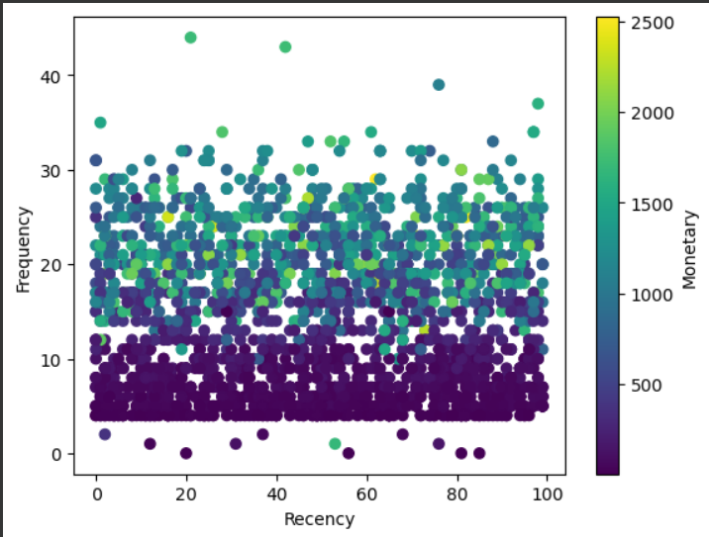

**Graphical Representation of Final RFM factor**

Conclusion:

Additionally, future research could explore the effectiveness of incorporating other variables such as customer demographics, psychographics, and behavioral data, as well as incorporating machine learning and predictive analytics techniques to improve the accuracy of the RFM framework. Moreover, testing the proposed solution through real-world experiments and comparing it with alternative models could provide further insight into the practical application and validity of the proposed approach. Overall, the LP approach used in this RFM analysis provides a valuable tool for direct marketers to optimize their marketing campaigns and achieve a better return on investment.

As an conclusion, optimization approach used in this research achieves a balance between **Type I** (missing profitable customers) and **Type II errors**. It helps identify both appropriate and inappropriate RFM segments based on three core characteristics: profitability, marketing objectives, and budget constraints.

By using the LP and analytical approaches to analyze RFM data, a marketing firm can make informed decisions about which customer segments to target for direct marketing campaigns. This can help maximize profits while also taking into account budget constraints and marketing objectives. Ultimately, by focusing on the most profitable customer segments, a firm can optimize its marketing efforts and improve its ROI.

Reference:

* Linear Programming and Economic Analysis by Robert Dorfman , Paul A. Samuelson, Robert M. Solow
* Dover Books on Computer Science [Paperback] Mathematical details and applications to control, warefare, and communictions:
* Optimization Theory with Applications by Donald A. Pierre
* Dover Books on Mathematics [Paperback] by Donald A. Pierre
* Clear Presentation: Methods of Mathematical Economics
* by Joel N. Franklin
* Springer-Verlag
* Schmittlein, David C. and Robert A. Peterson (1994), “Customer Base Analysis: An Industrial
* Purchase Process Application,” MarketingScience.