Table of Contents:

Abstract ________________________________________________________ 3

Problem Statement: ________________________________________________ 4

Data and EDA: ____________________________________________________ 5

Data into Enhanced Graphs: __________________________________________ 6

Linear programming Model build: _____________________________________ 7

RFM calculations and model Solution for future campaign: _________________ 8

Conclusion: ________________________________________________________ 9

Abstract:

Given a grocery company’s opensource dataset this coursework is presented with the problem to optimize and bring in the best campaigning expectation particular to customer centric. The using Linear programming model and the data with the information of the last 4 campaigns to study the customers buying habits and their buying potential. The main data set lacks some of the data source that is needed for this coursework and some of the data is been updated from other similar sources for RFM model creation. Customer data and data optimization are especially important in marketing optimization because they are used to help firms improve response rates, conversion rates, and campaign profitability.

The recency-frequency-monetary value (RFM) framework leads to highly effective marketing campaigns by enabling companies to categorize customers into homogenous segments based on their previous purchasing behaviour and then design highly customized promotional campaigns to reach those customers. According to this approach, customer data on the recency of purchase (R), frequency of purchase (F), and monetary value of purchase (M) are captured and stored for each customer.

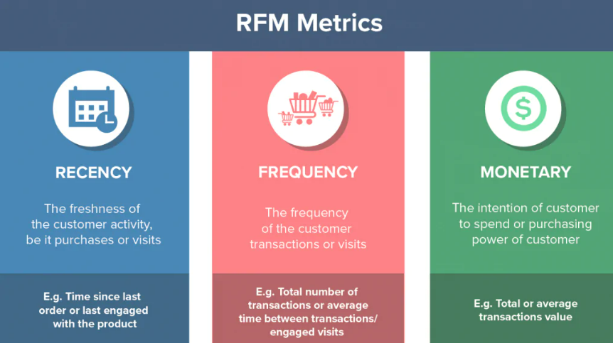

the three components of a customer segmentation model called RFM (Recency, Frequency, and Monetary). The RFM model is a customer segmentation framework used by businesses to identify and categorize their customers based on their purchasing behavior.

The first component, Recency, refers to how long it has been since a customer's last transaction with the business. This component measures the time interval between a customer's most recent purchase and the current date, expressed in units of time, such as days, weeks, months, or years. The recency metric is useful in identifying customers who may have lapsed in their purchasing behavior and may need to be re-engaged through targeted marketing campaigns.

The second component, Frequency, refers to the total number of transactions a customer has made within a fixed period. This component measures the number of times a customer has made a purchase within a specific timeframe, such as a month, quarter, or year. The frequency metric is useful in identifying customers who are loyal to the business and make repeat purchases.

The third component, Monetary, refers to the total amount of money a customer has spent with the business throughout their entire history. This component measures the total revenue generated by a customer, taking into account all their purchases. The monetary metric is useful in identifying high-value customers who are worth investing in through personalized marketing and loyalty programs.

By analyzing the RFM metrics of its customers, a business can segment its customer base into groups with similar purchasing behavior and develop targeted marketing strategies for each group. For example, customers who have high monetary value, high frequency, and recent purchases may receive different marketing messages than customers who have low monetary value, low frequency, and older purchases.

Problem Statement:

The project main prospective to combine the RFM values extracted from the data source and use it to maximize the customer attraction and also to promote the profit level to higher standard based on this upcoming campaign.

When a company wants to improve its customer retention rate, it's important to focus on recency first. This means that the company should prioritize getting back customers who may have gone to the competition. Frequency and monetary values are also important, but they should come second and third respectively. If marketing promotions have limited resources, they should allocate them towards customers who have the greatest long-term profit potential.

This coursework proposes a unique approach to help marketers maximize profitability by using RFM data. The methodology is based on a Linear programming (LP) approach to profit maximization, which includes varying marketing objectives and budget constraints. The model not only balances marketing priorities with budgets, but it also helps companies avoid two types of errors: Type I and Type II. Type I errors occur when companies ignore customers who could have returned and made additional purchases. Type II errors happen when companies target customers who are not ready to buy.

This model with two errors by identifying the right RFM segments to target, as well as those that should not be pursued because they are not profitable or don't align with marketing Linears. This model can help marketing firms determine whether to continue spending or curtail their relationships with specific RFM customer segments. A unique contribution of this coursework is incorporating RFM data into a LP approach that includes marketing Linears and budgets to determine the most profitable customer segments to target.

Data and EDA:

The Data set is processed with a variety of data that is mostly important to our project for speculation of the result but it also compresses of some unwanted data that is not needed for this particular case study.

Below are the data extracts and the customer profiling in numbers as presented in our Groupwork as well.

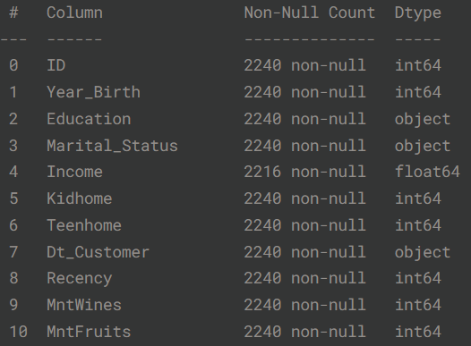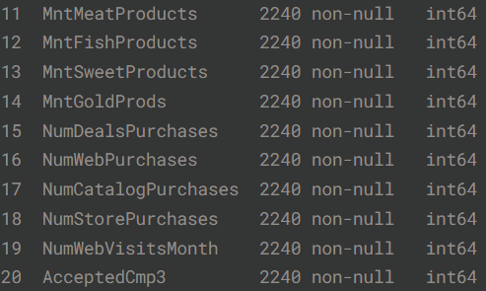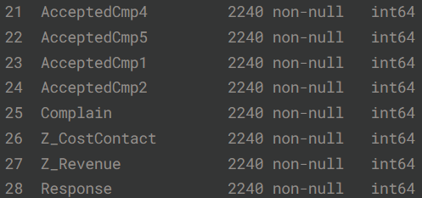

To classify the issue furthermore for this particular individual report study, I have drilled down some of the important aspects of the studies with extra data conclusion from dataset with similar aspects. With furthermore assumptions and calculations for this model, below graphical representation gives the budget and time and consistency allocation for the newly engaging campaign.

For source explanation simplicity, I have initially examine the relationship between future purchasing and recency/frequency alone; I will introduce monetary value later in the paper. We first split the 78-week dataset into two periods of equal length, and group customers on the basis of frequency (where x denotes the number of repeat purchases in the first 39-week period) and recency (where tx denotes the time of the last of these purchases). We then compute the average total spend for each of these groups in the following 39-week period.2

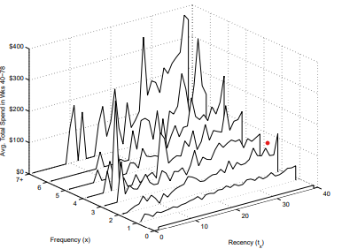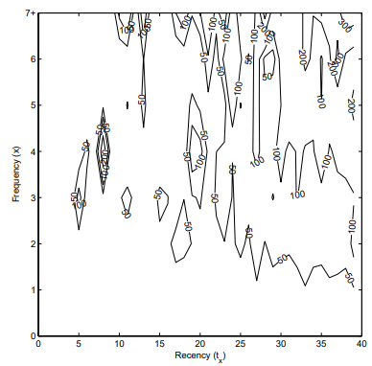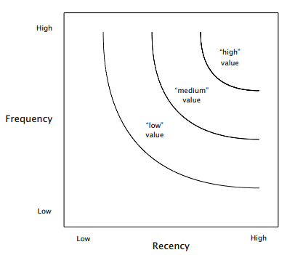

Data into Enhanced Graphs:

The Graphs discusses the relationship between recency and frequency with future purchasing. It represents the data into Graphs, there is a and positive association between recency and frequency, and when both measures are high, there may be additional synergies. However, the diagram also points out the limitations of the graph in Figure 1, which is based on a large number of customers but is still sparse and therefore somewhat untrustworthy. The "valleys" in the graph are simply due to the absence of observations for particular combinations of recency and frequency. Thus, it is important to develop a formal model that abstracts away from the observed data and fills in the gaps to provide a more accurate understanding of the relationship between recency, frequency, and future purchasing.

Linear programming Model build:

As per our discussion in presentation the linear model that suffices the entire model is represented with just monetary value but it is essential to carryout recency and frequency models as well to come to a clearer optimization.

Maximize $Zr=>Ri=>Ni \left(piV-C\right)xi$

Subject to:

$R\sum{}i-->1 NiCxi≤B$

With:

$Xi=>\left\{0,1\right\} i-->1……R$

Where the notations are as follows:

* i --> 1... 5 grouped recency categories
* j --> 1…5 grouped Frequency category
* k --> 1…5 grouped monetary category;
* V --> revenue backed persons;
* pi --> probability of recency purchase;
* pj --> probability of frequency purchase;
* pk --> probability of monetary purchase;
* Ni --> no of people in recency i;
* Nj --> no of people in frequency j;
* Nk --> no of people in monetary group k;
* C --> avg of fit marketing campaign;
* B --> Budget
* xi --> 1 if Customers who fall within the recency segment are targeted through the marketing campaign.; 0.

With Binary variables constrain, incorporating the above model, its further dived deep for the a concrete solution with a marketing campaign aims to maximize the expected profit (Zr) by targeting customers in recency I. The probability of a customer making a purchase is pi, while the probability of not making a purchase is (1-pi). The profit earned from a purchase is (V-C), where V is revenue and C is the cost of marketing. The expected profit from a single customer in state i is calculated by a which is simplified in another. The expected profit for the entire group of Ni customers in recency i is determined by another, which ensures that the total campaign cost does not exceed the budget (B). The cost of the campaign is on the left-hand side of the and is the sum of the costs for each group of customers (xi=1).

RFM calculations and model Solution for future campaign:

To implement the model, the first step is to categorize customers into five groups based on their recency of purchases. Group one consists of customers who have made the least recent purchases, while group five comprises customers who have made the most recent purchases. To determine the number of customers in each group, a pivot table can be utilized. The probability that a customer in each group will make a purchase can also be calculated using the same pivot table.

Using a campaign budget of $12,500, a cost per customer of $7.50, and an average revenue of $35 from each purchasing customer, demonstrates that the company should target customers in recency groups 3, 4, and 5 for its promotional efforts. This approach is expected to generate a total profit of $24,851.

We incorporate frequency as a key factor in our 0-1 LP model to further enhance our marketing strategy. The primary objective remains the same, which is to optimize profits while adhering to the allocated marketing budget.

To achieve this Linear, we introduce a new decision variable, represented as xj, which is a 0-1 binary variable. The value of xj is 1 if customers in frequency j are targeted in the promotional campaign and 0 otherwise.

$Zm=\sum_{k=1}^{m}{N}k\left(pkkV-C\right)Xk$

Subject to:

$\sum_{K=1}^{M}{Nk Cxk≤B}$

With:

$Xk=\left\{0,1\right\} K=1….M$

The above describes the objective function and constraints of a marketing campaign for the frequency case. The main Linear is to maximize the expected profit while staying within the marketing budget constraints. The decision variable in this case is a 0-1 variable, denoted as xj, which takes the value 1 if customers in frequency j are reached through the promotional campaign, and 0 otherwise.

Maximizes the expected profit (Zf) of the marketing campaign. Also ensures that the marketing budget constraint is not exceeded, where B represents the total budget allocated for the campaign. The left-hand side of the calculates the actual cost of the campaign, which is the sum of campaign costs for each group i of customers. Finally, the binary constraints for the decision variables xj, which ensures that only the selected customers are targeted through the campaign.

The solution to the frequency case involves organizing customers into five groups based on their frequency value, and using pivot tables to calculate the probability of purchase (pj) for each group. The results suggest that customers in frequency 3, 4, and 5 should be targeted through the campaign to generate a total profit of $41,876. This approach is applicable to firms where frequency and recency are the key factors in their marketing campaigns.

$$\sum_{i=1}^{R}{NiCxi+ \sum_{f=1}^{F}{NfCxf+ \sum_{k=1}^{M}{NkCxk≤B}}}$$

$xi=\left\{0,1\right\} i=1…R$

$xf=\left\{0,1\right\} f=1…F$

$xk=\left\{0,1\right\} k=1…M$

The above describes a formulation with multiple objective functions and constraints. It consists of three sub-objective functions combined, with different contribution coefficients. The main priority is to minimize issue, as it has a larger contribution coefficient comparatively.

Additionally, the formulation has three new constraints, which ensure that the previously achieved profit Linear from each respective model (VR=$24,851, VF=$41,876, and VM=$51,858) are still met for the overall budget (B=$12,500) is not exceeded, while other constraints ensure that the decision variables are binary, meaning they can only take on values of 0 or 1.

Overall, this formulation aims to maximize the profits while staying within the budget and achieving the profit Linear from previous models.

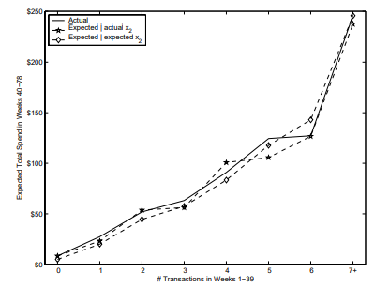

Conclusion:

The limitations of using RFM frameworks for predicting future customer behavior and profitability, and suggests avenues for future coursework to improve predictive accuracy. One limitation of RFM frameworks is that they are based on historical behavior and may not accurately capture future behavior and profit potential. While accuracy is always a potential limitation when forecasting is based on historical data, the shorter the time horizon considered, the less variation there is likely to be between past and future purchasing behavior. However, firms must still constantly review and manage their analytical models, monitor relevant external events, and keep track of competing models.

The framework suggests that firms should eventually integrate additional customer data with RFM data, as RFM focuses on customer purchasing behavior and does not consider the value of customer information when no purchase is made. marketing managers should consider capturing web browsing data as well as transactional data to better understand customer behavior and predict it more accurately. For example, one retailer identified products that customers browsed on their website but did not purchase and sent follow-up emails with personalized messages and promotional offers for those products.

The customer contact points, such as customer emails, social networking messages, and customer phone calls, which can indicate customer interest and propensity to buy in the future. By utilizing these data, firms can gain a greater understanding of customer behavior and develop more effective marketing offers and messages. Overall, the coursework suggests that while RFM frameworks have limitations, there are opportunities for future coursework to improve predictive accuracy by integrating additional customer data and utilizing various customer contact points.