File permissions in Linux

Project description
As a security professional supporting the research team at a large organization, I am responsible for auditing the file and directory permissions inside the /home/researcher2/projects directory. My goal is to verify whether the permissions granted to each owner type (user, group, and other) match the authorization they should have, and to correct any that grant unauthorized access. Using Linux commands, I inspect the existing permissions with ls -la and then modify the incorrect ones with chmod. These actions remove unauthorized access and help keep the file system secure by enforcing the principle of least privilege.

Check file and directory details
To check the permissions of every file and directory in the projects directory, including hidden files, I used the following command:
ls -la
The ls command lists the contents of a directory. The -l flag displays the output in long format, which shows the 10-character permissions string, the owner, and the group for each item. The -a flag includes hidden files, which are files whose names begin with a period (.), such as .project_x.txt. Without the -a flag, those hidden files would not appear in the listing. The command returned the following permissions for the five files and one subdirectory:
-rw-rw-rw- project_k.txt
-rw-r----- project_m.txt
-rw-rw-r-- project_r.txt
-rw-rw-r-- project_t.txt
-rw--w---- .project_x.txt
drwx--x--- drafts
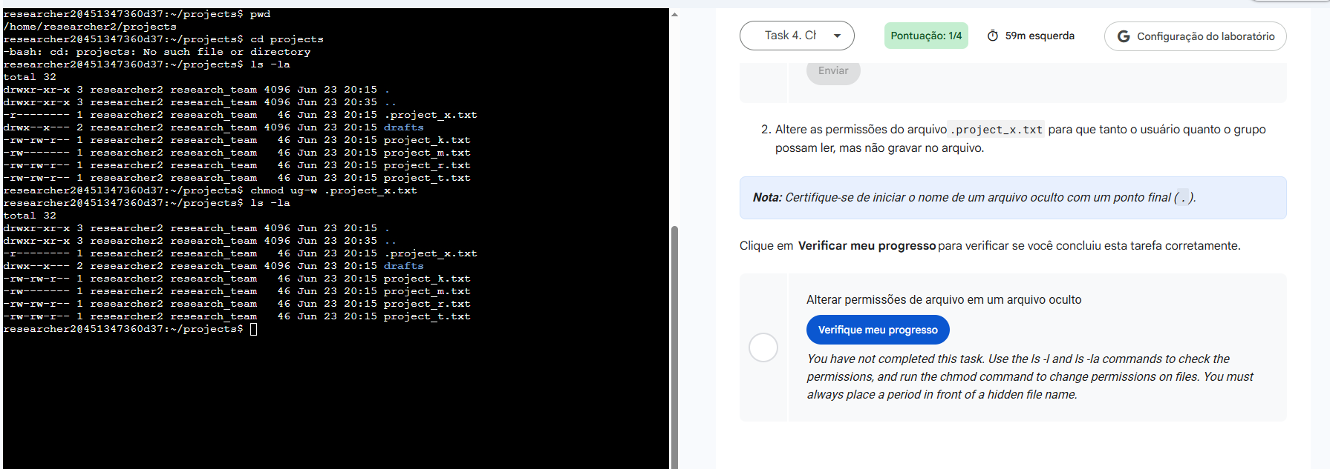

Describe the permissions string
As an example, I chose the permissions string for project_k.txt, which is -rw-rw-rw-. The 10-character string describes the item type and the permissions granted to each of the three owner types. The first character indicates the file type: a hyphen (-) means a regular file, while the letter d would mean a directory. The remaining nine characters are read in three groups of three. The first group (characters 2 to 4) shows the permissions of the user who owns the file; the second group (characters 5 to 7) shows the permissions of the group; and the third group (characters 8 to 10) shows the permissions of other, meaning all other users on the system. Within each group, r grants read access, w grants write access, and x grants execute access; a hyphen in any position means that permission has not been granted. Therefore, -rw-rw-rw- means a regular file in which the user, the group, and other can all read and write, but none of them can execute it.

Change file permissions
The organization does not allow other to have write access to any file. Based on the permissions found in the previous step, project_k.txt was the file that needed to be modified, because its string -rw-rw-rw- granted write access to other. To remove that permission, I used the following command:
chmod o-w project_k.txt
The chmod command changes the permissions of a file. In this command, o refers to other, the minus sign (-) removes a permission, and w is the write permission. After running it, I used ls -la again to confirm that the last group of three characters for project_k.txt no longer contained a w, changing the string from -rw-rw-rw- to -rw-rw-r--.
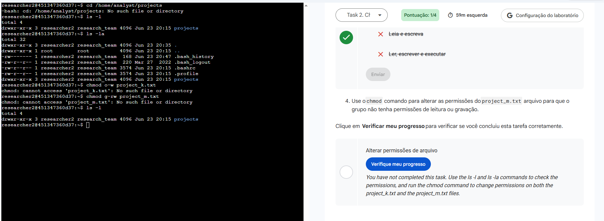

Change file permissions on a hidden file
The research team archived the .project_x.txt file, which is why it is hidden: in Linux, a file whose name begins with a period (.) is hidden and only appears in the listing when the -a flag is used with ls. This file should not be writable by anyone, but the user and the group must be able to read it. Its original permissions were -rw--w----, meaning the user could read and write, the group could only write, and other had no access. Two corrections were needed: remove write access from the user and the group, and grant read access to the group. I used the following command:
chmod u-w,g-w,g+r .project_x.txt
In this command, u-w removes write from the user, g-w removes write from the group, and g+r adds read for the group; the comma separates the changes so they are applied in a single command. The hidden file name must always begin with a period, otherwise chmod would not find the file. After running it, ls -la confirmed the permissions changed to -r--r-----, meaning the user and the group can read the file and no one can write to it.


Change directory permissions
The files and directories in the projects directory belong to the user researcher2, and only researcher2 should be able to access the drafts directory and its contents. The directory permissions were drwx--x---, which means the group still had execute access. For a directory, the execute (x) permission is what allows a user to enter it with cd, so the group needed to lose that access. While in the projects directory, I ran the following command:
chmod g-x drafts
Here g refers to the group, the minus sign (-) removes a permission, and x is the execute permission. After running the command, ls -la showed the drafts permissions as drwx------, meaning only the owner researcher2 can access the directory and its contents.


Summary
In this project, I examined the file and directory permissions belonging to researcher2 and corrected those that did not match the authorization each owner type should have. I used the ls -la command to inspect the permissions, including hidden files, and the chmod command to make three changes: removing write access from other on project_k.txt, removing write access while granting group read access on the hidden .project_x.txt file, and removing group execute access on the drafts directory. These changes removed unauthorized access and aligned the file system with the principle of least privilege, strengthening the security of the research team's environment.

