实 验 报 告

实验名称： 习题 9.5，复数类

学生姓名： 蒋雨初

学生学号： 58121102

实验日期： 2023/3/14

实 验 报 告 内 容
一．程序源代码
作业1：
#include <iostream>
using namespace std;

class Complex {
private:
double realPart;
double imaginaryPart;

public:
Complex(double r = 0.0, double i = 0.0) : realPart(r), imaginaryPart(i) {}

Complex add(const Complex& other) const {
double r = realPart + other.realPart;
double i = imaginaryPart + other.imaginaryPart;
return Complex(r, i);
}

Complex subtract(const Complex& other) const {
double r = realPart - other.realPart;
double i = imaginaryPart - other.imaginaryPart;
return Complex(r, i);
}

void print() { cout << "(" << realPart << ", " << imaginaryPart << ")"; }
};

int main() {
{
Complex c1(1.0, 7.0);
Complex c2(9.0, 2.0);

c1.print();
cout << " + ";
c2.print();

Complex c3 = c1.add(c2);
cout << " = ";
c3.print();
}
cout << endl;
{
Complex c1(10.0, 1.0);
Complex c2(11.0, 5.0);

c1.print();
cout << " - ";
c2.print();

Complex c3 = c1.subtract(c2);
cout << " = ";
c3.print();
}
}
作业2：
#include <iomanip>
#include <iostream>
using namespace std;
class Time {
public:
friend void tick(Time& t);
explicit Time() : hour(0), minute(0), second(0){};

void setTime(int, int, int);
void setHour(int);
void setMinute(int);
void setSecond(int);

unsigned int getHour() const;
unsigned int getMinute() const;
unsigned int getSecond() const;
void printUniversal() const;
void printStandard() const;

private:
unsigned int hour;
unsigned int minute;
unsigned int second;
};

void Time::setTime(int a, int b, int c) {
hour = a;
minute = b;
second = c;
}
void Time::printStandard() const {
cout << ((hour == 0 || hour == 12) ? 12 : hour % 12) << ':' << setfill('0') << setw(2) << minute << ':' << setw(2) << second
<< (hour < 12 ? " AM" : " PM");
}

void tick(Time& t) {
Time time(t);
int cur1 = 0, cur2 = 0;
for (int i = 0; i < 15; ++i) {
time.printStandard();
cout << endl;
time.second++;
if (time.second == 60)
time.minute++, time.second = 0;
if (time.minute == 60)
time.hour++, time.minute = 0;
time.hour %= 24;
}
}

int main() {
Time t;
t.setTime(23, 59, 57);
tick(t);

return 0;
}
作业3：
#include <algorithm>
#include <cassert>
#include <iostream>
#include <string>
using namespace std;

class HugeInteger {
private:
int digits[40];

public:
HugeInteger(int num = 0) {
int i;
for (i = 0; num; ++i, num /= 10)
digits[i] = num % 10;
fill(digits + i, end(digits), 0);
}
HugeInteger(const char* str) {
int len = strlen(str);
fill(digits + len, end(digits), 0);
transform(make_reverse_iterator(str + len), make_reverse_iterator(str), digits, [](const char ch) { return ch - '0'; });
}
~HugeInteger() {}
void input() {
char str[41];
cin >> str;
*this = HugeInteger(str);
}
void output() const {
int i = std::extent<decltype(digits)>::value
- count_if(rbegin(digits), rend(digits), [](const int a) { return !a; }); // compat before c++17
if (i == 0)
cout << 0;
else
copy_n(make_reverse_iterator(digits + i), i, ostream_iterator<int>(cout));
}
HugeInteger add(const HugeInteger& other) const {
HugeInteger res;
int carry = 0;

for (int i = 0; i < 40; i++) {
int sum = digits[i] + other.digits[i] + carry;
res.digits[i] = sum % 10;
carry = sum / 10;
}
return res;
}
HugeInteger subtract(const HugeInteger& other) const {
HugeInteger res;
int borrow = 0;
for (int i = 0; i < 40; i++) {
int diff = digits[i] - other.digits[i] - borrow;
if (diff < 0) {
diff += 10;
borrow = 1;
}
else
borrow = 0;
res.digits[i] = diff;
}
return res;
}
bool isEqualTo(const HugeInteger& other) const { return equal(begin(digits), end(digits), other.digits); }
bool isNotEqualTo(const HugeInteger& other) const { return !isEqualTo(other); }
bool isGreaterThan(const HugeInteger& other) const {
return lexicographical_compare(rbegin(digits), rend(digits), rbegin(other.digits), rend(other.digits), greater<int>());
}
bool isLessThan(const HugeInteger& other) const { return !isGreaterThan(other) && !isEqualTo(other); }
bool isGreaterThanOrEqualTo(const HugeInteger& other) const { return isGreaterThan(other) || isEqualTo(other); }
bool isLessThanOrEqualTo(const HugeInteger& other) const { return isLessThan(other) || isEqualTo(other); }
bool isZero() const {
return all_of(begin(digits), end(digits), [](const int a) { return !a; });
}
HugeInteger multiply(const HugeInteger& other) const {
HugeInteger res;
for (int i = 0; i < 40; i++) {
for (int j = 0; j < 40; j++) {
int k = i + j;
int prod = digits[i] * other.digits[j];
while (prod > 0) {
prod += res.digits[k];
res.digits[k] = prod % 10;
prod /= 10;
k++;
}
}
}
return res;
}
HugeInteger divide(const HugeInteger& other) const {
if (other.isZero())
throw invalid_argument("divided zero");
HugeInteger res;
HugeInteger remainder = *this;
for (int i = 39; i >= 0; i--) {
int quotient = 0;
while (remainder.isGreaterThanOrEqualTo(other)) {
remainder = remainder.subtract(other);
quotient++;
}
res.digits[i] = quotient;
remainder = remainder.multiply(HugeInteger("10"));
remainder.digits[0] = digits[i];
}
return res;
}
HugeInteger modulus(const HugeInteger& other) const {
if (other.isZero())
throw invalid_argument("mod zero");
HugeInteger remainder = *this;
for (int i = 39; i >= 0; i--) {
int quotient = 0;
while (remainder.isGreaterThanOrEqualTo(other)) {
remainder = remainder.subtract(other);
quotient++;
}
remainder = remainder.multiply(HugeInteger("10"));
remainder.digits[0] = digits[i];
}
return remainder;
}
};

int main() {
HugeInteger a("7654321"), b("7891234"), c(5), d(0);
a.output();
cout << " + ";
b.output();
cout << " = ";
a.add(b).output();
cout << endl;
b.output();
cout << " - ";
c.output();
cout << " = ";
b.subtract(c).output();
cout << endl;
assert(a.isEqualTo(a));
a.output();
cout << " is equal to ";
a.output();
cout << endl;
assert(a.isNotEqualTo(b));
a.output();
cout << " is not equal to ";
b.output();
cout << endl;
assert(b.isGreaterThan(a));
b.output();
cout << " is greater than ";
a.output();
cout << endl;
assert(c.isLessThan(a));
c.output();
cout << " is less than ";
a.output();
cout << endl;
assert(c.isLessThanOrEqualTo(c));
c.output();
cout << " is less than or equal to ";
c.output();
cout << endl;
assert(d.isGreaterThanOrEqualTo(d));
d.output();
cout << " is greater than or equal to ";
d.output();
cout << endl;
return 0;
}
作业4：
#include <algorithm>
#include <cassert>
#include <iomanip>
#include <iostream>
#include <string>
using namespace std;
class Date {
public:
Date() {
struct tm* ptr;
time_t t = time(0);
ptr = localtime(&t);
day = ptr->tm_mday;
month = 1 + ptr->tm_mon;
year = ptr->tm_year + 1900;
}
Date(int ddd, int yyyy) : year(yyyy) { setMMDDFromDDD(ddd); }
Date(int mm, int dd, int yy) : day(dd), month(mm), year(yy + 2000) {}
Date(const string& monthName, int dd, int yyyy) : day(dd), year(yyyy) { setMMFromMonth(monthName); }
void setDay(int d) { day = checkDay(d); }
void setMonth(int m) {
if (m >= 1 && m <= 12)
month = m;
else
cout << "Invalid month. Month set to 1 (January)." << endl;
}
void print() const { cout << month << "/" << day << "/" << year << endl; }
void printDDDYYYY() const { cout << convertDDToDDD() << " " << year << endl; }
void printMMDDYY() const {
int yy = convertYYYYToYY();
cout << setw(2) << setfill('0') << month << "/" << setw(2) << setfill('0') << day << "/" << setw(2) << setfill('0') << yy
<< endl;
}
void printMonthDDYYYY() const { cout << convertMMToMonth(month) << " " << day << ", " << year << endl; }
~Date() { cout << "Date object destructor for date " << month << "/" << day << "/" << year << "\n\n"; }

private:
int month;
int day;
int year;
int checkDay(int testDay) const {
static const int daysPerMonth[13] = { 0, 31, 28, 31, 30, 31, 30, 31, 31, 30, 31, 30, 31 };
if (testDay > 0 && testDay <= daysPerMonth[month]) {
return testDay;
}
if (month == 2 && testDay == 29 && isLeapYear()) {
return testDay;
}
cout << "Invalid day (" << testDay << "). Day set to 1." << endl;
return 1;
}
int daysInMonth(int m) const {
static const int daysPerMonth[13] = { 0, 31, 28, 31, 30, 31, 30, 31, 31, 30, 31, 30, 31 };
if (m == 2 && isLeapYear()) {
return 29;
}
return daysPerMonth[m];
}
bool isLeapYear() const {
if (year % 4 == 0 && year % 100 != 0 || year % 400 == 0) {
return true;
}
return false;
}
int convertDDToDDD() const {
static const int daysPerMonth[13] = { 0, 31, 28, 31, 30, 31, 30, 31, 31, 30, 31, 30, 31 };
int ddd = 0;
for (int i = 1; i < month; i++)
ddd += daysPerMonth[i];
ddd += day;
if (month > 2 && isLeapYear())
ddd++;
return ddd;
}
void setMMDDFromDDD(int ddd) {
static const int daysPerMonth[13] = { 0, 31, 28, 31, 30, 31, 30, 31, 31, 30, 31, 30, 31 };
int i;
for (i = 1; i <= 12; i++) {
if (ddd <= daysPerMonth[i])
break;
if (i == 2 && isLeapYear())
ddd--;
ddd -= daysPerMonth[i];
}
month = i;
day = ddd;
}
string convertMMToMonth(int m) const {
static const string monthNames[13] = { "", "January", "February", "March", "April", "May", "June",
"July", "August", "September", "October", "November", "December" };
if (m >= 1 && m <= 12)
return monthNames[m];
return "Invalid month";
}
void setMMFromMonth(string monthName) {
static const string monthNames[13] = { "", "January", "February", "March", "April", "May", "June",
"July", "August", "September", "October", "November", "December" };

int i = find(monthNames, end(monthNames), monthName) - monthNames;
if (i <= 12)
month = i;
}
int convertYYYYToYY() const { return year % 100; }
void setYYYYFromYY(int yy) {
if (yy >= 0 && yy <= 99)
year = yy >= 0 && yy <= 29 ? 2000 + yy : 1900 + yy;
}
};

int main() {
Date date1(256, 1999); // initialize using ddd yyyy format
Date date2(3, 25, 04); // initialize using mm/dd/yy format
Date date3("September", 1, 2000); // "month" dd, yyyy format
Date date4; // initialize to current date with default constructor
// print Date objects in default format
date1.print();
date2.print();
date3.print();
date4.print();
cout << '\n';
// print Date objects in 'ddd yyyy' format
date1.printDDDYYYY();
date2.printDDDYYYY();
date3.printDDDYYYY();
date4.printDDDYYYY();
cout << '\n';
// print Date objects in 'mm/dd/yy' format
date1.printMMDDYY();
date2.printMMDDYY();
date3.printMMDDYY();
date4.printMMDDYY();
cout << '\n';
// print Date objects in '"month" d, yyyy' format
date1.printMonthDDYYYY();
date2.printMonthDDYYYY();
date3.printMonthDDYYYY();
date4.printMonthDDYYYY();
cout << endl;
return 0;
}
作业5：
#include <iostream>
#include <iomanip>
using namespace std;

class SavingsAccount {
private:
double savingsBalance;
static double annualInterestRate;

public:
SavingsAccount(double balance) { savingsBalance = balance; }
void calculateMonthlyInterest() {
double monthlyInterest = savingsBalance * annualInterestRate / 12;
savingsBalance += monthlyInterest;
}
static void modifyInterestRate(double newRate) { annualInterestRate = newRate; }
double getBalance() { return savingsBalance; }
};

double SavingsAccount::annualInterestRate = 0;

int main() {
SavingsAccount saver1(2000.00);
SavingsAccount saver2(3000.00);
cout << fixed << setprecision(2);
cout << "Initial balances:\nSaver 1: $" << saver1.getBalance() << "\tSaver 2: $" << saver2.getBalance() << "\n\n";

SavingsAccount::modifyInterestRate(0.03);
saver1.calculateMonthlyInterest();
saver2.calculateMonthlyInterest();
cout << "Balances after 1 month's interest applied at .03:\nSaver 1: $" << saver1.getBalance() << "\tSaver 2: $"
<< saver2.getBalance() << "\n\n";

SavingsAccount::modifyInterestRate(0.04);
saver1.calculateMonthlyInterest();
saver2.calculateMonthlyInterest();
cout << "Balances after 1 month's interest applied at .04:\nSaver 1: $" << saver1.getBalance() << "\tSaver 2: $"
<< saver2.getBalance() << "\n\n";

return 0;
}
作业6：
#include <algorithm>
#include <cassert>
#include <iostream>
#include <string>
using namespace std;
class IntegerSet {
public:
IntegerSet() { emptySet(); }

IntegerSet(int arr[], int size) : IntegerSet() {
for_each_n(arr, size, [this](const int x) { insertElement(x); });
}

void emptySet() { fill_n(set, 101, 0); }

void inputSet() {
int num;
do {
cout << "Enter an element (-1 to end): ";
cin >> num;
if (validEntry(num))
insertElement(num);
else
cout << "Invalid Element" << endl;
} while (num != -1);
cout << "Entry complete" << endl;
}

void insertElement(int k) {
if (validEntry(k))
set[k] = 1;
}

void deleteElement(int m) {
if (validEntry(m))
set[m] = 0;
}

void printSet() const {
string res = "( ";
for (int i = 0; i <= 100; i++)
if (set[i] == 1)
res += to_string(i) + " ";
if (res == "( ")
cout << "---";
else
cout << res << ")" << endl;
}

bool isEqualTo(const IntegerSet& other) const { return equal(begin(set), end(set), begin(other.set)); }

IntegerSet unionOfSets(const IntegerSet& other) const {
IntegerSet result;
for (int i = 0; i <= 100; i++)
if (set[i] == 1 || other.set[i] == 1)
result.set[i] = 1;
return result;
}

IntegerSet intersectionOfSets(const IntegerSet& other) const {
IntegerSet result;
for (int i = 0; i <= 100; i++)
if (set[i] == 1 && other.set[i] == 1)
result.set[i] = 1;
return result;
}

private:
int set[101];
int validEntry(int x) const { return (x >= 0 && x <= 100); }
};

int main() {
IntegerSet A, B;
cout << "Enter set A:" << endl;
A.inputSet();
cout << "\nEnter set B:" << endl;
B.inputSet();
cout << endl;
cout << "Union of A and B is:" << endl;
A.unionOfSets(B).printSet();
cout << "Intersection of A and B is:" << endl;
A.intersectionOfSets(B).printSet();
assert(!A.isEqualTo(B));
cout << "Set A is no equal to set B" << endl;
cout << "\nInserting 77 into set A...\nSet A is now:" << endl;
A.insertElement(77);
A.printSet();
cout << "\nDeleting 77 from set A...\nSet A is now:" << endl;
A.deleteElement(77);
A.printSet();

return 0;
}
作业7：
#include <iomanip>
#include <iostream>
using namespace std;

class Time {
public:
explicit Time() : totalSeconds(0){};
void setTime(int h, int m, int s) { totalSeconds = h * 3600 + m * 60 + s; }
void setHour(int h) { totalSeconds = totalSeconds % 3600 + h * 3600; }
void setMinute(int m) { totalSeconds = totalSeconds % 3600 + m * 60; }
void setSecond(int s) { totalSeconds = totalSeconds % 60 + s; }
unsigned int getHour() const { return totalSeconds / 3600; }
unsigned int getMinute() const { return (totalSeconds % 3600) / 60; }
unsigned int getSecond() const { return totalSeconds % 60; }
void printUniversal() const {
cout << setfill('0') << setw(2) << getHour() << ":" << setw(2) << getMinute() << ":" << setw(2) << getSecond();
}
void printStandard() const {
cout << ((getHour() == 0 || getHour() == 12) ? 12 : getHour() % 12) << ":" << setfill('0') << setw(2) << getMinute()
<< ":" << setw(2) << getSecond() << (getHour() < 12 ? " AM" : " PM");
}

private:
unsigned int totalSeconds;
};

void tick(Time& t) {
t.setSecond(t.getSecond() + 1);
if (t.getSecond() == 60) {
t.setSecond(0);
t.setMinute(t.getMinute() + 1);
if (t.getMinute() == 60) {
t.setMinute(0);
t.setHour(t.getHour() + 1);
if (t.getHour() == 24) {
t.setHour(0);
}
}
}
}

int main() {
Time t;
t.setTime(18, 30, 22);
cout << "Universal time: ";
t.printUniversal();
cout << "\nStandard time: ";
t.printStandard();
cout << endl;
tick(t);
cout << "\nNew standard time: ";
t.printStandard();
cout << endl;
return 0;
}
二．实验结果的屏拷贴图
作业1：
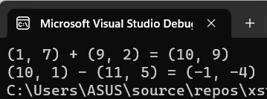
作业2：
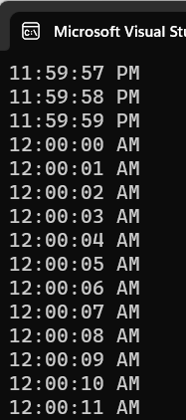
作业3：
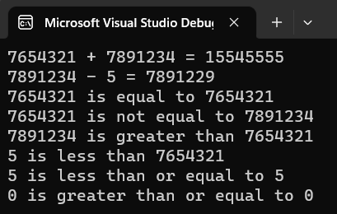
作业4：
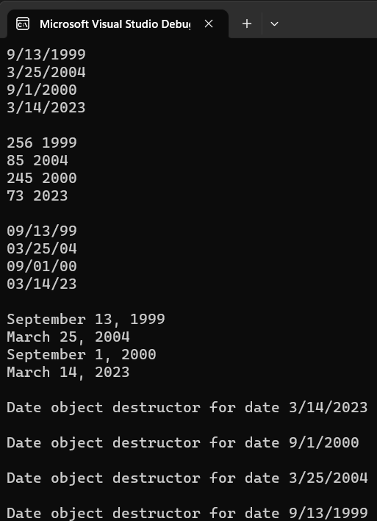
作业5：
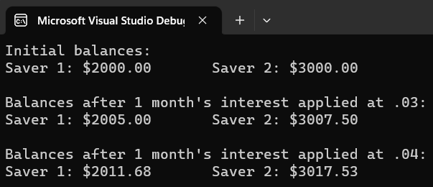
作业6：
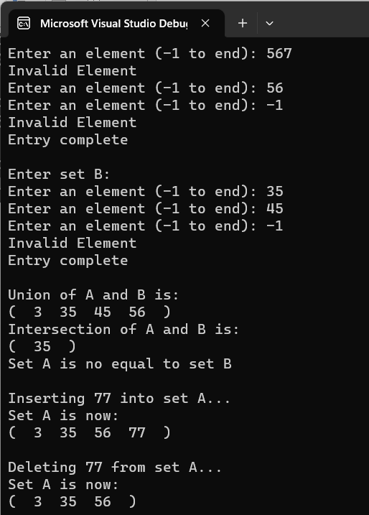
作业7：
