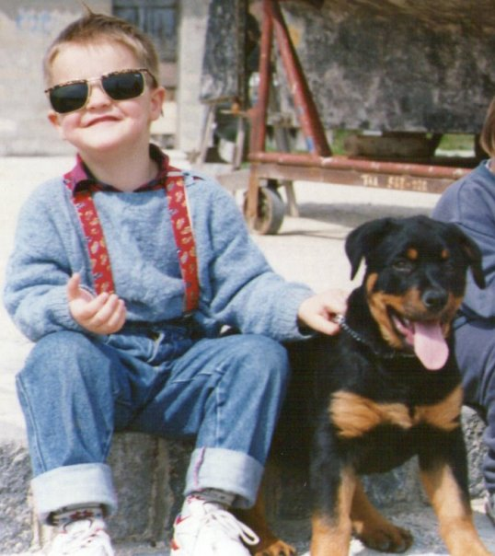**Luka Lalic**

**0123-456-789-231**

**luka.lalic@outlook.com**

**Street number town state**

## Profile

* Well-developed project management and IT skills combined with a flexible attitude to work.
* Strong organisational skills
* Can work independently or as part of a team.
* Get on well with people at all levels, easily making good working relationships.
* Adaptable and quick to learn new skills.

## Professional Skills:

* HTML5, CSS3, Jquery, WordPress, Bootstrap, Java, Python
* Adobe Photoshop, Adobe Illustrator, Adobe InDesign,

## Work Experience

**IT consultant @ Provider service**

**Jun 2015 - Present**

Developing and implementing hardware and software solutions for back-end stock management, front-end store-front and online webstore. Creating online presence and furthering market outreach via targeted online ads

**Technician @ ST-Link**

**Jan 2014 - Jun 2015**

Installing security systems including but not limited to CCTV, anti burglar alarms, fire protection systems, entry barriers and fingerprint authentication systems. System maintenance and server hardware & software reimplementation

**Web developer & designer @ Freelancer**

**Jan 2010 - Sep 2013**

Developing websites and web based solutions for small companies including health clinics, restaurants and personal portfolios. Logo and graphical design

**Education**

**Computing @ Northampton uni**

**Sep 2016 - Present**

**Graphic design @ GOGS**

**Sep 2006 - June 2010**

**References:**

Can provide upon request.