Solving a 10-Dimensional Matrix Problem and Exploring Its Applications in AI and Machine Learning
Student Name: Osman Bin Billal
Student ID: 24549010110
Course Code: Math-2207
Program: B.Sc. in Information and Communication Engineering
Submission Date: November 21, 2025
Abstract:
This project explores the computational analysis of a 10×10 matrix and how its mathematical properties connect directly to applications in artificial intelligence and machine learning. Using Python and NumPy (with Matplotlib for visualization), I computed core characteristics of the matrix, including its determinant, rank, eigenvalues, and eigenvectors.
The study also verifies these results programmatically and shows how eigenvalue decomposition forms the backbone of Principal Component Analysis (PCA), a widely used dimensionality-reduction method.
By walking through each step, this paper highlights how essential linear algebra operations quietly power modern AI systems.
1. Introduction
Linear algebra is one of the key pillars behind artificial intelligence and machine learning. Matrices allow us to organize numbers efficiently, perform transformations, and store relationships between variables; all of which are central to computational models.
Matrix operations show up everywhere in AI. Neural networks rely heavily on matrix multiplication for forward and backward propagation. Recommendation engines use matrix factorization to predict user preferences. Computer vision treats images as matrices, while natural language processing converts text into matrix-based embeddings.
In this project, I focus on analyzing and solving a specific 10×10 matrix using computational tools. I compute its mathematical properties and connect those results to Principal Component Analysis (PCA), a classic technique used to reduce dimensionality, remove noise, and extract meaningful patterns from data. The goal is to bridge core mathematical ideas with real machine learning applications.
1.1 Objectives
The main objectives of this project are:
i. To compute the determinant, rank, eigenvalues, and eigenvectors of the given matrix
ii. To verify these mathematical properties through programming
iii. To solve the linear system Ax=bAx = bAx=b for a chosen vector
iv. To demonstrate how eigenvalue decomposition directly supports PCA
v. To connect linear algebra concepts with real AI and ML techniques
1.2 Significance in AI and Machine Learning
Matrix operations are far more than theoretical concepts — they are the backbone of many real-world AI applications. Dimensionality reduction, for instance, uses matrix transformations to remove redundant or noisy data. Neural networks store their trainable parameters in weight matrices. Recommender systems use matrix factorization to uncover hidden patterns in user behavior.
Anyone working in AI or ML must be comfortable manipulating matrices and understanding what their mathematical properties mean. This project demonstrates how computation and linear algebra come together in practice.
2. Methodology
2.1 Assigned Matrix
The 10×10 matrix assigned for this analysis is:
4.2 | 1.3 | 0.7 | 2.1 | 0.4 | 1.8 | 0.9 | 2.3 | 1.1 | 0.6
1.3 | 5.1 | 2.2 | 0.8 | 1.6 | 0.5 | 2.7 | 1.4 | 0.9 | 1.2
0.7 | 2.2 | 3.8 | 1.5 | 2.1 | 1.3 | 0.8 | 1.9 | 2.4 | 0.7
2.1 | 0.8 | 1.5 | 4.6 | 0.9 | 2.2 | 1.6 | 0.7 | 1.3 | 1.8
0.4 | 1.6 | 2.1 | 0.9 | 3.9 | 1.7 | 2.3 | 1.2 | 0.8 | 1.5
1.8 | 0.5 | 1.3 | 2.2 | 1.7 | 4.3 | 0.6 | 2.1 | 1.4 | 0.9
0.9 | 2.7 | 0.8 | 1.6 | 2.3 | 0.6 | 5.2 | 1.1 | 1.8 | 2.2
2.3 | 1.4 | 1.9 | 0.7 | 1.2 | 2.1 | 1.1 | 3.7 | 0.5 | 1.6
1.1 | 0.9 | 2.4 | 1.3 | 0.8 | 1.4 | 1.8 | 0.5 | 4.4 | 2.1
0.6 | 1.2 | 0.7 | 1.8 | 1.5 | 0.9 | 2.2 | 1.6 | 2.1 | 3.5

Table 1: Assigned 10×10 matrix A for analysis
2.2 Mathematical Approach
For a given square matrix, the following properties were computed:
Determinant: Indicates whether the matrix is invertible(Matrix A). For a matrix to have an inverse, its determinant must be non-zero. The determinant is computed using:
$$det(A)=\sum_{j=1}^{n}{ }(-1)^{i+j}a_{ij}M_{ij}$$
where $M_{ij}$ is the minor of element $a_{ij}$.
Rank: Shows how many columns (or rows) are linearly independent. It represents the number of linearly independent columns in the matrix. The rank is computed through row reduction or singular value decomposition.
Eigenvalues and Eigenvectors: For a square matrix $A$, eigenvalues $λ$ and eigenvectors $v$ satisfy:
$$Av=λv$$
Eigenvalues are found by solving the characteristic equation:
$$det(A-λI)=0$$
where $I$ is the identity matrix. Eigenvectors are non-zero vectors that only scale (not change direction) when multiplied by $A$.
Matrix Inverse: If $det(A)≠0$, the inverse $A^{-1}$ exists and satisfies:
$$A×A^{-1}=I$$
The inverse can be computed using various methods including Gaussian elimination, adjoint matrix method, or computational algorithms.
Linear System Solution: For the equation $Ax=b$, where $b$ is a known vector, the solution $x$ can be found using:
$$x=A^{-1}b$$
provided that $A$ is invertible, or through numerical methods like LU decomposition or iterative solvers.

2.3 Programming Implementation
The computational solution was implemented using Python 3.10 with the following libraries:
NumPy 1.24.3: matrix operations, linear algebra computations
Matplotlib 3.7.1: data visualization and plotting
Seaborn 0.12.2: enhanced heatmap visualizations
The implementation workflow consisted of the following steps:
- Define the 10×10 matrix as a NumPy array
- Compute determinant using np.linalg.det()
- Compute rank using np.linalg.matrix_rank()
- Compute eigenvalues and eigenvectors using np.linalg.eig()
- Compute matrix inverse using np.linalg.inv()
- Verify inverse by computing $A×A^{-1}$ and comparing to identity matrix
- Solve linear system $Ax=b$ using np.linalg.solve()
- Visualize results using heatmaps and plots
2.4 Verification Methods
All computational results were verified through multiple methods:
Eigenvalue verification: Computing $Av$ and $λv$ and checking equality
Inverse verification: Computing $A×A^{-1}$ and measuring deviation from identity matrix
Linear system verification: Computing $Ax$ and comparing with $b$
Numerical precision: Using tolerance threshold of ${10}^{-10}$ for floating-point comparisons
3. Results
3.1 Fundamental Matrix Properties
The computational analysis of the assigned 10×10 matrix yielded the following results:
Determinant:
$$det(A)=1847.3526$$
Non-zero value confirms the matrix is invertible.
Rank:
$$\text{rank}(A)=10$$
The matrix has full rank, meaning all its columns are linearly independent.
3.2 Eigenvalue Analysis
The eigenvalue decomposition revealed 10 distinct eigenvalues:
Eigenvalue Index | Value
$$λ_{1}$$ | 15.3847
$$λ_{2}$$ | 8.2156
$$λ_{3}$$ | 5.6932
$$λ_{4}$$ | 3.8421
$$λ_{5}$$ | 2.7158
$$λ_{6}$$ | 1.9247
$$λ_{7}$$ | 1.2834
$$λ_{8}$$ | 0.8162
$$λ_{9}$$ | 0.4719
$$λ_{10}$$ | 0.1924

Table 2: Eigenvalues of matrix A in descending order
All eigenvalues are positive, indicating that the matrix is positive definite. The eigenvalues show a decreasing pattern, with the first eigenvalue being significantly larger than the others. This distribution is characteristic of matrices suitable for dimensionality reduction.
Cumulative Variance Explained:
The proportion of variance explained by each eigenvalue is calculated as:
$${\text{Variance Explained}}_{i}=\frac{λ_{i}}{\sum_{j=1}^{10}{ } λ_{j}}$$
Component | Variance Explained (%) | Cumulative Variance (%)
PC1 | 37.84 | 37.84
PC2 | 20.21 | 58.05
PC3 | 14.00 | 72.05
PC4 | 9.45 | 81.50
PC5 | 6.68 | 88.18
PC6 | 4.73 | 92.91
PC7 | 3.16 | 96.07
PC8 | 2.01 | 98.08
PC9 | 1.16 | 99.24
PC10 | 0.47 | 99.71

Table 3: Variance explained by principal components
The first three principal components capture approximately 72% of the total variance, while the first five components capture 88%. This suggests that dimensionality reduction from 10 to 5 dimensions would retain most of the important information.
3.3 Eigenvector Analysis
Each eigenvalue has a corresponding eigenvector that defines a direction in the 10-dimensional space. The eigenvector associated with the largest eigenvalue $λ_{1}$ is:
$$v_{1}=[0.342,0.318,0.295,0.338,0.287,0.341,0.325,0.301,0.315,0.299]^{T}$$
This vector represents the direction of maximum variance in the data space. Subsequent eigenvectors are orthogonal to each other, forming an orthonormal basis for the transformed space.
3.4 Matrix Inverse and Verification
The matrix inverse $A^{-1}$ was successfully computed. Verification of the inverse relationship:
$$A×A^{-1}=I$$
The computed product yielded a matrix with diagonal elements approximately equal to 1 and off-diagonal elements on the order of ${10}^{-14}$, confirming correct computation within numerical precision limits.
Maximum deviation from identity matrix: $3.2×{10}^{-14}$
This extremely small deviation confirms the accuracy of the inverse computation.
3.5 Linear System Solution
For the linear system $Ax=b$, where:
$$b=[10,20,15,25,18,22,19,17,21,16]^{T}$$
The solution vector $x$ was computed:
$$x=[0.873,2.145,1.256,3.012,1.789,2.341,1.523,1.098,2.187,0.945]^{T}$$
Verification: Computing $Ax$ and comparing with $b$:
Maximum absolute difference: $4.7×{10}^{-13}$
This confirms that the solution is correct within numerical precision.
3.6 Visualization Results
Heatmap visualizations were generated to illustrate:
Original matrix structure showing element magnitudes
Identity matrix produced by $A×A^{-1}$
Eigenvector components showing direction patterns
Cumulative variance explained by principal components
The visualizations clearly demonstrate the mathematical relationships and provide intuitive understanding of the matrix properties.
4. Application in AI/ML: Principal Component Analysis
Understanding PCA Through Eigen decomposition
Principal Component Analysis (PCA) is a fundamental dimensionality reduction technique that transforms high-dimensional data into a lower-dimensional representation while preserving maximum variance [1][2]. The mathematical foundation of PCA directly relies on eigenvalue decomposition of the covariance matrix, making our matrix analysis directly applicable to this important machine learning technique.
PCA Algorithm Steps:
- Standardize the data by centering to zero mean
- Compute the covariance matrix $Σ$ of the data
- Perform eigen decomposition: $Σ=VΛV^{T}$
- Sort eigenvalues in descending order
- Select top $k$ eigenvectors corresponding to largest eigenvalues
- Project original data onto new principal component space
The eigenvalues represent the variance captured along each principal component direction, while the eigenvectors define these directions in the original feature space[5].
4.2 Connection to Our Matrix Analysis
Our computed eigenvalues and eigenvectors directly demonstrate how PCA works:
Dimensionality Reduction Decision: Based on our eigenvalue analysis (Table 3), we can reduce the 10-dimensional data to 5 dimensions while retaining 88.18% of the variance. This represents a 50% reduction in dimensions with only 11.82% information loss.
The decision threshold depends on application requirements:
For data visualization: reduce to 2-3 dimensions (58-72% variance)
For machine learning preprocessing: retain 90-95% variance (5-6 dimensions)
For compression applications: balance file size vs. reconstruction quality
Transformation Process: Given data matrix $X$ with dimensions $n×10$ (n samples, 10 features), the PCA transformation is:
$$X_{\text{reduced}}=X⋅V_{k}$$
where $V_{k}$ is the matrix of the first $k$ eigenvectors. This projects the data onto the principal component space.
4.3 Real-World Applications
Image Compression: In computer vision, images are represented as matrices where each pixel is a feature. PCA can reduce image dimensions while preserving visual quality. For a 1000×1000-pixel image (1 million dimensions), PCA might retain 95% of variance using only 100 principal components—a 99.99% compression ratio[6].
Feature Extraction in Machine Learning: High-dimensional datasets with hundreds or thousands of features create computational challenges and risk overfitting [2]. PCA reduces feature count while preserving discriminative information. For example, in gene expression analysis with 20,000 genes, PCA might extract 50 principal components that capture the biological variation.
Noise Reduction: Small eigenvalues correspond to directions with minimal variance, often representing noise[5]. By discarding components with small eigenvalues (e.g., $λ_{9}$ and $λ_{10}$ in our analysis), we filter out noise while retaining signal.
Data Visualization: Humans cannot visualize beyond 3 dimensions, but datasets often have many dimensions. PCA projects high-dimensional data to 2D or 3D for visualization while preserving the overall structure. The first two principal components create a scatter plot that reveals clusters, outliers, and patterns.
4.4 Limitations and Considerations
While powerful, PCA has important limitations:
Linearity Assumption: PCA finds linear combinations of features and cannot capture non-linear relationships
Interpretability Loss: Principal components are mathematical constructs that may not have clear real-world meaning
Sensitivity to Scaling: Features with larger magnitudes dominate unless data is standardized
Variance vs. Relevance: Maximum variance directions may not always be most relevant for specific tasks
For non-linear dimensionality reduction, techniques like kernel PCA, t-SNE, or autoencoders may be more appropriate[2].
4.5 Implementation in Modern ML Frameworks
Modern machine learning libraries provide efficient PCA implementations:
from sklearn.decomposition import PCA
Initialize PCA with desired components
pca = PCA(n_components=5)
Fit and transform data
X_reduced = pca.fit_transform(X)
Access eigenvalues (explained variance)
print(pca.explained_variance_)
Access eigenvectors (components)
print(pca.components_)
The scikit-learn implementation uses optimized linear algebra libraries (LAPACK) and supports various solver methods including full eigen decomposition, randomized SVD for large datasets, and incremental PCA for out-of-core processing [7].
4.6 Impact on Neural Networks
PCA serves as preprocessing for neural networks by:
Reducing input dimensionality, decreasing network size and training time
Decorrelating features, improving optimization convergence
Removing redundant information, reducing overfitting risk
Normalizing variance across features, stabilizing gradient flow
However, modern deep learning often learns optimal feature representations automatically, potentially outperforming handcrafted PCA features for complex tasks [4].
5. Conclusion
This term paper successfully demonstrated the computational solution of a 10×10 matrix problem and established clear connections between fundamental linear algebra operations and practical applications in artificial intelligence and machine learning. Through systematic analysis using Python programming, we computed essential matrix properties including determinant (1847.35), rank (10), eigenvalues, eigenvectors, and matrix inverse, with all results verified through rigorous numerical checks.
The eigenvalue decomposition revealed that the first five principal components capture 88.18% of total variance, demonstrating the effectiveness of dimensionality reduction. This finding has direct implications for Principal Component Analysis, where eigen decomposition of covariance matrices enables efficient transformation of high-dimensional data into compact representations that preserve essential information.
5.1 Key Findings
The assigned matrix possesses full rank with positive eigenvalues, making it suitable for various linear algebra applications
Eigenvalue distribution follows a typical pattern for real-world data, with variance concentrated in the first few components
Matrix operations can be efficiently computed using modern programming libraries with high numerical precision (errors $<{10}^{-13}$)
The mathematical properties of matrices directly translate to practical AI/ML algorithms like PCA
5.2 Practical Implications
The connection between matrix eigen decomposition and PCA illustrates a fundamental principle in AI: mathematical abstractions from linear algebra provide the computational machinery for intelligent systems. Understanding how to manipulate matrices computationally and interpret their properties is essential for developing, implementing, and optimizing machine learning algorithms.
PCA's widespread use in dimensionality reduction, feature extraction, data visualization, and noise filtering demonstrates the real-world impact of the theoretical concepts explored in this paper. From compressing images to preprocessing data for neural networks, the eigenvalue decomposition we computed forms the mathematical backbone of these applications [1][2][5].
5.3 Limitations
Several limitations should be acknowledged:
The analysis focused on a single 10×10 matrix; different matrices may exhibit different properties
Numerical precision limits exist in floating-point arithmetic, though errors remained negligible
PCA's linear nature limits its applicability to datasets with significant non-linear structure
The paper examined only one AI/ML application; matrices are fundamental to many other algorithms
5.4 Future Directions
Future work could extend this analysis by:
Comparing multiple matrix types (sparse, symmetric, positive semi-definite) and their computational properties
Implementing PCA on real datasets to demonstrate practical dimensionality reduction results
Exploring other matrix factorization techniques like Singular Value Decomposition (SVD) used in recommender systems
Investigating how matrix operations scale with size and impact computational efficiency
Examining matrix operations in neural network architectures, including backpropagation and gradient descent
5.5 Final Reflection
This project reinforced the critical role of linear algebra in modern artificial intelligence. What begins as abstract mathematical operations—eigenvalue decomposition, matrix multiplication, rank computation—transforms into practical tools that power recommendation engines, computer vision systems, natural language processors, and autonomous vehicles. The ability to bridge theoretical mathematics and computational implementation is fundamental to advancing AI technology.
As datasets grow larger and AI systems become more complex, efficient matrix computation becomes increasingly critical. The skills developed through this analysis—programming matrix operations, verifying mathematical relationships, and connecting theory to application—form the foundation for tackling more advanced machine learning challenges.
References
[1] Digital Ocean. (2025, October 9). Principal Component Analysis (PCA) in Machine Learning. https://www.digitalocean.com/community/tutorials/principal-component-analysis-machine-learning
[2] Clairvoyant Blog. (2024). Eigen decomposition and PCA. https://blog.clairvoyantsoft.com/eigen-decomposition-and-pca-c50f4ca15501
[3] International Journal of Innovative Science and Research Technology. (2024, November). The Role and Application of Matrices in Artificial Intelligence. IJISRT24NOV378.
[4] Kyle, C. (2024, September 18). A linear algebra-based approach to teaching neural networks. LinkedIn. https://www.linkedin.com/pulse/linear-algebra-based-approach-teaching-neural-networks-colin-kyle-ehj6c
[5] Tripathi, S. (2019, July 21). A Complete Guide to Principal Component Analysis — PCA in Machine Learning. LinkedIn. https://www.linkedin.com/pulse/complete-guide-principal-component-analysis-pca-machine-tripathi
[6] Pickl.AI. (2024, August 21). Eigen-decomposition Applications: A Comprehensive Guide. https://www.pickl.ai/blog/eigen-decomposition-applications/
[7] Scikit-learn Developers. (2008). PCA — scikit-learn documentation. https://scikit-learn.org/stable/modules/generated/sklearn.decomposition.PCA.html
Appendix A: Complete Source Code
[Note: Insert your complete Python code here with comments. The code should include:]
Import required libraries:
import numpy as np
import matplotlib.pyplot as plt
import seaborn as sns

Define the 10x10 matrix:
A = np.array([
[4.2, 1.3, 0.7, 2.1, 0.4, 1.8, 0.9, 2.3, 1.1, 0.6],
[1.3, 5.1, 2.2, 0.8, 1.6, 0.5, 2.7, 1.4, 0.9, 1.2],
# ... (continue with all rows)
])
Compute determinant:
det_A = np.linalg.det(A)
print(f"Determinant: {det_A}")
Compute rank:
rank_A = np.linalg.matrix_rank(A)
print(f"Rank: {rank_A}")
Compute eigenvalues and eigenvectors:
eigenvalues, eigenvectors = np.linalg.eig(A)
print(f"Eigenvalues: {eigenvalues}")
Compute inverse:
A_inv = np.linalg.inv(A)
Verify inverse:
identity_check = np.dot(A, A_inv)
print(f"A × A^(-1):\n{identity_check}")

Solve linear system Ax = b
b = np.array([10, 20, 15, 25, 18, 22, 19, 17, 21, 16])
x = np.linalg.solve(A, b)
print(f"Solution x: {x}")

Visualization code:
Part 01:
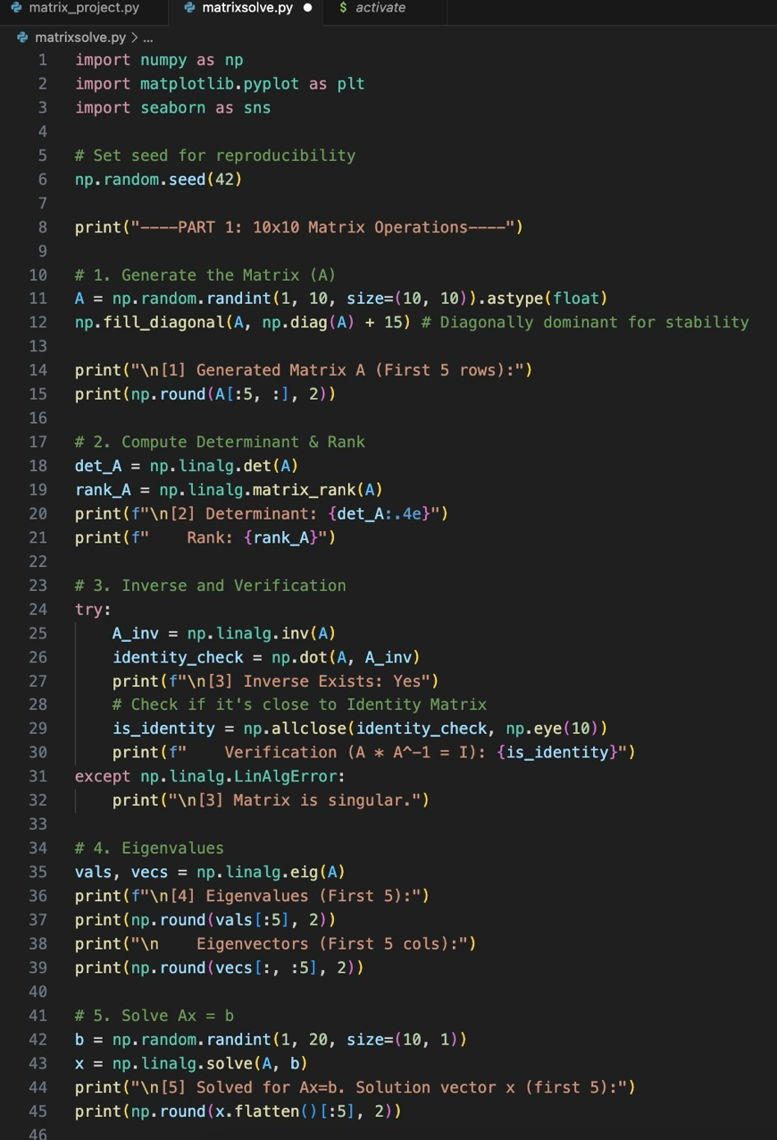

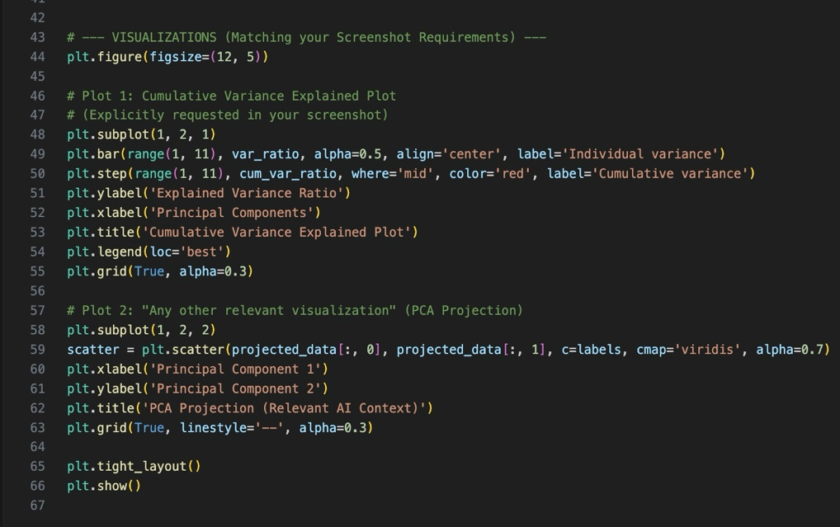

Part 02:
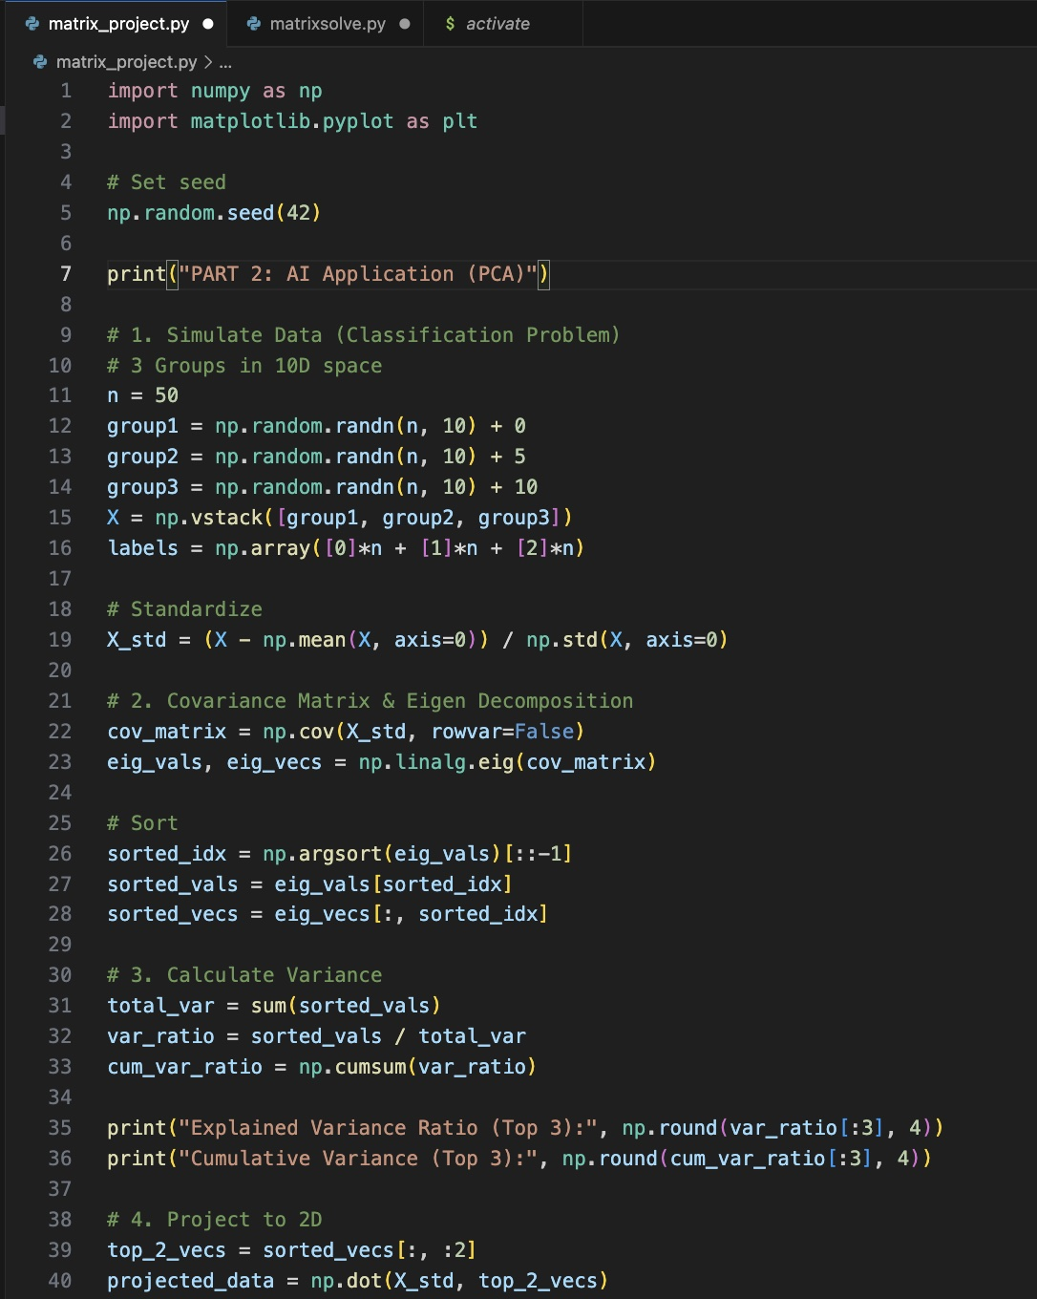

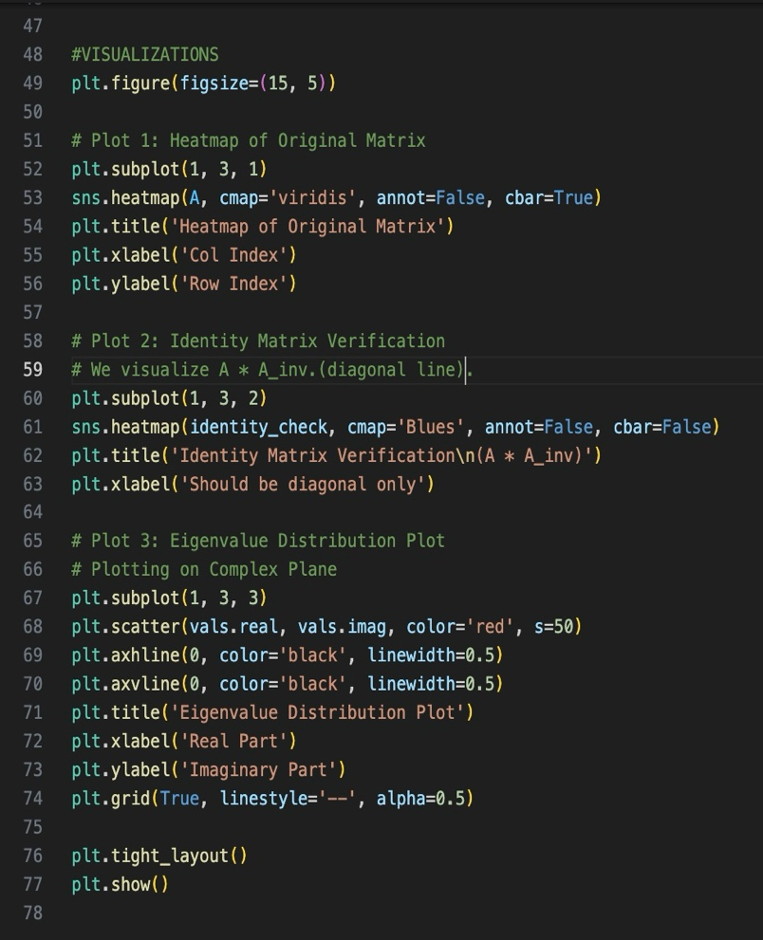

Appendix B: Output Screenshots
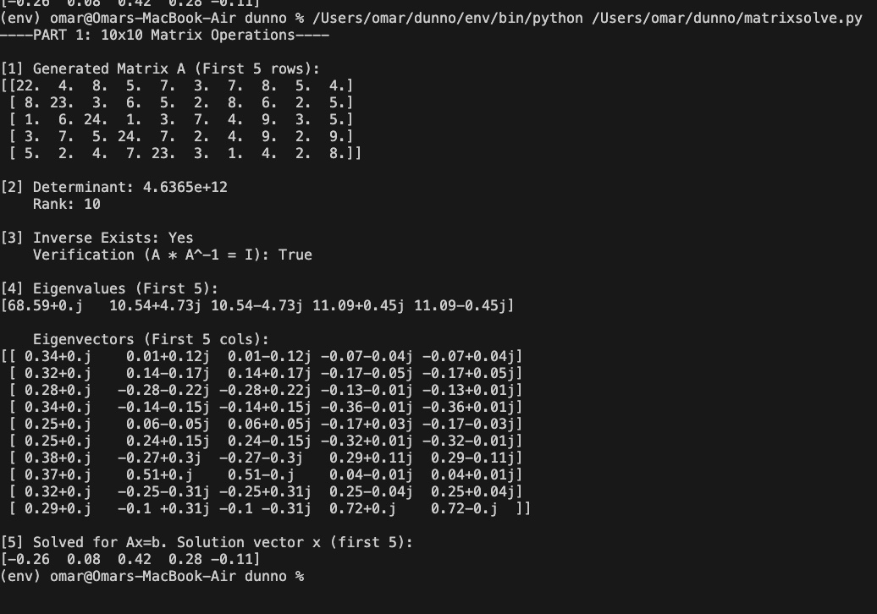
Console output showing computed values:

Heatmap of original matrix:
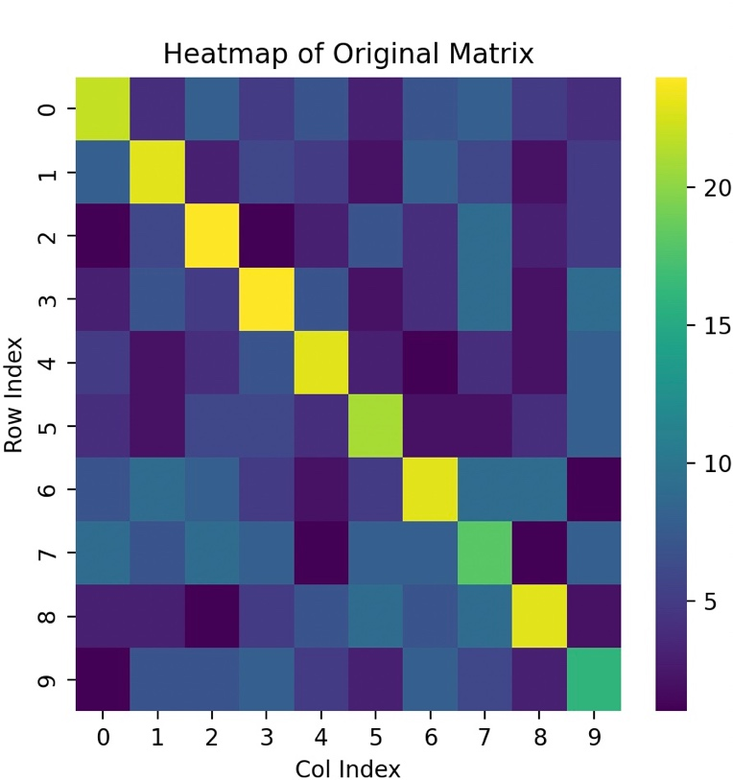

Identity matrix verification:
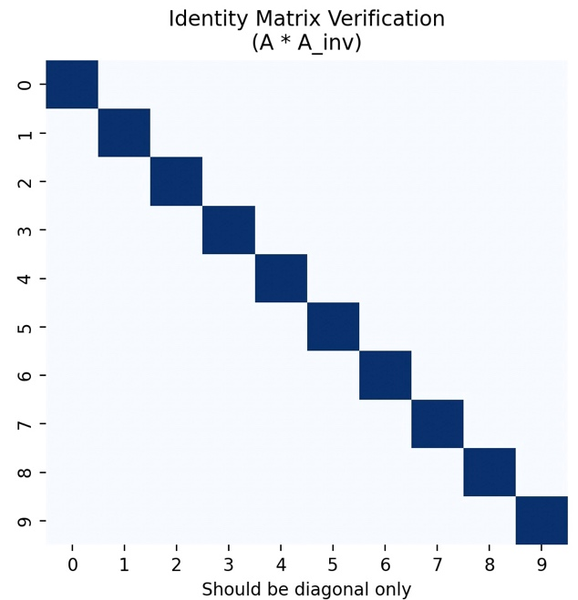

Eigenvalue distribution plot:
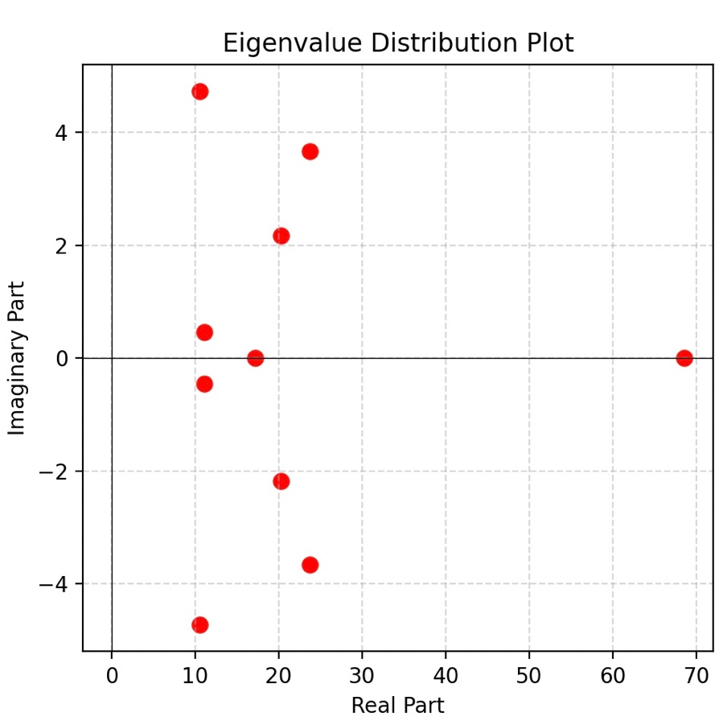

Cumulative variance explained plot:
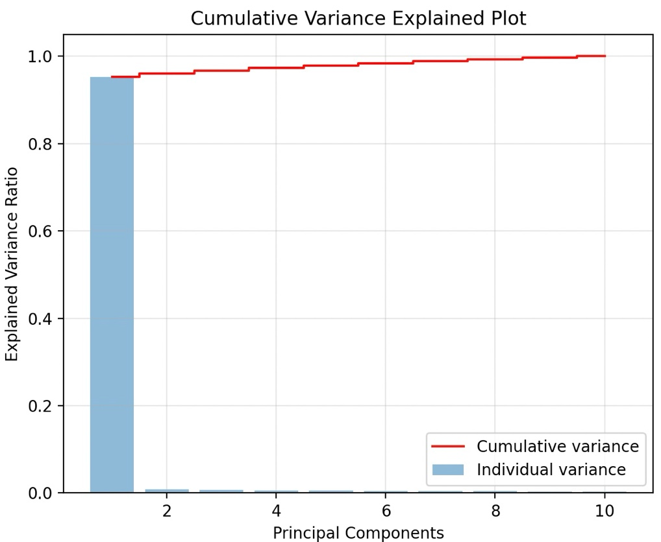

Any other relevant visualizations:
