**Homework #7**

**Mean Value Analysis**

Name: Peitong Shi

SFSU ID: 915604994

CSC641 – 01

Instructor: Dr. Jozo J. Dujmović

Dec. 8th 2017

1. According to the question, we learn that there are two cases.

**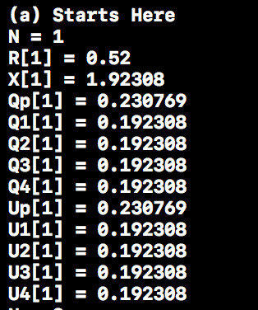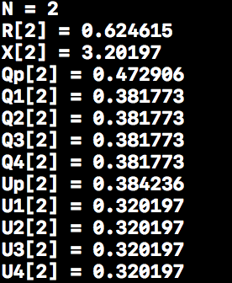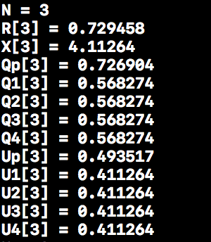  
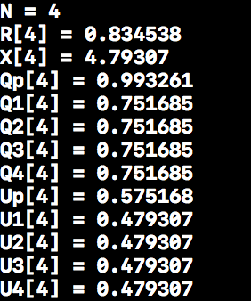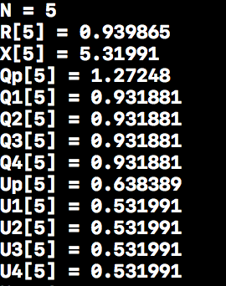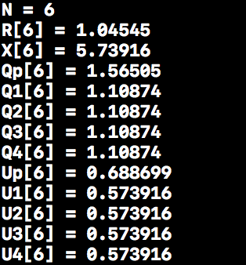**

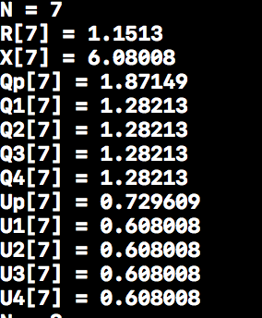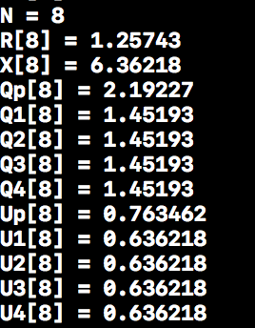

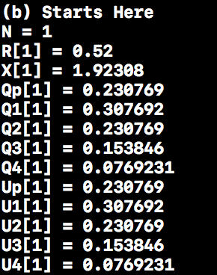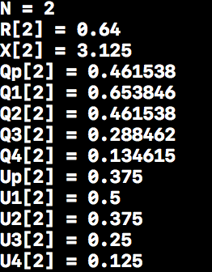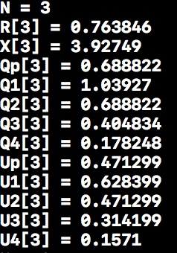

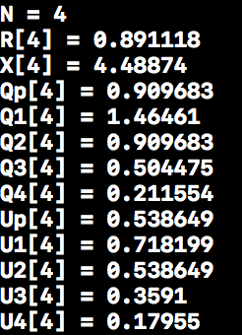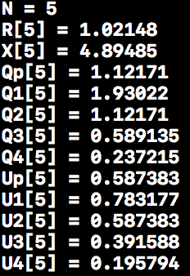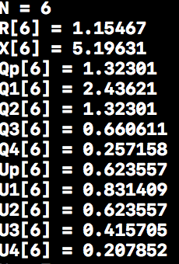

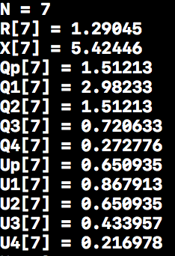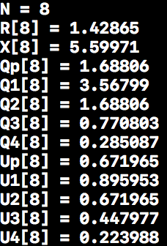

1. $$N = 40, λ=\frac{1}{S_{p}}=\frac{1}{0.003}, μ=\frac{1}{S_{d}}=\frac{1}{0.01}$$ $U=1-p_{0}=p_{1}+p_{2}+…+p_{8}$, $ρ=\frac{λ}{μ}=\frac{3}{10}$ $$p_{1}=4ρ*p_{0}=\frac{12}{10}p_{0} , p_{2}={16\left(\frac{3}{10}\right)}^{2}*p_{0}, p_{3}={64\left(\frac{3}{10}\right)}^{3}*p_{0}, \\ p_{4}={256\left(\frac{3}{10}\right)}^{4}*p_{0} \\ p_{5}={1024\left(\frac{3}{10}\right)}^{5}*p_{0}, p_{6}={3072\left(\frac{3}{10}\right)}^{6}*p_{0}, \\ p_{7}={6144\left(\frac{3}{10}\right)}^{7}*p_{0},p_{8}={6144\left(\frac{3}{10}\right)}^{8}*p_{0} \\ 1=p_{0}+p_{1}+p_{2}+…+p_{8}= \\ p_{0}\left(1+\frac{12}{10}+\left(16*{\frac{3}{10}}^{2}\right)+\left(64*{\frac{3}{10}}^{3}\right)+\left(256*{\frac{3}{10}}^{4}\right)+\left(1024*{\frac{3}{10}}^{5}\right)+\left(3072*{\frac{3}{10}}^{6}\right)+\left(6144*{\frac{3}{10}}^{7}\right)+\left(6144*{\frac{3}{10}}^{8}\right)\right)→ p_{0}=0.072, U=1- p_{0}=0.928$$ $Since R=\frac{n*s}{U_{p}}-z, z=0, R=\frac{320S_{p}}{U_{p}}=320*\frac{0.003}{0.928}$**= 1.0345 $X=\frac{J}{Z+R}, Z=0, X=\frac{8}{1.0345}=7.7332$**，

In conclusion, this model is faster than the model (a) in Fig.1

1. **(a)** D1 = D2 = D3 = D4 = 0.01 * 10 = 0.1, Dp = 0.003 * 40 =0.12

Bottle neck is Processor in this case.

N $=\frac{0.4+0.12+5}{0.12}=46$

*

**(b)**D1 = 0.01*16 =0.16, D2 = 0.01*12 = 0.12, D3=0.01*8=0.08, D4=0.01*4=0.04

Dp = 0.003*40 = 0.12.

Bottle neck is D1 in this case.

N $=\frac{0.16+0.12+0.08+0.04+0.12+5}{0.16}=34.5$

*

**Source code**

**//**

**// main.cpp**

**// Mean_Value_Analysis**

**//**

**// Created by PEITONG SHI on 07/12/2017.**

**// Copyright © 2017 PEITONG SHI. All rights reserved.**

**//**

**#include <iostream>**

**using namespace std;**

**double Sp = 0.003;**

**double Sd = 0.01;**

**double max(double v, double w, double x, double y, double z) {**

**double max = v;**

**if (w>max) { max = w;}**

**if (x>max) { max = x;}**

**if (y>max) { max = y;}**

**if (z>max) { max = z;}**

**return max;**

**}**

**void mva1(double w,double x,double y,double z){**

**double Vp = 40.0;**

**double V1 = w;**

**double V2 = x;**

**double V3 = y;**

**double V4 = z;**

**double Dp = Sp*Vp;**

**double D1 = Sd*V1;**

**double D2 = Sd*V2;**

**double D3 = Sd*V3;**

**double D4 = Sd*V4;**

**double R[9], Rp[9], R1[9], R2[9], R3[9],R4[9];**

**double Qp[9], Q1[9], Q2[9], Q3[9], Q4[9];**

**double X[9], Up[9], U1[9], U2[9], U3[9], U4[9];**

**for (int a = 0; a <= 8; a++) {**

**Qp[a] = 0.0;**

**Q1[a] = 0.0;**

**Q2[a] = 0.0;**

**Q3[a] = 0.0;**

**Q4[a] = 0.0;**

**R[a] = 0.0;**

**Rp[a] = 0.0;**

**R1[a] = 0.0;**

**R2[a] = 0.0;**

**R3[a] = 0.0;**

**R4[a] = 0.0;**

**X[a] = 0.0;**

**Up[a] = 0.0;**

**U1[a] = 0.0;**

**U2[a] = 0.0;**

**U3[a] = 0.0;**

**U4[a] = 0.0;**

**}**

**int N = 8;**

**for (int i = 1; i <= N ; i++) {**

**Rp[i] = Dp*(1+Qp[i-1]);**

**R1[i] = D1*(1+Q1[i-1]);**

**R2[i] = D2*(1+Q2[i-1]);**

**R3[i] = D3*(1+Q3[i-1]);**

**R4[i] = D4*(1+Q4[i-1]);**

**R[i] = Rp[i]+R1[i]+R2[i]+R3[i]+R4[i];**

**X[i] = i/R[i];**

**Qp[i] = X[i]*Rp[i];**

**Q1[i] = X[i]*R1[i];**

**Q2[i] = X[i]*R2[i];**

**Q3[i] = X[i]*R3[i];**

**Q4[i] = X[i]*R4[i];**

**Up[i] = X[i]*Dp;**

**U1[i] = X[i]*D1;**

**U2[i] = X[i]*D2;**

**U3[i] = X[i]*D3;**

**U4[i] = X[i]*D4;**

**cout<<"N = " << i << endl;**

**// cout<<"Rp[" << i <<"] = " << Rp[i] <<"\nR1[" << i << "] = " << R1[i] << "\nR2[" << i**

**// <<"] = " << R2[i] << "\nR3[" << i << "] = " << R3[i] << "\nR4[" << i << "] = " << R4[i]<<endl;**

**cout<<"R["<<i<<"] = " <<R[i]<<endl;**

**cout<<"X["<<i<<"] = " <<X[i]<<endl;**

**cout<<"Qp["<<i<<"] = "<<Qp[i]<<endl;**

**cout<<"Q1["<<i<<"] = "<<Q1[i]<<endl;**

**cout<<"Q2["<<i<<"] = "<<Q2[i]<<endl;**

**cout<<"Q3["<<i<<"] = "<<Q3[i]<<endl;**

**cout<<"Q4["<<i<<"] = "<<Q4[i]<<endl;**

**cout<<"Up["<<i<<"] = "<<Up[i]<<endl;**

**cout<<"U1["<<i<<"] = "<<U1[i]<<endl;**

**cout<<"U2["<<i<<"] = "<<U2[i]<<endl;**

**cout<<"U3["<<i<<"] = "<<U3[i]<<endl;**

**cout<<"U4["<<i<<"] = "<<U4[i]<<endl;**

**}**

**}**

**void mva2(double w, double x, double y, double z) {**

**double Vp = 40.0;**

**double V1 = w;**

**double V2 = x;**

**double V3 = y;**

**double V4 = z;**

**double Z = 5.0;**

**double Dp = Sp*Vp;**

**double D1 = Sd*V1;**

**double D2 = Sd*V2;**

**double D3 = Sd*V3;**

**double D4 = Sd*V4;**

**double R[100], Rp[100], R1[100], R2[100], R3[100],R4[100];**

**double Qp[100], Q1[100], Q2[100], Q3[100], Q4[100];**

**double X[100], Up[100], U1[100], U2[100], U3[100], U4[100];**

**for (int a = 0; a <= 100; a++) {**

**Qp[a] = 0.0;**

**Q1[a] = 0.0;**

**Q2[a] = 0.0;**

**Q3[a] = 0.0;**

**Q4[a] = 0.0;**

**R[a] = 0.0;**

**Rp[a] = 0.0;**

**R1[a] = 0.0;**

**R2[a] = 0.0;**

**R3[a] = 0.0;**

**R4[a] = 0.0;**

**X[a] = 0.0;**

**Up[a] = 0.0;**

**U1[a] = 0.0;**

**U2[a] = 0.0;**

**U3[a] = 0.0;**

**U4[a] = 0.0;**

**}**

**double N_star = (D1+D2+D3+D4+Dp+Z)/max(D1,D2,D3,D4,Dp);**

**cout<<"**************************"<<endl;**

**cout<<" N* is " << N_star <<" "<<endl;**

**cout<<"**************************"<<endl;**

**for (int i = 1; i <= 2*N_star ; i++) {**

**Rp[i] = Dp*(1+Qp[i-1]);**

**R1[i] = D1*(1+Q1[i-1]);**

**R2[i] = D2*(1+Q2[i-1]);**

**R3[i] = D3*(1+Q3[i-1]);**

**R4[i] = D4*(1+Q4[i-1]);**

**R[i] = Rp[i]+R1[i]+R2[i]+R3[i]+R4[i];**

**X[i] = i/(Z+R[i]);**

**Qp[i] = X[i]*Rp[i];**

**Q1[i] = X[i]*R1[i];**

**Q2[i] = X[i]*R2[i];**

**Q3[i] = X[i]*R3[i];**

**Q4[i] = X[i]*R4[i];**

**Up[i] = X[i]*Dp;**

**U1[i] = X[i]*D1;**

**U2[i] = X[i]*D2;**

**U3[i] = X[i]*D3;**

**U4[i] = X[i]*D4;**

**// cout<<"Rp[" << i <<"] = " << Rp[i] <<"\nR1[" << i << "] = " << R1[i] << "\nR2[" << i**

**// <<"] = " << R2[i] << "\nR3[" << i << "] = " << R3[i] << "\nR4[" << i << "] = " << R4[i]<<endl;**

**// cout<<R[i]<<endl;**

**// cout<<Up[i]<<endl;**

**cout<<X[i]<<endl;**

**}**

**}**

**int main(int argc, const char * argv[]) {**

**cout<<"--------------------\n";**

**cout<<"(a) Starts Here\n";**

**mva1(10.0,10.0,10.0,10.0);**

**cout<<"--------------------\n";**

**cout<<"(b) Starts Here\n";**

**mva1(16.0,12.0,8.0,4.0);**

**cout<<"--------------------\n";**

**cout<<"(a) Starts Here\n";**

**mva2(10.0,10.0,10.0,10.0);**

**cout<<"--------------------\n";**

**cout<<"(b) Starts Here\n";**

**mva2(16.0,12.0,8.0,4.0);**

**return 0;**

**}**