Report: Airplane crashes analysis (1919-2023)  
Camilla Bonomo for International Alliance for Safe Skies

The dataset of airplane accidents (1919-2023) include tons of data and information. Starting from this dataset it is possible to collect usefull insights.

The first visualisation is showing the evolution of airplane accidents over time.  
 Here it is possible to define a peak in 1944 (period of geopolitcal tension and WWII) and a drop in 2023.

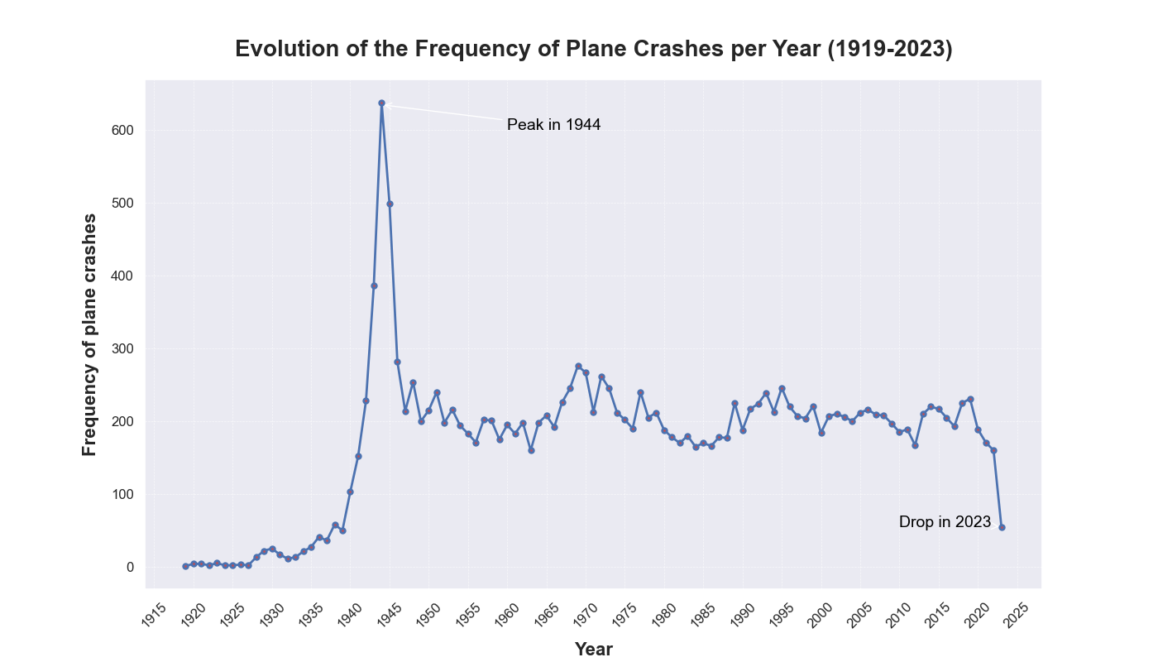

During this 105 years the country that has registered the highest number of airplane crashes on its territory is the USA, followed by Russia, Canada,UK and Brazil.

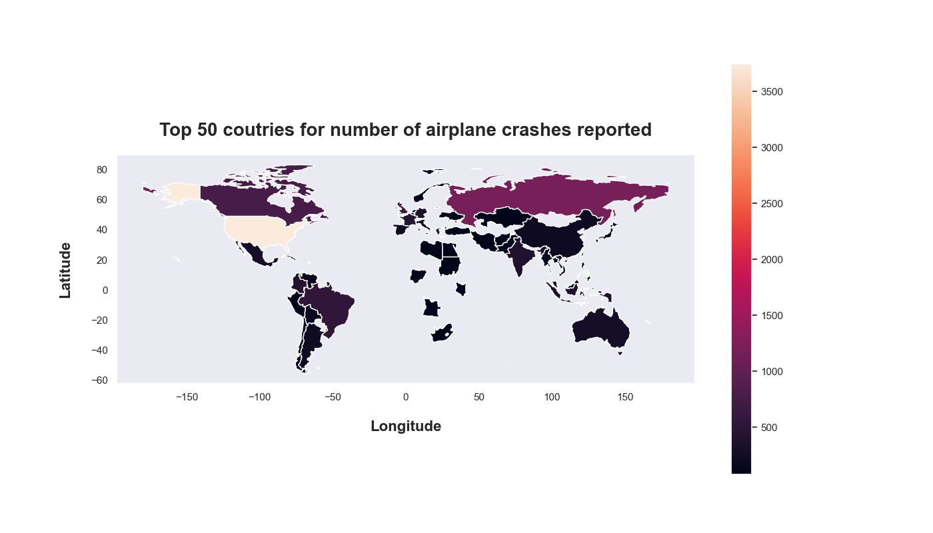

Considering the accidents in USA, it is clear that the operator USAF was the most resposible for them.

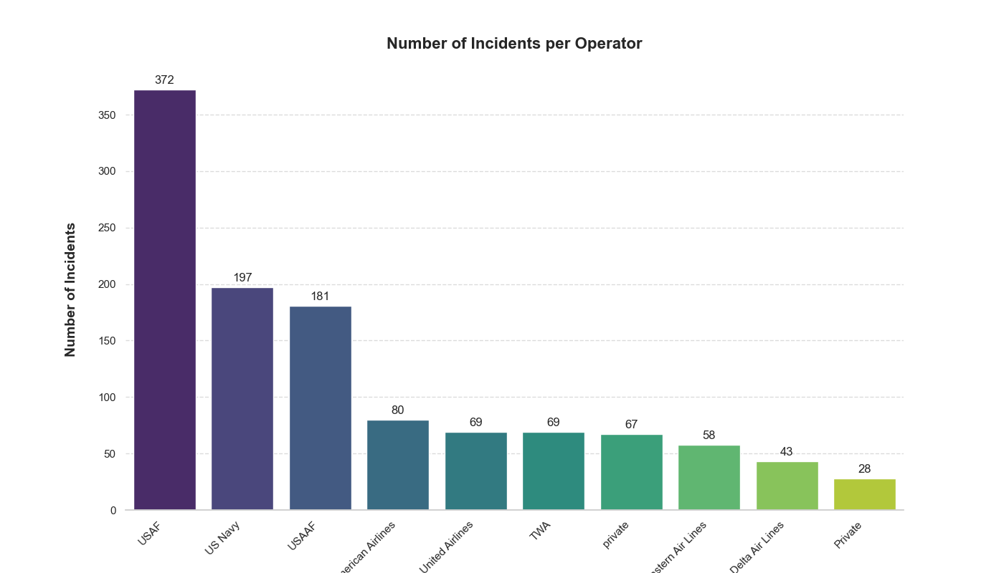

It is showed by the data that USAF opearator has caused the most accidents in USA causing 1909 fatalities in 105 years of registrations.

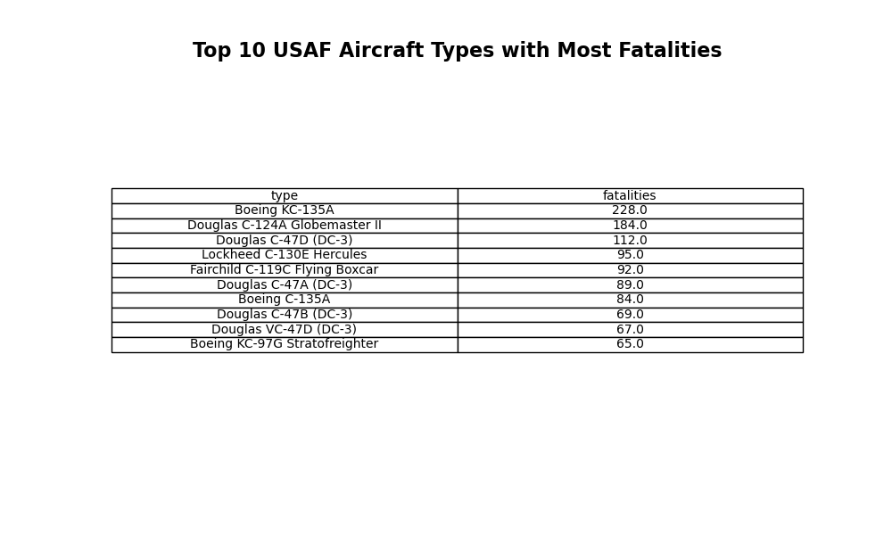

Moreover, data are showing that the most dangerous type of USAF aircraft is the Boeing KC-135A with an ammount of 228 fatalities out of 1909.

Searching for the most dangerous type of aircraft among all the operators it has emerged that USAAF Douglas C-47A (DC-3) has caused 1751 fatalities all over the world.  
Moreover, it can be noticed that other two USAAF aircraft are present in this top 10 table, making us suppose that USAAF could be the most dangerous operator as reguards number of fatalities  
We have already seen that this operator was at the 3rd place for number of accidents in the USA as well.

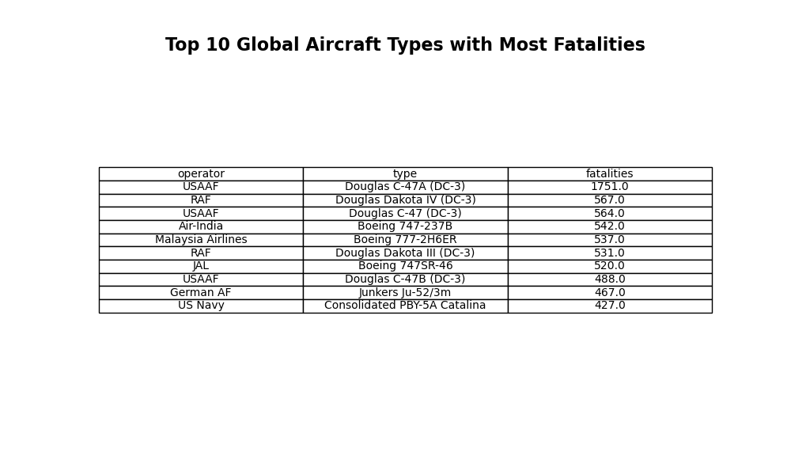

At this point it is interesting to understand which operators are the most and least dangerous for number of accidents and for number of fatalities.

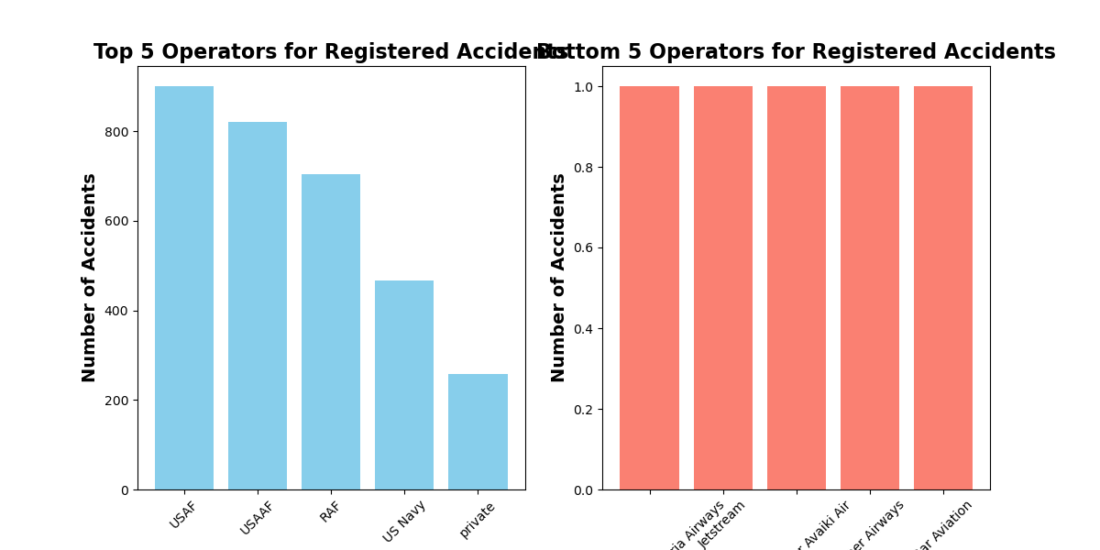

It emerges that USAF and USAAF confirm themselves as the operators with more registered accidents all over the world, while the operators on the graphs on the right (with slamon bars) are the safest for number of accidents on the top and fatalities on the bottom.  
It also emerges that in the group of the safest operators, everyone has made at least 1 accidents.

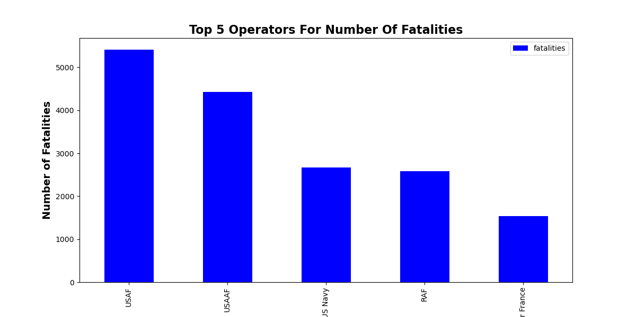

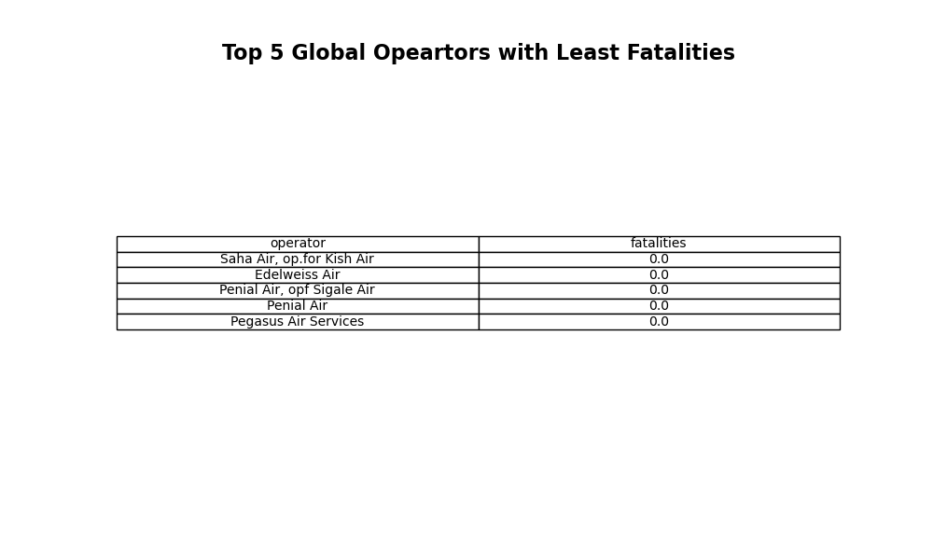

the safest operators for number of fatalities may have done some accidents but they didnt caused any deaths; on the other hand, the safest operators for number of accidents have done just 1 accident cousing some fatalities.  
Finally, we can see that USAF and USAAF are also at the top for number of fatalities caused (along with US Navy and RAF).