Spooky game
GAME DESIGN DOCUMENT
By Vaity, OldAchoK and Milocurran for Scream Jame 2025

Introduction 2
Game Summary Pitch 2
Player experience 5
Platform 5
Development software 6
Genre 6
Target audience 6
Concept 6
Gameplay overview 6
Primary mechanics 7
Secondary mechanics 7
Art design 8
Audio 8
Music 8
Sound effects 8
Game Experience 8
UI 8
Controls 8
Development Timeline 8

Introduction

Game Summary Pitch
‘Spooky Game’ is an action game, where you play as an noob blogger, you decided to make some shock content on ruins of old fabric, but accidentally became part of trash-comedy-movie. Will you handle your fear, take your balls in hand and escape ancient shadow or it will get your ass?

Inspiration
Amnesia: The Dark Descent  Legendary survival horror with walking and hiding mechanics and huge accent on dark story. | 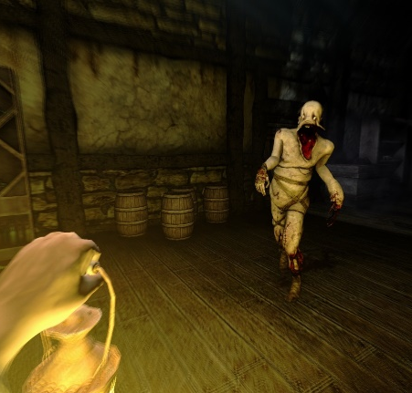
Phasmophobia  Popular multiplayer survival horror with camera and other ghost detecting elements. | 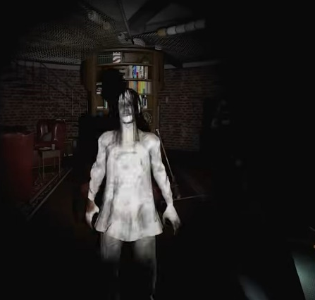
Poop Killer - Flush or Die | 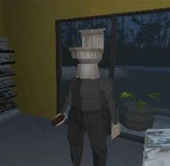

Player experience
Player as blogger would need to face darkness and mystic of an old fabric. Throughout old ruins of industrial zone player would witness history of its place, face puzzle, hide from monsters and pray to left this place alive. Player would need to use camera gear, and properly react to surprises.

Platform
The game will be released on Windows, Linux, Android

Development software
- Godot 4.5
- Blender for 3d modeling
- Photoshop for concepts
- Github version control
- Krita for UI
-

Genre
Single player, Indie, First person, Action, Horror, Adventure, Puzzle

Target audience
Utilizing simple to understand mechanics with casual gameplay difficulty, but have some horror elements, jumpscares and even blinding lights.

Concept

Gameplay overview
Player is blogger, has camera of front and back view. The goal is to survive in strange place. It’s inhabitant’s feel some foreign in their home, they would interfere with player, remember the gear is heavy, and run is not an option. But some places blocked by riddles, wanted go further - solve it.
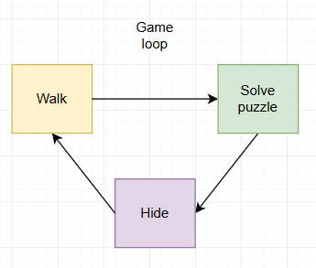
Gameplay loop

Primary mechanics
Mechanic
Walking
Player can move in all directions.
Camera
Player can view environment in 3d dimension.

Secondary mechanics
Mechanic
Crawl
Player can crawl for hiding reasons.

Art design WIP
Low-poly art style with realistic textures to provide a feeling of “retro games” to players.
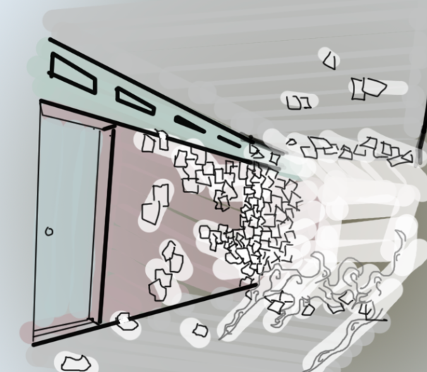
Puzzle design

Audio WIP

Music
-

Sound effects
-

Game Experience

UI
-

Controls
Keyboard
WASD + mouse

Development Timeline
# | Assignment | Type | Status | Finish by | Notes
1 | Game Design Document | Other | In progress
2 | Base player controller | Programming | Completed
3 | 3D modeling | Assets | In progress
4 | Sound design | Assets | Partially completed
5 | Enemies mechanics | Programming | Completed |  | Base
6 | User Interface | Programming | Partially completed |  | Highly important

