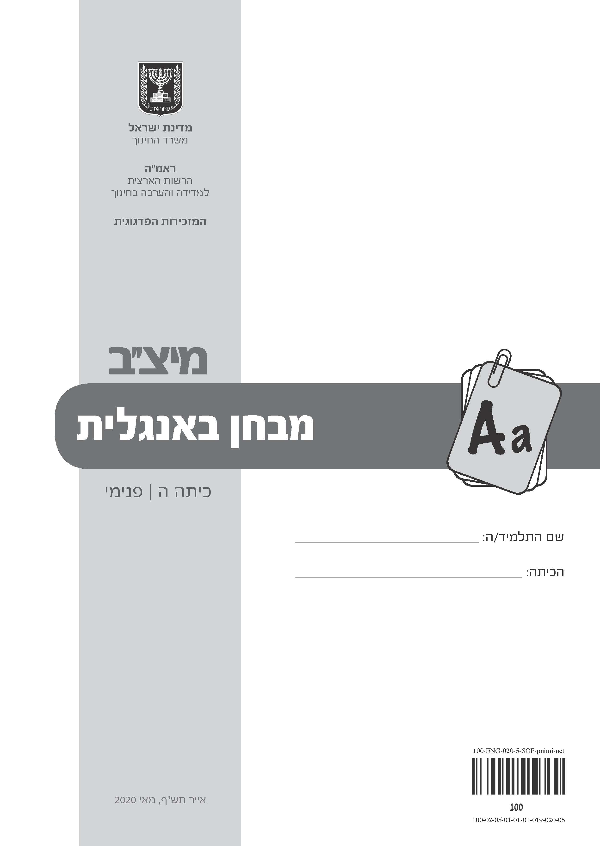

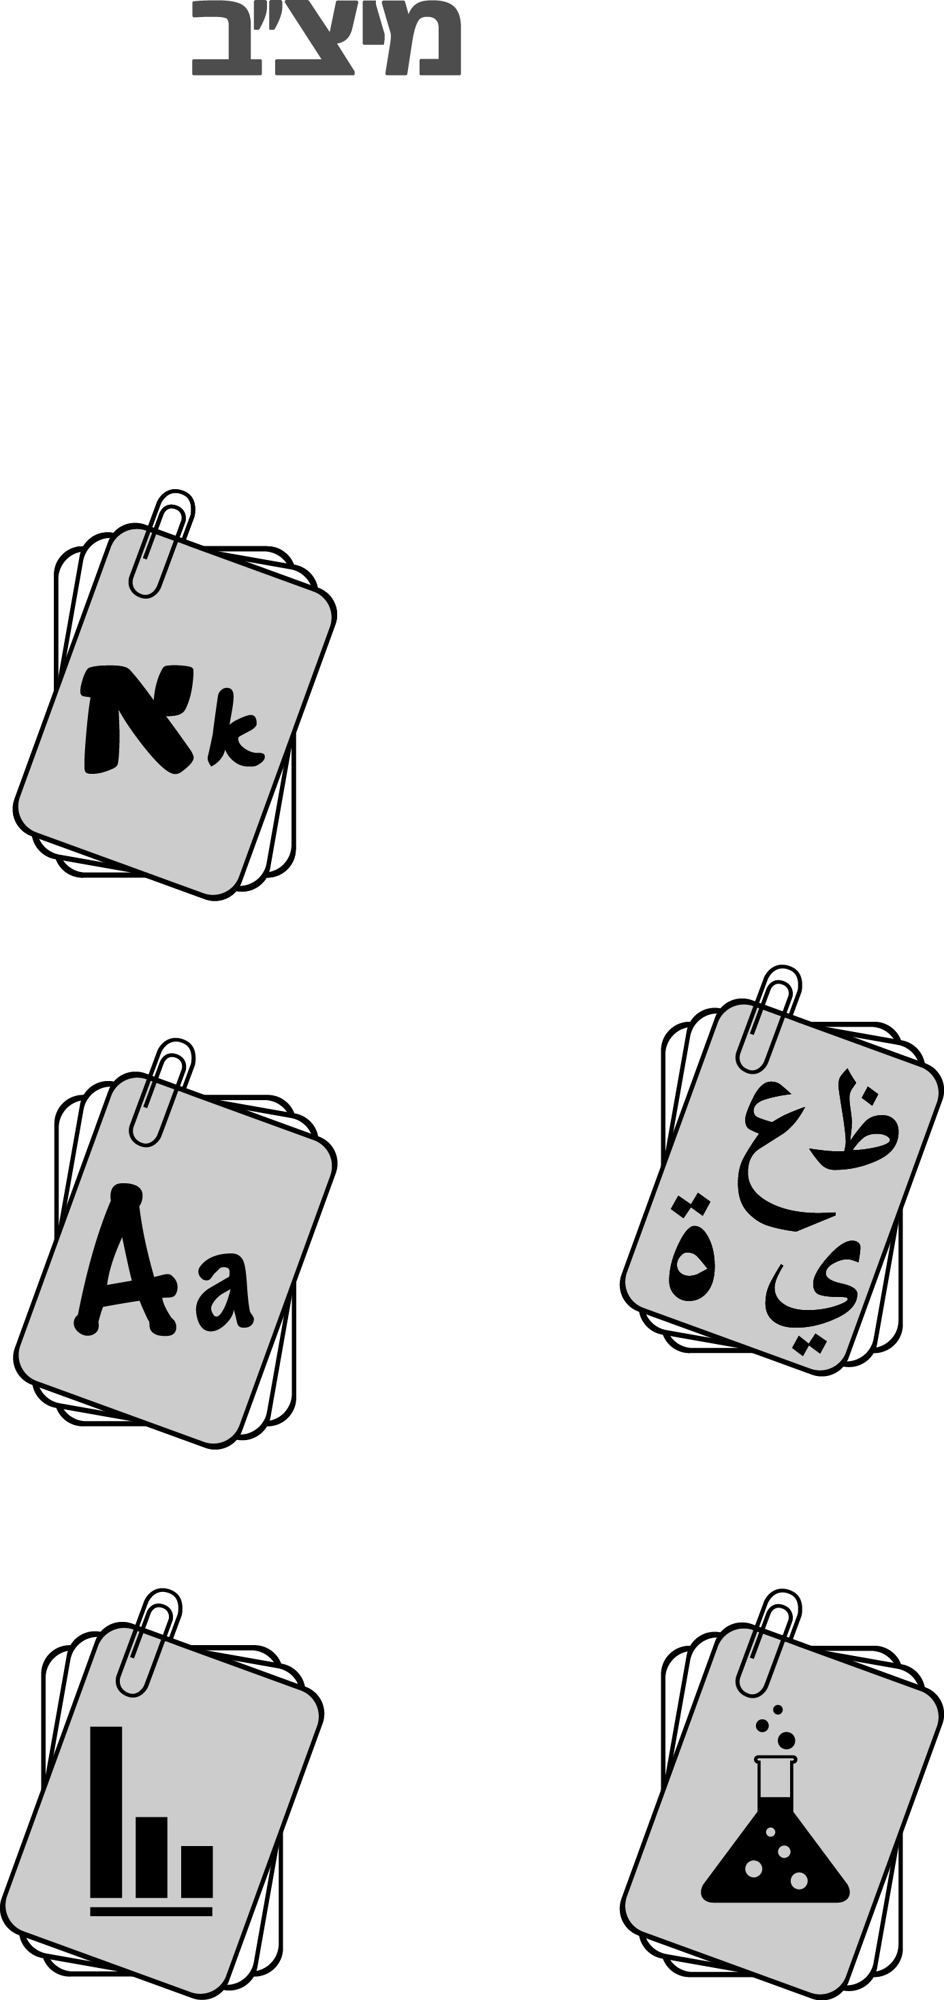
תלמידים יקרים שלום,

לפניכם מבחן באנגלית .

אתם תתבקשו לקרוא קטעים ולהשיב על השאלות.
קראו את כל הקטעים בעיון והשיבו על כל השאלות ברצינות רבה ובתשומת
לב.
כתבו את תשובותיכם באנגלית.
לא תוכלו להיעזר במילון מכיוון שבמבחן נבדק גם אוצר המילים שלכם
באנגלית.
לרשותכם 90 דקות, אך אם תזדקקו לזמן נוסף, בקשו מהמורה.

בהצלחה!
TASK 1משימה
1.
Below are some game cards.  Choose the correct answer to  complete the sentence on each card. |  | לפניכם קלפי משחק.  סמנו את התשובה הנכונה כדי להשלים  את המשפט שבכל קלף.

1. |  | It‛s sweet and many kids like to eat it. It‛s __.
a summer
b chocolate
c a computer
d a restaurant

2. |  | When a new pupil comes to your school,  you say, “__”
a Welcome!
b I‛m sorry!
c Thank you!
d What a mess!

3. |  | When your friend looks sad, you ask, “__”
a What's the weather like?
b What‛s the time?
c What happened?
d What do you mean?

4. |  | When your friend goes on holiday,  you say, “__”
a It's nice to meet you!
b What's the problem?
c How are you?
d Have a good time!

5. |  | When we are thirsty, we __.
a drink water
b call a friend
c go to sleep
d do homework

6. |  | When you don't come on time, you are __.
a hungry
b small
c funny
d late

7. |  | When you want to know where someone lives,  you ask for the __.
a date
b letter
c address
d question

המשיכו לעבוד בעמוד הבא.
TASKמשימה 2

Read the diary entries below and  answer the questions in English. |  | קראו את קטעי היומן שלפניכם, וענו  באנגלית על השאלות.

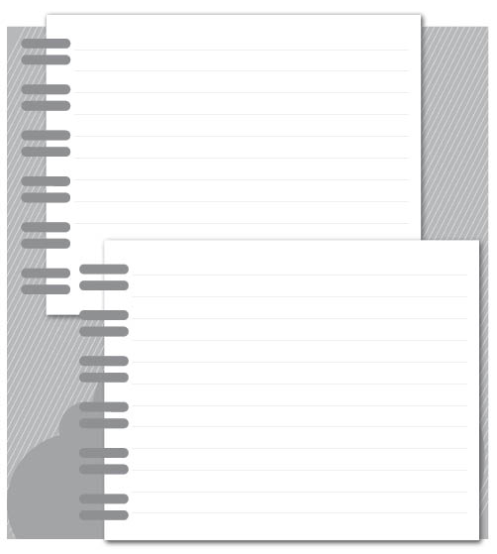
Dear Diary*,
I'm so happy. Uncle Fred and Aunt Julie from
America are coming to visit us next week. Every
time they are in Israel, they come to our house
for dinner.
I always enjoy talking to Uncle Fred and Aunt
Julie. They have funny stories to tell us.
Dana
Monday, October 25th
Dear Diary,
Uncle Fred and Aunt Julie are coming today.
My family is getting ready for the visit. Mom
and Dad are in the kitchen making dinner. My
big brother David is cleaning the garden chairs
and I will put flowers on the table.
I am so excited. I can’t wait!
Look! I see Uncle Fred and Aunt Julie outside.
Wow, they have a new dog! What a surprise!
I’ll write again soon…
Dana
Tuesday, November 2nd
* Diary - יומן
Where do Uncle Fred and Aunt Julie live?
2.

When Uncle Fred and Aunt Julie come, Dana likes to ____.
3.
a show them her diary
b listen to their stories
c make lots of food
d play with their dog

When did Uncle Fred and Aunt Julie come to visit Dana's family?
.4
Write the day and the date:
day date

What did David do before the visit?
.5
a He played in the garden.
b He read a funny book.
c He cleaned the chairs.
d He gave the flowers water.
Dana says, "I can't wait!"
She is waiting to ____ her uncle and aunt.
.6
a help
b write to
c cook with
d see

At the end of the text Dana says "What a surprise!"
What was the surprise?
.7

Why did Dana stop writing in her diary?
.8
a Her uncle and aunt arrived.
b The dinner was ready.
c She was tired.
d Her brother needed help.
.9
What could Dana say to her uncle  and aunt after the visit described in  the diary? |  | מה יכלה דנה להגיד לדוד ולדודה שלה  לאחר הביקור המתואר ביומן?

a We enjoyed visiting America.
b I'm happy you came to our house.
c You have a beautiful garden.
d Thank you for the lovely flowers.

TASK משימה 3
.10
Look at the picture below.  Write five things that you see in  the picture.  Use correct spelling. |  | התבוננו בתמונה שלפניכם.  כתבו חמישה דברים שאתם רואים  בתמונה.  הקפידו על כתיב נכון.

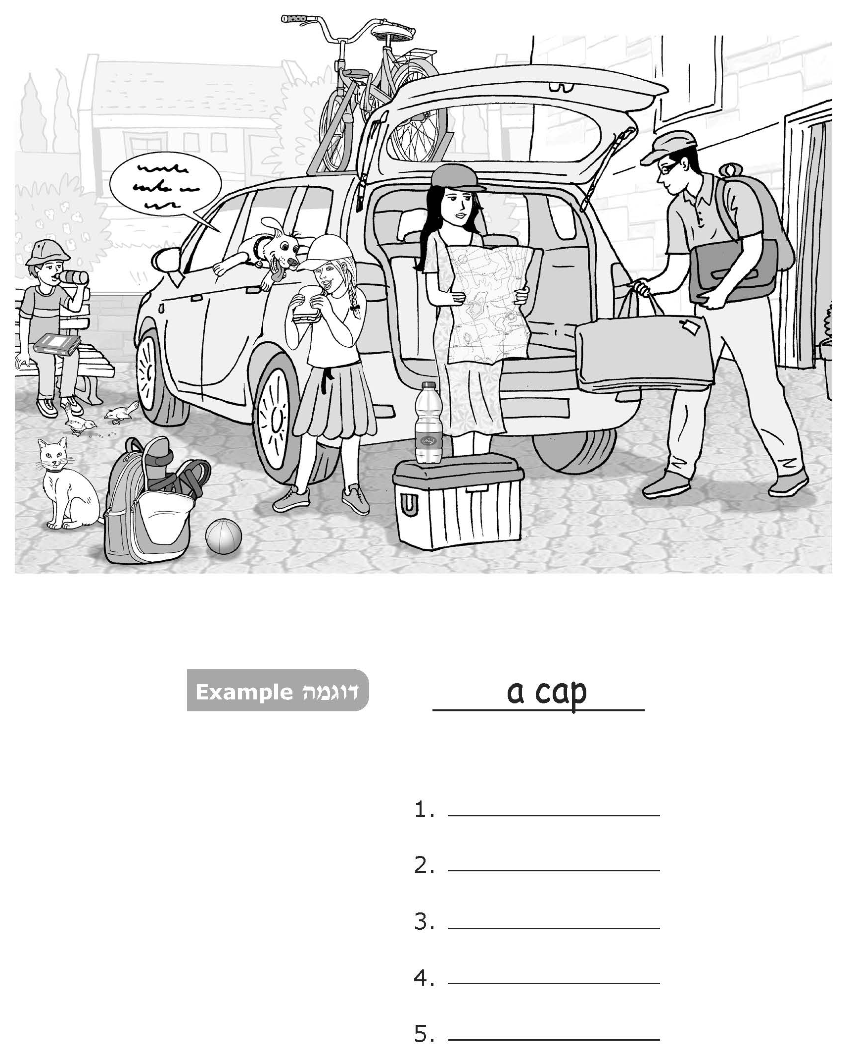

.11
Look at the picture on the previous  page again.  Write a full sentence in English  under each instruction.  Use correct grammar, spelling and  punctuation. |  | התבוננו שוב בתמונה שבעמוד הקודם.  כתבו משפט שלם באנגלית מתחת לכל  הוראה.  הקפידו על דקדוק נכון, על כתיב נכון  ועל סימני פיסוק נכונים.

1. | Choose one person from the picture  and write what he looks like. |  | בחרו אדם אחד מהתמונה  וכתבו איך הוא נראה.
2. | Choose one person from the picture  and write what he is doing. |  | בחרו אדם אחד מהתמונה  וכתבו מה הוא עושה.
3. | Choose one item from the picture  and write where it is placed. |  | בחרו פריט אחד מהתמונה  וכתבו היכן הוא נמצא.
4. | If the dog could talk,  what would he say? |  | אילו היה הכלב יכול לדבר,  מה הוא היה אומר?
 | The dog says: " "
TASKמשימה 4
Read the text below and answer  the questions in English. |  | קראו את הטקסט שלפניכם, וענו  באנגלית על השאלות.

Amazing Pets Magazine | March, 2019
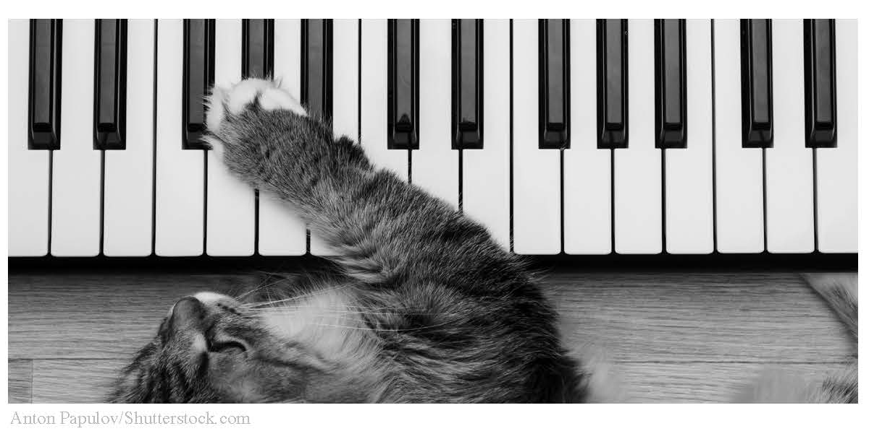
Missy
the
Cat

Missy is a gray cat from New York City. Missy looks like all other cats, but
there is something very different about her – she can play the piano*!
Missy's owner**, Bob, is a piano teacher. Missy liked to sit in the living room
and listen to Bob and his students playing the piano. One night, when Missy
was a year old, she jumped out of bed, ran to the piano and started playing
it. Missy enjoyed the sound of the piano so much that she started playing it
every day.
5
Today Missy is five years old, and she is a very good piano player. Missy
plays the piano at school parties and music shows. When Missy plays music,
everybody stands up and claps their hands. It is always a very special show.
10
Bob makes videos of Missy playing the piano and puts them on the Internet.
More than 10 million people watch the videos every month.
Bob found*** Missy on the street and gave her a home. This is where she
learned how to play the piano. Now Missy and her music make millions of
people happy.
15

* piano — פסנתר ** owner — בעלים *** found — מצא
What do we know about Bob?
12.
a Bob learns music on the Internet.
b Bob plays music on the street.
c Bob teaches music at his house.
d Bob sings in music shows.

Where does Missy play the piano?
13.
Write two answers.
a.
b.

What do people do when they see Missy playing the piano?
14.
.

.15
Tick (✓) Yes or No next to  each sentence. |  | סמנו ב-✓ כן או לא ליד כל משפט.

 |  | Yes | No
a. | Today, Missy is a street cat.
b. | Many people watch Missy playing the piano.
c. | Missy started playing the piano when she was a year old.

Another text in this magazine can be about ____.
16.
a Mr. John, a man who makes special balloons
b Danny, a 2-year-old boy who reads books
c Peter, an elephant that lives in the jungle
d Molly, a dog that makes cups of tea

17.
One good thing leads to another.  Choose the example from the text  that shows this. |  | דבר טוב אחד גורם לדבר טוב אחר.  בחרו את הדוגמה המראה זאת בטקסט.

a | Missy helps people. |  | People make Bob happy.
b | Bob helps Missy. |  | Missy makes people happy.
c | People help Bob. |  | Bob makes Missy happy.
d | People help Missy. |  | Bob makes other people happy.

– The End –

