GAME CARDS

Below are some game cards.  Complete the sentences that appear on the cards.  In each card mark the  correct answer with an ×. |  | לפניכם קלפי משחק.  השלימו את המשפטים שמופיעים  על גבי הקלפים.  סמנו × ליד התשובה הנכונה בכל קלף.

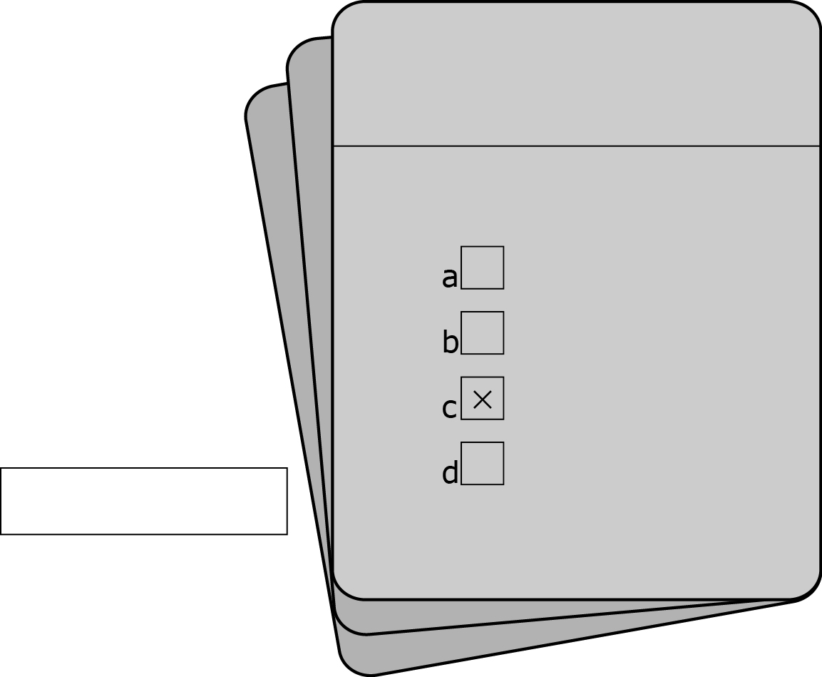
דוגמה Example
speaks
walks
writes
stands

A teacher __ on a board.

1.  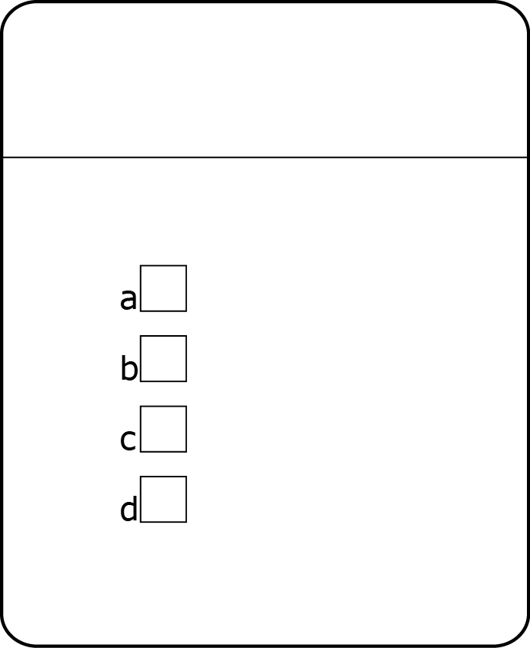  ride a bike  cook dinner  go to sleep  buy bread  People __ in the kitchen. | 2.  year  month  week  day  You have a birthday every__.
3.  singer  teacher  fireman  doctor  A __ helps sick people. | 4.  are happy  are angry  are tired  are hurt  People smile when they__.
5.
say
write
draw
work
Use a pencil to ___ your name.

