BACK IN TIME
Read the following text.  Answer the questions in English  according to the text. |  | קראו את הטקסט שלפניכם.  ענו באנגלית על השאלות לפי הטקסט.
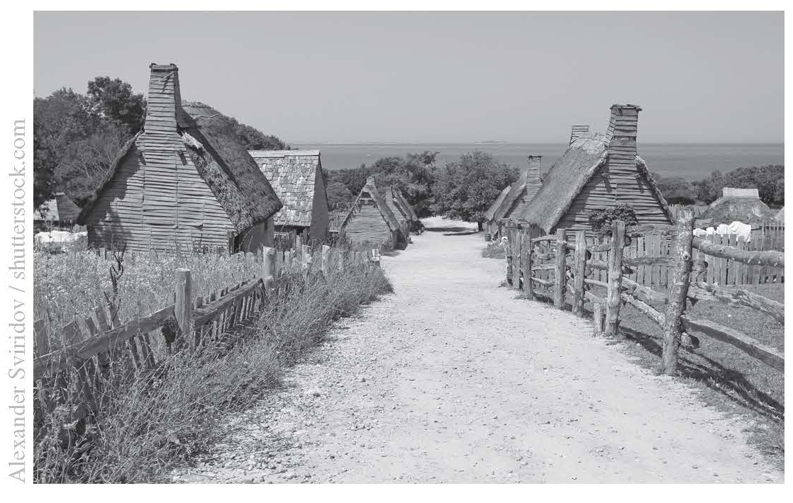
Now and Then Magazine May, 2019
Back
in
Time
By Jack Smith
Do you want to go back in time? Buy a ticket and visit the Living
History Museum in Florida, USA. This special museum looks like a real
village, and all the people that work there are actors*. When you visit
the museum, you can see how people lived 400 years ago. You can
watch the actors build houses, grow fruit and vegetables and cook
their meals over the fire. They don't have televisions, computers or
phones. There are no cars; the actors ride horses to go from place to
place.
Many people from all over the world come to visit the Living History
Museum. The actors take the visitors around the village and teach
them about life a long time ago. Sometimes the visitors ask the
actors questions like, "Do you watch TV?" or "Do you have phones?"
and the actors say, "What is a TV?" or "What are phones?" The actors
are so good, that sometimes visitors believe what they are saying,
and forget that they are visiting a museum and not a real village.
They feel like they are really going back in time.
*actors – שחקנים

סמנו את התשובה הנכונה להשלמת המשפט.
Visitors at the museum learn about ___.
1.
a countries all over the world
b the history of computers
c actors on television
d life many years ago

סמנו את התשובה הנכונה.
What is special about the Living History Museum?
2.
a 400 people work there.
b It looks like an old village.
c All the visitors are from the USA.
d People can live there.

.3
Would an actor in the Living  History Museum say the following  sentences?  Tick (✓) Yes or No next to  each sentence. |  | האם שחקן במוזאון המתואר בטקסט  היה אומר את המשפטים שלפניכם?  סמנו (✓) כן או לא ליד כל משפט.

 |  | Yes | No
a. | "Let's cook potatoes over the fire."
b. | "This is the village bus."
c. | "Let's go to feed the horses."
ענו באנגלית על השאלה לפי הטקסט.
Why do visitors sometimes forget that they are in a museum?
.4

סמנו את התשובה הנכונה.
Why does the writer, Jack Smith, begin the text with a question?
5.
a to get people to read the text
b to say he wants to go back in time
c to tell the readers he needs an answer
d to ask about the museum

Do you want to visit the Living History Museum?
6.
Explain your answer in English  using information from the text. |  | הסבירו את תשובתכם באנגלית  בעזרת מידע מהטקסט.

