ANIMALS AND COLORS
Read the following text.  Answer the questions in English  according to the text. |  | קראו את הטקסט שלפניכם.  ענו באנגלית על השאלות לפי הטקסט.

Animals and Colors
Do you know that some animals change color?
There are animals that change color to hide so other animals
can't see them. Animals hide when they are in danger or when
they hunt* for food. Sometimes animals change color to look dangerous. They want other animals to be afraid of them and
run away.
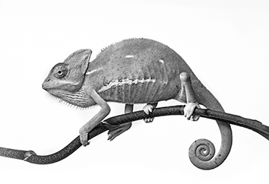
Chameleons are animals that change color. Many
chameleons are green, but sometimes they change
color to hide. For example, when chameleons
are on a tree and they feel afraid, they change
color to brown to look like the branches**. Some
chameleons change color to black when they want to
scare other animals away.
chameleon

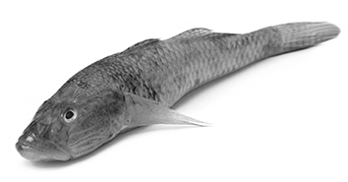
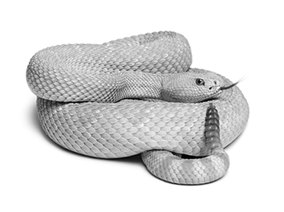
There are different kinds of fish that change color.
For example, goby fish change color when they
want to hide from dangerous sea animals. Goby
fish can be white when they swim near white rocks
or they can be red near red rocks.
There are animals that don't need to change color
to hide. For example, some snakes that live in the
desert are the same color as sand. This helps the
snakes hide and catch small animals.
snake

Goby fish

* hunt – לצוד
chameleon: © Kuttelvaserova Stuchelova/shutterstock.com
goby fish: © Swapan Photography/shutterstock.com
snake: © Eric Isselee/shutterstock.com
** branches – ענפים

שאלות Questions
1. Tick (✓) the two correct answers. |  | 1. סמנו (✓) את שתי התשובות הנכונות.
Why do animals change color?
to hide
to help other animals
to be colorful
to grow
to look dangerous

2. When do animals hide?
Write two answers in English according to the text. |  | כתבו באנגלית שתי תשובות לפי  הטקסט.

1.
2.

ענו באנגלית על השאלה.
3. How do chameleons scare animals away?

בחרו את התשובה הנכונה להשלמת המשפט.
4. Snakes in the desert don't need to change color because ___.
a  their color is black
b  they hide behind rocks
c  they are dangerous animals
d  they are the same color as sand

5. Tick (✓) Yes or No next to  each sentence. |  | 5. סמנו (✓) כן או לא ליד כל משפט.

 |  | Yes | No
a. | Chameleons can change color to brown when they are afraid.
b. | Snakes in the desert are colorful animals.
c. | Goby fish change color to look dangerous.

6. Which question has an answer in the text? |  | 6. לאיזו שאלה יש תשובה בטקסט?
a  When are snakes dangerous?
b  When are goby fish white?
c  What do chameleons eat?
d  What colors do animals like?

