THE PLASTIC BOTTLE CLASSROOMS
Read the following text.  Answer the questions in English according to the text. |  | קראו את הטקסט שלפניכם.  ענו באנגלית על השאלות לפי הטקסט.

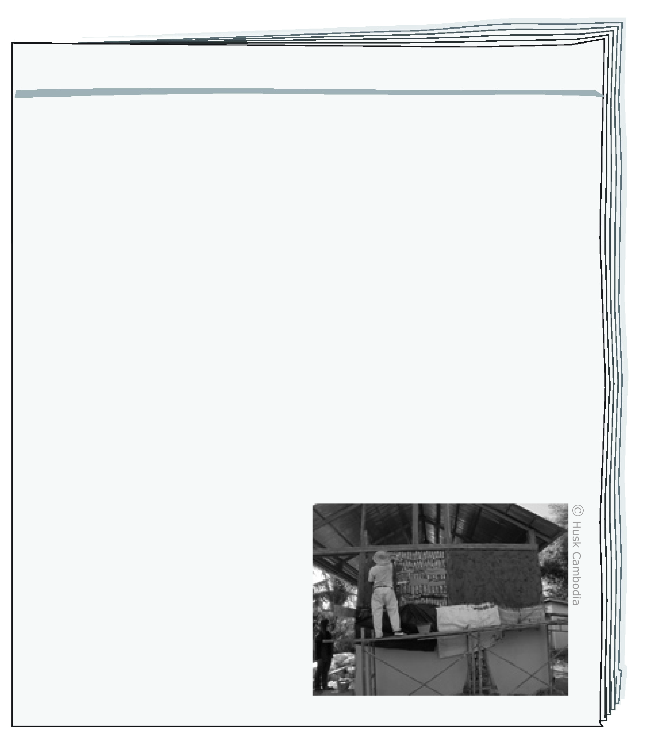
The Plastic Bottle Classrooms
By Jim Black

Lisa, a young teacher from the USA, came to Africa in 2012 to teach at a school in a small village. The school didn't have money and the classrooms didn't have walls. It was difficult for pupils to study in classrooms without walls.
Lisa wanted to help build walls for the classrooms. She saw* many empty plastic bottles around the village. She had a great idea.
She wanted to use the bottles to build walls for the classrooms.
She asked every pupil to find 20 plastic bottles and bring them to school. Other people in the village helped too. Together they had 6,000 bottles. The pupils put sand inside the bottles to make them heavy and strong. Then they used the bottles to build walls for the classrooms.
The children were happy with
their work. They liked to study
in classrooms with walls, and
they were happy that the
village was clean. Lisa said,
"You don't need money to
make a change. It's important
to work together."
January 21, 2013
Around the World Magazine
* saw – ראתה

שאלות Questions
בחרו את התשובה הנכונה.
1. Why does Lisa come to the village?
a to give money to the school
b to build plastic bottle walls
c to clean the village
d to teach children

בחרו את התשובה הנכונה.
2. What is Lisa's great idea?
a to clean the village
b to build walls from bottles
c to use plastic to make bottles
d to teach in a different school

ענו באנגלית על השאלה.
3. Why do the pupils put sand in the bottles?

4. Tick () the two correct answers. |  | 4. סמנו () את שתי התשובות הנכונות.
Why are Lisa and her pupils happy with their work?
They learn about Africa.
They make plastic bottles.
The village is clean.
The classrooms have walls.
The school got a lot of money.

5. Number the sentences from  2 to 5 according to the order  of the events in the text.  Event number 1 is already marked. |  | 5. מספרו את המשפטים מ-2 עד 5  על פי סדר האירועים שבטקסט.  אירוע מספר 1 כבר מסומן.
The pupils build walls.
The pupils find bottles in the village.
Lisa sees that the classrooms don't have walls.
The pupils are happy to study in the classrooms.
1 Lisa comes to the village.

6. How do you think the children feel before Lisa comes to the village?  Explain your answer in English using information from the text |  | 6. איך לדעתכם הילדים מרגישים לפני שליסה מגיעה לכפר?  הסבירו את תשובתכם באנגלית לפי הטקסט.

