GITA
Read the following text.  Answer the questions in English  according to the text. |  | קראו את הטקסט שלפניכם.  ענו באנגלית על השאלות לפי הטקסט.

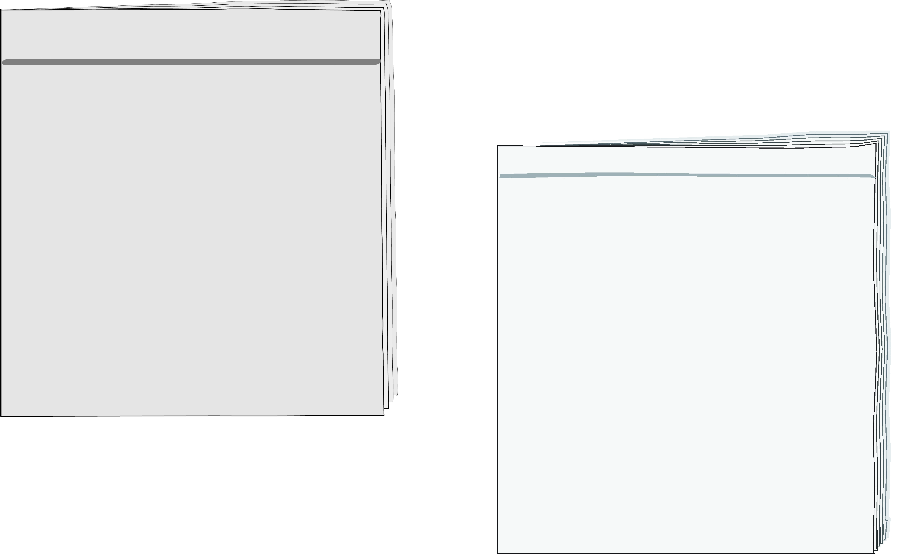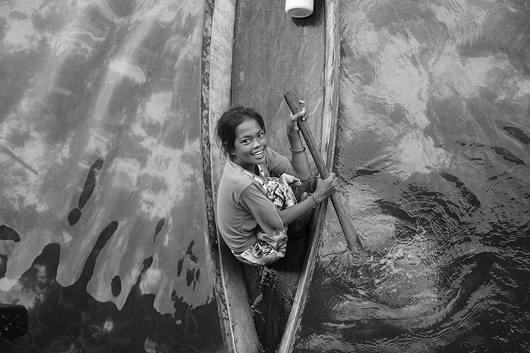
Around the World MagazineMarch, 2018

Hi, my name is Gita. I'm eleven years old. I don't live in a city
or a village like many other children. I live on a boat in the sea near India.
I don't walk or ride a bike to school because my school is on
a boat too. My friends and I swim to school every morning. At school we build boats together with our teacher. We also learn how to catch fish.
Every afternoon I help my parents catch fish. I'm a very good swimmer and can swim under water for a long time. Sometimes
I swim in very deep* water to catch big fish.
Tomorrow I'm going with my
family to the city for the first time.
I want to help my parents sell
fish in the market. I'm excited to
see the houses and shops there.
I hope we sell all the fish we have!
© Ra'uf Hussin/shutterstock.com

* deep – עמוקים

בחרו את התשובה הנכונה.
1. Where does Gita live?
a  near a market
b  in a village
c  on a boat
d  in a city

בחרו את התשובה הנכונה.
2. How does Gita get to school?
a  she walks
b  she swims
c  on a boat
d  on a bike

3. Tick (✓) the two correct answers. |  | 3. סמנו (✓) את שתי התשובות הנכונות.
What does Gita learn at school?
to catch fish
to swim fast
to buy fish
to build boats
to ride a bike

4. How does Gita help her parents?
Write two answers in English according to the text. |  | כתבו באנגלית שתי תשובות לפי  הטקסט.

1.
2.

בחרו את התשובה הנכונה.
5. What is a good name for the text?
a  My Big Fish
b  Water Girl
c  Swimming Alone
d  Living in the City

6. Circle Yes or No. |  | 6. הקיפו כן או לא.

Do you want to study in Gita's school? Yes / No

Explain your answer using information from the text. |  | הסבירו את תשובתכם בעזרת מידע מהטקסט.

