A SPECIAL TOWN
Read the following text.  Answer the questions in English according to the text. |  | קראו את הטקסט שלפניכם.  ענו באנגלית על השאלות לפי הטקסט.

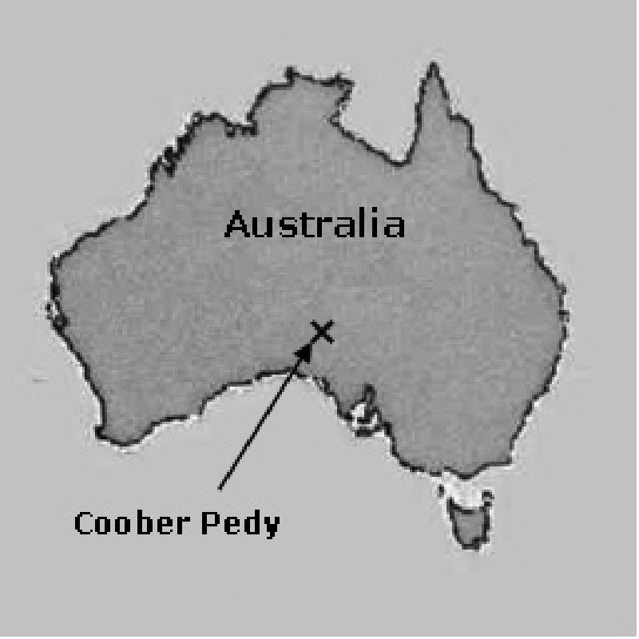
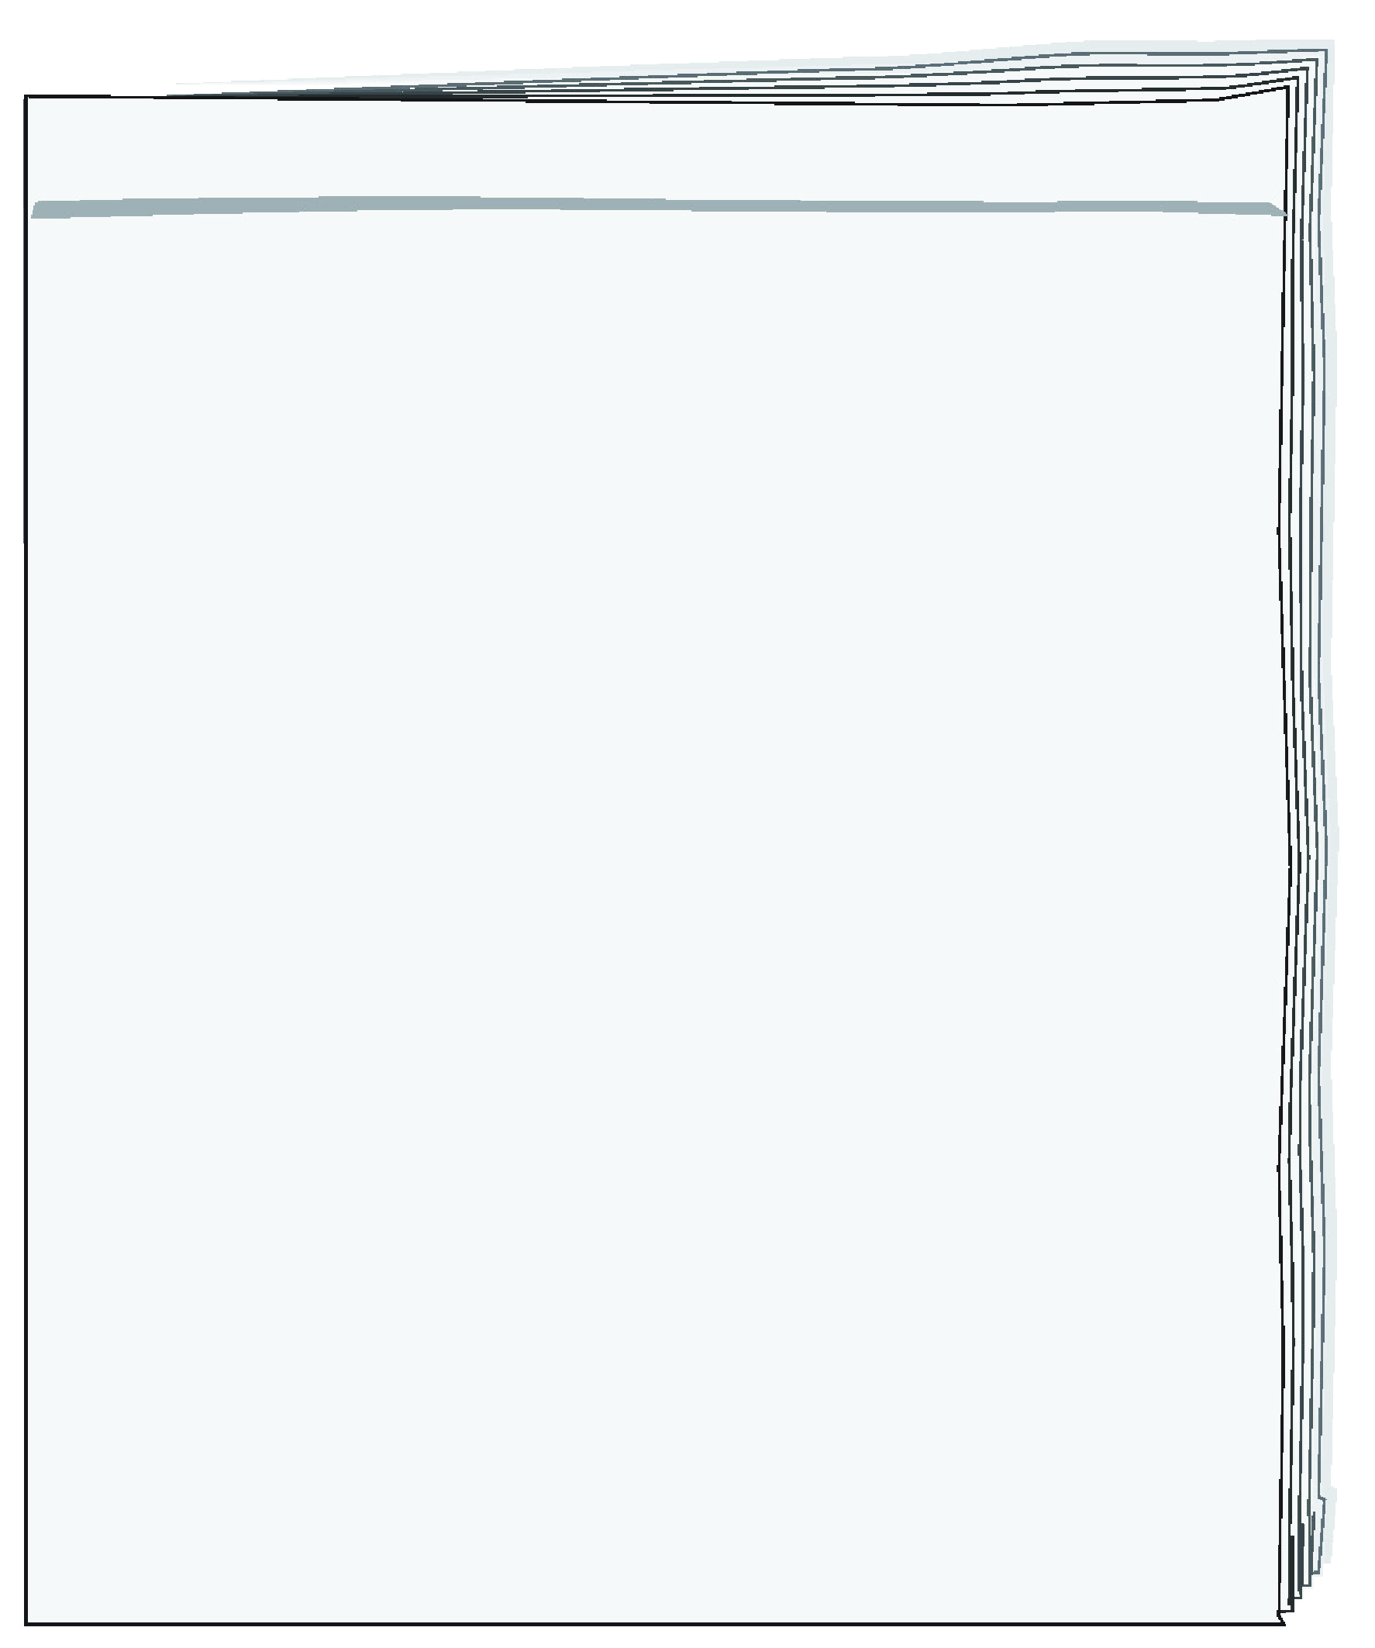
Amazing Places – Magazine for Kids March, 2017

A Special Town

I live in a small town in Australia called
Coober Pedy. When people come here
they are always surprised*. They do not see
any trees, houses or people. They feel the
hot air and see only sand. So where is the
town? The town is under your feet.
People take a train to go down to this
special town under the ground**.
In Coober Pedy people live under the ground because it is very hot outside. There are houses, schools, shops and parks, all under the ground.
People from all over the world like to visit Coober Pedy. They like to stay here at night because it is quiet, cool and dark – everything you need for a good sleep. Movie makers think this town under the ground is interesting. They come here to make movies. I think my town is great.

Ben
Coober Pedy, Australia
* surprised מופתע –
** ground – אדמה
שאלות Questions
בחרו את התשובה הנכונה להשלמת המשפט.
1. Coober Pedy is __.
a the writer of the text
b a beautiful store
c a place in Australia
d an interesting movie

בחרו את התשובה הנכונה.
2. Why are people surprised when they come to Coober Pedy?
a They think it is very small.
b It has a very special name.
c It is a beautiful place.
d They can’t see the town.

בחרו את התשובה הנכונה להשלמת המשפט.
3. Why do people in Coober Pedy build their houses under the ground?
Because they want to __.
a make movies
b live in Australia
c build a big town
d live in a cool place

4. Ben likes Coober Pedy.
Copy words that show this. |  | העתיקו מילים המראות זאת.

בחרו את התשובה הנכונה להשלמת המשפט.
5. Ben's text is in a magazine. The magazine is about __.
a special kids
b amazing places
c Coober Pedy
d underground towns

ענו באנגלית על השאלה.
6. How is Coober Pedy different from where you live? |  | 6. מה ההבדל בין Coober Pedy ובין מקום מגוריכם?

