
TECHNICAL PROPOSAL
Digital and Financial Capability Training for BISP Beneficiaries
DFLT Phase III: from wallet access to independent, safe and sustained use for 1,000,000 women
RFP reference | RFP No. 194, cross-referencing EOI Ref. 27
Issuing agency | Karandaaz Pakistan · Karandaaz Digital: Supporting G2P Digitization in Pakistan
Submitted by | Sustainable Development Policy Institute (SDPI), Center of Adaptive Social Protection & Economic Empowerment (CASPEE)
Proposed duration | 22 months
Submission | October 2026, Islamabad
Contact: fareehaarmughan@sdpi.org · (009251) 2278134
Contents
Executive Summary 1
1. Understanding of the Assignment and Context 1
1.1 The transition: from cash access to account use 1
1.2 The beneficiary universe and the barriers to use 1
1.3 Implications for design 1
2. SDPI’s Track Record and Evidence Base 1
2.1 What we did and how we did it in DFLT Phase II 1
2.2 What the Phase II data show about BISP women 1
2.3 What SDPI brings to Phase III 1
3. Component 1: Diagnostic, Curriculum Design and Capacity Building 1
3.2 Segmenting beneficiaries into actionable groups 1
4. Component 2: Roll-Out Planning and Go-to-Market Strategy 1
4.1 SDPI’s roll-out methodology and GTM architecture 1
4.2 Geographic allocation methodology 1
4.3 Cohort prioritisation methodology 1
4.4 Alignment with BISP payment cycles: tranche-anchored scheduling 1
4.5 Beneficiary outreach and mobilisation strategy 1
4.6 Blended Training Deployment Plan 1
4.7 Training deployment model 1
4.8 Behavioural reinforcement, quality assurance and governance 1
4.9 Risk management 1
5. Component 3: Field Implementation, Beneficiary Training and Behavioural Reinforcement 1
5.1 Delivering structured training to one million women 1
5.2 Deploying digital content in coordination with sessions 1
5.3 Onboarding readiness support 1
5.4 Integration with payment touchpoints: the Tranche Window Protocol 1
5.5 Sequenced behavioural reinforcement programme 1
5.6 Phase 1 pilot and course-correction methodology 1
6. Component 4: Monitoring, Reporting and Endline Assessment 1
6.1 Indicator framework mapped to the success measures 1
6.2 Baseline and endline assessment 1
6.3 Tracking training quality, participation and coverage 1
6.4 Measuring behavioural outcomes 1
6.5 Feedback loops 1
6.6 Reporting protocols 1
6.7 Data management, privacy and ethics 1
7. Work Plan, Deliverables and Payment Milestones 1
8. Level of Effort, Field Deployment and Activity Plan 1
9. Implementation Governance, Team and Quality Assurance 1
10. Innovation, Value Addition and Sustainability 1
Annex A: IVR Scripts 1
Annex B: SMS Nudge Sequence 1
Annex C: Methodological Notes 1

Abbreviations
Term | Meaning | Term | Meaning
BISP | Benazir Income Support Programme | IVR | Interactive Voice Response
CASPEE | Center of Adaptive Social Protection & Economic Empowerment, SDPI | LMA | Limited Mandate Account
DFLT | Digital and Financial Literacy Training | MEL | Monitoring, Evaluation and Learning
DRCA | Digital Readiness & Capability Assessment (task-based) | NSER | National Socio-Economic Registry
DTMF | Keypad tone input used in IVR quizzes | P2P | Person-to-person transfer
FI | Financial institution (bank, microfinance bank, EMI) | SSPA | Sindh Social Protection Authority
GRM | Grievance Redressal Mechanism | ToT | Training of Trainers
IC | Implementation Coordinator | USSD | Short codes dialled on any handset (e.g., *786#)

Executive Summary
Pakistan has crossed the supply-side threshold of G2P digitisation. More than eight million SIMs have been issued by the Benazir Income Support Program and, since July 2026, BISP Cash Grants are now being paid through digital wallets in the woman’s own name. Women in Pakistan remain 25% less likely than men to use mobile internet & Access without capability converts into agent dependency at the payment counter.
Every woman will move from Readiness to Capability (As per my comment; we have to devise the strategy, now as we are bidding we have to act that we don’t know what they want and we have to make the professionally that well divide each phase into 2 implementation advisories ( readiness & Capability) to an assisted first independent cash-out within one BISP payment cycle, and the 1,000,000 target will be sized, phased and resourced from the BISP beneficiary universe ( Instead of the Universe, this word isn’t good, like we have to use the super professional wording, you can write like the BISP Benefeciary database upwards (Section 4.1):
- Sized from the BISP universe. SDPI will distribute the target across Punjab, Sindh, Khyber Pakhtunkhwa and Balochistan in proportion to the 25.4 million households on BISP’s Beneficiaries Data Portal (54.6%, 25.5%, 15.8% and 4.1%), giving 546,343, 254,711, 158,280 and 40,666 women, (We don’t need to write the numbers here, just write directly the percentage that Punjab share will be this and so on because of the data portal sharing) delivered through eight zones: three in Punjab, two each in Sindh and Khyber Pakhtunkhwa, and one in Balochistan covering Quetta, Zhob, Hub and Chaman.
- Three phases anchored to BISP tranches. Phases of 250,000, 400,000 and 350,000 follow Karandaaz’s tranches ( Now this word isn’t correct? Karandaaz is giving money? Now what are the karandaaz tranches? ) , and each closes on a BISP payment: trainers staff Assisted Support Desks at payment points ( So as per our strategy there will be a lot of the payment touchpoints, now previously there were the tranches and there were the payment disbursement activities but as now a lot of benefeciaries have their digital wallet sim and now there’s no need of the camps, they can just go to any retaiker shop and get the payment out of their digital wallet now the real questions is that where do trainers sit ? at specific retaile shops? Or at their own tehsil pffoce for the bene tht are uneducated and can’t get their money out of it or for the complaints? So we have to devise the strategy or because this is the RFP, we don’t have to touch anything like I am giving a lot of details just for your context so you write better, and an IVR survey seven days later records whether the woman withdrew herself, entered her own PIN and received the full amount. ( So you are again confusing 2 things,
We are the SDPI, we can’t have a record because we aren’t in the BISP, we are the 3rd Party implementer and then now understand that because BISP issued the sims and they hd their first tranche and disbursements perfectly happene and now the BISP is now wanting to train the benefeciaries and Karandaaz is supporting this. And now we wanted to be the implementer

- One trainer, cohorts of 30, 16 sessions a month. The first month builds Readiness (a 150-minute session) and the second builds Capability (180 minutes). In Phase 1 each month is stretched to six weeks so that 250,000 women are trained within one quarter; Phases 2 and 3 run over four months each. The model requires 353, 419 and 368 trainers, a standing corps of 440 and one ToT in every zone. ( For the next month, now understand like we have to write the super professional and with a lot of clarity and now understand that we have 3 phases defined by the Karandaaz, and then we have the ToT first to train the Trainers thatll teach the benefeciaries, so what do you think how much trainers are required? Let’s say that you defined the propotion of Punjab to 50% now the target is 250,000 and the

- Five actionable segments defined by device access and functional literacy, pre-assigned from BISP data and confirmed at registration (Section 3.2). Each segment receives its own channel package, giving a national 72:28 physical-to-digital split that ranges from 68:32 in Punjab to 78:22 in Balochistan.
- A voice-first digital layer: about 14 IVR lessons with keypad quizzes per beneficiary, up to 18 SMS nudges from the trusted 8171 identity and WhatsApp video for smartphone users, all triggered automatically from attendance records.
- Continuous, verifiable reporting: geofenced attendance, CNIC verification, audio audits and a live dashboard, with WhatsApp notification reporting to Karandaaz and BISP, a 7,520-woman panel for baseline, midline and endline, and data feeds to the third-party MEL firm.
- Delivered by a team that has done it. In DFLT Phase II SDPI trained and verified 252,700 BISP women in ten months and has registered a further 275,229 under the SSPA chapter. The systems, trainer pool and evidence built there are ready on day one (Section 2).
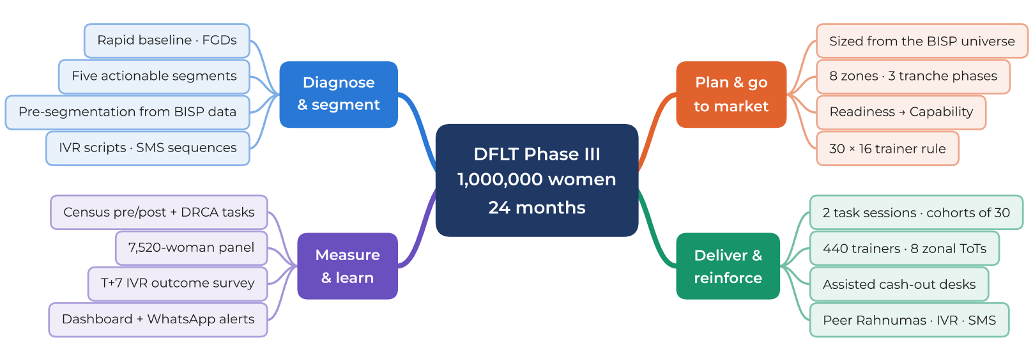
Figure 1: DFLT Phase III at a glance: the four components of SDPI’s proposal
Table 1: Proposal at a glance
Parameter | SDPI proposal
Methodology | BISP universe → provincial shares → 1,000,000 distributed → 8 zones → 3 tranche-anchored phases → Readiness and Capability cohorts → trainers and zonal ToTs → close at the payment counter
Beneficiaries and geography | 1,000,000 women · Punjab 546,343 · Sindh 254,711 · KP 158,280 · Balochistan 40,666 · 8 zones
Phasing | Phase 1: 250,000 (M6–M8) · Phase 2: 400,000 (M11–M14) · Phase 3: 350,000 (M17–M20) · tranche windows at M9, M15 and M21 · gate reviews at M9 and M15
Learning journey | Mobilise → Session A Readiness → reinforcement → Session B Capability → reinforcement → assisted cash-out at the next tranche → 90-day sustained-usage nudges
Field force | 440 trainers (419 at peak + 5% reserve) · 8 zonal ToTs · 36 ICs · 8 Zonal and 4 Provincial Coordinators · ≈33,000 Peer Rahnumas
Digital channels | ≈13.9 million IVR calls · ≈14.1 million SMS · ≈8.2 million WhatsApp video pushes · 8 zonal IVR nodes
Evidence and reporting | Census pre/post on app · task-based DRCA · 7,520-woman panel · post-disbursement IVR outcome survey · 3 learning reports · quarterly reports

1. Understanding of the Assignment and Context

1.1 The transition: from cash access to account use
BISP supports more than ten million families and has moved its quarterly instalment, raised to PKR 14,500 from January 2026, onto wallets opened in the beneficiary’s name with district-assigned partner institutions. The shift from Limited Mandate Accounts, which accepted only designated inflows and prohibited deposits and local transfers, to full-mandate accounts removes the supply-side ceiling on usage. It does not by itself change behaviour. Three features of the new system define what the training must achieve:
- The SIM is the account. BISP issues the SIM, the wallet is pre-provisioned and biometrically verified, and the beneficiary only has to keep and operate it. A lost, sold or surrendered SIM is a lost account; a shared PIN is shared cash.
- The agent counter is the moment of truth. With biometric ATMs scarce, cash-out happens at retail agents, where illegitimate deductions of PKR 500–1,000, PIN capture and false “biometric failure” claims are repeatedly reported in field work and BISP consultations.
- Functions open in stages. BISP and its partners link the enablement of wider wallet functions to enhanced DFLT and grievance redressal. Training is therefore part of the payment system’s risk architecture, not an add-on.

1.2 The beneficiary universe and the barriers to use
BISP’s Beneficiaries Data Portal (DLI-7) records 26.3 million beneficiary households, of which 25.4 million are in the four provinces covered by this proposal: Punjab 13.9 million, Sindh 6.5 million, Khyber Pakhtunkhwa 4.0 million and Balochistan 1.0 million. This universe is the starting point of SDPI’s allocation methodology (Section 4.1). The same portal describes the conditions in which women will learn and use their wallets: 58.8% of households live in a single room (67.6% in Sindh) and 20.4% have eight or more members (33.2% in Balochistan and 27.9% in Khyber Pakhtunkhwa). In such households a handset is rarely private, PIN entry is easily observed and decisions about money are taken jointly.
Three further constraints shape the design. The gender digital gap: women in Pakistan are 25% less likely than men to use mobile internet. Literacy: only one in five BISP women trained by SDPI could read and write, so no step of the training can depend on reading. Cash-out infrastructure: fewer than 6,000 of the country’s 16,000 ATMs are biometric, so the first independent withdrawal takes place at a retail agent. SDPI’s records from DFLT Phase II (Section 2.2) confirm the pattern within the BISP population: phone ownership is high, smartphone use on the woman’s own number is low, and before training only 4% of women had ever transacted on a wallet.

1.3 Implications for design
Five implications follow and run through every section of this proposal. First, the curriculum must be task-based and narrow: SIM custody, PIN and OTP secrecy, scam recognition, verification of the 8171 payment message, balance checks, zero-fee cash-out, transfers, bill payment, saving and grievance redressal. Second, the trust deficit is addressed by human contact first: every woman is onboarded in person at a BISP venue before digital reinforcement begins. Third, delivery must be differentiated by device access and literacy, not by geography alone, and voice rather than WhatsApp must carry most of the digital load. Fourth, the schedule must follow BISP’s payment calendar, so that a woman’s first independent withdrawal happens with support on hand. Fifth, as BISP’s leadership framed it in the technical working group, the programme must first make women ready for the Social Protection Wallet and then capable of using it. SDPI’s methodology maps those two steps onto each Karandaaz phase (Section 4.1), while the digital layer carries the broader financial-capability content advocated by development partners.

2. SDPI’s Track Record and Evidence Base
DFLT Phase III is the fourth step of a programme that SDPI has evaluated, designed or implemented at every stage (Figure 2). This section sets out what SDPI did in DFLT Phase II, how it did it and what the data show. Phase III does not repeat Phase II: SDPI will use the systems, trainer pool and evidence built there to start at national scale from the first month, while the roll-out itself is defined by the methodology in Section 4 and validated by the Phase III baseline (Section 3.1).
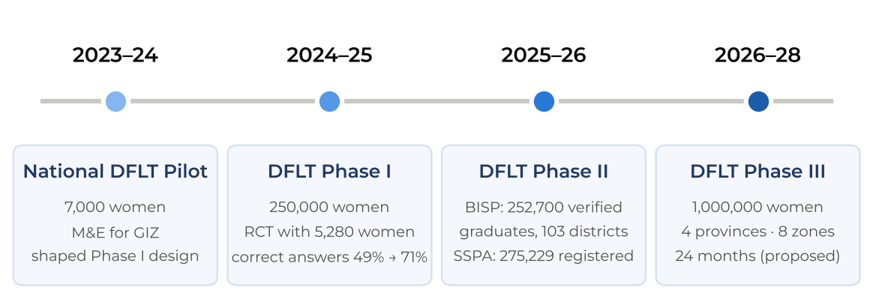
Figure 2: The DFLT evidence pathway, 2023–2028

2.1 What we did and how we did it in DFLT Phase II
BISP chapter (October 2025 – August 2026). SDPI delivered the national roll-out through a two-day classroom model at BISP tehsil offices in cohorts of 20–22 women. 237 trainers were hired on a merit framework agreed with BISP from 9,734 applicants and posted at 147 duty stations in 103 districts and 163 tehsils, plotted to a 50:50 urban–rural split. 272,570 women were registered and 252,700 verified as DFLT graduates, with the target achieved on 31 July 2026 and every graduate verified against the NSER. Delivery peaked at 45,675 registrations in April 2026 (Figure 3).
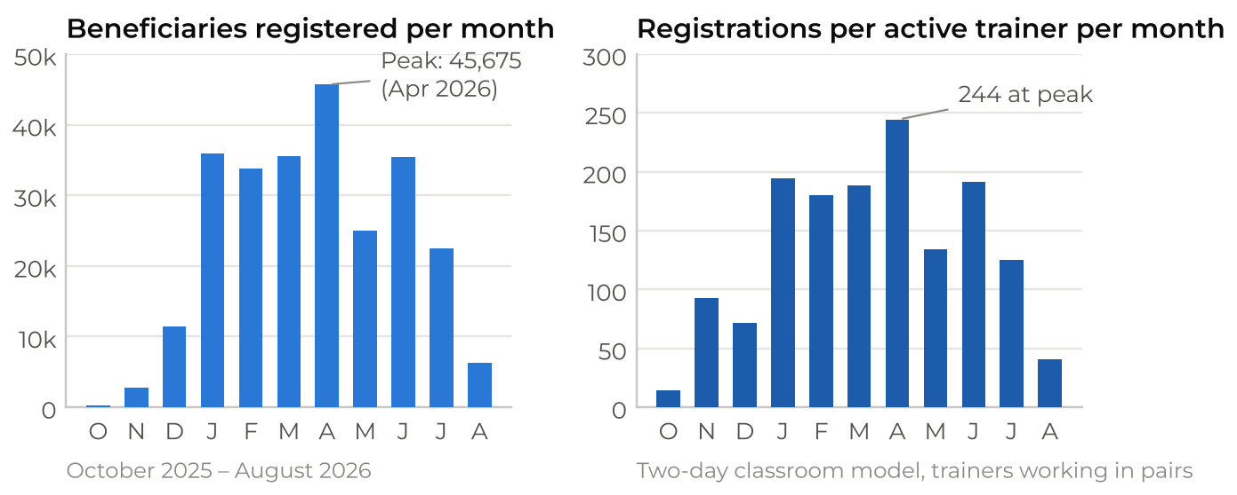
Figure 3: DFLT Phase II delivery: monthly registrations and productivity per active trainer
Source: SDPI DFLT Phase II database; 185–189 trainers were active in peak months.
SSPA chapter (Sindh). Under the Sindh chapter SDPI has registered 275,229 women by 1 October 2026: 148,718 agricultural women workers in the flood-prone districts (92.5% attendance) and 126,511 MAMTA beneficiaries (95.9% attendance), across 24,053 sessions at 5,896 mapped venues in 437 dehs of 65 talukas, supported by a university camp model of more than 600 trained students and 8,076 in-person IC monitoring visits.
Systems built in-house. The complete cycle ran on SDPI’s DFLT App: registration, attendance, teaching logs and pre/post tests, with geofencing that locks forms to a one-kilometre radius of the approved venue, live-camera-only Day-2 capture, and an OCR reader that matches the CNIC photographed on Day 2 to the CNIC registered on Day 1. Of 16,323 sessions, 13,753 carry audio audits and 9,453 were reviewed in full. Eleven coordinators at BISP headquarters made random video calls into live sessions, and a Node/Express dashboard with ten timestamp types gave BISP and GIZ same-day visibility. Classroom learning was reinforced by 13 animated videos pushed through the official WhatsApp Business API to 131,000 beneficiaries, announced in advance by an 8171 SMS.
Results. On the Day-1 instrument, correct answers rose from 49.5% to 70.8% (+21.3 percentage points; 25,584 pre-tests and 22,748 post-tests); recognition of 8171 as BISP’s official SMS code rose from 80.0% to 99.0%, and knowledge that money can be transferred from a feature phone from 70.0% to 80.6%. DFLT Phase I’s randomised evaluation (5,280 women, four treatment arms) found the largest effects where classroom training was combined with digital videos.

2.2 What the Phase II data show about BISP women
Registration records for 254,648 BISP women across 100 districts, cohort “show-of-hands” diagnostics for 130,040 women and 275,229 SSPA registrations form the largest recent profile of the target population (Figure 4).
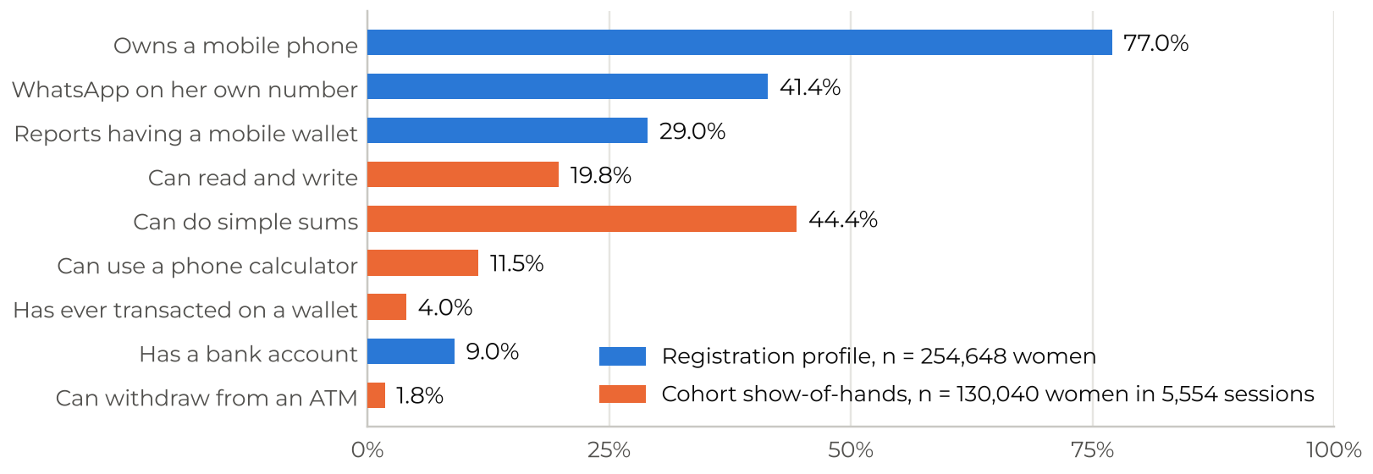
Figure 4: Baseline digital and financial capability of BISP women trained in DFLT Phase II
Source: SDPI DFLT Phase II database (extract of 7 August 2026); active registrations excluding records of terminated trainers; show-of-hands recorded by trainers at the start of each cohort.
The picture is one of access without use. Phone ownership is high in Punjab (82%) but falls to 64% in Balochistan and to 38% across the SSPA chapter’s rural districts (23% among agricultural women workers). WhatsApp on the woman’s own number, the practical marker of a usable smartphone, ranges from 50% in Punjab to 16% in Balochistan. Self-reported wallet ownership (29%) is seven times actual wallet use (4%), 63.9% of women have no formal schooling and 37.9% live in joint or extended households.
Applying the Phase III segmentation rule (Section 3.2) to these records shows how unevenly device access and literacy are distributed (Figure 5) and how learning differs between groups (Figure 6). Four findings inform the design as planning assumptions, to be re-estimated from the Phase III baseline: women reachable only by voice and text (segments C and D) are the largest group, so IVR rather than WhatsApp must be the backbone channel; Punjab can carry a heavier digital load, because its digitally ready share is three times that of the other provinces; women without their own phone learn least (post-test 66% and 64% against 73% for digitally ready women); and Balochistan, with the lowest baseline (40%) and the smallest gain (+13 points), needs a distinct approach.
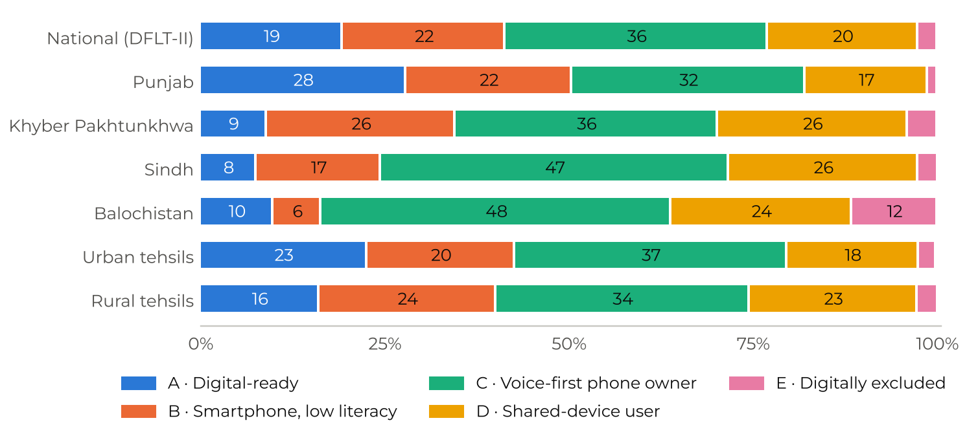
Figure 5: Segment composition of DFLT Phase II registrations, nationally, by province and by settlement type
Source: SDPI DFLT Phase II database. Tehsils classified as urban or rural by the administrative status of their main centre.
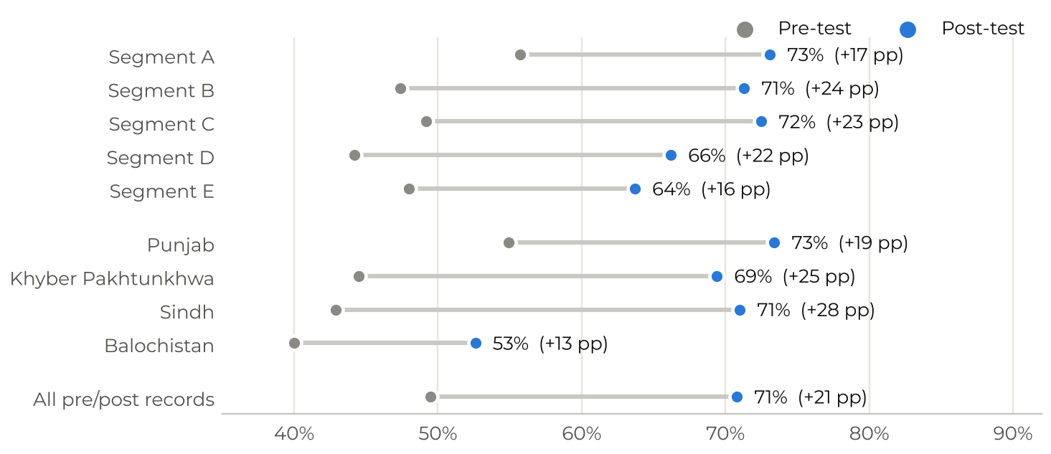
Figure 6: DFLT Phase II Day-1 knowledge score before and after training, by segment and province
Source: SDPI DFLT Phase II pre/post tests on the DFLT App (25,584 pre-tests; 22,748 post-tests), linked to registration profiles by CNIC.

2.3 What SDPI brings to Phase III
Table 2: DFLT Phase II evidence and how SDPI will use it in Phase III
DFLT Phase II evidence | How SDPI will use it in Phase III
Two full training days capped throughput at about 244 registrations per trainer-month, and audio reviews show that trainers compressed or skipped sections in most sessions. | Two short, single-purpose sessions a month apart; one trainer per cohort of 30; 16 sessions per trainer per month; digital channels carry repetition.
Device access varies sharply: WhatsApp on own number is 50% in Punjab and 16% in Balochistan; phone ownership is 23% among Sindh agricultural women. | Five-segment model with differentiated channel packages and provincial modality splits (Section 3.2).
Knowledge is not behaviour: 89% know an agent may not deduct a fee, yet deductions persist at the counter. | Role-play of the counter conversation, mock POS practice, and trainers deployed at payment points in every tranche window.
Wallet ownership is not use: 29% report a wallet, 4% have ever transacted. | An assisted first transaction in Session B and a schedule anchored to the next BISP tranche.
The official 8171 identity drives trust: recognition reached 99% after training. | All SMS and IVR content branded through BISP’s 8171 identity, never through unknown numbers or links.
A tested field stack: DFLT App, geofencing, CNIC OCR, audio audits, live dashboard and a pool of 649 trained facilitators. | Deployed from Month 1 and extended with IVR telephony, WhatsApp notification reporting and a pre-verified venue registry.

3. Component 1: Diagnostic, Curriculum Design and Capacity Building
Under this component SDPI will establish the evidence, content and trainer capacity on which the roll-out depends. Sections 3.1 and 3.3–3.9 are prepared by SDPI’s curriculum and capacity-building team; Section 3.2 sets out how SDPI will segment beneficiaries and the digital content (IVR scripts and SMS nudge sequences) that links the diagnostic to differentiated channel deployment.
[Content team input] 3.1 Rapid baseline assessment
Scope to cover: diagnostic methodology and tools; focus group discussions with women and with men of beneficiary households; use of DFLT Phase I and Phase II data; device-access and connectivity profiling; gender constraints (mobility, trust, household dynamics). The segmentation in Section 3.2 consumes the outputs of this assessment.

3.2 Segmenting beneficiaries into actionable groups
A segment is useful only if it changes what happens to a woman: which channel reaches her, which format she can learn from, how much human contact she needs, and who must be involved for her to act. SDPI therefore segments on the two variables that determine reach and learnability (device access and functional literacy) and treats geography, wallet experience, household structure and age as overlays that adjust dosage. Geography alone would misallocate effort: in SDPI’s Phase II records, rural and urban tehsils differ by only 6.5 percentage points in the share of digitally ready women, while provinces differ by a factor of three (Section 2.2).

3.2.1 Segmentation rule
SDPI will assign segments in three steps that use Phase III data rather than historical averages:
- Pre-segmentation from BISP data. At inception SDPI will request, under the data-sharing protocol, each listed woman’s Benazir SIM and wallet-activation status and her NSER education, household-size and disability fields, so that a provisional segment is known before mobilisation and selects the invitation channel.
- Validation in the rapid baseline. The baseline and FGDs (Section 3.1) test the thresholds, in particular whether primary schooling is the right literacy cut-off and how shared handsets are used, and fix the final rule before the D3 content package.
- Confirmation at registration. Five questions on the DFLT App, answered in under three minutes, confirm or correct the provisional segment and assign the channel package automatically (Figure 7).
The rule is deliberately simple so that it can be applied in the field, audited and reproduced by the third-party MEL firm.
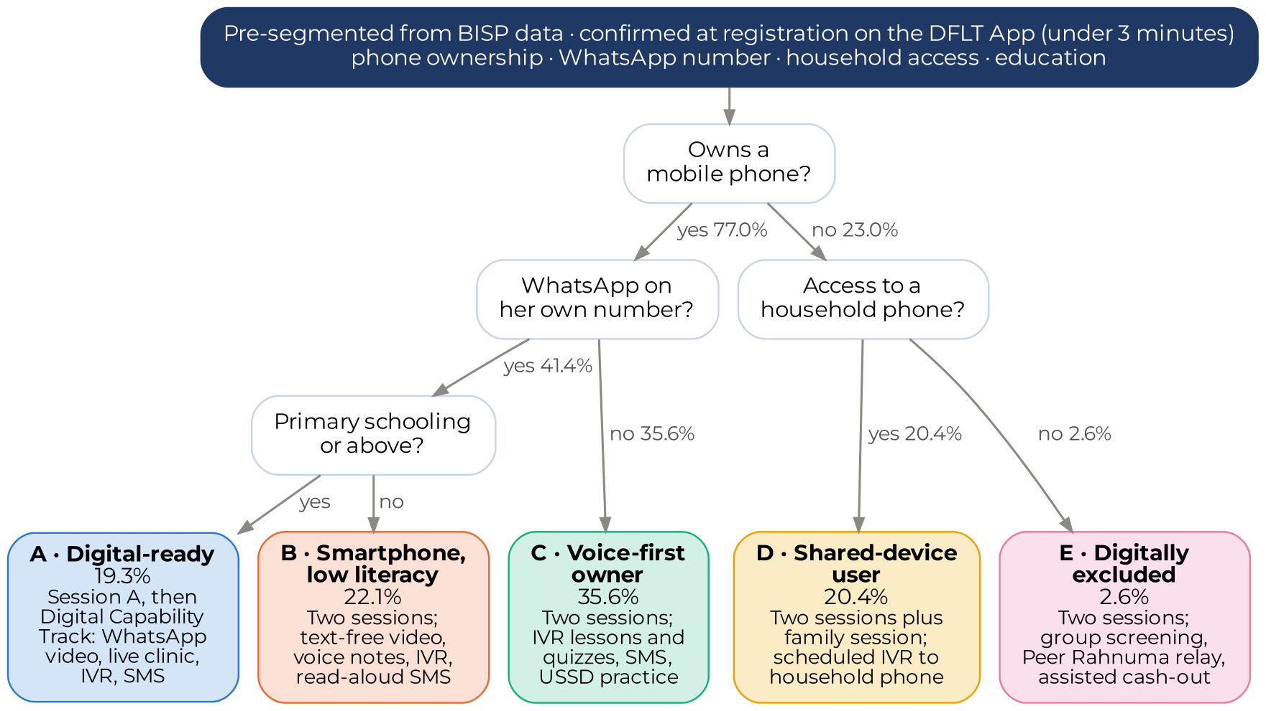
Figure 7: Segmentation decision rule and the resulting channel package
Shares are planning priors from 254,648 DFLT Phase II registrations and will be replaced by Phase III baseline and registration data. “Primary schooling or above” excludes religious-only education.
A literacy threshold set at matric, which has been suggested for a digital-first stream, would admit only about one beneficiary in nine (11.3% in SDPI’s Phase II profiles). The device-plus-primary-schooling rule identifies about one woman in five as digitally ready and a further fifth who hold a smartphone but need text-free formats, giving a usable digital audience of about 40% without lowering standards.

3.2.2 The five segments
Table 3: Beneficiary segments, planning shares and SDPI’s training response
Segment and definition | Planning share | Training and channel response
A · Digital-ready: owns a phone, WhatsApp on her own number, primary schooling or above | ≈19% (Punjab ≈28%, Sindh ≈8%); most likely to hold a wallet or bank account already | Session A in person, then a Digital Capability Track replacing Session B: WhatsApp video, two live digital clinics, IVR quizzes, e-guide and wallet simulator. Recruited as Peer Rahnumas.
B · Smartphone, low literacy: owns a phone with WhatsApp but no formal schooling | ≈22%; almost all without formal schooling; majority rural | Both sessions in person; text-free animated video, trainer voice notes, IVR, SMS read aloud by a family member; one live clinic.
C · Voice-first owner: owns a phone without WhatsApp on her number | ≈36% (Sindh and Balochistan ≈47%); WhatsApp often available elsewhere in the household | Both sessions in person with USSD practice on her own handset; IVR is the backbone channel (weekly lessons with keypad quizzes) supported by SMS.
D · Shared-device user: no phone of her own, access to a household phone | ≈20% (Khyber Pakhtunkhwa and Sindh ≈26%); majority rural | Both sessions plus a 30-minute family session; IVR scheduled to the household phone at her preferred time and addressed to her; Peer Rahnuma follow-up.
E · Digitally excluded: no phone and no household access | ≈3% nationally, ≈12% in Balochistan | Both sessions; group screening of videos at the venue; Peer Rahnuma relay; priority for assisted cash-out at the tranche window.
Planning shares are priors from SDPI’s DFLT Phase II profiles (Section 2.2). They are used only to size channel volumes until the Phase III baseline and the first month of registrations replace them.
Two design consequences hold under any plausible segment mix. IVR, not WhatsApp, is the backbone channel, because women who can be reached only by voice and text form the largest group. Women without their own phone (segments D and E) receive more human contact: a family session, Peer Rahnuma follow-up and priority at the payment desk.

3.2.3 Keeping segmentation live
Segments are not fixed labels. SDPI will add three registration fields for Phase III: whether the BISP SIM is in her own handset and active, whether her wallet is activated and PIN-set, and her preferred language and call-time window. A woman is re-assessed at Session B and can migrate, for example from D to C when she acquires a phone, or from B to A when she completes the video track. Cohorts are mixed, not streamed: every cohort combines segments so that segment A and B women can be nominated as Peer Rahnumas for their neighbours, and only the digital track for segment A runs separately. Segment assignment drives four automated actions in the MIS: the channel package, the IVR call window, the language of audio content and the follow-up priority for trainers.

3.2.4 Differentiated channel deployment
Table 4: Planned dosage by segment across the 22-week journey
Channel (unit) | A | B | C | D | E
In-person sessions (A 150 min · B 180 min) | Session A | A + B | A + B | A + B + family | A + B + Rahnuma visit
IVR lessons and quizzes (≈3 min each) | 8 | 14 | 18 (+3 quiz) | 14 (household phone) | via Rahnuma
SMS nudges (8171 identity) | 18 | 10 | 18 | 10 | —
WhatsApp micro-videos (≤ 2 MB) | 14 | 14 | household where available | household where available | group screening
Live digital clinics (45 min group call) | 2 | 1 | — | — | —
Resulting digital share of contact time | 56% | 31% | 21% | 14% | 8%
The split follows from what each segment can receive rather than from a fixed ratio. Applied to the planning segment mix it gives a national 72:28; SDPI will recompute it from the Phase III baseline at inception and from live registrations at each gate. Section 4.6 shows how it varies by province and connectivity band.

3.2.5 IVR scripts and SMS nudge sequences
The digital content is written for women who cannot read, may be listening on someone else’s phone and distrust unknown callers. Seven design rules apply to every script:
- Trusted identity: SMS are dispatched through BISP’s 8171 channel (with a PTA-registered masked sender as fallback) and IVR calls present a whitelisted caller ID announced in Session A; no message ever contains a link or asks for a PIN, OTP or CNIC number.
- One behaviour per contact: each IVR call lasts 60–150 seconds, opens with a short drama in a female voice, states one rule and tests it with a keypad question that gives corrective feedback.
- Shared-phone safe: calls open with “if this phone belongs to someone else, please hand it to her”, and content is written to be heard in front of family members.
- Localised audio: Urdu master scripts are recorded in Punjabi, Saraiki, Pashto, Sindhi and Balochi/Brahvi, the languages in which sessions are actually conducted.
- Two-segment SMS: Urdu Unicode SMS are kept within 134 characters (two segments), with variables for date, venue, bank-specific USSD code and helpline.
- Timed to behaviour: messages are scheduled against the training date and the BISP tranche date, not a fixed calendar.
- Measurable and opt-out: every call logs answer, listen-through, keypad responses and replays; pressing 8 stops further calls.
Table 5: IVR library (full scripts in Annex A)
Code | Title and timing | Segments | Target behaviour | Data captured
IVR-1 | Your SIM is your bank account · Day 1 after Session A | A–D | Keep the SIM in her own handset; never hand it over | Reach, identity check, quiz
IVR-2 | Your PIN, your secret · Day 7 | A–D | Refuse PIN/OTP requests; avoid guessable PINs | Quiz accuracy, replay
IVR-3 | Three checks at the counter · Day 2 after Session B | A–D | Own PIN, full amount, read the 8171 message; refuse deductions | Quiz, helpline replay
IVR-4 | Payment is coming · T−3 days | A–D | Wait for the 8171 message; know where help is | Help-request callbacks
IVR-5 | Did you receive your full amount? · T+7 days | A–D | Self-report and complaint registration | Outcome indicators, GRM tickets
IVR-6 | Missed-call helpline · always on | All | Replay lessons, balance-check help, report fraud | Inbound demand by topic
IVR-7 to 9 | Sending money and paying bills; saving in the wallet; my money, my decision | A–D | Use cases beyond cash-out; women’s control of their account | Quiz, self-reported use
Sample: IVR-3, “Three checks at the counter” (Urdu master; English rendering in Annex A).
Node | Prompt (Urdu) | Logic
Drama | ایجنٹ: باجی، آپ کی قسط آ گئی ہے، پانچ سو روپے کٹیں گے۔ خاتون: نہیں بھائی، یہ سرکاری رقم ہے، اس میں کوئی کٹوتی نہیں ہوتی۔ پن میں خود لگاؤں گی اور پوری رقم لوں گی۔ | 45 seconds; two female and one male voice
Rule | رقم نکلواتے وقت تین باتیں یاد رکھیں: پن خود لگائیں، پوری رقم گن کر لیں، اور فون پر آنے والا پیغام دیکھیں۔ | Played twice
Quiz | اگر ایجنٹ پیسے کاٹے تو آپ کیا کریں گی؟ خاموش رہنے کے لیے 1 دبائیں۔ انکار کر کے شکایت کرنے کے لیے 2 دبائیں۔ | 2 → praise; 1 → corrective message, ask again
Help | شکایت کے لیے {ہیلپ لائن} پر کال کریں یا اپنے بی آئی ایس پی تحصیل دفتر جائیں۔ نمبر دوبارہ سننے کے لیے 5 دبائیں۔ | 5 → repeat; 8 → opt out

Table 6: SMS nudge sequence linked to the beneficiary journey (full Urdu text in Annex B)
Stage | Codes and timing | Purpose and behavioural lever
Mobilise | M1 (T−3), M2 (T−1 evening) | Invitation from a trusted sender; reminder to bring CNIC and the Benazir SIM phone; “training is free” to counter fee fears
Readiness | R1 (Day 0, within 2 hours) · R2 (Day 2) · R3 (Day 5) · R4 (Day 9) · R5 (Day 14) · R6 (3 days before Session B) | Salience of the SIM/PIN rule; 8171 as the only genuine sender; first self-performed balance check with a bank-specific USSD code; scam-call script; SIM activity; commitment to return
Capability | C1 (Day 0) · C2 (Day 3) · C3 (Day 7) · C4 (Day 12) | Reinforce the three counter checks; zero-deduction rule with helpline; safe transfers; small savings left in the wallet
Tranche window | T1 (T−3) · T2 (payment day) · T3 (T+6) · T4 (on complaint) | Wait for 8171 confirmation; three checks and help-desk location; prime the IVR outcome survey; closed-loop GRM ticket with 72-hour response
Sustained use | S1 (+30 days) · S2 (+60 days) · T1 before the next tranche · F1 (fraud alerts as needed) | One self-performed transaction a month; a true local social norm (“x% of trained women in your district withdrew themselves”); rapid warnings on new scam patterns
Sample messages (each within two Unicode segments):
Code | Urdu text | English meaning
R1 | تربیت میں شرکت کا شکریہ۔ یاد رکھیں: اپنی سم اور پن کسی کو نہ دیں، ایجنٹ کو بھی نہیں۔ | Thank you for attending. Remember: never give your SIM or PIN to anyone, not even the agent.
R2 | بی آئی ایس پی کے پیغامات صرف 8171 سے آتے ہیں۔ کسی اور نمبر سے انعام یا رقم کا پیغام دھوکہ ہے۔ | BISP messages only come from 8171. A prize or payment message from any other number is fraud.
T1 | آپ کی قسط جلد آپ کے والیٹ میں آئے گی۔ 8171 کا پیغام آنے کے بعد ہی ایجنٹ کے پاس جائیں۔ | Your instalment will reach your wallet soon. Go to the agent only after the 8171 message arrives.
C2 | ایجنٹ کو آپ کی رقم سے کٹوتی کا کوئی حق نہیں۔ کٹوتی ہو تو {ہیلپ لائن} پر شکایت کریں۔ | The agent has no right to deduct from your money. If he does, complain to {helpline}.
All scripts are submitted with the D3 content package for Karandaaz and BISP approval; the content team integrates them with the curriculum and gender-intentional modules (Sections 3.3–3.7). The helpline and GRM routing will be confirmed with BISP at inception.
[Content team input] Sections 3.3 to 3.9
3.3 Task-based, action-oriented curriculum and learning-outcome variables · 3.4 Localisation across languages, literacy levels and regional norms · 3.5 Blended content package (facilitator and trainer guides, participant booklets and job aids, flyers, demonstration toolkits and simulations; short videos, digital media and e-guides) · 3.7 Gender-intentional content · 3.8 Training of Trainers and certification of at least 1,200 BISP master trainers (coordinated with the UN Women-led track to avoid duplication) · 3.9 Peer educator model.
Interfaces fixed by this proposal: two sessions (150 and 180 minutes); cohorts of 30; segment-specific formats (Table 3); IVR and SMS library (Tables 5 and 6); Peer Rahnuma role (Section 5.5); zonal ToT schedule, one ToT in each of the eight zones (Section 4.7).

4. Component 2: Roll-Out Planning and Go-to-Market Strategy
SDPI’s go-to-market (GTM) strategy is built from the BISP beneficiary universe upwards. Every number in this section follows from four parameters (provincial shares, a cohort of 30, 16 sessions per trainer per month and the length of each phase), so the plan can be recomputed whenever BISP or Karandaaz changes one of them and will be recalibrated at each gate from the data described in Section 6.

4.1 SDPI’s roll-out methodology and GTM Strategy
SDPI will convert the national target into provinces, zones, phases, cohorts, trainers and payment windows in eight steps (Figure 8). Steps 1 to 4 size the work, steps 5 and 6 schedule it against BISP’s payment cycle, and steps 7 and 8 resource the field force and close each phase at the payment counter.
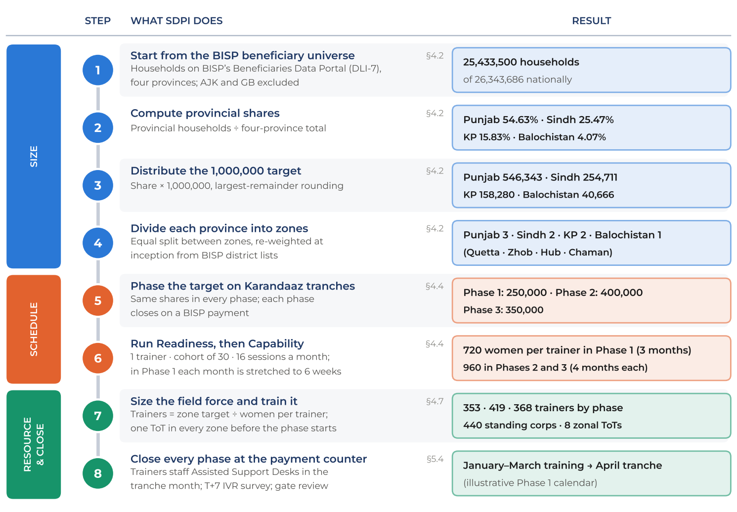
Figure 8: SDPI’s DFLT Phase III roll-out methodology in eight steps
Section references show where each step is detailed. Trainer numbers are rounded up zone by zone.
Worked example: Punjab in Phase 1
Steps 1–3. Punjab holds 13,895,420 of the 25,433,500 households in the four provinces (54.63%), so it receives 136,586 of the 250,000 women in Phase 1.
Step 4. The provincial figure is divided between North, Central and South Punjab: 45,529 women per zone.
Steps 5–6. A trainer runs 16 sessions a month for cohorts of 30. In Phase 1 Readiness runs for six weeks (24 cohorts, 720 women) and Capability for the next six weeks with the same women, so each trainer graduates 720 women in the quarter.
Step 7. 45,529 ÷ 720 = 63.2, rounded up to 64 trainers per zone and 192 in Punjab, each zone trained in its own zonal ToT.
Step 8. With training from January to March, the same 192 trainers staff Assisted Support Desks across Punjab during the April tranche, and the T+7 IVR survey feeds the Phase 1 gate review.

The roll-out runs on two branches at once. The phased branch follows Karandaaz’s tranches of 250,000, 400,000 and 350,000 beneficiaries, each closed by a quality gate. The regional branch distributes every phase across eight zones in all four provinces (three in Punjab, two each in Sindh and Khyber Pakhtunkhwa and one in Balochistan), each run from a zonal hub with its own coordinator. Phase 1 therefore functions as a pilot in every geography rather than in two or three provinces: course corrections at the Month 9 gate are based on evidence from urban, peri-urban, rural, conservative and low-connectivity tehsils alike, and no province enters the 400,000-beneficiary scale-up untested.
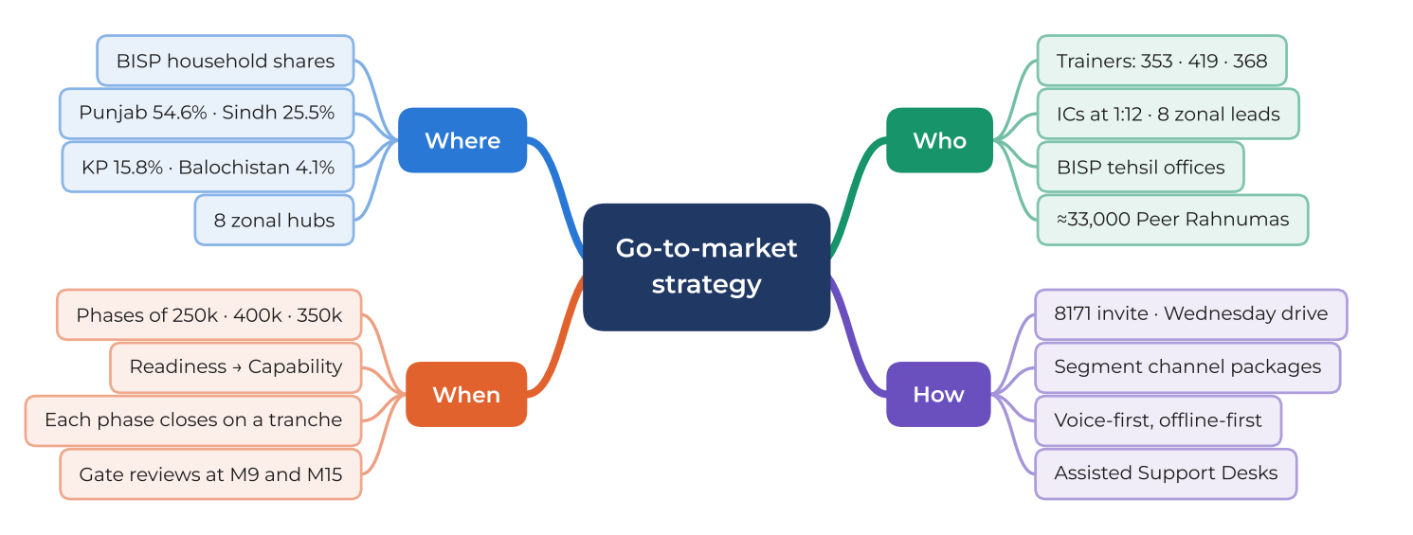
Figure 9: Go-to-market strategy: where, when, who and how

4.2 Geographic allocation methodology
SDPI will distribute the national target in proportion to the household distribution of the NSER population in the four provinces, as published on BISP’s Beneficiaries Data Portal (DLI-7). Azad Jammu and Kashmir and Gilgit-Baltistan are excluded; Islamabad Capital Territory (190,619 households) will be served from the North Punjab hub within the agreed national total. Provincial shares are applied identically to each phase and split equally between zones, and will be re-weighted at inception using BISP’s district beneficiary lists (Figure 10, Table 7).
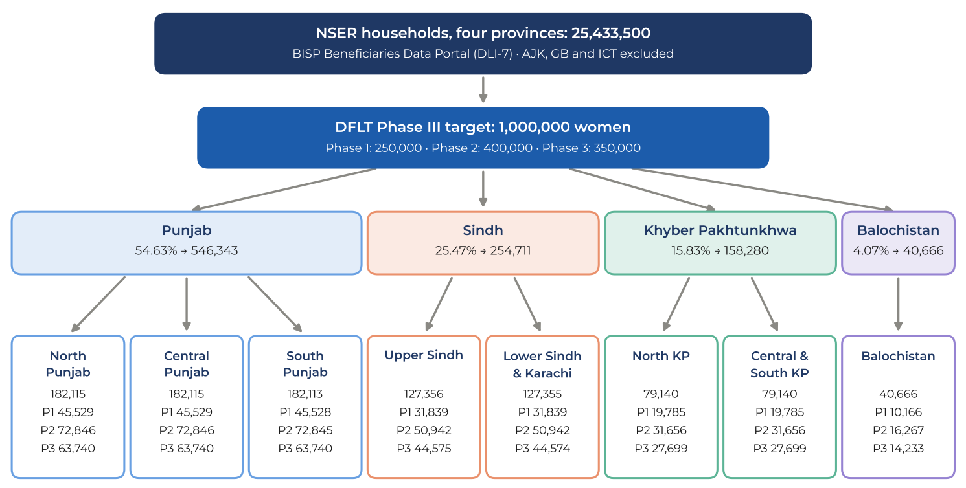
Figure 10: Allocation cascade from NSER households to provinces and zones
Zone figures show the total and the Phase 1 · Phase 2 · Phase 3 split.

Table 7: Provincial allocation of the 1,000,000 target by phase
Province | NSER households | Share | Phase 1 | Phase 2 | Phase 3 | Total | Zones
Punjab | 13,895,420 | 54.63% | 136,586 | 218,537 | 191,220 | 546,343 | 3
Sindh | 6,478,200 | 25.47% | 63,678 | 101,884 | 89,149 | 254,711 | 2
Khyber Pakhtunkhwa | 4,025,592 | 15.83% | 39,570 | 63,312 | 55,398 | 158,280 | 2
Balochistan | 1,034,288 | 4.07% | 10,166 | 16,267 | 14,233 | 40,666 | 1
Total | 25,433,500 | 100% | 250,000 | 400,000 | 350,000 | 1,000,000 | 8
Source: BISP Beneficiaries Data Portal (dli7.bisp.gov.pk), HH Size Summary, accessed 8 October 2026; allocation by largest-remainder rounding.

4.3 Cohort prioritisation methodology
Within each zone, SDPI will bring tehsils into each phase in an order set by a Tehsil Sequencing Index that combines readiness, need and feasibility (Table 8). The underlying logic is a simple theory of change: training produces behaviour only where the woman already holds a live wallet and will receive a payment soon, so readiness gates entry, need sets priority among ready tehsils, and feasibility determines the delivery mode rather than exclusion.
Table 8: Tehsil Sequencing Index
Dimension | Indicator and source | Use in sequencing
Readiness (gate) | Share of beneficiaries with Benazir SIM issued and wallet active (BISP); tranche paid on wallet rails | Tehsils enter a phase only when wallet issuance is substantially complete
Need | Beneficiary density (NSER households); share of segments D and E (BISP SIM and wallet data, baseline estimates); share never trained under DFLT I or II | Higher need moves a tehsil earlier among ready tehsils
Representativeness (Phase 1) | Urban, peri-urban and rural mix in every zone; at least one low-connectivity and one conservative tehsil per zone | Ensures the pilot tests every context
Feasibility | Venue availability at BISP offices and Nashonuma centres; security advisories; connectivity band | Sets delivery mode and support level; hard-to-reach tehsils are concentrated in Phase 3 as the RFP requires
De-duplication | CNIC match against about 548,000 women already trained under DFLT Phase II (BISP and SSPA chapters) | Previously trained women are excluded from the target and offered digital refreshers only
Within a tehsil, women whose wallets are active but who have not yet transacted independently are mobilised first if BISP can provide a data for the specific tehsils, followed by newly enrolled beneficiaries. Women above 60 and those with disabilities are routed to the assisted protocol of segments D and E irrespective of device access.

4.4 Alignment with BISP payment cycles: tranche-anchored scheduling
BISP pays quarterly. SDPI will therefore schedule each phase backwards from a tranche date so that the woman’s Capability session ends shortly before the payment she will withdraw herself, with SDPI trainers deployed at payment points during the window. In Phase 1 the one-month Readiness and Capability blocks are stretched to six weeks each, which fits the 250,000 target into one quarter while keeping trainer numbers stable. Phases 2 and 3 run over four months in two waves (four weeks of Session A followed by four weeks of Session B for each wave), with the mid-phase tranche supported on Wednesdays and Saturdays. Table 9 shows the cycle using January as an illustrative start of the roll-out; actual dates are fixed at inception against BISP’s confirmed tranche calendar.

Table 9: Tranche-anchored roll-out calendar (illustrative start in January)
Illustrative month | Project month | Activity
January – mid-February | M6–M7 | Phase 1 Session A (Readiness): each trainer runs 24 cohorts of 30
Mid-February – March | M7–M8 | Phase 1 Session B (Capability): the same cohorts return after about six weeks
April | M9 | BISP tranche: 10–14-day assisted cash-out window · T+7 IVR outcome survey · D6 Phase 1 review and Learning Report 1
May | M10 | Course correction, refresher ToT, top-up recruitment, Phase 2 mobilisation
June – September | M11–M14 | Phase 2 in two waves; July tranche supported mid-phase
October | M15 | BISP tranche: Phase 2 assisted cash-out · D8 midline and Learning Report 2
November | M16 | Phase 3 preparation in hard-to-reach tehsils
December – March | M17–M20 | Phase 3 in two waves; January tranche supported mid-phase
April | M21 | BISP tranche: Phase 3 assisted cash-out · Learning Report 3
May – July | M22–M24 | 90-day sustained-usage window (July tranche), endline, final evaluation and hand-over

4.5 Beneficiary outreach and mobilisation strategy
BISP provides beneficiary lists, venues and the authority of its tehsil offices. The mobilisation sequence builds trust before it asks for time:
- Incremental lists. BISP shares tehsil lists in batches aligned with the monthly plan; the DFLT App requests the next batch automatically when the current one is 30% depleted.
- Trusted invitation. An 8171 SMS three days before the session and an IVR reminder the evening before (M1, M2), naming the BISP venue and stating that training is free.
- Wednesday mobilisation day. Trainers work with BISP Assistant Directors, Benazir Nashonuma staff, to confirm cohorts, follow up non-responders by phone and invite male household members where gate-keeping is likely.
- Payment-point pipeline. During each tranche window, Assisted Support Desks register untrained women for the next phase, turning the payment queue into the next mobilisation list.

4.6 Blended Training Deployment Plan
This section responds to sub-section 3A of the RFP. SDPI’s operating principle refines “reach through digital, reinforce through human” for this population: onboard through human contact, then reinforce and scale through digital channels, and return to human support at the payment counter. Digital channels are used for awareness before training, but no woman is expected to begin learning from a cold call or an unsolicited video.

(i) Physical-to-digital split by segment and geography
So, we decided not to go with this, we decided that we would be going through full digital and full physical
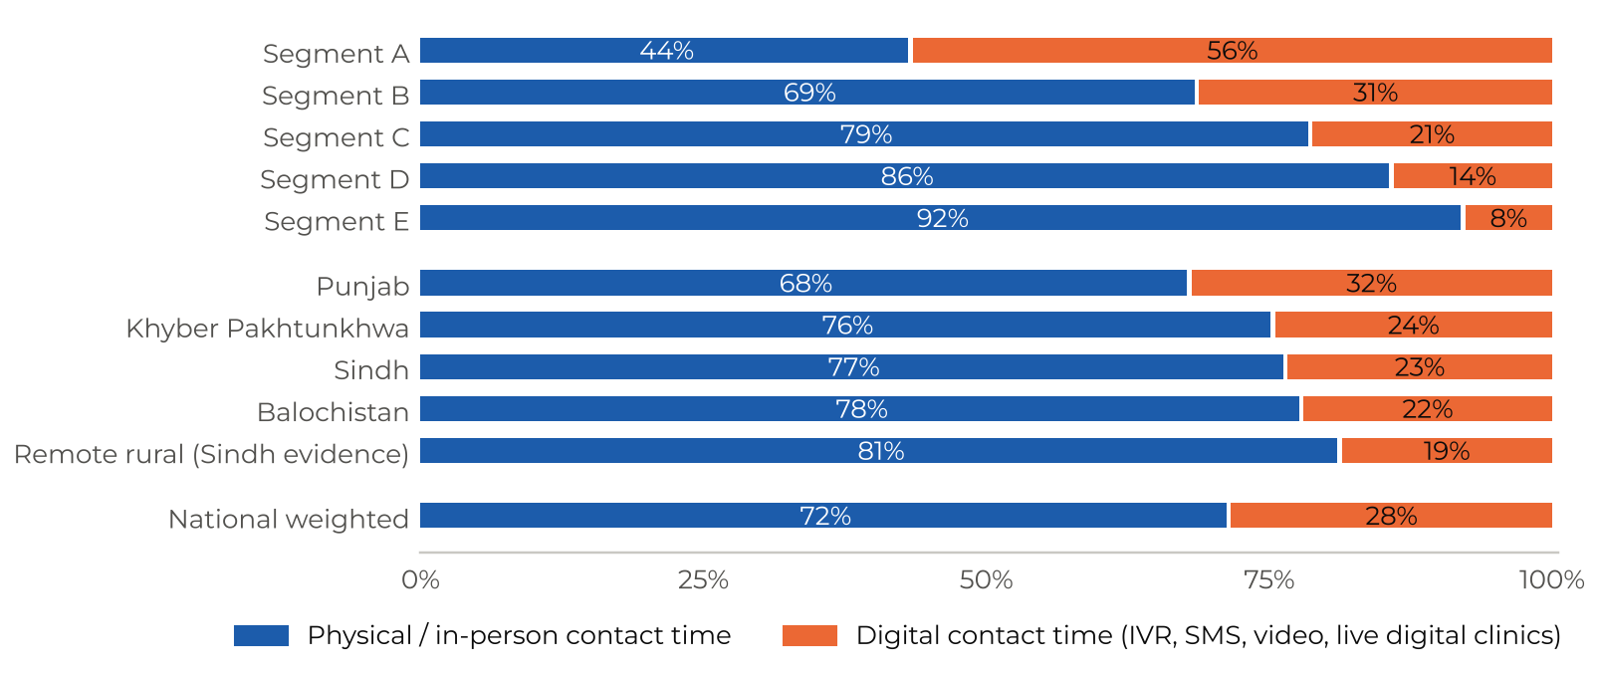
Figure 11: Proposed physical-to-digital split of contact time by segment and geography

(ii) Channel-to-content map
Table 10: Training content mapped to delivery channels (P = primary channel · R = reinforcement)
Content | Sessions | Demo kit / simulator | Video (venue · WhatsApp) |  | IVR | SMS | Print job aid | Peer / family | Payment desk
Awareness and invitation
SIM custody and activity
PIN and OTP secrecy
Scam recognition; 8171 verification
Balance check (USSD or app)
Zero-fee cash-out; three counter checks
Transfers and bill payment
Saving in the wallet
Grievance redressal
Household dynamics; her control of her account

(iii) Sequencing across the beneficiary journey
Figure 12 shows how physical, voice, smartphone, community and data touchpoints interact from mobilisation to sustained use. Digital awareness precedes the session; reinforcement is triggered automatically within two hours of the attendance record; and the journey closes at the tranche window and the 90-day mark, when sustained usage is measured.
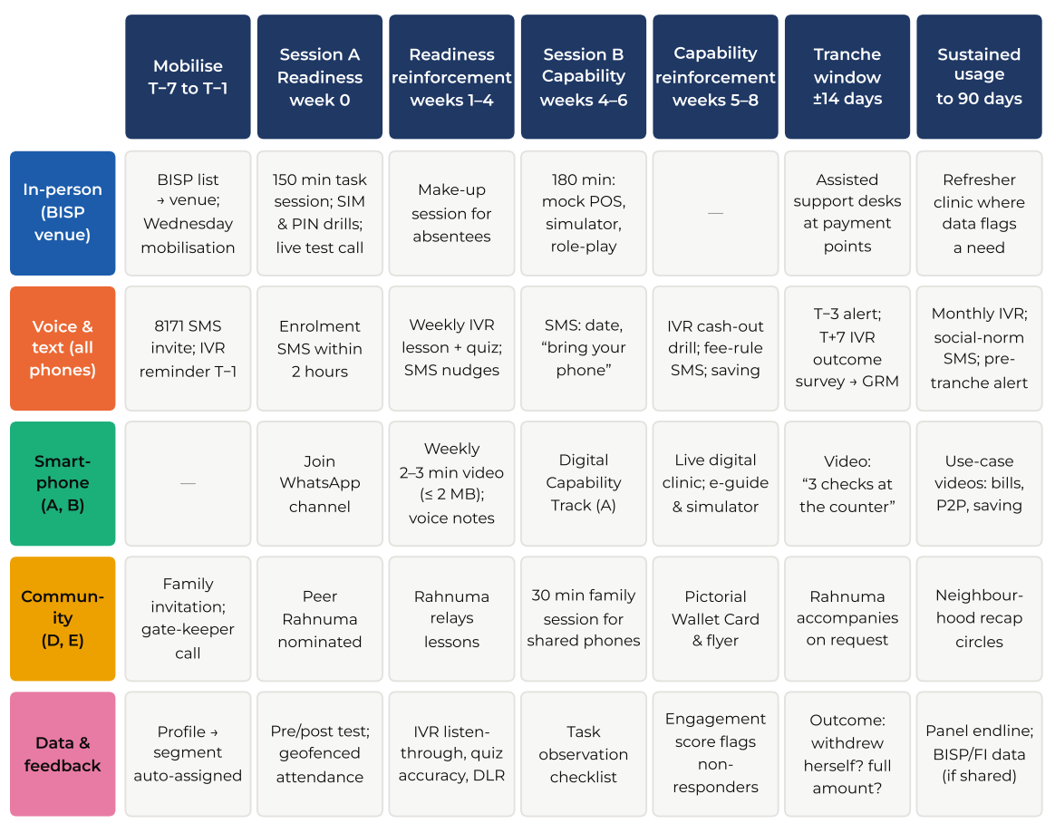
Figure 12: Beneficiary journey and sequencing map

Technical feasibility and offline-first contingency
Feasibility rests on channels that work on any handset. IVR uses keypad input and runs on 2G; SMS needs no data; video is compressed to 2 MB or less (about two to three minutes at low resolution) and is also screened at venues, including the LED screens installed at Benazir Nashonuma centres. Because beneficiaries’ numbers are spread across all four mobile operators, SDPI will procure IVR and SMS routing from all of them. Each tehsil is assigned a connectivity band from DFLT App synchronisation logs and published coverage (Table 11).
Table 11: Connectivity bands and delivery adjustments
Band | Definition | Delivery adjustment | Data capture
A | Dependable 3G/4G at the venue and in households | Full channel package including WhatsApp video and live clinics | Near real-time sync
B | Intermittent data | Videos side-loaded at the venue from the trainer’s device; IVR and SMS carry reinforcement | Offline capture, delayed sync with embedded timestamps
C | No dependable data | IVR, SMS and pre-loaded content only; an additional physical follow-up replaces part of the digital load | Offline capture; sync at zonal hub
Contingencies are pre-defined: a WhatsApp failure reroutes the lesson to IVR; three unanswered IVR attempts trigger an SMS and a Peer Rahnuma visit; an outage switches the app to offline mode without loss of records; and if the 8171 channel is unavailable, a PTA-registered masked sender ID agreed with BISP is used.

4.7 Training deployment model

Trainer allocation
Each trainer will deliver one session a day to a cohort of 30 on four days a week, or 16 sessions a month. Because each woman attends two sessions, a trainer graduates 720 women in Phase 1 (three months) and 960 in each of Phases 2 and 3 (four months). The requirement is therefore Trainers = zone target ÷ (30 × 16 × months ÷ 2), giving 353, 419 and 368 trainers by phase (Table 12). SDPI will hire a standing corps of 440 (the Phase 2 peak plus a 5% reserve): 374 before Phase 1 and 66 more in Month 10; in Phase 3, 51 trainers are redeployed to tranche-window and sustained-usage support. The plan provisions two in-person sessions for every woman; time released where segment A women complete the digital track (about 10% of sessions nationally) is reserved for make-up sessions and family sessions, protecting delivery against attendance shocks.
Table 12: Zone-wise targets, trainers and Implementation Coordinators
Zone | Phase 1 target | Trainers | Phase 2 target | Trainers | Phase 3 target | Trainers | ICs (peak)
North Punjab | 45,529 | 64 | 72,846 | 76 | 63,740 | 67 | 6
Central Punjab | 45,529 | 64 | 72,846 | 76 | 63,740 | 67 | 6
South Punjab | 45,528 | 64 | 72,845 | 76 | 63,740 | 67 | 6
Upper Sindh | 31,839 | 45 | 50,942 | 54 | 44,575 | 47 | 5
Lower Sindh & Karachi | 31,839 | 45 | 50,942 | 54 | 44,574 | 47 | 5
North KP (Hazara–Malakand) | 19,785 | 28 | 31,656 | 33 | 27,699 | 29 | 3
Central & South KP | 19,785 | 28 | 31,656 | 33 | 27,699 | 29 | 3
Balochistan (Quetta–Zhob–Hub–Chaman) | 10,166 | 15 | 16,267 | 17 | 14,233 | 15 | 2
Total | 250,000 | 353 | 400,000 | 419 | 350,000 | 368 | 36
Capacity per trainer: 720 women in Phase 1, 960 in Phases 2 and 3. Implementation Coordinators at one per 12 trainers per zone (minimum two): 29, 36 and 32 in Phases 1–3.

Recruitment, ToT and field coordination
SDPI will recruit trainers on a merit framework agreed with BISP, drawing first on its pool of 649 trained DFLT facilitators (237 from the BISP chapter and 412 from the SSPA chapter) and a 9,734-applicant pipeline, with preference for women fluent in the local language. One ToT will be held in each of the eight zones in Month 5, so that every zone’s trainers are trained together on local languages, venues and payment arrangements (run in batches of up to 35 where a zone’s cohort is larger), followed by refresher ToTs in Months 10 and 16 that carry the course corrections. Coordination runs through Provincial Coordinators (4), Zonal Coordinators (8) and Implementation Coordinators, who conduct a mix of in-person and phone spot checks, liaise with BISP tehsil Assistant Directors and resolve venue and list issues within 48 hours (Figure 16, Section 9). Certified BISP master trainers co-facilitate sessions in their tehsils alongside SDPI trainers, so that at least 80% deliver one or more sessions during the programme, as required by the success measures.

Weekly operating rhythm, venues and onboarding support
Table 13: Weekly operating rhythm of a field trainer
Day | Activity
Monday, Tuesday, Thursday, Friday | One cohort session (10:00–13:00) at the BISP venue; afternoon follow-up calls to absentees, assisted first transactions and sync of records
Wednesday | Mobilisation with the BISP tehsil office; venue checks; family sessions and make-up sessions; mid-phase tranche support when a payment falls in the week
Saturday | Data reconciliation, QA feedback from the previous week’s audio audits, 15-minute micro-refresher and virtual zonal huddle
Tranche windows (10–14 days) | Classroom sessions pause; trainers staff Assisted Support Desks at BISP offices, campsites and high-volume agent clusters
Venues are drawn first from BISP tehsil offices and Benazir Nashonuma centres, then government schools and community halls. Every venue is verified in advance against a checklist (privacy, seating for 30, power for screening, distance, washroom) and stored in a venue registry before the phase starts. Onboarding support is built into each Session A through a five-point SIM and wallet check (SIM in her own handset; SIM active; wallet activated; PIN set privately by her; balance checked by her). Account-level problems such as failed activation, blocked SIMs and PIN resets are referred to BISP and the account-holding institution through an agreed escalation sheet, in line with the division of responsibility set out in the EOI clarifications. Integration with payment touchpoints is described in Section 5.4.

4.8 Behavioural reinforcement, quality assurance and governance
The GTM strategy carries three cross-cutting systems detailed elsewhere in this proposal: the sequenced behavioural reinforcement programme across digital and community channels (Section 5.5); the quality-assurance stack of geofenced attendance, CNIC OCR, audio audits, IC spot checks and call-back verification (Section 6.3); and governance and reporting protocols, including the WhatsApp notification channel (Sections 6.6 and 9).

4.9 Risk management
Table 14: Assignment-specific risks and mitigation
Risk | L / I | Mitigation built into the design
Low attendance or failure to return for Session B (mobility, chores, travel cost) | M / H | Venues within ~30 minutes; 10:00 start; same weekday and venue for Session B; 8171 and IVR reminders; Wednesday make-ups; daily absentee flags to trainers
Male gate-keeping and household resistance | H / H | Family session for shared-device users; invitation call to male household members; content framed around household benefit and her legal right to her own account; female trainers
Weak connectivity and limited device access | H / M | Voice-first channels; connectivity bands; side-loaded video; group screening; offline-first app
Literacy barriers | H / M | Icon-based job aids; audio and role-play; no step depends on reading; read-aloud SMS for segment B
Delays in BISP tranches or beneficiary lists | M / H | Phase calendars re-anchored to confirmed tranche dates; reinforcement extended; incremental list sharing with automatic replenishment
Agent resistance or retaliation at counters | M / H | Agent briefings and posters coordinated with BISP and banks; trainers at payment points; weekly deduction hotspot reports to BISP and FIs
Fraudsters impersonating the programme | M / H | Programme never asks for PIN, OTP or money; only 8171 and the announced caller ID; F1 fraud alerts within 24 hours of a new pattern
Security in merged districts of KP and parts of Balochistan | M / H | Local recruitment; clearance with BISP and district administrations; flexible scheduling; phone-based monitoring where movement is restricted
Floods, extreme heat and seasonal migration | M / M | Seasonal calendar per zone; contingency days in each phase; shift to IVR-led reinforcement
Trainer attrition | M / M | 5% reserve; rolling recruitment from SDPI’s trained facilitator pool; refresher ToTs
Data protection breach | L / H | Controls set out in Section 6.7
L / I: likelihood and impact (H high, M medium, L low). The risk register is updated monthly and reported at each gate.

5. Component 3: Field Implementation, Beneficiary Training and Behavioural Reinforcement

5.1 Delivering structured training to one million women
SDPI will deliver training in about 33,350 cohorts of 30, each meeting twice. The session architecture below fixes duration, purpose and the tasks each woman practises; the content team’s curriculum (Section 3.3) supplies the facilitator scripts and materials. Toolkits (pictorial Wallet Card, participant job aid, flyer) are issued at Session A and tracked in the app, so that distribution can be confirmed for every cohort.
Table 15: Session architecture
 | Session A: Readiness (150 minutes) | Session B: Capability (180 minutes)
Purpose | Make the woman ready to hold and protect her Social Protection Wallet | Make her capable of withdrawing, transacting and complaining on her own
Tasks practised | Keep the SIM in her own handset · set and hide a PIN · recognise a scam call or SMS · verify an 8171 message · check her balance by USSD on her own phone | Conduct the counter conversation on a mock POS · read the credit SMS and count the amount · send money and pay a bill on the simulator · leave a small saving · register a complaint
Digital link | Short videos screened at the venue; live test IVR call to every phone; enrolment in IVR, SMS and (A, B) WhatsApp | Assisted first real transaction where the wallet allows; Peer Rahnuma nominated; tranche-window information
Recorded on app | Attendance (geofenced), segment, five-point SIM and wallet check, pre-test | Attendance (live camera, CNIC OCR), post-test, task checklist for a random 20% of each cohort

5.2 Deploying digital content in coordination with sessions
- Screening at venues: two or three short videos per session on the LED screens at Benazir Nashonuma centres or on the trainer’s tablet, so that segment E women also see the content.
- Automatic triggers: when a trainer submits attendance, the MIS queues the R1 SMS within two hours and IVR-1 the next day, in the woman’s language and call window; segment A and B women receive the WhatsApp welcome video the same evening.
- Live test call: during Session A the trainer triggers a test IVR call to every phone in the room, so that women practise answering an unknown number and pressing keys, and invalid numbers are corrected on the spot.
- Digital job aids: the Wallet Card image and a one-page e-guide are shared from the trainer’s device by WhatsApp where connectivity permits, or side-loaded in Band B and C tehsils.

5.3 Onboarding readiness support
Every Session A includes the five-point SIM and wallet check. Trainers follow a hands-off rule: they never touch a woman’s PIN, SIM, cash or biometric, and guide her verbally while she performs each step herself. Issues that the woman cannot resolve in the session are logged with a reason code and routed through an escalation sheet agreed with BISP and the partner institutions (for example, SIM not received or blocked: BISP tehsil office; wallet not activated or PIN locked: the account-holding institution’s helpline or agent; suspected fraud: GRM). The dashboard tracks each case to closure and reports bottlenecks by institution and district.

5.4 Integration with payment touchpoints: the Tranche Window Protocol
For 10–14 days after each BISP tranche, classroom delivery pauses and trainers staff Assisted Support Desks in pairs at BISP tehsil offices, campsites and high-volume agent clusters selected from BISP payment data and the previous window’s complaint hotspots (about 200 desks per window at peak). Desks explain the three counter checks, help women read the 8171 credit message, accompany first-time withdrawals at biometric agents without handling cash or PINs, register complaints, and enrol untrained women for the next phase (Figure 13).
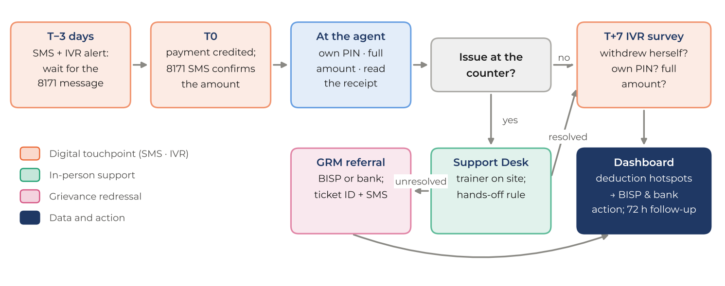
Figure 13: Tranche Window Protocol: from pre-payment alert to complaint resolution

5.5 Sequenced behavioural reinforcement programme
Reinforcement is designed around the specific moments at which behaviour fails, not around a content calendar. Each barrier identified in Section 1.2 is matched with a behavioural lever and a channel calibrated to device access and literacy:
Table 16: Behavioural levers used in reinforcement
Barrier | Lever | How it is delivered
Forgetting at the moment of action | Timely prompts | T−3 and payment-day SMS and IVR; bank-specific USSD code in the message
Fear of confronting the agent | Rehearsed “if-then” plan | Counter role-play in Session B; IVR-3 drama; Wallet Card phrases
Low confidence with the handset | Mastery through practice | Own-phone USSD practice; simulator; assisted first transaction
“Women like me don’t do this” | True local social norm | S2 SMS with the actual district share of trained women who withdrew themselves
Male control of the device | Household engagement and commitment | Family session; IVR addressed to her on the shared phone at her chosen time
Spending the whole instalment at once | Default and labelling | “Leave a little in the wallet” (C4, IVR-8) at each tranche
Distrust of unknown callers | Trusted messenger | 8171 identity; caller ID announced in Session A; BISP venue and staff
Community channels carry reinforcement to women the digital layer cannot reach. Each cohort nominates a Peer Rahnuma (about 33,000 in all), normally a segment A or B woman, who receives a 15-minute briefing in Session B and joins a trainer-led WhatsApp group. She relays IVR lessons to neighbours without phones, accompanies first withdrawals on request and convenes a monthly recap circle; she never handles money, PINs or SIMs, and is recognised with a BISP–SDPI certificate. This cascade from trainer to Rahnuma to neighbour extends coverage among segments D and E at negligible cost. Printed Wallet Cards and flyers are distributed at venues and payment points, and zero-deduction posters at agent outlets are placed where BISP and the partner institutions agree.

5.6 Phase 1 pilot and course-correction methodology
SDPI will run Phase 1 as a learning operation with a measurement plan fixed before roll-out. Four design questions are tested through cohort-level randomised variations that cost nothing extra to run: (i) morning against evening IVR call windows; (ii) social-norm against standard SMS wording; (iii) offering Peer Rahnuma accompaniment against not offering it; and (iv) a 45-second against a 90-second IVR drama. Results feed D6 and Learning Report 1. Progression to Phase 2 is governed by explicit gate criteria agreed with Karandaaz:
Table 17: Phase 1 quality gate (D6) criteria
Indicator | Gate threshold | Action if not met
Session A attendance of mobilised women | ≥ 85% | Revise mobilisation script, venue mix and timing in affected tehsils
Return to Session B | ≥ 80% of Session A attendees | Shorten the gap, add Wednesday make-ups, strengthen T−3 reminders
Knowledge gain (pre to post) | ≥ 70% of women improve by ≥ 20% | Revise modules with the lowest item gains; refresher ToT
Digital readiness tasks (DRCA sub-sample) | ≥ 60% complete all five core tasks | Add practice time and simulator drills
IVR reach | ≥ 55% answer at least one lesson; ≥ 60% average listen-through | Change call windows, voice talent or language mix
Independent withdrawal at first tranche (self-report) | ≥ 50% (stretch target 70%) | Increase desk coverage; revise the counter role-play
Sessions meeting quality standard | ≥ 60% | Targeted coaching; replace under-performing trainers

6. Component 4: Monitoring, Reporting and Endline Assessment
SDPI holds reporting responsibility; outcome verification rests with the independent third-party MEL firm, and every SDPI indicator, dataset and dashboard is designed to be read and audited by that firm.

6.1 Indicator framework mapped to the success measures
Table 18: Indicator framework
RFP objective | Indicator (SDPI definition) | Source and frequency | Target
Functional digital readiness | % completing five core tasks (own SIM in handset, private PIN entry, balance check, scam identification, verifying a credit SMS) | DRCA: 20% cohort sub-sample at Session B; panel endline | ≥ 60%
Knowledge and capability | % with ≥ 20% improvement from pre- to post-test; % reporting increased confidence | App pre/post (census); panel | ≥ 70%; ≥ 60%
Onboarding and initial transactions | % accessing a full-mandate wallet; % completing ≥ 1 transaction within 30 days | Assisted-transaction log; T+7 IVR survey; BISP/FI data where shared | ≥ 40%; ≥ 40%
Active and sustained use | % of transactors with ≥ 2 further transactions in 90 days; % using ≥ 2 use cases; GRM awareness among those with an issue | Panel endline; IVR surveys; FI data where shared | ≥ 50%; ≥ 30%; ≥ 50%
BISP institutional capacity | Master trainers certified; % meeting competency; % delivering ≥ 1 session | ToT records; co-facilitation logs | 1,200; ≥ 80%; ≥ 80%
Blended model deployed | % of implementation areas with full blended package; % completing minimum dosage; % of engagement through digital channels | MIS; telephony and WhatsApp logs | 100%; ≥ 70%; ≥ 20% (plan: 28%)
Scale and quality | Women reached; % completing minimum dosage; % sessions meeting quality standard | MIS; QA index | 1,000,000; ≥ 60%; ≥ 60%
Evidence for scale-up | Areas covered by MEL system; quarterly reports; learning reports presented to BISP | Reporting log | 100%; 8; ≥ 3
Minimum dosage: both sessions (or Session A plus the Digital Capability Track for segment A) and at least three reinforcement lessons completed with ≥ 50% listen-through or video completion.

6.2 Baseline and endline assessment
Assessment is task-based: women are asked to do, not only to say. The Digital Readiness and Capability Assessment (DRCA) observes five core tasks on her own handset or a demonstration phone and adds knowledge items on fees, saving and grievance routes. It is administered at three levels:
- Census pre/post on the DFLT App for every woman, giving cohort, trainer and district-level learning gains.
- Cohort sub-sample DRCA for a random 20% of each cohort at Session B, observed by the trainer and spot-verified by ICs and audio audits.
- Panel survey of 7,520 women (1,880 per province, stratified by settlement type and segment), drawn from the three phases in proportion to volume and interviewed at baseline (Session A), midline (first tranche window) and endline (at least 90 days after training). The design yields 1,600 completed endlines per province after 15% attrition, enough to estimate a proportion within ±3.5 percentage points at 95% confidence with a design effect of 2.

6.3 Tracking training quality, participation and coverage
Physical delivery is tracked through geofenced attendance, live-camera capture and CNIC OCR, session start and end photographs, and toolkit issue. Digital delivery is tracked from telephony records (calls placed, answered, listen-through, keypad responses, replays, opt-outs), SMS delivery receipts and WhatsApp delivered and read status, all linked to the woman’s record. Quality is assessed through a session quality index on six pillars (clarity, relevance, accessibility, communication, method and adherence to time), scored from audio audits of at least 30% of sessions, IC spot checks of at least 10% of sessions, and telephonic call-backs to a random 10% of attendees that also confirm attendance and recall.

6.4 Measuring behavioural outcomes
Behaviour is measured from three sources. The T+7 IVR outcome survey (IVR-5) asks every reachable woman whether she withdrew the instalment herself, entered her own PIN, received the full amount and kept a saving, and converts reported deductions into GRM tickets. The panel endline captures transaction frequency and use cases. Administrative data on wallet activity, dormancy and transaction types will be used where BISP and the partner institutions agree to share it; SDPI will propose a data-sharing protocol at inception based on hashed CNIC matching, and does not assume such data by default.

6.5 Feedback loops
Data is turned into decisions at four speeds: daily flags to trainers and ICs (absentees, unreachable numbers, low-quality sessions); a weekly zonal huddle; a monthly content and channel review, in which IVR quiz error patterns identify the messages that need rewriting; and the phase gates (Figure 14).
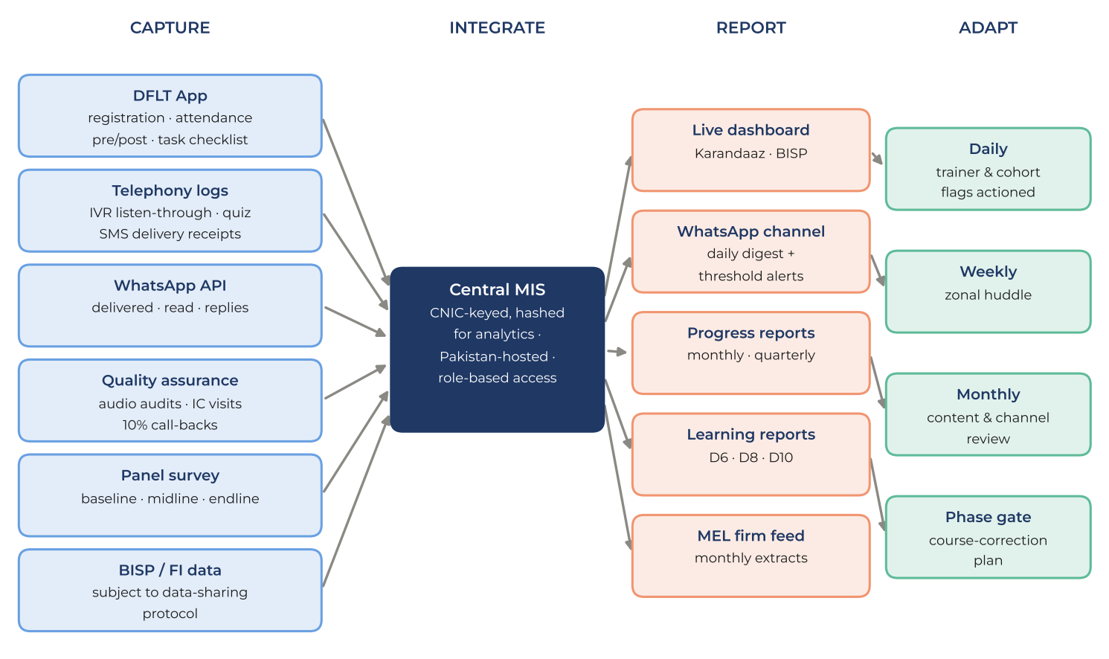
Figure 14: Monitoring data flow and feedback loops

6.6 Reporting protocols
SDPI’s live dashboard will report every KPI by zone, tehsil and trainer, and will be complemented by a WhatsApp notification channel: every evening, Karandaaz and BISP focal persons and zonal leads receive an automated digest of the day’s KPIs, and threshold breaches (for example, attendance below 80% in a tehsil or a spike in deduction reports) are pushed as alerts in real time.
Table 19: Reporting schedule
Product | Frequency | Audience | Content
Live dashboard | Continuous | Karandaaz, BISP, MEL firm | Reach, attendance, quality, digital engagement by zone, tehsil and trainer
WhatsApp digest and alerts | Daily; real-time alerts | Karandaaz and BISP focal persons, zonal leads | Daily KPIs and exceptions
Monthly progress note | Monthly | Karandaaz | Plan against actual, issues, risk register
Quarterly progress report | Quarterly (8) | Karandaaz, BISP, MEL firm | All success measures; digital readiness, onboarding, transactions, feedback
Learning reports | M9, M15, M21 | BISP (formal presentation), Karandaaz | Modality performance; channel effectiveness; cash-out and agent practices
Data feed to MEL firm | Monthly | Third-party MEL firm | De-identified extracts with data dictionary

6.7 Data management, privacy and ethics
Data handling follows SBP and PTA regulatory provisions and BISP’s data policies. Informed consent is recorded in the woman’s language at registration and covers data use, calls and messages. The programme never asks for or stores PINs, OTPs or passwords. CNICs are hashed in the analytics layer; data is encrypted in transit and at rest on Pakistan-hosted servers with role-based access and audit logs. Calls and SMS go only to consenting registered beneficiaries, between 09:00 and 20:00, with a one-key opt-out. All beneficiary data, content, software and dashboards are handed over to BISP and Karandaaz at close, consistent with the intellectual property terms of the RFP. A code of conduct, female trainers for women’s sessions and a beneficiary complaint channel about programme staff complete the safeguarding framework.

7. Work Plan, Deliverables and Payment Milestones
SDPI proposes a 24-month assignment, rescaling the RFP’s illustrative 14-month schedule as permitted in Section 4, sub-section 5. The additional months are used where they add value: a full quarter per phase so that each phase closes on a BISP tranche, a course-correction month after each gate, and a 90-day sustained-usage window after Phase 3 so that the endline measures behaviour rather than recall (Figure 15).
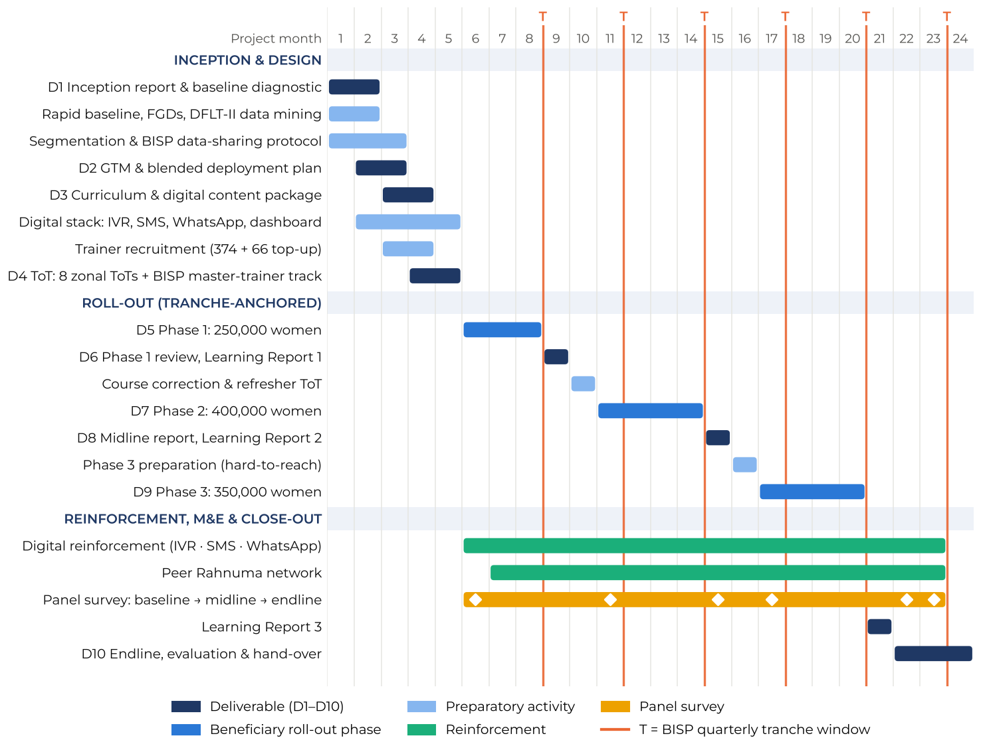
Figure 15: Work plan and Gantt chart (24 months)
T marks a BISP quarterly tranche window. Diamonds on the panel bar mark survey rounds.
Table 20: Deliverables and payment schedule
Deliverable | Month | Payment | Key contents
D1 Inception report and baseline diagnostic | M2 | 10% | Methodology, governance, staffing, BISP coordination; baseline findings; segmentation framework; initial modality split by segment and geography; data-sharing protocol
D2 GTM, blended deployment plan and roll-out strategy | M3 | 10% | Zone allocations re-weighted on BISP lists; tehsil sequencing; tranche calendar; channel-content map; sequencing framework; QA, governance and risk register
D3 Curriculum and training materials package | M4 | 10% | Approved physical and digital content, including the IVR library, SMS sequences and videos in all languages
D4 ToT completion report | M5 | 10% | Eight zonal ToTs; trainer certification; BISP master-trainer track; Peer Rahnuma briefing kit; deployment readiness
D5 Phase 1 roll-out (250,000) with pilot summary | M8 | 15% | Completion records, toolkit distribution, digital activation, early findings and agreed corrections
D6 Phase 1 review and course-correction report | M9 | 5% | Gate assessment (Table 17), tranche-window outcomes, randomised variation results, Learning Report 1
D7 Phase 2 roll-out (400,000) | M14 | 15% | Completion records with refined modality deployment and full reinforcement programme
D8 Midline progress report | M15 | 5% | Cumulative reach, quality, channel effectiveness, early behavioural outcomes, updated risk register, Learning Report 2
D9 Phase 3 roll-out (350,000) | M20 | 15% | Completion records prioritising hard-to-reach tehsils; sustained reinforcement for all cohorts
D10 Final evaluation and close-out report | M24 | 5% | Endline findings; physical vs digital outcomes by segment and geography; recommendations for national scale-up; full data and asset hand-over

8. Level of Effort, Field Deployment and Activity Plan
The level of effort is derived directly from beneficiary volumes and geography (Section 4.7) rather than from generic staffing ratios. Table 21 summarises person-months by role; Table 22 lists activities with their cost heads, without pricing, as required by Clause 10 of the RFP. The financial proposal follows the same structure.
Table 21: Level of effort by role (person-months over 24 months)
Role | Number | Deployment | Person-months
Field trainers | 374 → 440 → 389 | M5–M21 (Phase 1, Phase 2, Phase 3 corps incl. 5% reserve) | 6,844
Implementation Coordinators | 29 → 36 → 32 | M5–M21 | 553
Zonal Coordinators | 8 | M3–M22 | 160
Provincial Coordinators | 4 | M2–M23 | 88
Call-back and digital support agents | 12 | M6–M23 | 216
Audio quality reviewers | 10 | M6–M21 | 160
Panel survey enumerators | ≈ 20,900 interviews | Baseline, midline, endline rounds | ≈ 119
Key experts and PMU (see Table 23) | 12 positions | M1–M24, full or intermittent | 204
Table 22: Activity plan with cost heads (without pricing)
Activity | Cost heads | Quantity basis
Inception, baseline and segmentation | Professional fees; FGDs (venue, travel, refreshments, transcription); data analysis | 32 FGDs (women and men, four per zone)
Content and digital production | Voice talent and studio; animation; translation; facilitator guides; demonstration kits; Wallet Cards, job aids and flyers | 9 IVR scripts × 6 languages; 440 demo kits; 1,000,000 Wallet Cards
Digital infrastructure and channels | IVR nodes and SIP trunks; airtime; SMS; WhatsApp Business API; app upgrade; hosting; dashboard and notification service | ≈13.9 m IVR calls; ≈14.1 m SMS; ≈8.2 m video messages; 8 IVR nodes
Recruitment and ToT | Advertising and selection; ToT venues; travel and daily allowances; ToT materials; certification | 13 first-wave batches + refreshers at M10 and M16
Field delivery | Trainer and coordinator remuneration; mobility and data allowances; session consumables; temporary zonal hubs | ≈33,350 cohorts; ≈66,700 sessions; 8 zonal hubs
Tranche windows | Desk materials, banners, local transport | 6 windows × ≈200 desks
Peer Rahnuma network | Briefing kits, certificates | ≈33,000 Rahnumas (no stipend)
Monitoring, QA and learning | Panel survey; audio QA; call-back centre; IC spot checks; learning reports | 7,520-woman panel; ≥30% audio coverage; 10% call-backs
Management and reporting | PMU operations; communications; audit; applicable taxes | 24 months

9. Implementation Governance, Team and Quality Assurance
Governance separates strategic oversight from operational control (Figure 16). A Project Steering Committee of Karandaaz, BISP and SDPI meets quarterly and at each phase gate to approve course corrections. A Technical Working Group meets monthly to resolve operational issues with BISP wings and partner institutions. The Project Management Unit at CASPEE, SDPI, runs the national operations room with five specialist cells, and the field chain runs from Provincial to Zonal to Implementation Coordinators and trainers, linked at tehsil level to BISP Assistant Directors.
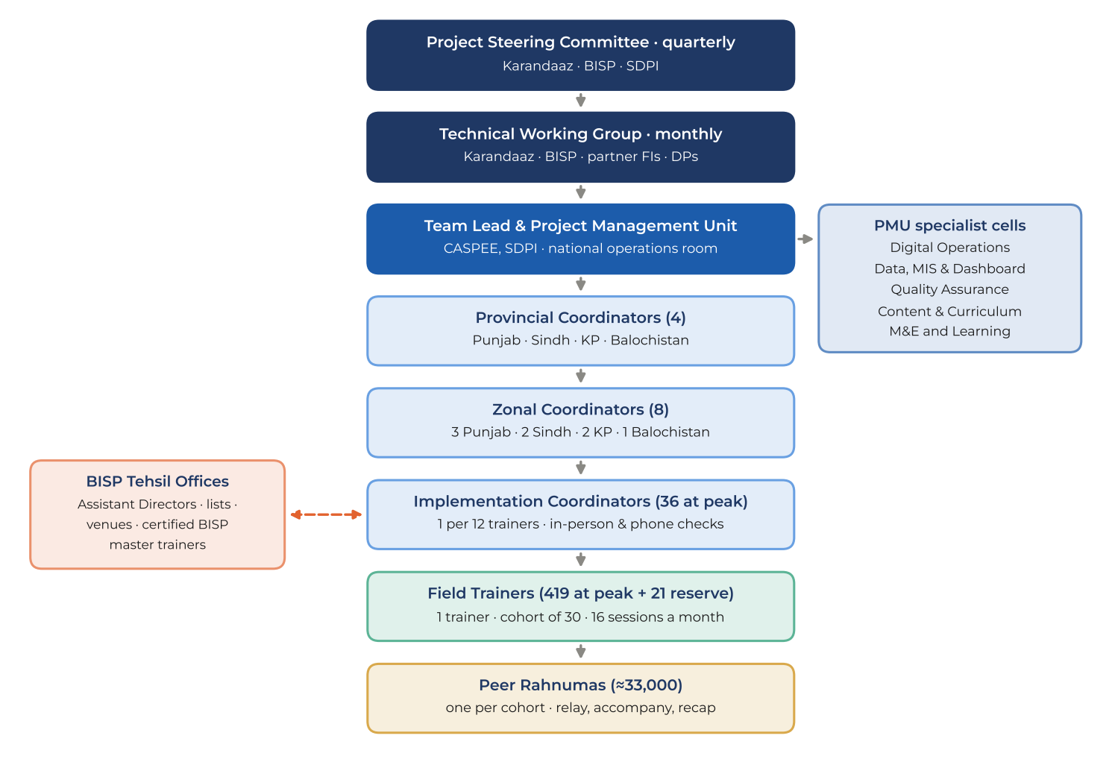
Figure 16: Governance and field coordination structure
Table 23: Key personnel
Name | Proposed role | Relevant experience
Dr Fareeha Armughan | Team Lead | Led DFLT Phase II (550,000 women across BISP and SSPA chapters) and DFLT Phase I; GIZ M&E of the 2023–24 national DFLT pilot
Syed Sajid Ali | Digital Financial Services and Financial Inclusion Expert | Senior Consultant, NIBAF, State Bank of Pakistan; economic research and policy advisory
Dr Kamran Khan | Data, Dashboard and Digital Channels Lead | Built the DFLT App, OCR verification, live dashboard and WhatsApp API video delivery for DFLT Phase II
Dr Asma Fiaz | M&E and Data Analysis Lead | Senior Data Analyst, DFLT Phases I and II
Ehtasham Afzal | IT and Systems Engineer | Manages DFLT Phase II Sindh chapter data systems
Anam Malik | Provincial Coordinator | Managed all DFLT Phase II operations in Khyber Pakhtunkhwa
Iffat Rubab | Provincial Coordinator | Managed DFLT Phase II operations in Sindh and Balochistan (BISP chapter)
Asma Rubab | Provincial Coordinator | Managed DFLT Phase II operations for MAMTA beneficiaries
[To be confirmed] | Curriculum, gender and ToT leads; Punjab coordinator; additional expert (Waqar) | CVs to be attached in the common SDPI format
Quality assurance is independent of the delivery line: the QA cell reports to the Team Lead, not to the field chain, and its audio audits, call-backs and spot checks feed the session quality index described in Section 6.3.

10. Innovation, Value Addition and Sustainability
- Tranche-anchored learning. Training is timed so that the first independent withdrawal happens days after the Capability session, with trainers at the payment point. Learning is tested in the real transaction, not only in a post-test.
- Segmentation that routes itself. Five registration questions assign each woman to a segment that automatically sets her channel package, language and call window, at no marginal cost.
- A live test call in every classroom. Women practise answering and responding to an IVR call before they leave, which raises digital reach and corrects numbers on the spot.
- Low-cost voice infrastructure. Eight zonal IVR nodes on open-source telephony provide about 200,000 calls a month each, so the main cost is airtime rather than platforms; every keypad answer becomes learning data.
- Learning while delivering. Cohort-level randomised variations in Phase 1 answer design questions at no additional cost and inform the scale-up.
- The payment queue as a mobilisation channel, and the WhatsApp notification channel that brings daily programme data to decision-makers’ phones.
Sustainability. The programme is designed to leave a working ecosystem with BISP rather than end with the contract: 1,200 certified BISP master trainers who have co-delivered sessions; an approved, localised content and IVR library; a segmentation rule that BISP can apply at enrolment; and a reachable, consented database of a million women with an IVR and SMS channel that BISP can use for future payment alerts, Nashonuma messages or graduation and livelihood programmes. All assets vest in Karandaaz and BISP at close.

Annex A: IVR Scripts
Urdu master scripts with English renderings. Each script is recorded by female voice artists in Urdu, Punjabi, Saraiki, Pashto, Sindhi and Balochi/Brahvi; the language is set from the beneficiary profile, with 0 to switch to Urdu. Unless stated otherwise, every call opens with the greeting and identity check of IVR-1 (node 1) and closes with node 5. Variables appear in braces.

IVR-1: “Your SIM is your bank account” (Day 1 after Session A)
Node | Urdu prompt | English rendering | Logic and data
1 Greeting | السلام علیکم۔ یہ بینظیر انکم سپورٹ پروگرام کی والیٹ تربیت کی کال ہے۔ اگر آپ نے حال ہی میں یہ تربیت حاصل کی ہے تو 1 دبائیں۔ اگر یہ فون کسی اور کا ہے تو براہِ کرم فون اُس خاتون کو دے دیں اور پھر 1 دبائیں۔ | Greetings. This is a call from BISP’s wallet training. If you recently attended the training, press 1. If this phone belongs to someone else, please hand it to her and press 1. | 1 → node 2; no input in 10 s → repeat once; else end and retry in her next call window (maximum 3 attempts)
2 Drama | نسرین ایجنٹ کی دکان پر گئیں۔ ایجنٹ بولا: باجی، اپنی سم مجھے دے دیں، میں ٹھیک کر دیتا ہوں۔ نسرین نے کہا: نہیں بھائی، یہ سم میرا بینک کھاتہ ہے، یہ میرے فون میں ہی رہے گی۔ | Nasreen went to the agent’s shop. He said: “Sister, give me your SIM, I’ll fix it.” Nasreen said: “No brother, this SIM is my bank account; it stays in my phone.” | Listen-through logged
3 Rule | یاد رکھیں: آپ کی بینظیر سم آپ کا بینک کھاتہ ہے۔ سم ہمیشہ اپنے فون میں رکھیں، ہر مہینے کم از کم ایک کال کریں، اور سم کبھی کسی کو نہ دیں۔ | Remember: your Benazir SIM is your bank account. Keep it in your own phone, make at least one call a month, and never give it to anyone. | Played twice
4 Quiz | اگر کوئی آپ سے سم مانگے تو آپ کیا کریں گی؟ سم دینے کے لیے 1 دبائیں۔ انکار کرنے کے لیے 2 دبائیں۔ | If someone asks for your SIM, what will you do? Press 1 to give it. Press 2 to refuse. | 2 → “Well done!”; 1 → corrective message and quiz repeated once; first-attempt accuracy logged
5 Close | یہ سبق دوبارہ سننے کے لیے 9 دبائیں۔ اگلا سبق ایک ہفتے بعد آئے گا۔ یہ کالیں بند کروانے کے لیے 8 دبائیں۔ اللہ حافظ۔ | Press 9 to hear this lesson again. The next lesson comes in a week. Press 8 to stop these calls. Goodbye. | 9 → replay; 8 → opt-out recorded

IVR-2: “Your PIN, your secret” (Day 7 after Session A)
Node | Urdu prompt | English rendering | Logic and data
2 Drama | شازیہ کو فون آیا: میں بی آئی ایس پی سے بول رہا ہوں، آپ کا انعام نکلا ہے، فون پر آنے والا کوڈ بتائیں۔ شازیہ نے کہا: بی آئی ایس پی کبھی کوڈ نہیں مانگتا، اور فون بند کر دیا۔ | Shazia got a call: “I’m calling from BISP, you have won a prize, tell me the code you just received.” Shazia said: “BISP never asks for a code,” and hung up. | Listen-through logged
3 Rule | بی آئی ایس پی یا بینک کبھی فون کر کے آپ کا پن یا کوڈ نہیں مانگتے۔ پن لگاتے وقت ہاتھ سے چھپائیں، اور 1234 یا اپنی پیدائش کا سال پن نہ بنائیں۔ | BISP and banks never call to ask for your PIN or code. Cover the keypad when entering your PIN, and never use 1234 or your year of birth. | Played twice
4 Quiz | کوئی فون پر کوڈ مانگے تو آپ کیا کریں گی؟ کوڈ بتانے کے لیے 1 دبائیں۔ فون بند کرنے کے لیے 2 دبائیں۔ | If someone asks for a code on the phone, what will you do? Press 1 to tell the code. Press 2 to hang up. | 2 correct; 1 → corrective message, repeat once

IVR-3: “Three checks at the counter” (Day 2 after Session B)
Node | Urdu prompt | English rendering | Logic and data
2 Drama | ایجنٹ: باجی، آپ کی قسط آ گئی ہے، پانچ سو روپے کٹیں گے۔ خاتون: نہیں بھائی، یہ سرکاری رقم ہے، اس میں کوئی کٹوتی نہیں ہوتی۔ پن میں خود لگاؤں گی اور پوری رقم لوں گی۔ | Agent: “Sister, your instalment has arrived; 500 rupees will be deducted.” Woman: “No brother, this is government money; nothing is deducted. I will enter my PIN myself and take the full amount.” | Two female voices, one male
3 Rule | رقم نکلواتے وقت تین باتیں یاد رکھیں: پن خود لگائیں، پوری رقم گن کر لیں، اور فون پر آنے والا پیغام دیکھیں۔ | When withdrawing, remember three things: enter your PIN yourself, count the full amount, and read the message on your phone. | Played twice
4 Quiz | اگر ایجنٹ پیسے کاٹے تو آپ کیا کریں گی؟ خاموش رہنے کے لیے 1 دبائیں۔ انکار کر کے شکایت کرنے کے لیے 2 دبائیں۔ | If the agent deducts money, what will you do? Press 1 to stay silent. Press 2 to refuse and complain. | 2 correct; 1 → corrective message, repeat once
5 Help | شکایت کے لیے {ہیلپ لائن} پر کال کریں یا اپنے بی آئی ایس پی تحصیل دفتر جائیں۔ نمبر دوبارہ سننے کے لیے 5 دبائیں۔ | To complain, call {helpline} or visit your BISP tehsil office. Press 5 to hear the number again. | 5 → repeat; replays logged

IVR-4: “Your payment is coming” (three days before the tranche)
Node | Urdu prompt | English rendering | Logic and data
2 Message | آپ کی قسط اگلے چند دنوں میں آپ کے والیٹ میں آ جائے گی۔ 8171 کا پیغام آنے کے بعد ہی ایجنٹ کے پاس جائیں۔ وہاں تین باتیں یاد رکھیں: پن خود لگائیں، پوری رقم لیں، اور پیغام دیکھیں۔ | Your instalment will reach your wallet in the next few days. Go to the agent only after the 8171 message arrives. There, remember three things: enter your PIN yourself, take the full amount, and check the message. | Listen-through logged
3 Help desk | ہماری ٹیم {تاریخوں} میں {مقام} پر آپ کی مدد کے لیے موجود ہو گی۔ اگر آپ چاہتی ہیں کہ ہماری ٹیم آپ کو کال کرے تو 1 دبائیں۔ | Our team will be at {venue} on {dates} to help you. If you would like our team to call you, press 1. | 1 → callback request to zonal queue

IVR-5: Outcome survey (seven days after the tranche)
Node | Urdu prompt | English rendering | Logic and data
Intro | السلام علیکم۔ بی آئی ایس پی والیٹ تربیت کی طرف سے صرف ایک منٹ کے چند سوال۔ | Greetings. A few one-minute questions from BISP’s wallet training. | Identity check as IVR-1
Q1 | اس بار کی قسط کیا آپ نے خود نکلوائی؟ خود نکلوائی ہے تو 1، کسی اور نے نکلوائی ہے تو 2، ابھی نہیں نکلوائی تو 3 دبائیں۔ | Did you withdraw this instalment yourself? Press 1 if yourself, 2 if someone else did, 3 if not yet withdrawn. | Self-withdrawal indicator; 3 → Q6
Q2 | پن کس نے لگایا؟ خود لگایا تو 1، ایجنٹ یا کسی اور نے لگایا تو 2 دبائیں۔ | Who entered the PIN? Press 1 if you did, 2 if the agent or someone else did. | Asked if Q1 = 1
Q3 | کیا رقم میں سے کوئی کٹوتی ہوئی؟ کوئی کٹوتی نہیں ہوئی تو 1، کٹوتی ہوئی تو 2 دبائیں۔ | Was anything deducted? Press 1 for no deduction, 2 if money was deducted. | Asked if Q1 = 1 or 2
Q4 | کتنی کٹوتی ہوئی؟ پانچ سو روپے تک 1، پانچ سو سے ایک ہزار تک 2، ایک ہزار سے زیادہ 3 دبائیں۔ شکایت درج کروانے کے لیے 9 دبائیں۔ | How much was deducted? Press 1 up to 500 rupees, 2 for 500–1,000, 3 for more than 1,000. Press 9 to register a complaint. | 9 → GRM ticket and SMS T4; hotspot mapping
Q5 | کیا آپ نے کچھ رقم والیٹ میں بچا کر رکھی ہے؟ ہاں کے لیے 1، نہیں کے لیے 2 دبائیں۔ | Have you kept some money saved in your wallet? Press 1 for yes, 2 for no. | Saving indicator
Q6 | اگر رقم نکلوانے کے لیے مدد چاہیے تو 1 دبائیں، ہماری ٹیم آپ کو کال کرے گی۔ | If you need help withdrawing your money, press 1 and our team will call you. | Callback queue
Close | آپ کا شکریہ۔ یاد رکھیں، پوری رقم آپ کا حق ہے۔ اللہ حافظ۔ | Thank you. Remember, the full amount is your right. Goodbye.

IVR-6: Missed-call helpline (always on)
Node | Urdu prompt | English rendering | Logic and data
Menu | خوش آمدید۔ پچھلا سبق دوبارہ سننے کے لیے 1، بیلنس دیکھنے کا طریقہ سننے کے لیے 2، دھوکے یا کٹوتی کی شکایت کے لیے 3، اور ہمارے نمائندے سے بات کرنے کے لیے 4 دبائیں۔ | Welcome. Press 1 to hear your last lesson again, 2 to hear how to check your balance, 3 to report fraud or a deduction, 4 to speak to our representative. | A missed call triggers an automatic callback within 15 minutes; 2 plays her bank’s USSD steps; 3 opens a GRM ticket; 4 connects 09:00–17:00, otherwise callback queue

IVR-7 (sending money and paying bills), IVR-8 (saving in the wallet) and IVR-9 (my money, my decision) follow the same drama–rule–quiz structure and are finalised with the content team’s gender-intentional modules.

Annex B: SMS Nudge Sequence
All messages are in Urdu Unicode within two segments (134 characters), sent through BISP’s 8171 channel between 09:00 and 20:00. Segments A and C receive the full sequence (18 scheduled messages); segments B and D receive the ten messages marked “all”; segment E is reached through Peer Rahnumas. T4 and F1 are event-triggered.
Code | Timing | Sent to | Urdu text | English meaning
M1 | T−3 before Session A | all | بی آئی ایس پی: آپ کی مفت ڈیجیٹل والیٹ تربیت {تاریخ} کو {مقام} پر ہے۔ شناختی کارڈ اور فون ساتھ لائیں۔ | BISP: your free digital wallet training is on {date} at {venue}. Bring your CNIC and phone.
M2 | T−1, evening | all | یاد دہانی: کل صبح 10 بجے آپ کی تربیت ہے۔ اپنی بینظیر سم والا فون ضرور لائیں۔ تربیت بالکل مفت ہے۔ | Reminder: your training is tomorrow at 10 am. Bring the phone with your Benazir SIM. The training is completely free.
R1 | Day 0, within 2 hours | all | تربیت میں شرکت کا شکریہ۔ یاد رکھیں: اپنی سم اور پن کسی کو نہ دیں، ایجنٹ کو بھی نہیں۔ | Thank you for attending. Never give your SIM or PIN to anyone, not even the agent.
R2 | Day 2 | all | بی آئی ایس پی کے پیغامات صرف 8171 سے آتے ہیں۔ کسی اور نمبر سے انعام یا رقم کا پیغام دھوکہ ہے۔ | BISP messages only come from 8171. A prize or payment message from any other number is fraud.
R3 | Day 5 | A, C | آج اپنا بیلنس خود دیکھیں: اپنے فون سے {USSD} ملائیں اور پن خود لگائیں۔ | Check your balance yourself today: dial {USSD} on your phone and enter your PIN yourself.
R4 | Day 9 | A, C | کوئی فون پر آپ کا پن یا کوڈ مانگے تو فوراً فون بند کر دیں۔ بینک اور بی آئی ایس پی کبھی پن نہیں مانگتے۔ | If anyone asks for your PIN or code on the phone, hang up at once. Banks and BISP never ask for your PIN.
R5 | Day 14 | A, C | اپنی سم چالو رکھیں: ہر مہینے کم از کم ایک کال یا پیغام کریں۔ سم کسی کو نہ دیں۔ | Keep your SIM active: make at least one call or message every month. Never give your SIM to anyone.
R6 | 3 days before Session B | all | {تاریخ} کو آپ کی دوسری تربیت ہے: رقم نکلوانا اور بھیجنا عملی طور پر سیکھیں۔ فون ساتھ لائیں۔ | Your second training is on {date}: practise withdrawing and sending money. Bring your phone.
C1 | Day 0 after Session B | all | شاباش! آپ نے والیٹ کا استعمال سیکھ لیا۔ رقم نکلواتے وقت پن خود لگائیں اور پوری رقم گن کر لیں۔ | Well done! You have learnt to use your wallet. When withdrawing, enter your PIN yourself and count the full amount.
C2 | Day 3 | all | ایجنٹ کو آپ کی رقم سے کٹوتی کا کوئی حق نہیں۔ کٹوتی ہو تو {ہیلپ لائن} پر شکایت کریں۔ | The agent has no right to deduct from your money. If he does, complain to {helpline}.
C3 | Day 7 | A, C | رقم بھیجنے سے پہلے نمبر دو بار چیک کریں۔ بھیجنے کے بعد آنے والا پیغام محفوظ رکھیں۔ | Check the number twice before sending money. Keep the message you receive after sending.
C4 | Day 12 | A, C | ہر قسط میں سے تھوڑی رقم والیٹ میں چھوڑ دیں۔ چھوٹی بچت مشکل وقت میں کام آتی ہے۔ | Leave a little of each instalment in your wallet. Small savings help in hard times.
T1 | T−3 before each tranche | all | آپ کی قسط جلد آپ کے والیٹ میں آئے گی۔ 8171 کا پیغام آنے کے بعد ہی ایجنٹ کے پاس جائیں۔ | Your instalment will reach your wallet soon. Go to the agent only after the 8171 message arrives.
T2 | Payment day | all | رقم نکلواتے وقت 3 باتیں: پن خود لگائیں، پوری رقم لیں، رسید کا پیغام دیکھیں۔ مدد: {مدد مرکز} | Three things when withdrawing: enter your PIN yourself, take the full amount, check the receipt message. Help: {help desk}.
T3 | T+6 | all | کیا آپ کو پوری رقم ملی؟ کل ہماری کال آئے گی، بٹن دبا کر جواب دیں۔ | Did you receive the full amount? We will call tomorrow; please answer by pressing a button.
T4 | On complaint | event | آپ کی شکایت درج ہو گئی ہے، نمبر {ٹکٹ}۔ ہماری ٹیم 72 گھنٹوں میں آپ سے رابطہ کرے گی۔ | Your complaint is registered, number {ticket}. Our team will contact you within 72 hours.
S1 | +30 days | A, C | اس مہینے والیٹ سے ایک کام خود کریں: بیلنس دیکھیں، بل جمع کرائیں یا رقم بھیجیں۔ | This month, do one thing yourself on your wallet: check your balance, pay a bill or send money.
S2 | +60 days | A, C | آپ کے ضلع میں {x}٪ تربیت یافتہ خواتین نے پچھلی قسط خود نکلوائی۔ آپ بھی کر سکتی ہیں! | In your district, {x}% of trained women withdrew their last instalment themselves. You can too!
F1 | New scam pattern | event | خبردار! "{جعلی پیغام}" جیسا پیغام دھوکہ ہے۔ کسی کو پن یا کوڈ نہ بتائیں۔ | Warning! A message like “{fake message}” is fraud. Do not tell anyone your PIN or code.

Annex C: Methodological Notes

Data sources
- BISP Beneficiaries Data Portal (dli7.bisp.gov.pk), HH Size Summary and Room Summary, accessed 8 October 2026: the allocation base for the methodology (Section 4.1) and the household-structure indicators in Section 1.2.
- SDPI DFLT Phase II database (extract of 7 August 2026), used for the track record (Section 2) and as planning priors for segment shares and channel volumes until the Phase III baseline replaces them: 272,942 registrations, of which 254,648 active registrations exclude 18,294 records of terminated trainers; 48,332 Day-1 and 41,180 Day-2 pre/post records; 17,968 teaching forms (show-of-hands for 130,040 women in 5,554 sessions after consistency checks); 8,131 audio reviews; 3,452 IC monitoring records.
- SSPA chapter analytics database (built 1 October 2026): 275,229 registrations.

Definitions and formulae
- Allocation: province target = 1,000,000 × province households ÷ 25,433,500, applied to each phase and rounded by largest remainder; zones receive equal shares of the provincial phase target.
- Trainers: zone trainers = ceiling (zone phase target ÷ capacity), with capacity = 30 × 16 × months ÷ 2 (720 for three months, 960 for four months).
- Segments: A = owns phone, WhatsApp on own number, primary schooling or above; B = as A without formal schooling (religious-only education counted as no formal schooling); C = owns phone, WhatsApp not on own number; D = no own phone, household access; E = neither.
- Modality split: digital share = digital minutes ÷ (digital + physical minutes) per segment, using IVR 3 minutes per call, video 3 minutes, SMS 0.5 minute, live clinic 45 minutes, voice note 2 minutes, self-paced e-guide 30 minutes (A), group screening 30 minutes (E); physical minutes are 150 (A), 330 (B, C) and 360 (D, E, including family session or Rahnuma visit). Geographic splits weight segment shares by each geography’s segment mix.
- Telephony: about 13.9 IVR calls and 14.1 SMS per beneficiary on the segment mix; peak load of about 1.6 million calls a month (Phase 2 plus the Phase 1 tail) is carried by eight nodes rated at about 200,000 calls a month each.
- Panel sample: n = 1.96² × 0.25 × 2 ÷ 0.035² ≈ 1,568, rounded to 1,600 completed endlines per province; 1,880 recruited per province allowing for 15% attrition.

Profit (Pakistan Today), “Over 10 million BISP women become account holders after 16 years”. Accounts were reported across HBL (3.1 million), Bank Alfalah (3.0 million), Bank of Punjab (2.0 million), JazzCash (1.2 million) and Easypaisa (about 0.7 million); fewer than 6,000 of the country’s 16,000 ATMs are biometric, so most withdrawals will take place at biometric-enabled retail agents.
BISP Beneficiaries Data Portal (dli7.bisp.gov.pk), HH Size Summary and Room Summary, accessed 8 October 2026; shares computed by SDPI for Punjab, Sindh, Khyber Pakhtunkhwa and Balochistan.
GSMA Mobile Gender Gap Report 2025, as reported by Profit (Pakistan Today), 15 May 2025: women’s mobile internet use rose to 45% in 2024.
In SDPI’s audio audits of DFLT Phase II sessions, Urdu was used in 57.7%, Punjabi in 24.5%, Saraiki in 19.9%, Pashto in 17.5% and Sindhi in 5.4% of sessions (more than one language may be used in a session).
Section 4, sub-section 5 of the RFP describes Phase 1 as covering two to three pilot provinces or regions. Query 10 of the EOI clarifications confirms that the number of phases, per-phase volumes and KPIs may be proposed by the bidder. SDPI proposes all eight zones in Phase 1 so that the pilot represents the full mix of contexts while remaining a gated, quarter-scale operation.
In SDPI’s DFLT Phase II registrations, 97.1% of beneficiaries gave a valid mobile number, only 5.2% shared a number with another beneficiary, and numbers were spread across Jazz (33%), Ufone (26%), Telenor (23%) and Zong (17%).
These parameters are within demonstrated capacity. In DFLT Phase II, SDPI trainers were active on 13.5 days a month at peak while running two-day sessions in pairs, so 16 single sessions a month is a modest step, and cohorts of 30 are feasible at BISP venues once each session is a single task block.

