Proof of concept

Contents

1. First tests 1

1.1 Open Field 1

2.1 Greenhouse 3

2. Foraging-preference experiment 7

3. References 10

# First tests

A proof of concept was performed to test whether the robotic flower does what it was designed to do. Multiple insects in different settings were used on July 16, 2021, at the Botany building (PLTK) of the KU Leuven in Heverlee. The question was if the robotic flowers could attract visitors by offering artificial nectar and if so, correctly register the visit data. Therefore, the CSV-file with visit data of the robotic flower had to be compared to the manually collected visit time and visit duration. Two robotic flowers were used of which the nectar reservoir was filled with Biogluc (50% w/w) sugar syrup (composed of 25.0% sucrose, 37.5% fructose, 34.5% dextrose, 2.0% maltose, 1% higher sugars and 0.05% preservatives) made by Biobest (Billiet et al., 2016).

## 1.1 Open Field

As a first setting, the robotic flower was placed in the garden. Floral visitors were recorded in an open field setting, being a small botanical garden. When the visitor went in the feeding hole, the probing time and duration were noted (table 1). The captured individuals were identified and besides *Bombus terrestris*, also *B. pascuorum*, *Anthidium manicatum*, *Apis mellifera*, *Psythirus sp.*, Syrphidae, Bombyliidae and even one Lepidopteran showed interest in the robotic flower (at least to a certain extent). After manually registering visits, we compared this to the data collected by the robotic flower. 7 out of the 10 visitors that actually went in the feeding hole to drink were recorded by the robotic flower, but we noticed that some visits were not or only partly recorded (See table 1). In retrospect, this could be partly explained by the ‘SENSOR_SENSITIVITY’ value that was used. The sensitivity of the IR detection system, that was set at a good value for the breadboard prototype, might have been insufficient sensitive in the garden conditions, especially for the smaller floral visitors. For butterflies, with their long proboscis, a more refined feeding hole would probably be needed to get sufficient blocking of the infrared sensor.

|  |  |  |  |  |  |  |  |  |  |
| --- | --- | --- | --- | --- | --- | --- | --- | --- | --- |
|  | **Manual measurement** | | | | | **Robotic Flower** | | **Analysis Robotic Flower system** | |
|  | **Species** | **Class** | **Remarks** | **Visit Time (hh:mm)** | **Visit Duration (s)** | **Visit Time (hh:mm:ss)** | **Visit Duration (s)** | **Visit registration** | **Percentage time** |
| **1** | Syrphidae | Fly |  | 13:33 | 8 |  |  | x |  |
| **2** | *Bombus pascuorum* | Bee | male | 13:45 | 5 |  |  | x |  |
| **3** | Bombyliidae | Fly |  | 14:08 | 240 | 14:08:49 | 78 | Yes | 33% |
| **4** | Lepidoptera | Butterfly |  | 14:13 | 158 |  |  | x |  |
| **5** | *Bombus pascuorum* | Bee | didn’t drink | 14:19 |  |  |  |  |  |
| **6** | Syrphidae | Fly | didn’t drink | 14:22 |  |  |  |  |  |
| **7** | *Anthidium manicatum* | Bee |  | 14:59 |  | 14:59:17 | 2 | Yes |  |
| **8** | Bombyliidae | Fly | didn’t drink | 15:11 |  |  |  |  |  |
| **9** | *Apis mellifera* | Bee | didn’t drink | 15:23 |  |  |  |  |  |
| **10** | *Apis mellifera* | Bee | 2nd visit by same bee | 15:39 | 35 | 15:39:23 | 26 | Yes | 74% |
| **11** | *Apis mellifera* | Bee | 3th visit by same bee | 15:39 | 10 | 15:40:01 | 14 | Yes | 140% |
| **12** | *Apis mellifera* | Bee |  | 15:49 | 8 | 15:49:20 | 3 | Yes | 38% |
| **13** | *Bombus terrestris* | Bee |  | 15:51 | 148 | 15:51:26 | 52 | Yes | 35% |
| **14** | *Bombus terrestris* | Bee | male | 15:56 | 9 | 15:57:20 | 9 | Yes | 100% |

**Table 1**

## 2.1 Greenhouse

The second setting was in the greenhouse with the robotic flower placed inside a small flight cage (60 × 60 × 60 cm; front and back in clear vinyl, right and left in polyester netting mesh, Bugdorm, Megaview Ltd.; Fig. 1) together with lab-reared floral visitors from Biobest (Westerlo, Belgium). Two species were tested in separate trials: bumble bees (*Bombus terrestris*), and *Eupeodes corollae* (a common European species of Syrphidae). After a training period, both speciesshowed great interest in the robotic flower, making it sometimes hard to visually discriminatemultiple visits. That is most likely why the results of the manual data collection often showonly one visit where the robotic flower recorded multiple visits (Table 2).All visits detected manuallywere also present in the data sent by the robotic flower.

The robotic flower has a visit timeaccurate to the second while the manual registration only had minutes, but the visit times seemto match perfectly, as can be seen in Table 2. The ‘duration overlap’ gives a view on the difference between manual and the robotic measurement of the visit duration (the separate robotic flower timings added together and divided by the manual timing). This was close to 100% in many cases, and the deviations can be explained in different ways. A duration overlap is different from 100% could be the effect of multiple visits that were measured by the robotic flower compared to one large visit in the manual censuses. The small gaps in between these visits can explain the difference in visit duration. For example, in visit 5 in the flight cage setup (Table 2), the manual measurement shows one long visit of 77 seconds, while the robotic flower registered five different visits of 9, 5, 4, 12 and 27 seconds. The total of the three separate visits gives a duration of 57 seconds, which means a duration overlap of 74%. When looking closer to the intervals between those visits, we see gaps of 2, 5, 1 and 12 seconds. Taking these gaps into account, the result is a duration of 77 seconds and thus a duration overlap of 100%. In visits with a small duration, the duration overlap can drastically deviate from the target value of 100% because of manual registration bias. Starting or stopping the timer a fraction later or earlier and rounding errors by the observer has a big impact if the visit duration was only a couple of seconds. For example, visit 19 (Table 2) had a manual measured duration of only 2 seconds, while the robotic flower registered 3 seconds. Only one second difference in this case leads to a duration overlap percentage of 150%.

Figure 1

Looking critically at the results of the analysis of the robotic flower, it can be concluded that the detection of visits works as it should, provided that the IR sensitivity is set to the right value for the set-up. A calibration is thus recommended before starting an experiment using the robotic flowers. This proof of concept also showed that not only bumble bees but also many other floral visitors can be investigated even with the same hardware parts. In the set-up with the flight cage, we had satisfactory results for the syrphids *E. corollae* although it is advisable to reduce the diameter of the feeding hole specifically to better match their body size.

|  |  |  |  |  |  |  |
| --- | --- | --- | --- | --- | --- | --- |
| **Table 2** | | |  | |  | |
| **Manual Measurement** | | | **Robotic Flower** | | **Analysis Robotic Flower system** | |
| **Species** | **Visit Time (hh:mm)** | **Visit Duration (s)** | **Visit Time (hh:mm:ss)** | **Visit Duration (s)** | **Visit registration** | **Duration overlap (%)** |
| *B. terrestris* | 15:18 | 128 | 15:18:16 | 51 | Yes | 98% |
| 15:19:09 | 52 |
| 15:20:02 | 23 |
| *B. terrestris* | 15:21 | 27 | 15:21:06 | 20 | Yes | 96% |
| 15:21:38 | 6 |
| *B. terrestris* | 15:22 | 67 | 15:22:04 | 3 | Yes | 93% |
| 15:22:09 | 1 |
| 15:22:12 | 58 |
| *B. terrestris* | 15:23 | 56 | 15:23:17 | 10 | Yes | 66% |
| 15:23:30 | 12 |
| 15:23:51 | 15 |
| *B. terrestris* | 15:24 | 77 | 15:24:09 | 9 | Yes | 74% |
| 15:24:20 | 5 |
| 15:24:30 | 4 |
| 15:24:35 | 12 |
| 15:24:59 | 27 |
| *B. terrestris* | 15:28 | 39 | 15:28:03 | 27 | Yes | 82% |
| 15:28:39 | 5 |
| *B. terrestris* | 15:33 | 26 | 15:33:54 | 22 | Yes | 104% |
| 15:34:18 | 5 |
| *B. terrestris* | 15:35 | 23 | 15:35:09 | 25 | Yes | 109% |
| *B. terrestris* | 15:35 | 9 | 15:35:48 | 3 | Yes | 33% |
| *B. terrestris* | 15:35 | 29 | 15:35:56 | 21 | Yes | 72% |
| *B. terrestris* | 15:37 | 13 | 15:37:03 | 9 | Yes | 69% |
| *B. terrestris* | 15:37 | 5 | 15:37:22 | 14 | Yes | 280% |
| *B. terrestris* | 15:37 | 14 | 15:37:44 | 12 | Yes | 100% |
| 15:37:58 | 2 |
| *B. terrestris* | 15:42 | 46 | 15:42:11 | 39 | Yes | 98% |
| 15:42:52 | 6 |
| *B. terrestris* | 15:43 | 7 | 15:43:05 | 30 | Yes | 125% |
| *B. terrestris* | 15:43 | 17 |
| *B. terrestris* | 15:43 | 31 | 15:43:38 | 8 | Yes | 90% |
| 15:43:48 | 2 |
| 15:43:56 | 18 |
| *B. terrestris* | 15:44 | 47 | 15:44:49 | 37 | Yes | 79% |
| *B. terrestris* | 15:45 | 2 | 15:45:30 | 3 | Yes | 150% |
| *B. terrestris* | 15:46 | 5 | 15:46:00 | 1 | Yes | 140% |
| 15:46:15 | 6 |
| *B. terrestris* | 15:47 | 10 | 15:47:04 | 38 | Yes | 127% |
| *B. terrestris* | 15:47 | 20 |
| *E. corollae* | 15:56 | 75 | 15:56:15 | 3 | Yes | 85% |
| 15:56:53 | 13 |
| 15:57:41 | 30 |
| 15:58:17 | 18 |
| *E. corollae* | 15:59 | 175 | 15:58:43 | 190 | Yes | 109% |

# Foraging-preference experiment

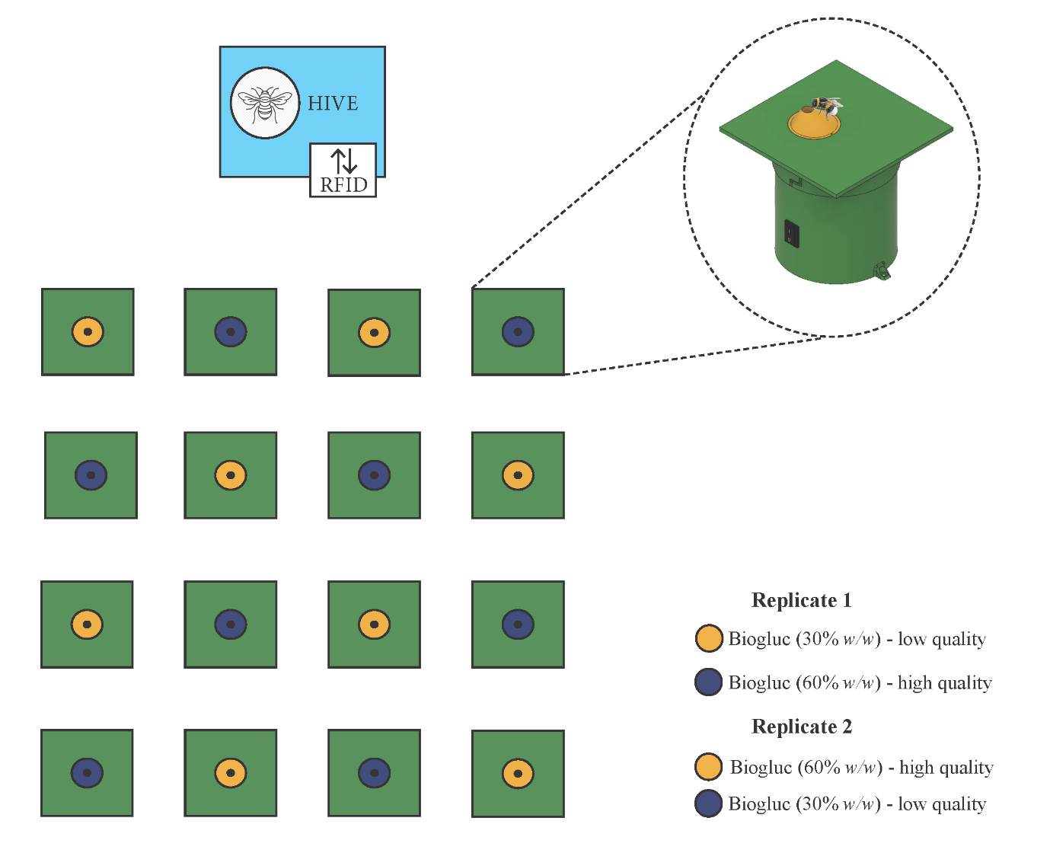To further prove the value of this new robotic flower, we performed a bumblebee foraging-preference experiment with two reward qualities in a greenhouse setting. After training on less rewarding flowers, we expect an initial preference for these lower-quality flowers (flower constancy) with a gradual shift towards the higher quality option during the trial (Heinrich, 1981). To test this, a robotic flower field consisting of 16 robotic flowers, alternating less and more rewarding flowers in a 4x4 setup, was used in two subsequent replicate trials (Fig. 2). The two types of flowers are represented by different colours, yellow and blue, so that foragers can discriminate between them visually and associate them with reward quality (Hammer & Menzel, 1995). We used Biogluc 30% *w/w* (less rewarding) and 60% *w/w* (more rewarding) as artificial nectar with preservatives to reduce microbial growth (Billiet et al., 2016). For both trials, a 7-weeks old lab-reared *B. terrestris* colony was placed in the arena with the robotic flowers. Before a trial, colonies were fed pollen and Biogluc ad libitum directly in the nest, but Biogluc supply was ceased 24 hours in advance to stimulate foraging. A trial started with 36 hours of training, where the colony was placed in a closed bug dorm with two 30% w/w rewarding flowers (without refilling gap). Subsequently, the bug dorm was opened at night to allow foraging in the arena starting the next morning. A refill gap of 30 minutes was implemented during this experimental phase.

Figure 2: Schematical setup of the proof of concept, where in both replicates the low and high quality sources were switched between the yellow and blue flower.

In total, 70 177 visits were recorded in this proof of concept. During the daily inspection of the setup within peak activity time-slots, a maximum of five foragers at once were observed. with the earliest flower visit at 7:36 and the latest at 19:17, the natural light regime of October in Leuven (sunrise ~7:55, sunset ~19:00) was well visible.

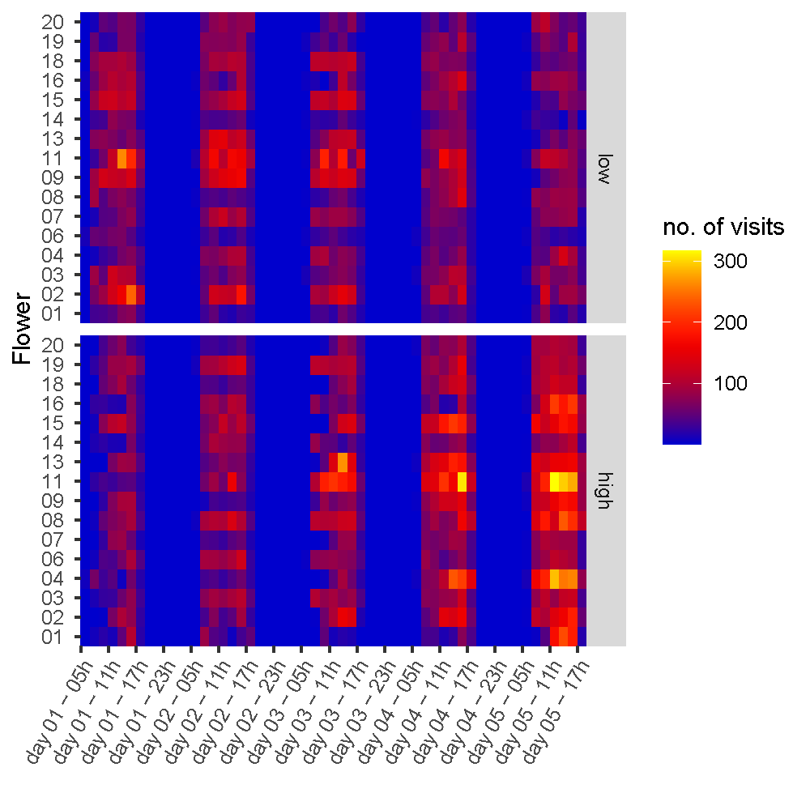The data were analysed using R version 4.2.1 (R Core Team, 2022). A heatmap representing the number of visits per flower per treatment (Fig. 3) already indicates an initial preference for the low concentration flowers with a switch towards the high concentration during the experiment.

Figure 3: A heatmap of the number of flower visits per quality of the nectar reward over the experimental period.

Data on the number of visits per hour per flower (n) were used in a general linear mixed model with Poisson distribution and an observation level random factor to account for overdispersion:

fit = glmer(**n** ~ (1|**flower**) + **concentration** * scale(**exp_day**) +

mSpline(**hour_of_day**, df=7, Boundary.knots = c(0,24), periodic=TRUE) + (1|obs),

family = poisson (link="log"), data = model_data,

control = glmerControl(optimizer = "Nelder_Mead", optCtrl = list(maxfun=100000)))

As can be seen in the Anova table (table 3), the model gives a significant effect of experimental day (*p* = 0.00039), as well as a significant interaction between the Biogluc concentration and experimental day (*p* < 2.2e-16). A significant effect was also found for the circadian rhythm in foraging (*p* < 2.2e-16).

In the first day after being trained on the low concentration, bumblebees visit the low concentration flowers about double as much as they visit high concentration flowers (high/low contrast ratio = 0.525, *p* < 0.0001). There is a linear trend of increasingly more visits towards the high concentration compared to the low concentration (high/low contrast estimate = 0.338, *p* < 0.0001), resulting in no significant difference in visitation rate between the two concentrations on the third experimental day (high/low contrast ratio = 1.032, *p* = 0.2765). On the last experimental day, the preference has switched to little over double the amount of visits to high concentration flowers compared to the low concentration flowers (high/low contrast ratio = 2.030, *p* < 0.0001). The effect plot (Fig. 4) gives a clear view on this preference shift, including the circadian rhythm in foraging.

**Table 3: Anova**

|  |  |  |  |
| --- | --- | --- | --- |
| Predictor | Chisq | Df | P value |
| Interept | 47.28744 | 1 | 6.13E-12 *** |
| Concentration | 1.184415 | 1 | 0.276 |
| Experimental day | 12.57797 | 1 | 0.00039 *** |
| Hour of day | 3205.677 | 7 | < 2.2E-16 *** |
| Conc. : Exp. Day | 265.8984 | 1 | < 2.2E-16 *** |

**Table 4: Estimated marginal means of linear trends (emtrends)**

|  |  |  |  |
| --- | --- | --- | --- |
| Contrast | Estimate | SE | P value |
| High/Low | 0.338 | 0.0207 | < 0.0001 *** |

**Table 5: Estimated marginal means (emmeans)**

|  |  |  |  |  |
| --- | --- | --- | --- | --- |
| Contrast | Day | Ratio | SE | P value |
| High/Low | 1 | 0.525 | 0.0270 | < 0.0001 *** |
| High/Low | 2 | 0.736 | 0.0268 | < 0.0001 *** |
| High/Low | 3 | 1.032 | 0.0303 | 0.2765 |
| High/Low | 4 | 1.448 | 0.0514 | < 0.0001 *** |
| High/Low | 5 | 2.030 | 0.1019 | < 0.0001 *** |

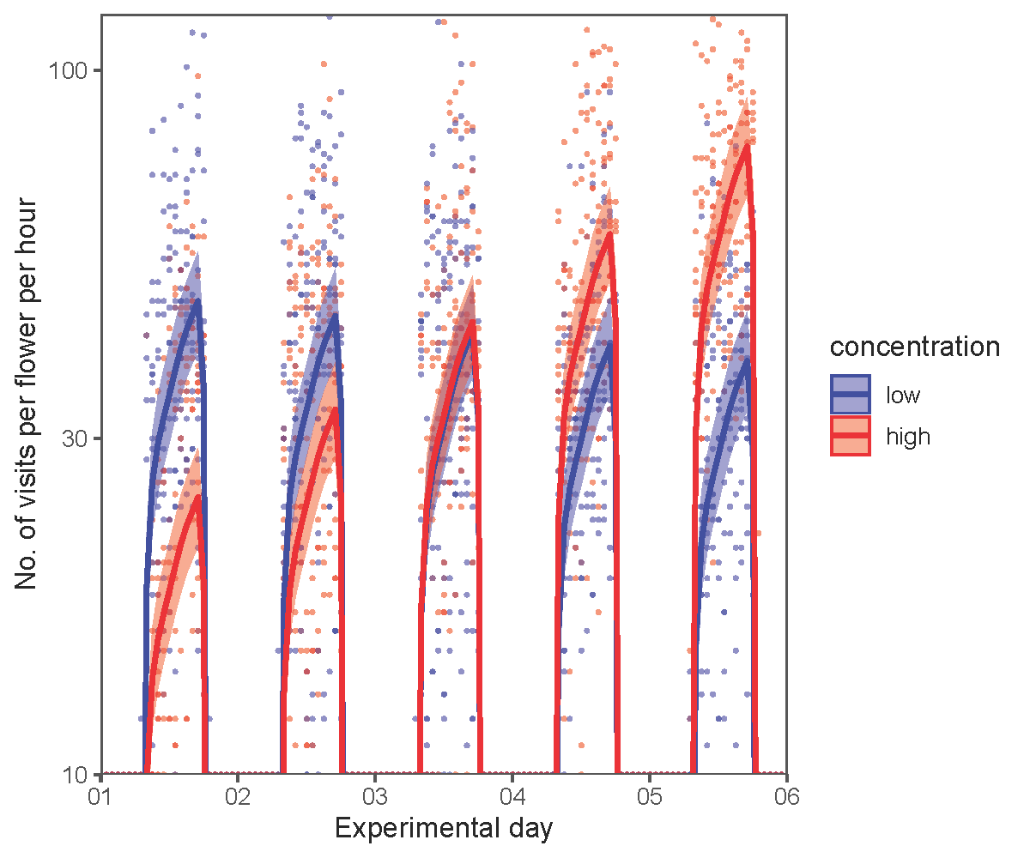

Figure 4: An effect plot of the number of bumblebee flower visits per concentration as predicted by the generalized linear mixed model plotted over the raw data.

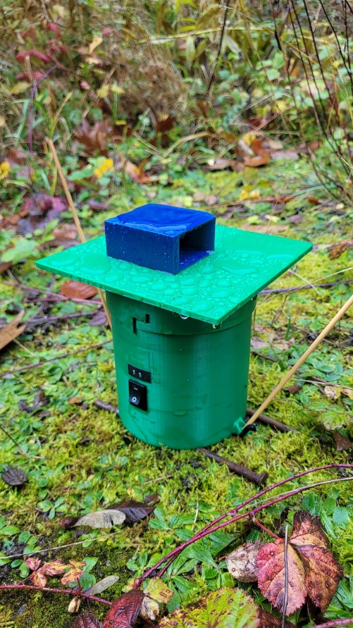

# Waterproof testing

A robotic flower was put outside in rainy conditions (November 2023, Leuven) to see if the system can withstand the water (Fig. 5). For this test, we used the roofed central flower disk design to prevent water entering the feeding hole. To make sure the flower bottom is not soaked completely in the wet underground, we elevated it slightly from the ground. To prevent tipping over by the wind or uncareful by passers (e.g. nosy birds), the flower was anchored in the ground.

The flower kept working as long as the battery was charged and did not show any signs of leakage, which proved the system’s water resistance.

Figure 5: a robotic flower placed outside in the rain, anchored in the ground to prevent it from being blown over.

# References

Billiet, A., Meeus, I., Van Nieuwerburgh, F., Deforce, D., Wackers, F., & Smagghe, G. (2016). Impact of sugar syrup and pollen diet on the bacterial diversity in the gut of indoor-reared bumblebees (Bombus terrestris). *Apidologie*, *47*(4), 548-560. <https://doi.org/10.1007/s13592-015-0399-1>

Hammer, M., & Menzel, R. (1995). Learning and memory in the honeybee. *The Journal of Neuroscience*, *15*(3), 1617-1630. <https://doi.org/10.1523/jneurosci.15-03-01617.1995>

Heinrich, B. (1981). *Bumblebee economics* (3 ed.). Harvard University Press.

R Core Team. (2022). *R: A language and environment for statistical computing*.In R Foundation for Statistical Computing. <https://www.R-project.org/>