**III. Frequency Shift Key (FSK)**

**1. Modulation of Frequency Shift Keying (FSK) signal from a Random Binary Sequence**

Introduce: Frequency Shift Keying (FSK) is a digital modulation technique used to transmit binary data over a carrier frequency. In this technique, the binary data is used to modulate the frequency of the carrier signal. There are two carrier frequencies used in FSK modulation, one for transmitting binary 0 and the other for transmitting binary 1.

In this experiment, a random binary sequence will be used to modulate the frequency of the carrier signal. The following steps will be taken to perform the FSK modulation.

**1.1 Generation of Carrier Signal(s):**

The first step in FSK modulation is to generate the carrier signal(s). The carrier signal is a sinusoidal wave that is used to transmit the binary data. The frequency of the carrier signal is changed depending on the binary data being transmitted. In this exercise, two carrier frequencies, $f_{1}$ and $f_{2}$ (denoted by $Hz$), will be used to represent binary 0 and binary 1, respectively.

The experiment we will show below has two values of $f_{1}$, $f_{2}$ which are set to 100 and 50 respectively

f1 = 100 # The frequency of the first carrier signal.

f2 = 50 # The frequency of the second carrier signal

**1.2 Generation of Binary Data Sequence:**

The next step is to generate the binary data sequence that will be used to modulate the carrier signal. The binary data sequence is a series of binary digits (0s and 1s) that represent the information being transmitted. In this example, instead of a random binary sequence that will be generated to demonstrate the FSK modulation technique, we will experiment with a fixed binary sequence to test the effect of Gaussian noise in section 3.

# binary_data: The binary data sequence that will be modulated.

binary_data = [1, 0, 1, 0, 1, 0, 1, 0, 1, 0]

**1.3 FSK Modulation:**

Once the carrier signal(s) and binary data sequence have been generated, the next step is to perform the FSK modulation. The FSK modulation is performed by multiplying the carrier signal by the binary data sequence. The resulting signal is the FSK modulated signal.

The mathematical formula for the FSK modulation can be represented as follows:

$$FSK Modulated Signal = Carrier Signal × Binary Data Sequence$$

Where:

$$Carrier Signal = Acos(2πf_{1}t) or Acos(2πf_{2}t)$$

$Binary Data Sequence =$ 0 or 1

$A$ = Amplitude of the carrier signal

$f_{1}$, $f_{2}$ = Carrier frequencies representing binary 0 and binary 1, respectively, denoted by $Hz$

$t$ = Time, denoted by $s$

Here are data values we used for the experiment:

A = 1 # The Amplitude of signal

N = 1000 # The number of samples in the time domain.

f1 = 100 # The frequency of the first carrier signal.

f2 = 50 # The frequency of the second carrier signal

t = np.linspace(0, 1, N) # The time vector, generated using the numpy function "linspace" from 0 to 1 with N samples.

N0 = 2 # The power spectral density of the Gaussian noise.

General carrier:

# carrier1: The first carrier signal, generated using the numpy cosine function with 2pif1*t as the argument.

carrier1 = np.cos(2*np.pi*f1*t)

# carrier2: The second carrier signal, generated using the numpy cosine function with 2pif2*t as the argument.

carrier2 = np.cos(2*np.pi*f2*t)

Perform FSK modulation:

# fsk_modulated_signal: The FSK modulated signal, generated by replacing each symbol of the binary data with the corresponding carrier signal.

fsk_modulated_signal = np.zeros(N)

for i in range(len(binary_data)):

    if binary_data[i] == 1:

        fsk_modulated_signal[i*N//len(binary_data):(i+1)*N//len(binary_data)] = carrier1[i*N//len(binary_data):(i+1)*N//len(binary_data)]

    else:

        fsk_modulated_signal[i*N//len(binary_data):(i+1)*N//len(binary_data)] = carrier2[i*N//len(binary_data):(i+1)*N//len(binary_data)]

**1.4 Plotting the FSK Modulated Signal:**

Finally, the FSK modulated signal is plotted to visualize the effect of the FSK modulation. The plot of the FSK modulated signal will show how the frequency of the carrier signal changes based on the binary data sequence being transmitted.

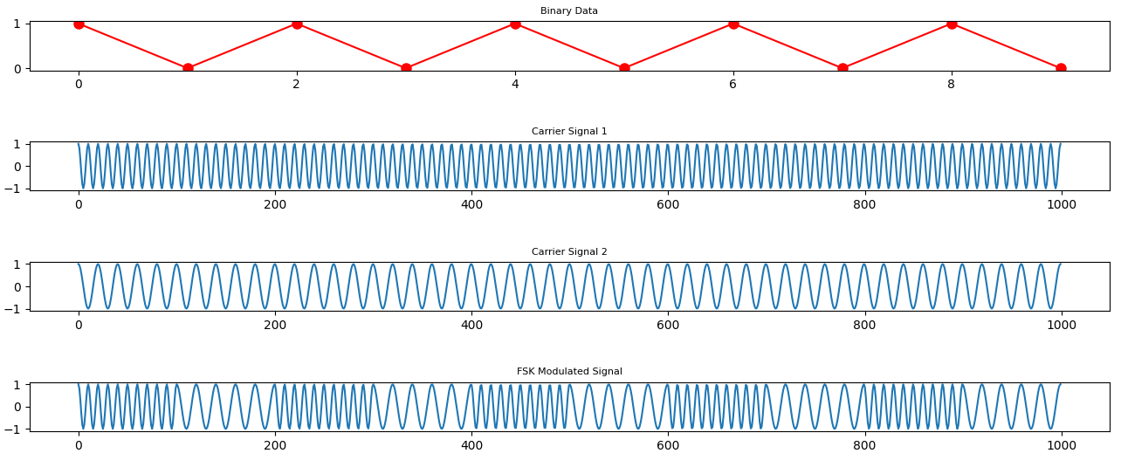

By generating the carrier signal(s), binary data sequence, and performing the FSK modulation, a FSK modulated signal can be obtained that accurately represents the binary data being transmitted.

**2. Demodulation of Frequency Shift Keying (FSK) Signal**

Once the FSK modulated signal has been generated, the next step is to demodulate the signal to recover the original binary data. The process of converting the FSK modulated signal back into the binary data sequence is called FSK demodulation. The following steps will be taken to perform the FSK demodulation.

**2.1 Correlation of FSK Modulated Signal with Carrier Signal:**

The first step in FSK demodulation is to correlate the FSK modulated signal with the carrier signal. Correlation is a mathematical operation that measures the similarity between two signals. In FSK demodulation, the FSK modulated signal is correlated with the carrier signal to generate decision variables.

The mathematical formula for the correlation between the FSK modulated signal and the carrier signal can be represented as follows:

$$Decision Variable = ∫\left(FSK Modulated Signal\right)× \left(Carrier Signal\right)dt$$

**2.2 Obtainment of Demodulated Binary Data:**

Once the decision variables have been generated, the next step is to obtain the demodulated binary data. The demodulated binary data is obtained by comparing the decision variables with a threshold value. If the decision variable is greater than the threshold value, the demodulated binary data is 1, and if the decision variable is less than the threshold value, the demodulated binary data is 0.

The mathematical formula for obtaining the demodulated binary data can be represented as follows:

$$Demodulated Binary Data = 1 if Decision Variable > Threshold, 0 otherwise$$

The function is represented in experiment as below:

# demodulated_binary_data: The demodulated binary data, obtained by deciding the symbol based on the decision variable calculated from the correlation between the noisy signal and each carrier signal.

demodulated_binary_data = np.zeros(len(binary_data))

for i in range(len(binary_data)):

    data_segment = r[i*(N//len(binary_data)):(i+1)*(N//len(binary_data))]

    carrier1_segment = carrier1[i*(N//len(binary_data)):(i+1)*(N//len(binary_data))]

    carrier2_segment = carrier2[i*(N//len(binary_data)):(i+1)*(N//len(binary_data))]

    decision_variable1 = np.sum(data_segment * carrier1_segment)

    decision_variable0 = np.sum(data_segment * carrier2_segment)

    if decision_variable1 - decision_variable0 > threshold:

        demodulated_binary_data[i] = 1

    else:

        demodulated_binary_data[i] = 0

In the absence of noise, the binary string returned after demodulation will be the same as the original binary string.

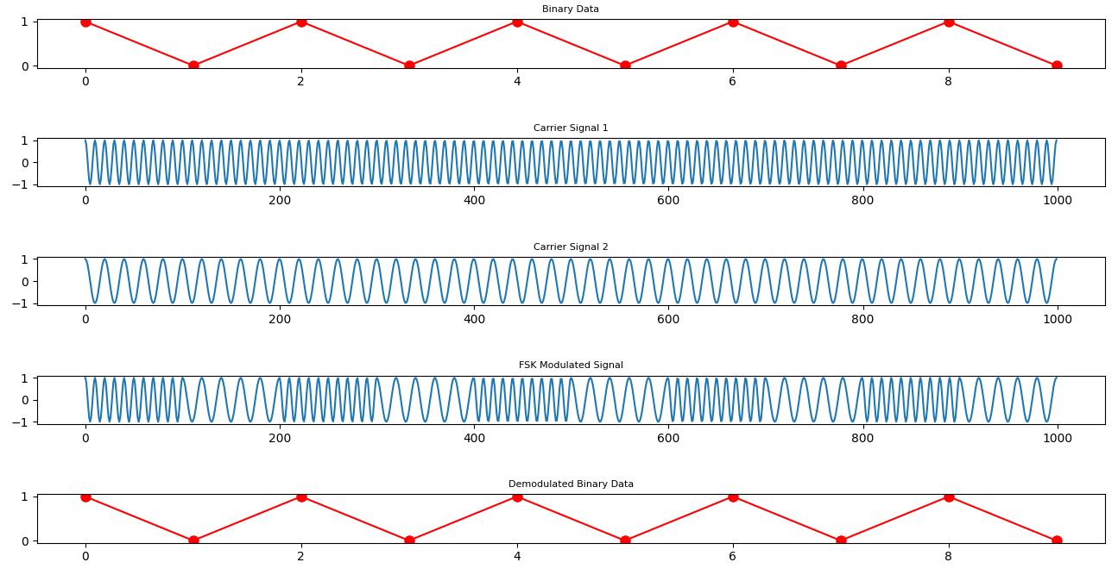

By performing the correlation between the FSK modulated signal and the carrier signal, and obtaining the demodulated binary data based on the decision variables, the original binary data can be recovered accurately.

**3. Investigation of the Effect of Gaussian Noise on Frequency Shift Keying (FSK) Modulation/Demodulation**

In any communication system, the transmission of data is subjected to various sources of interference, such as noise, that can affect the quality of the received signal. In this section, we will investigate the effect of Gaussian noise on the FSK modulation/demodulation process.

**3.1 Gaussian Noise:**

Gaussian noise is a type of random noise that is widely used to model various sources of interference in communication systems. Gaussian noise has a zero mean and a variance of $\frac{N_{0}}{2}$, where $N_{0}$ is the power spectral density of the noise.

The equation for adding Gaussian noise to the transmitted waveform can be represented as follows:

$$r\left(t\right)= s\left(t\right)+ n\left(t\right)$$

Where:

$s\left(t\right)$ = FSK Modulated Signal

$n\left(t\right)$ = Gaussian Noise with zero mean and variance $\frac{N_{0}}{2}$

$r\left(t\right)$ = Received Signal

**3.2 Error Probability:**

The next step is to numerically compute the error probability, which is a measure of the performance of the communication system in the presence of noise. The error probability can be calculated by comparing the demodulated binary data with the original binary data sequence. If the demodulated binary data is different from the original binary data sequence, an error has occurred.

The mathematical formula for error probability can be represented as follows:

$$Error Probability = \frac{Number of Errors}{Total Number of Bits Transmitted}$$

Overall, this section investigates the effect of Gaussian noise on the FSK modulation/demodulation process. The addition of Gaussian noise to the transmitted waveform is modeled, and the error probability is calculated to assess the performance of the communication system in the presence of noise.

**4. Deriving the Bit Error Probability of a Gaussian Channel using Frequency Shift Keying (FSK) Modulation/Demodulation**

In this section, we will derive the bit error probability of a Gaussian channel using the FSK modulation/demodulation method described in this exercise. This derivation will provide an understanding of the relationship between the signal-to-noise ratio (SNR) and the bit error probability for the FSK modulation/demodulation process.

**4.1 Signal-to-Noise Ratio (SNR):**

The signal-to-noise ratio (SNR) is a measure of the relative strength of the signal compared to the noise in a communication system. The SNR can be calculated as follows:

$$SNR =\frac{Signal Power}{Noise Power}$$

**4.2 Bit Error Probability:**

In the presence of noise, the demodulated binary data may not be the same as the original binary data sequence, resulting in errors. The bit error probability is a measure of the number of errors that occur during the transmission of binary data.

The bit error probability can be calculated as follows:

$$Bit Error Probability = 1 -{ (1 + SNR)}^{\frac{-1}{2}}$$

Where SNR is the signal-to-noise ratio, and the expression inside the parentheses is the complementary error function, denoted as erfc(x).

**4.3 FSK Modulation/Demodulation in Gaussian Channel:**

In the case of FSK modulation/demodulation in a Gaussian channel, the signal-to-noise ratio can be calculated as follows:

$$SNR =\frac{Signal Power}{Noise Power}$$

$$=\frac{Energy per Bit}{Noise Power Spectral Density}$$

Using the above equation, the bit error probability can be derived as follows:

$$Bit Error Probability = 1 - {\left(1 +\frac{Energy per Bit}{Noise Power Spectral Density}\right)}^{-\frac{1}{2}}$$

In conclusion, this chapter presents the derivation of the bit error probability of a Gaussian channel using the FSK modulation/demodulation process. The derivation provides an understanding of the relationship between the signal-to-noise ratio and the bit error probability for the FSK modulation/demodulation process in the presence of noise.