COMP316 – 18A Assignment 2 Report
Yunhao Fu
ID: 1255469

Abstract
This report is for COMP316 – 18A assignment 2. This is an assignment about searching on map using both best first and a star algorithm.
The main difference between these two similar algorithm is that the a star consider both the heuristic value from current position to goal position and the how far it already went. While the best first algorithm only maintains the heuristic value which is greedy.
Other differences please see the following table:

Strategy | Selection from Frontier | Halts? | Space
Best first | Globally minimal h(p) | NO | Exponential
A star | Minimal cost(p) + h(p) | YES | Exponential
Figure 1 Summary of Search Strategies (Poole & Mackworth, 2017, p. 92)

The “Halts?”, as it said in the book, indicates that “Is this method guaranteed to halt if there is a path to a goal on a graph with a finite number of neighbours for each node?”

Result
Three maps are provided on Moodle for testing. One more beautiful graph as I created is going to show the difference on the “Halts?” problem.

Map1.txt Result:
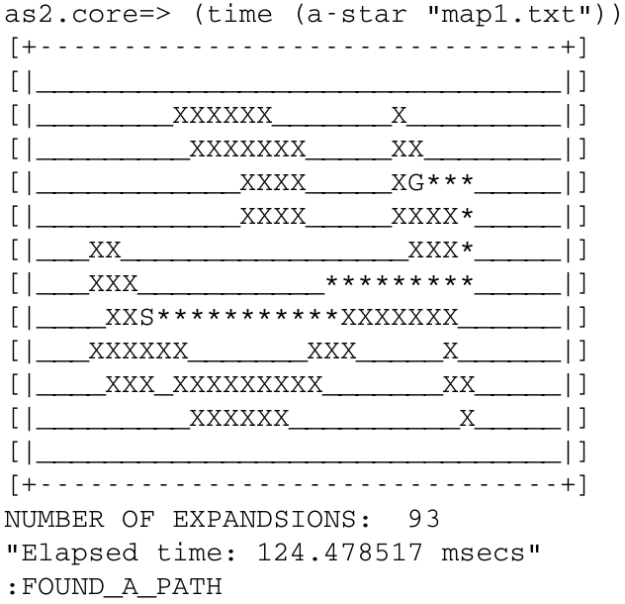
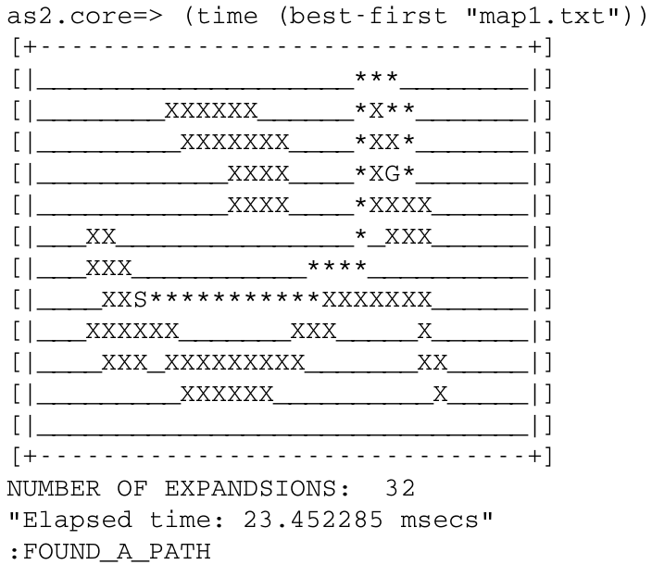

Let us compare these two graphs with different paths. A star chooses to go from the bottom of G to the goal while best first is going to approach goal from the top. A star really does a good job since the total path length (26) is less than the length of best first path (28) by 2. Somehow the best first search has shorter time duration and expansion, this is because this algorithm only considers heuristic value.

Map2.txt Result:
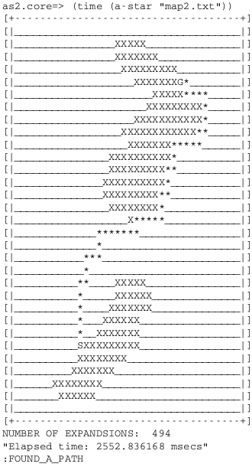
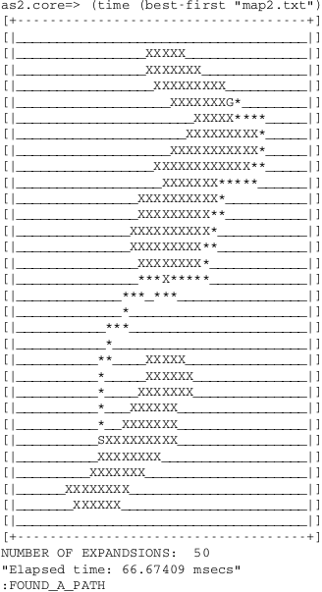

The difference of path is not obvious at the most beginning and end. The best first is more like to “go ashore” as quick as possible and pass around the land while a star will find a good point to “debark”. A star gives a better way, which is the optimal path from the start point to goal point. The length of best first search is 47 and a star is 45, which is better and optimal.

Map3.txt Result:
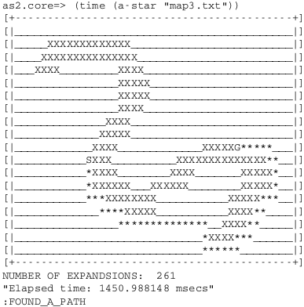
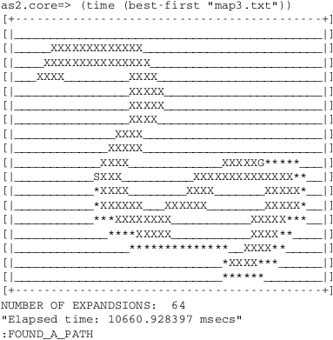

The result of map3 is as usual. The number of expansions in a-star is greater than best-first. But this time, both a star and best first find the optimal path which length is 50. So, we can conclude that best first has ability to find the optimal path, but it just stops at the time when the frontier is goal.

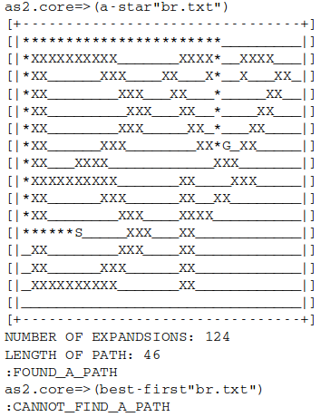
Br.txt Result:

This example is going to show the “Halt?” problem. Since I put a threshold of total frontiers, once the length of all frontiers exceeds the threshold, it halts and returns :CANNOT_FIND_A_PATH. In short, the best first is not optimal because it may take longer time to figure out the path, BUT a star can do a great job! Previous examples already show the best-first could find sub-optimal route. So, I create a graph to discuss the “Halt?” problem.
Reference
Poole, D., & Mackworth, A. (n.d.). 3.7.3 Summary of Search Strategies - Artificial Intelligence 2E. Retrieved April 13, 2018,from http://artint.info/2e/html/ArtInt2e.Ch3.S7.SS3.html

End of Report

