Lab 1: Setting up Virtual Machines
INSTRUCTIONS:
- Rename this document by substituting out FirstNameLastName with your own.
- You will need both of your VMs to complete this lab.
- Complete all green boxes in this lab sheet.
- Submit your renamed document to the submission link on Blackboard before the deadline.


When you log in to the Rocky Linux virtual machine, you may see a message similar to the following:
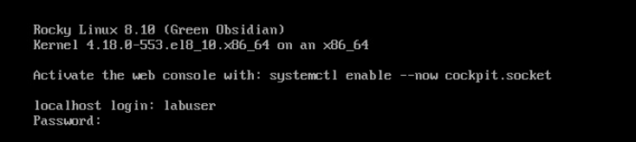
Do not activate the web console or use it for any part of this or any lab. We will be working exclusively in the command-line interface (CLI) to develop critical Linux administration skills. All tasks should be completed using the terminal.


Task 1: Create / Check a Non-root User
- Ubuntu VM:
  - By default, the root account is locked. Use the pre-configured labuser account with sudo access.
- Rocky Linux VM:
  - Initially you will need to log in as root and then create a new user named labuser:
sudo adduser labuser

  - Set a password for the labuser account:
sudo passwd labuser

  - Add labuser to the wheel group to grant sudo privileges:
sudo usermod -aG wheel labuser

What is the wheel group? The wheel group is a special user group that is commonly used for granting administrative privileges to users. Specifically, users in the wheel group are granted permission to execute commands with superuser (root) privileges through the sudo command. This setup is common in Linux distributions like Rocky Linux, CentOS, RHEL, and Fedora, and it provides an added layer of security. In semester 1, you may recall we gave labuser elevated privileges by adding the line: labuser ALL=(ALL) ALL to the sudoers file found at /etc/sudoers which is edited using the visudo command. Adding labuser to the wheel group is another method. It means anyone who is a member of the wheel group can run any command as any user, including root, by prefixing the command with sudo.
  - Log out from the root account and log in as labuser.
  - Verify sudo access:
sudo whoami

Ensure the output is root.
Why is root the output of sudo whoami when you are logged in as labuser ? The sudo whoami command outputs root because the sudo command temporarily elevates your permissions to those of the root user for the duration of the command. When you run sudo whoami, it executes the whoami command with root privileges, and thus the result is root. When logged in as the labuser account, using whoami without sudo would correctly return labuser.

Task 2: Set Hostnames
- Rocky Linux VM:
  - Check the current hostname:
hostnamectl status
  - Change the hostname:
sudo hostnamectl set-hostname rocky-firstname

Replace firstname with your first name.
  - Log out and log back in to see the new hostname reflected.
- Ubuntu VM:
  - Follow the same steps to rename the Ubuntu VM (QTerminal is the name of the terminal available on lubuntu found in the start menu System Tools):
sudo hostnamectl set-hostname ubuntu-firstname

Complete this box by pasting screenshot(s) of:

Each of your VMs (with the name of your VM visible) to show that you changed the hostname and that you are logged on with the labuser account.

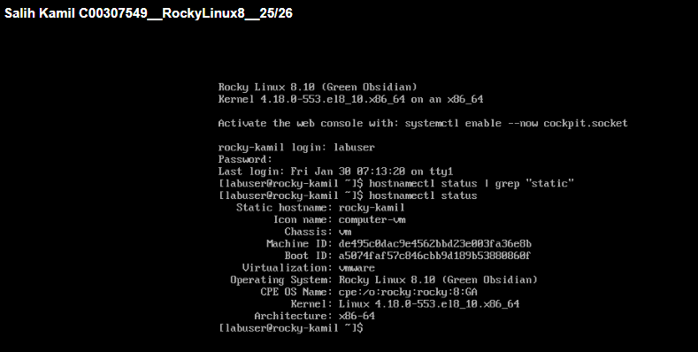

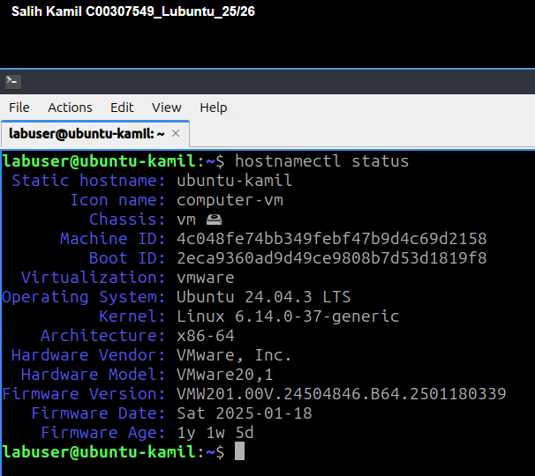

Task 3: Configuring Network Settings
Part 1: Inspect Network Interfaces
- Check the network interface information on both VMs:
ip a

- Note the MAC addresses and interface names (e.g., ens192, ens224).

Part 2: Configure Public Network (Dynamic IP)
- Rocky Linux VM:
  - Use nmtui to configure the public network interface (ens192):
nmtui

  - Set IPv4 CONFIGUTRATION to <AUTOMATIC> for DHCP, ensure Automatically connect is selected, <OK> and activate the connection.
  - Verify the dynamic IP address:
ip a
- Ubuntu VM:
  - Verify the public network interface (ens192 Wired connection 1) has picked up a dynamic IP address automatically:
ip a

Part 3: Configure Private Network (Static IP)
- Rocky Linux VM:
  - Use nmtui to configure the private network interface (ens224) with a static IP:
nmtui

  - Set IPv4 CONFIGUTRATION to <Manual> for set a static IP Address of 192.168.56.10/24, ensure Automatically connect is selected, <OK> and activate the connection.
  - Verify the static IP address:
ip a
- Ubuntu VM:
  - Use nmtui to configure the private network interface for ens224 Wired connection 2:
nmtui

  - Assign the static IP address 192.168.56.20, save, and activate the connection.
Complete this box by pasting screenshot(s) of:

Each of your VMs (with the name of your VM visible) with the output of the ip a command to show that each VM has a public and private IP address as advised.

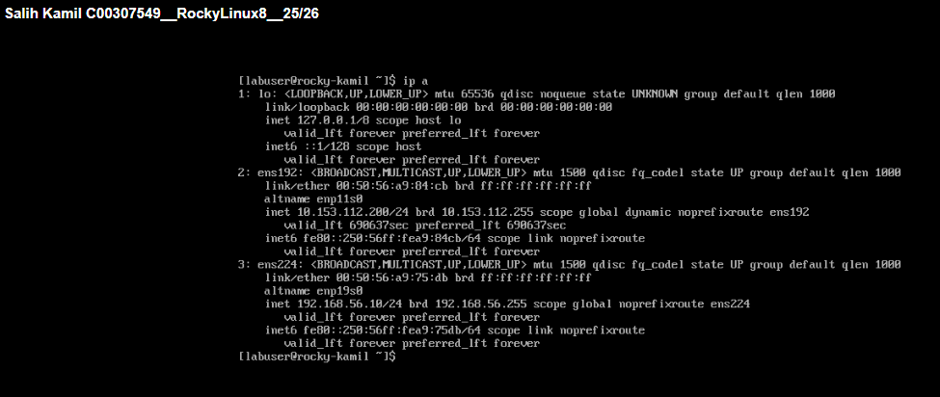

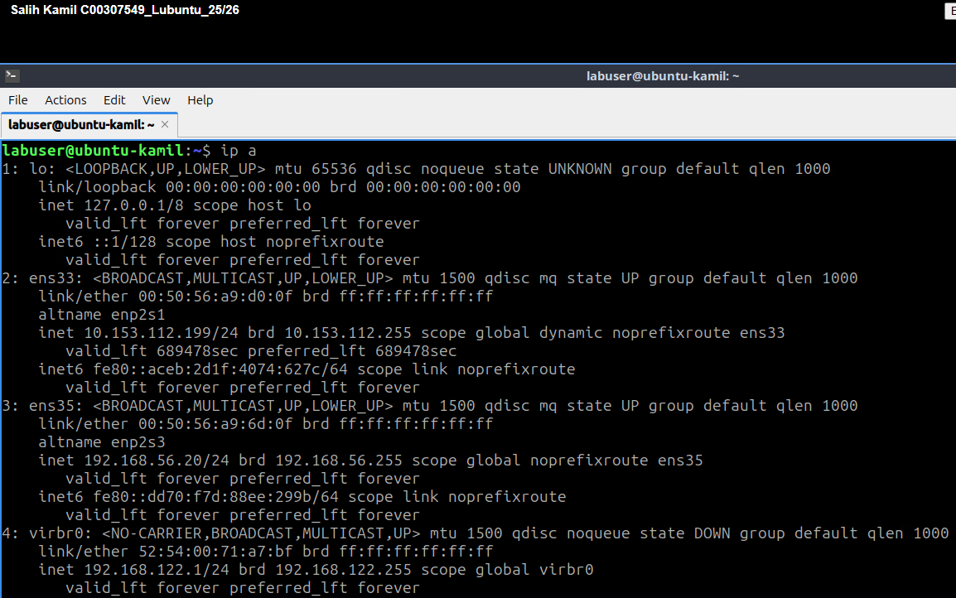

Task 4: Testing Connectivity
- Ping Test:
  - From the Rocky Linux VM, ping the Ubuntu VM:
ping 192.168.56.20
  - From the Ubuntu VM, ping the Rocky Linux VM:
ping 192.168.56.10

- Internet Access Test:
  - Verify internet access by installing a package (e.g., nano):
sudo dnf install nano # Rocky Linux
sudo apt install nano # Ubuntu

Complete this box by pasting screenshot(s) of:

Each of your VMs (with the name of your VM visible) with the output of the ping command to show that each VM can communicate with each other on the private network.

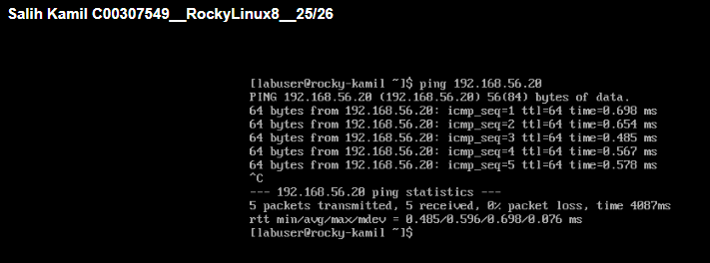

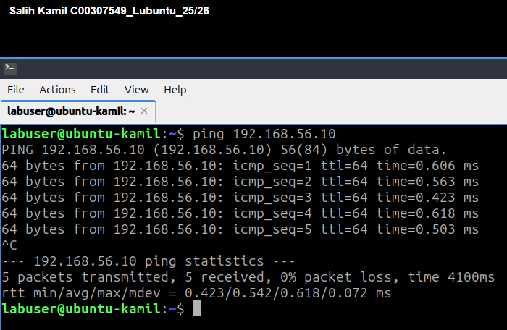

Task 5: Check Firewall Status (and enable if not already)
  - From the Rocky Linux VM, check the status of firewalld and if not active then run:
sudo systemctl start firewalld
sudo systemctl enable firewalld
  - From the Ubuntu VM, check the status of ufw and if not active then run:
sudo systemctl start ufw
sudo systemctl enable ufw

