Lab 2 Part A: OS Updates, Package Management and Repositories

INSTRUCTIONS:
- Rename this document by substituting out FirstNameLastName with your own.
- Login and complete tasks as labuser.
- Carry out all tasks (unless explained otherwise) on both VMs
- Complete all green boxes in this lab sheet.
- Submit your renamed document to the relevant submission link on Blackboard before the deadline.

Part A: Updating and Managing Packages

Task 1: Updating Repository Metadata
- Update Repository Metadata:
# Rocky Linux:
sudo dnf makecache

# Ubuntu:
sudo apt update

- Observe the output: Note the differences in how Rocky Linux and Ubuntu display their results.

Complete this box by answering these questions based on the task above:

What does Hit indicate in the Ubuntu output? Hit output indicates that the package metadata for that repository is already up-to-date and does not need to be downloaded again. It means the local cache has the latest information.

Why is it important to update repository metadata? Updating repository metadata ensures that the package manager knows about the latest available versions of software and security patches. Without updating, you might install outdated or vulnerable packages.

Task 2: Checking and Perform Updates
- Check for available updates:
# Rocky Linux:
sudo dnf check-update

# Ubuntu:
sudo apt list -–upgradable

- Filter the list to display security updates only on Rocky Linux:
# Rocky Linux:
dnf updateinfo list security

Complete this box by answering these questions based on the task above:

Which packages are being updated due to security patches? None. The only output was “Last metadata expiration check: 0:16:37 ago on Fri 30 Jan 2026 07:44:10 EST”

Research one or two of those packages using the CVE Details website and describe the vulnerability being addressed. (Include CVE ID, summary of the issue, and potential impact)

I will research the OpenSSL package.
Title: ASN1_TYPE Type Confusion in the PKCS7_digest_from_attributes() function
CVE ID: CVE-2026-22796

A type confusion bug in PKCS#7 signature verification allows malformed data to trigger an invalid or NULL pointer dereference, resulting in a crash. The issue stems from PKCS7_digest_from_attributes() accessing a message digest without validating its ASN.1 type. It is low severity (DoS only, legacy API), affects OpenSSL 3.6–3.0, 1.1.1, and 1.0.2, and does not affect FIPS modules.

Potential impact: Malformed PKCS#7 input can crash affected applications, causing a Denial of Service.

Why is it critical to apply these patches?
To prevent attackers from crashing services using a known OpenSSL flaw.

What attacks might exploit an unpatched vulnerability?
An attacker could send malformed PKCS#7 data to trigger a crash, causing a Denial-of-Service attack against applications that perform PKCS#7 signature verification.

- Update all installed packages:
# Rocky Linux:
sudo dnf update

# Ubuntu:
sudo apt upgrade

Task 3: Installing, Removing and Searching for Packages
- Install a package (e.g., nano) on both systems:
# Rocky Linux:
sudo dnf install nano

# Ubuntu:
sudo apt install nano

- Verify the installation by running: nano

- Remove the package:
# Rocky Linux:
sudo dnf remove nano

# Ubuntu:
sudo apt remove nano

  - Verify the removal by running nano again.

- Search for a package (e.g., curl):
# Rocky Linux:
sudo dnf search curl

# Ubuntu:
sudo apt search curl

- Compare the search results and note differences in formatting and detail.

Task 4: Managing Package Cache
- Check the current package cache size:
# Rocky Linux:
du -sh /var/cache/dnf

# Ubuntu:
sudo du -sh /var/cache/apt

- Clear the package cache:
# Rocky Linux:
sudo dnf clean all

# Ubuntu:
sudo apt clean

- Recheck the package cache size to confirm the clearing.

Part B: Adding and Using Additional Repositories

While the default Rocky Linux repositories include many packages, you may need to enable additional repositories like EPEL for tools required in later labs. This lab guides you through adding EPEL to Rocky Linux and exploring its functionality.

For example, if you try running the htop command before enabling EPEL, you might receive the error: command not found.


Task 5: Enable EPEL on Rocky Linux

1: Install Required Packages
First, install the dnf-plugins-core package and the epel-release package:

sudo dnf install dnf-plugins-core epel-release

- dnf-plugins-core: Provides utilities for managing repository priorities - ensuring that packages from third-party repositories do not overwrite official Rocky Linux packages if they share the same name.
- epel-release: Installs the Extra Packages for Enterprise Linux (EPEL) repository configuration

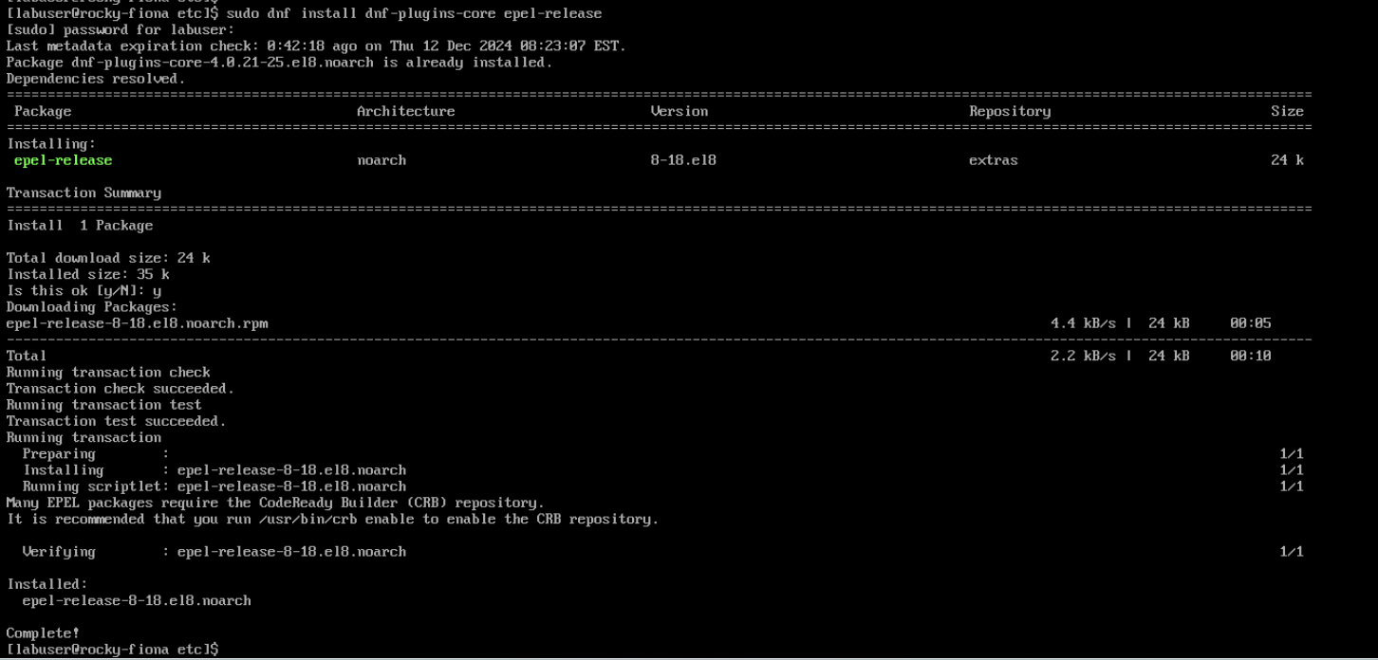

2: Verify the EPEL Repository is Enabled
Once the installation is complete, you can verify that the EPEL repository is enabled by checking the repository configuration in the /etc/yum.repos.d/ directory. Look for a file named epel.repo.

Verify the repository status:
sudo dnf repolist
Look for the EPEL repository in the output.

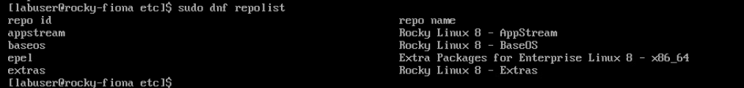

3: Configure Repository Priorities
Edit the repository files to avoid conflicts.

- Edit the Rocky-BaseOS.repo file:

sudo vi /etc/yum.repos.d/Rocky-BaseOS.repo

Add the line priority=1 under the [baseos] section, like so:
[baseos]
name=Rocky Linux $releasever – Base
. . .
#baseurl=http://dl.rockylinux.org/$contentdir/$releasever/BaseOS/$basearch/os/
gpgcheck=1
. . .
gpgkey=file:///etc/pki/rpm-gpg/RPM-GPG-KEY-rockyofficial
priority=1
Do the same for Rocky-Extras.repo

- Edit the epel.repo file:

sudo vi /etc/yum.repos.d/epel.repo

Add the line priority=10 under the [epel] section, and set priority=11 for any additional sections.
[epel]
name=Extra Packages for Enterprise Linux 8 – $basearch
#baseurl=https://download.example/pub/epel/8/Everything/$basearch
. . .
gpgcheck=1
. . .
gpgkey=file:///etc/pki/rpm-gpg/RPM-GPG-KEY-EPEL-8
priority=10

4: Update the system
Once the repository files are configured, update your system:
sudo dnf upgrade

5: Search for a package from EPEL (e.g., htop)
To search for package in the EPEL repository:
dnf search htop
This will show you the htop package and other related packages available in the EPEL repository.

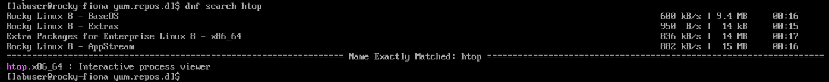

6: Install and Test a Package
To install a package from EPEL, use the dnf install command. For example, to install htop ( a process viewer)
sudo dnf install htop
Ensure that the repository listed in the output is EPEL.

Test that the htop package was installed correctly by running:
htop
This will launch the htop process viewer, confirming the successful installation of a package from EPEL.
Use Ctrl+Z to exit.


Task 6: Download and Install Google Chrome on Ubuntu

**You must complete this using the command line (do not use the GUI).

Step 1: Install wget utility

What is wget? wget is a command-line utility used for downloading files from the web. It supports HTTP, HTTPS, and FTP protocols, allowing users to retrieve files from URLs directly to their system. It's commonly used for automating file downloads, retrieving large datasets, or downloading files in scripts, as it works non-interactively (i.e., it doesn't require user input once the command is issued). Learn more about wget: https://linuxize.com/post/wget-command-examples/

Since the Chrome browser is not included in the Ubuntu default repository, we need to install the wget utility by running:

sudo apt install wget

Step 2: Download .deb Package for Google Chrome
Now that wget is installed, use it to download the latest stable package of Google Chrome. Run the following command:
wget https://dl.google.com/linux/direct/google-chrome-stable_current_amd64.deb

This will download the .deb file to your current directory.

The result should look similar to this:

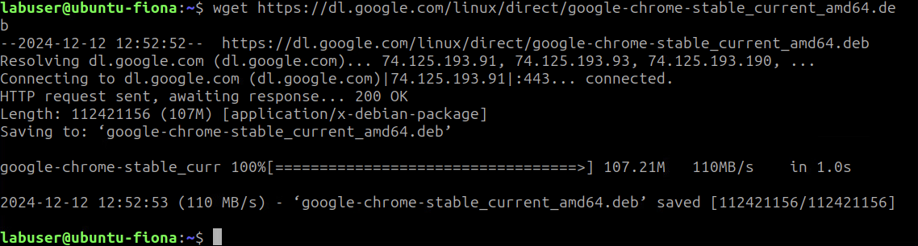

Take a look at the contents of your home directory to see the locally downloaded .deb file.
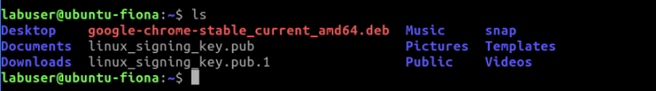
To confirm the file was downloaded, list the contents of the directory:

ls -l

Step 3: Install Google Chrome
Use the dpkg command to install the downloaded package:

sudo dpkg -i google-chrome-stable_current_amd64.deb

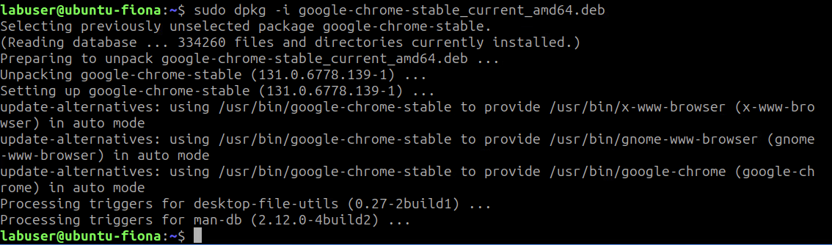

What is the purpose of the -i action in the command above? Use man pages to find out and write your (short) answer here:
It is used to install a .deb package file (or upgrade it if that package is already installed).

Step 4: Launch Chrome
To start Google Chrome, type the following command:

google-chrome

You can also find it in the start menu under Internet.

Complete this box by pasting a screenshot of:

Your Ubuntu VM (with the name of your VM visible) with Google Chrome open.

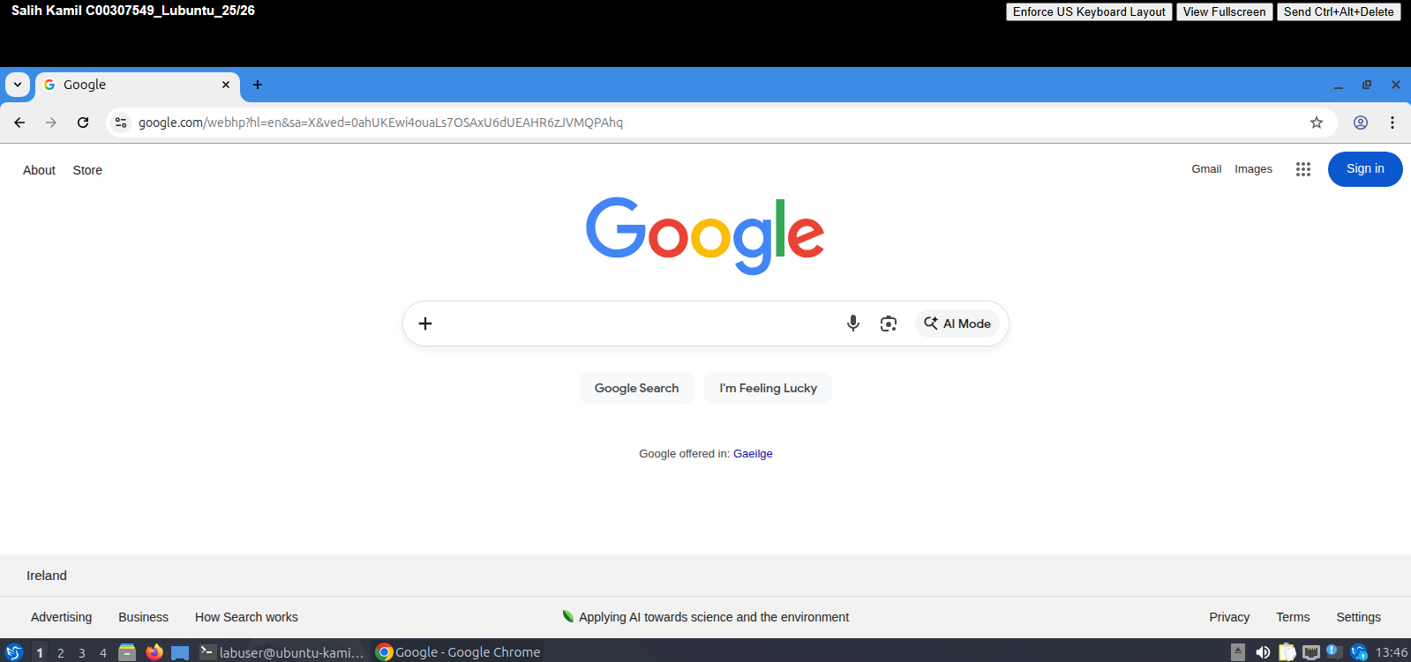

Step 5 (Optional): Uninstall Google Chrome
To remove Google Chrome from your system, run:

sudo apt purge google-chrome-stable

The deb file for Google Chrome should still exist on your local filesystem so it is easy to reinstall again if wanted.

Task 7: Download an Image File using wget
Step 1: Download an Image Using wget
Using wget, download an appropriate image. This is a sample command (swap out actual image file name):

wget https://www.example.com/sample-image.jpg

After the download completes, list the files in your directory to confirm:

ls -l

Step 2: View the Image
To view the image, you may need to install an image viewer (Eye of Gnome) first:

sudo apt install eog

Then, use the following command to open the image:

eog sample-image.jpg

Complete this box by pasting a screenshot of:

Your Ubuntu VM (with the name of your VM visible) with an image file open in an image viewer app.

