Lab 2 Part B: Verifying Checksum

INSTRUCTIONS:
- Rename this document by substituting out FirstNameLastName with your own.
- Login and complete tasks as labuser.
- You can use either of your VMs to complete this lab.
- Complete all green boxes in this lab sheet.
- Submit your renamed document to the submission link on Blackboard before the deadline.

This lab teaches you how to generate hash values (checksums) for files, understand their importance in verifying file integrity, and use Linux command-line tools to verify files downloaded from the internet.

Important note:
MD5 checksums are included here only for educational purposes to understand hashing concepts and checksum verification. However, MD5 is no longer considered secure due to known vulnerabilities.
For all real-world applications, including verifying downloads, use SHA-256 or stronger hash functions.

Part 1: Working with Local Files and Checksums

- Copy a file for testing
We will use a copy of the /etc/group file to demonstrate this exercise. To set that up use the cp command to create a copy of the file in the labuser’s home directory with a name of groups.csv as shown below.
sudo cp /etc/group /home/labuser/groups.csv

- View the file contents
Assuming your current location is labusers home directory, take a look at the contents of the groups.csv file using cat or a text editor.
cd
sudo cat /home/labuser/groups.csv
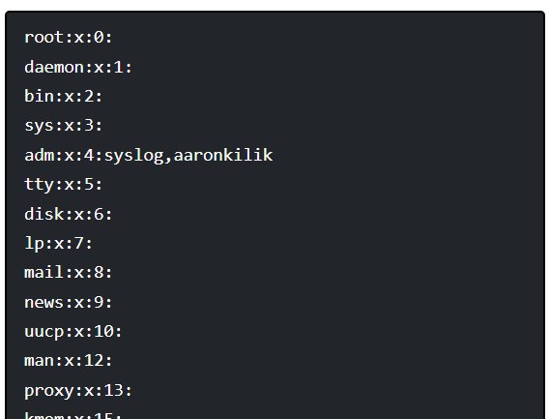

- Generate an MD5 checksum (educational step only)
Run the md5sums command to generate a hash value for the file as follows:
md5sum groups.csv

# Expected output example (your output may be different)
bc527343c7ffc103111f3a694b004e2f groups.csv
Take a screenshot of the result (i.e., use the snipping tool)

Reminder: MD5 is useful here to demonstrate that even small changes alter the checksum drastically. But remember, MD5 should not be trusted for security-critical verification.

- Alter the contents of the file by adding the following to a new line at the bottom: cyber:x:1001: and saving your changes.

- Then run the md5sum groups.csv command again. Observe the hash value this time in comparison to the first time (see your screenshot if needed):
md5sum groups.csv

# Example output
46798b5cfca45c46a84b7419f8b74735 groups.csv

- You will notice that the hash value has now changed, indicating that the contents of the file where altered.

- Now, delete the last line of the file, cyber:x:1001: Then run the md5sum groups.csv command again. Observe the hash value is back to the original value now that the content is back to what it was.

- Rename the file to groups_list.txt
mv groups.csv groups_list.txt

- Run the command below to generate its hash value again:
md5sum groups_list.txt

# Example output
bc527343c7ffc103111f3a694b004e2f groups_list.txt

- From the output above, the hash value is still the same even when the file has been renamed, with its original content.

Important: md5 sums only verifies/works with the file content rather than the file name.

The file groups_list.txt is a duplicate of groups.csv, so, add another copy of the groups.csv to your home directory (as you did in step 1) and then try to generate the hash value of the files at the same time as follows. You will see that they both have equal hash values, this is because they have the exact same content.
md5sum groups_list.txt groups.csv

# Example output
bc527343c7ffc103111f3a694b004e2f groups_list.txt
bc527343c7ffc103111f3a694b004e2f groups.csv

- You can redirect the hash value(s) of a file(s) into a text file and store, share them with others. For the two files above, you can issue the command below to redirect generated hash values into a text file for later use:
md5sum groups_list.txt groups.csv > myfiles.md5

- To check that the files have not been modified since you created the checksum, run the next command. You should be able to view the name of each file along with “OK”. The -c or --check option tells md5sums command to read MD5 sums from the files and check them.
md5sum -c myfiles.md5

groups_list.txt: OK
groups.csv: OK

- Remember that after creating the checksum, you cannot rename the files or else you get a “No such file or directory” error, when you try to verify the files with new names. For instance:

mv groups_list.txt new.txt
mv groups.csv file.txt
md5sum -c myfiles.md5

ERROR Message:

md5sum: groups_list.txt: No such file or directory
groups_list.txt: FAILED open or read
md5sum: groups.csv: No such file or directory
groups.csv: FAILED open or read
md5sum: WARNING: 2 listed files could not be read

- Remember that after creating the checksum, you cannot rename the files or else you get a “No such file or directory” error, when you try to verify the files with new names. For instance:

mv groups_list.txt new.txt
mv groups.csv file.txt
md5sum -c myfiles.md5

This exercise showed you how to generate hash values for files and create a checksum for later verification of file integrity in Linux. Although security vulnerabilities in the MD5 algorithm have been detected, MD5 hashes still remains useful especially if you trust the party that creates them.

- You should also generate a SHA-256 checksum (recommended for practice)
This time you would use sha256sum groups.csv
Compare outputs before and after modification to see changes.

Part 2: Verifying Checksums of Downloaded Files

- Download a small package and its official SHA-256 checksum
(Examples: Nmap, VLC, FileZilla — all provide SHA-256 sums.)

Download the file and the .sha256 checksum file.

Remember if the standard package repositories on Rocky Linux or Ubuntu do not have the specific package you want to download – you can use the wget utility.

Complete this box by pasting screenshot(s) of:

Your chosen VM (with the name of your VM visible) to show that you verified the checksum of any small downloaded package.

