Lab 3 Part A: Installing and Configuring ClamAV Anti-Virus


INSTRUCTIONS:
- Rename this document by substituting out FirstNameLastName with your own.
- Login and complete tasks as labuser.
- Complete this lab on your Ubuntu server.
- Complete all green boxes in this lab sheet.
- Submit your renamed document to the relevant submission link on Blackboard before the deadline.

In this lab, you'll install and configure ClamAV on an Ubuntu system. The process is similar for other Linux distributions like Rocky Linux, so mastering the Ubuntu setup will give you a solid foundation.

- Update the Package List and Upgrade installed Packages: As a best practice, ensure that your system is up to date by running:
sudo apt update && sudo apt upgrade

- Install ClamAV: Ubuntu's default repositories contain the latest version of ClamAV. Install ClamAV and its daemon service with:
sudo apt install clamav clamav-daemon -y

- Update the ClamAV Virus Database: To detect the latest threats, ClamAV needs an updated virus signature database. If your system has internet access, you can update the database using clamav-freshclam. Start by stopping the clamav-freshclam service:
systemctl stop clamav-freshclam

- Navigate into the clamav directory:
cd /etc/clamav

- Manually Update the Virus Database: Use the following command to update the database manually:
sudo freshclam

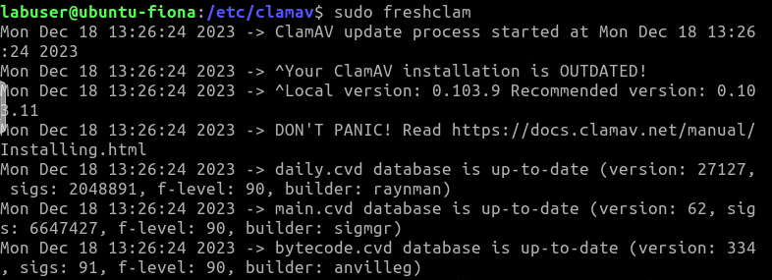

- Restart the ClamAV Service: After the update, start the clamav-freshclam service to keep the virus database up to date in the background:
sudo systemctl start clamav-freshclam

- Enable Automatic Updates: Ensure that the service is enabled to run on system boot, so future updates happen automatically:
sudo systemctl enable clamav-freshclam

- The virus databases are stored under /var/lib/clamav/
ls -alh1 /var/lib/clamav/

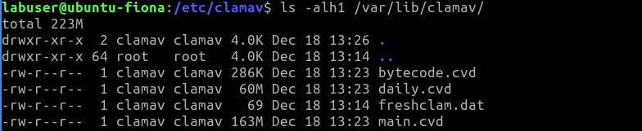

- Restart the ClamAV Daemon: To finalise, restart the ClamAV userspace daemon:
systemctl restart clamav-daemon

Using ClamAV to Scan Files
Once ClamAV is set up, you can start scanning your system for viruses using the clamscan command. Here are some common options:

Scan a Directory:
clamscan /home/
This scans all the user directories under /home/.

Scan the home directory of labuser specifically:
clamscan /home/labuser

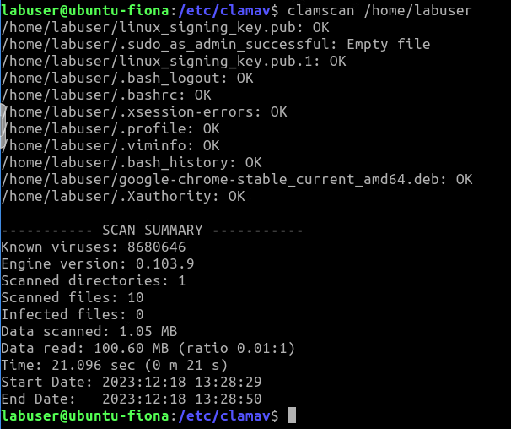

Scan a Specific File (swap filename.docx for one that actually exists):
clamscan /home/labuser/filename.docx

Print infected files only (-i, --infected);
clamscan -i /

Recursively Scan Directories: (-r, --recursive).
clamscan -i -r /home
This scans all files within /home/, recursively searching through subdirectories.
Remove infected files (--remove[=yes/no(*)]). Be cautious with this option, as it will permanently delete any infected files:
clamscan -r --remove /home/USER
# (e.g. swap USER for a user that exists like labuser)

Move Infected Files: Instead of deleting infected files, you can move them to a quarantined directory:
clamscan -r -i --move=/home/USER/infected /home/

This was just a sample of options to use. There is quite long list of other options for various usage of clamscan. Check out man clamscan for more details.

Testing ClamAV
To test if ClamAV is functioning correctly, you can download a harmless test file known as the EICAR test file. This file is specifically designed to trigger antivirus alerts without containing any real malware.

- Download the Test File:
wget -P /tmp https://secure.eicar.org/eicar_com.zip

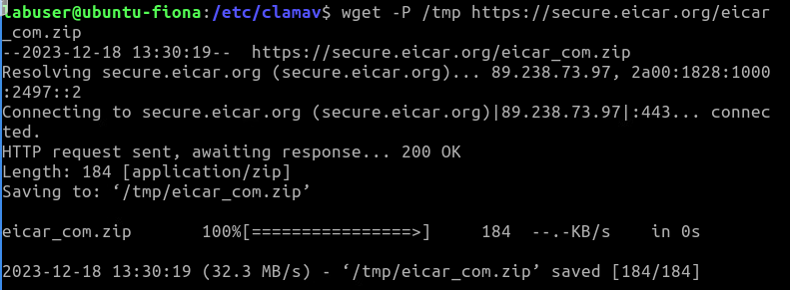

- Scan the Directory Containing the Test File:
clamscan -ir /tmp/
If ClamAV is set up correctly, it should detect and flag the test file as a virus.

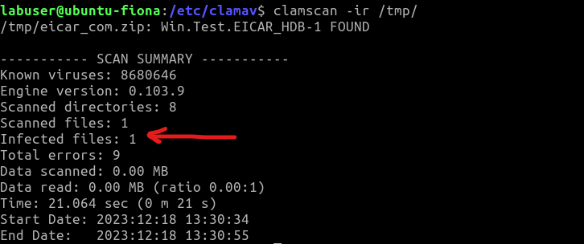

- Now using the commands your learned earlier under the “Using ClamAV to Scan Files” section – see if you can remove the infected file.

Complete this box by pasting a screenshot of:

Your Ubuntu VM (with the name of your VM visible) showing the detection of the virus on your server.

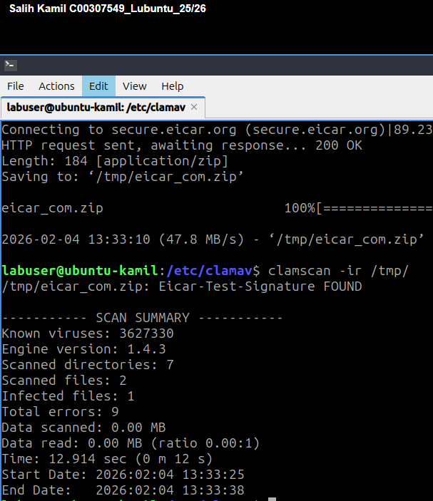

Understanding ClamAV Return Codes
After running a scan, ClamAV will return a code indicating the result:
0: No virus found.
1: Virus(es) found.
2: Some error(s) occurred.
NOTE: clamscan can be CPU intensive especially if it scanning a large directory.


If you did want to setup ClamAV on your Rocky Linux VM then try repeating the same steps or look for a tutorial online specific to Rocky Linux 8.

Complete this:

Discover any known vulnerabilities and exposures with ClamAV:

- Search for vulnerabilities (CVEs) related to ClamAV at cvedetails.com or cve.org
- Document the most recent CVE (Common Vulnerabilities and Exposures) related to ClamAV in the following format:

CVE-ID or Name: ClamAV PDF Scanning Buffer Overflow Vulnerability
Max CVSS: 9.8
EPSS Score: _______
Published: 2025-06-18
Brief Description: A serious flaw in ClamAV’s PDF scanning allows specially made PDF files to overflow memory, which can crash the scanner and cause a denial of service. In some cases, it may also let an attacker run their own code with ClamAV’s permissions.

Which version(s) of ClamAV was the vulnerability found with? 3.1

Check which version of ClamAV you installed on your Ubuntu VM and take note of the version here: 1.4.3

