Lab 3 Part B: Encryption with GPG
INSTRUCTIONS:

- Rename this document by substituting out FirstNameLastName with your own.
- Login and complete tasks as labuser.
- Complete this lab on your Ubuntu server.
- Complete all green boxes in this lab sheet.
- Submit your renamed document to the relevant submission link on Blackboard before the deadline.

This lab consists of five parts and will guide you through generating and managing GPG key pairs for secure communication. You'll practice encrypting, decrypting, and verifying files to understand real-world cryptographic workflows.

🔹 For the best learning experience, complete this lab with a classmate to simulate key exchange and secure messaging. If working alone, you can act as both sender and receiver.

Part 1: Generate Your Own Public/Private Key Pair

What Are Public and Private Keys?
Think of it like a mailbox:
- Public Key: The "address" of your mailbox. You share it with anyone who wants to send you a message.
- Private Key: The "key" to open your mailbox. Only you have access to it. It must be kept secret.
Messages encrypted with your public key can only be opened with your private key.

- Install GPG
GPG is often pre-installed on Linux distributions, but if it isn’t, you can install it using the following command:
sudo apt install gpg

- Check Your GPG Version
gpg --version

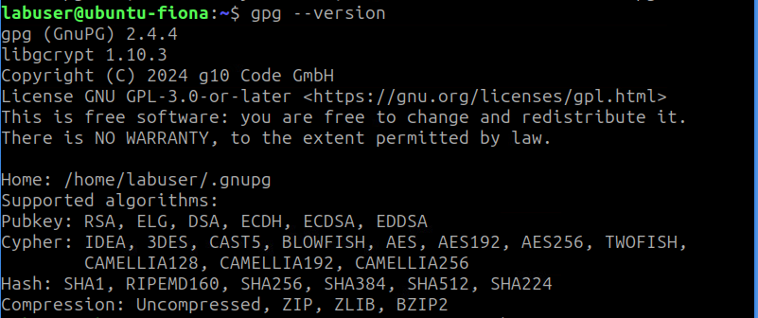

This command shows the current GPG version installed on your system and provides details like the location of the GPG configuration directory (~/.gnupg) and supported cryptographic algorithms.

- Generate Your Key Pair
Generate your key pair using elliptic curve cryptography (ECC), which is more secure than traditional RSA keys.
gpg --expert --full-gen-key

Choose key type:
You will be prompted to choose the type of key you want. Select the option 9 for ECC (Elliptic Curve Cryptography) *default*.
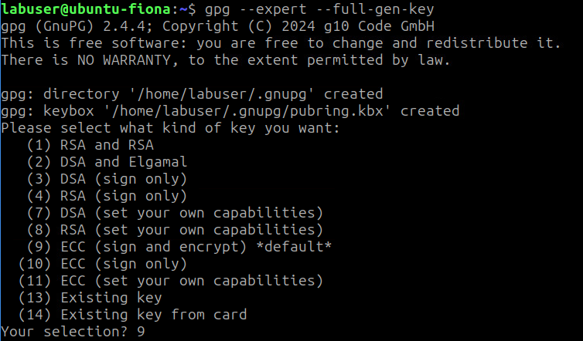
Select the elliptic curve:
Next, choose option 1 to generate an ed25519 key, which is a secure and widely used ECC curve.
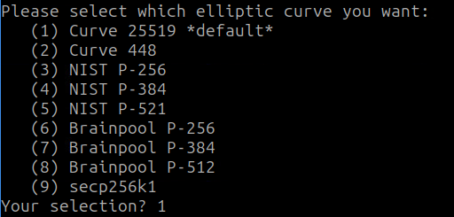

Set expiration time:
For security reasons, key pairs should expire. Choose an expiration time of 2 years. You can extend it later if needed. When prompted to confirm, type y and press Enter.
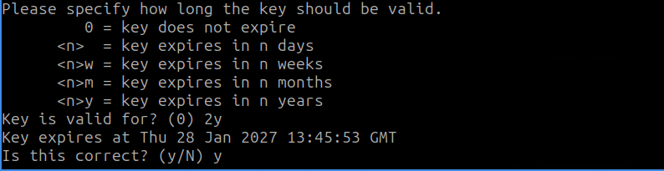

Provide user information:
You'll be asked to provide identification information. Enter your name and email address, leaving the Comments field blank. Your email address will be used to identify your key.
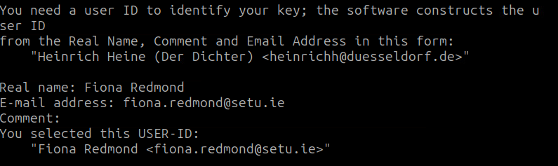

Create a passphrase:
Create a strong passphrase to protect your private key. This passphrase will be required to use your private key, so make sure to remember it (write it down).
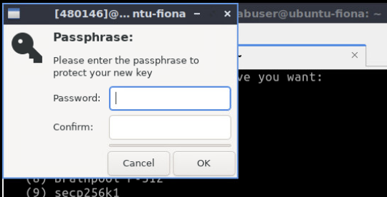
Once completed, GPG will display a fingerprint. Save this fingerprint for later use. This is a hexadecimal value used to identify your public key.
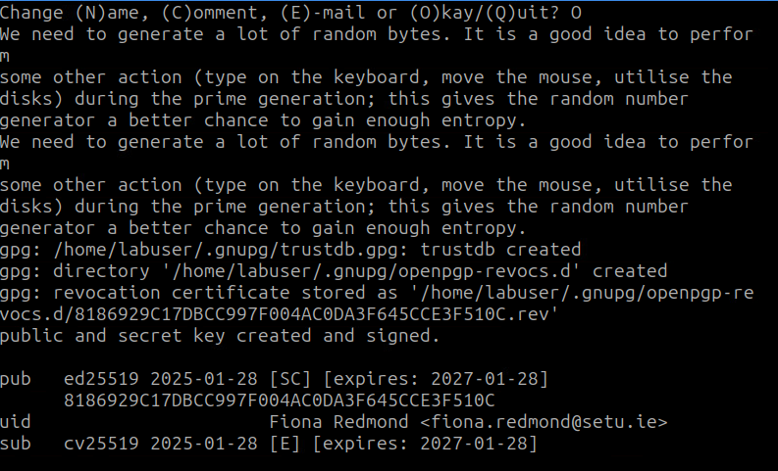
Your public key is stored as a hidden directory in your home directory ~/.gnupg/. This key can be shared freely, while your private key (in ~/.gnupg/private-keys-v1.d/) must be kept secure. If your private key is compromised, the revocation certificate (automatically generated) can be used to revoke the key pair.

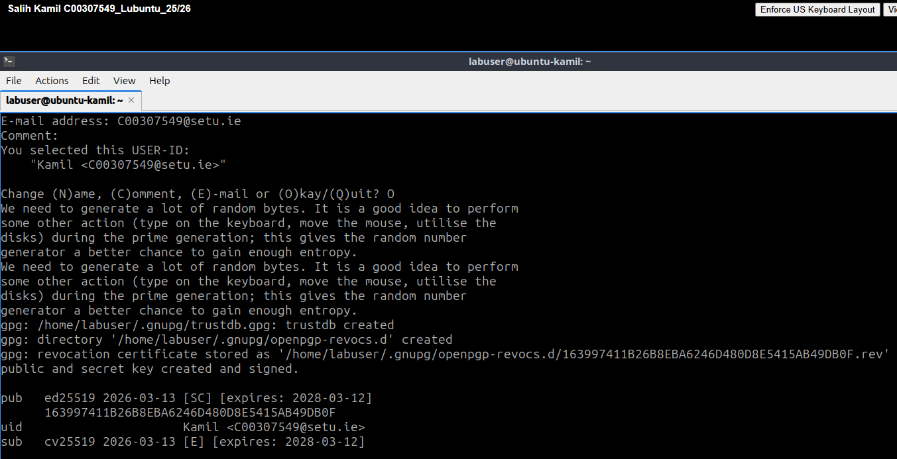

- Export Your Public Key
To share your public key:
Replace user-id with your GPG email address
gpg --armor --export user-id > pubkey.asc
# Example: gpg --armor --export alice@example.com > pubkey.asc
The --armor option converts your key to a readable text format (ASCII). This creates a file called pubkey.asc, which can be shared.

Find your public key file (e.g. in your home directory) and provide it to anyone who wants to communicate with you securely.

- (Optional) Export Your Private Key
Although you should not share your private key, it’s useful to back up your private key.
Replace user-id with your GPG email address
gpg --armor --export-secret-keys user-id > privkey.asc
# Example: gpg --armor --export-secret-keys alice@example.com > privkey.asc
This command exports your private key to a file called privkey.asc in a text-based format. Store this file securely (e.g., on an encrypted external drive), as anyone with access to your private key and passphrase can impersonate you.

- Protect Your Keys
Your private key should be kept as secure as possible, just like you would protect sensitive documents. Here are some guidelines:
- Store your private key in a safe place, like an encrypted USB drive or a location with limited access.
- Keep your passphrase secure. If you forget it, you will lose access to your private key, and no one else can decrypt your messages.
- Store your revocation certificate safely. This certificate allows you to revoke your public key if your private key is ever compromised. If someone else obtains your revocation certificate, they can misuse it to invalidate your key pair.

Recommendation: Think of your private key as a house key. If it's lost/stolen, someone can break into your digital "house."

In this part of the lab, you learned how to:
- Install and check the GPG version on your system.
- Generate a secure public/private key pair using elliptic curve cryptography.
- Export and protect your keys, including creating a revocation certificate.
Part 2: Public Key Management

In this part, you'll learn how to:
- Upload your public key to a key server so others can find it
- Import and verify others' public keys
- Manage your keyring

Work with a classmate to exchange and verify public keys. If working alone, simulate both sender and receiver roles.

- Check Your Own Public Key
Run the following command to list your own GPG public key. Replace user-id with your GPG email address.
gpg --list-sigs user-id

Sample output:
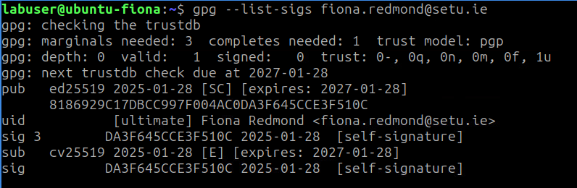

The last 16 characters of the long string (e.g., 8186929C17DBCC997F004AC0DA3F645CCE3F510C which is my key fingerprint) are your Key ID. As you can see, my key ID is therefore DA3F645CCE3F510C.

Verify that your fingerprint matches the one from earlier.

- Upload Your Public Key on a Key Server

Why? This allows others to send you encrypted messages without needing to exchange files manually. Never share your private key - only your public key. You can upload your public key to one of many key servers around the world (e.g., MIT, Ubuntu) so others can find it.

How? Use this command to upload your key: Replace KEY_ID with your key’s ID (the last 16 characters of the fingerprint).

gpg --send-key key-id

By default, this uploads to hkps://keys.openpgp.org. You can specify a different server with:
gpg --keyserver keyserver.ubuntu.com --send-keys KEY_ID
Click the long verification link sent to your email. (Some providers delay emails for up to 15 minutes to prevent spam. Please be patient).
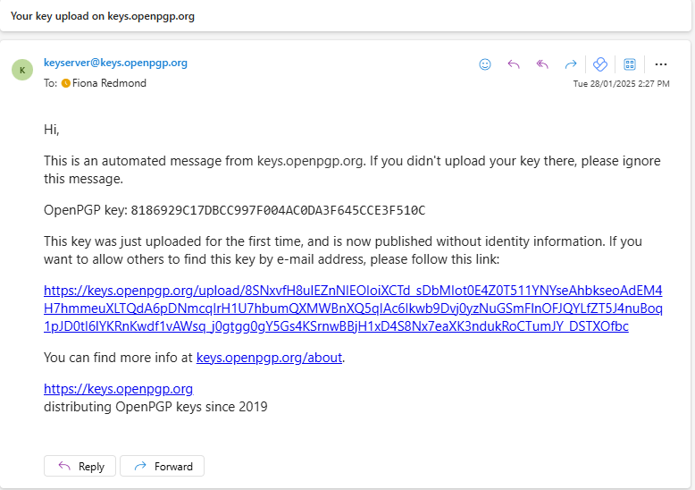
You will need to verify your email address by clicking on Send Verification Email. This way, an imposter can’t upload a fake key with your email address as the identifier.
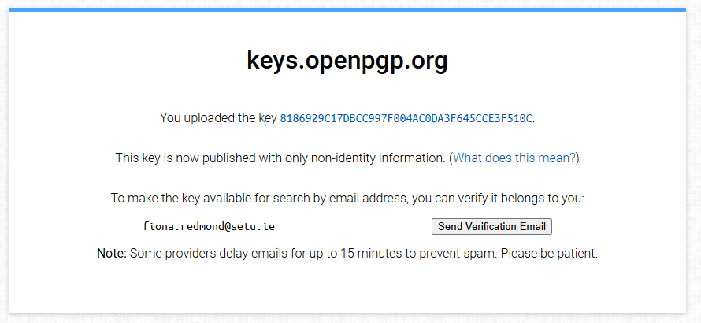

When you receive the verification email - click the long link again:
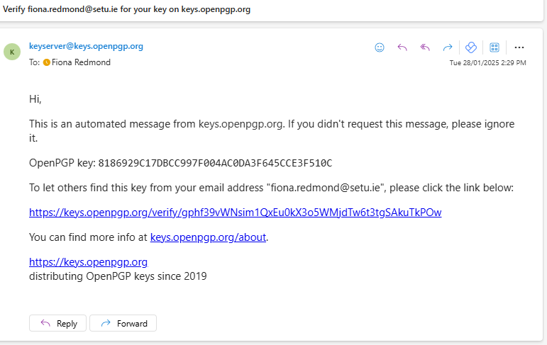

And you should receive another email similar to this:
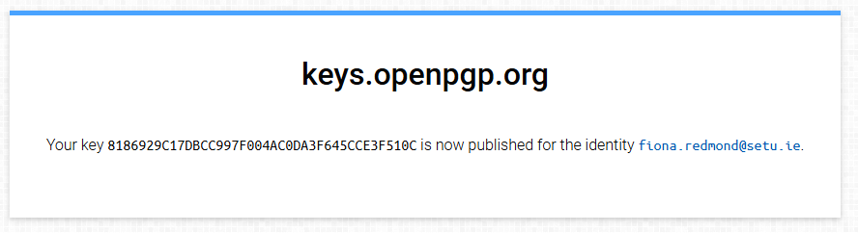

Once verified, you can search your key on the keyserver:
gpg --search user-id

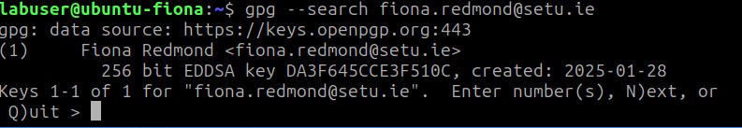

When it asks what to do with the key, press N since the key is already on your system.

- Find and Import a Classmate’s Public Key
If working with a classmate, try finding their key on the key server:
gpg --search user-id

Import from a file:
If their key is found, import it (swap name of file):
gpg --import classmate-pubkey.asc

Alternatively (If key is not on a key server): Ask your classmate to export their public key and share it with you. They can do this using:
gpg --export --armor their-email@example.com > classmate-pubkey.asc

Then, you import the received key using:
gpg --import classmate-pubkey.asc

- Verify a Public Key Before Trusting It
Before using a key, confirm it belongs to the right person:

  - View the key’s fingerprint:
gpg --fingerprint user-id

  - Contact the person directly (phone, video, in-person) and ask them to read out their fingerprint.

  - Compare fingerprints to ensure they match.

  - If correct, sign the key to mark it as trusted:
gpg --sign-key key-id
You must have your private key to sign another’s public key.

Optionally, you can upload the signed key back to the key server:
gpg --send-key key-id

Note: Signing and uploading the key may reveal that you know the key owner, which could raise privacy concerns.

- Manage Your Keyring
List all stored public keys:
gpg --list-keys

List Your private keys
gpg --list-secret-keys

Sample output
/home/labuser/.gnupg/pubring.kbx
----------------------------------
pub ed25519 2024-01-31 [SC] [expires: 2026-01-30]
B0C318B4F5F288B813BD11C1C37AD4E68F0AC05D
uid [ultimate] Fiona <xxx@xxx.com>
ssb cv25519 2024-01-31 [E] [expires: 2026-01-30]

# Here you should see the public keys you’ve imported and trusted from others.

Delete a public key (if needed):
gpg --delete-key key-id

Summary so far for this part:
- You generated and uploaded your public key
- You imported a classmate’s key and verified it
- You managed your keyring and learned key maintenance

Manage GPG Keys in Passwords and Keys app (Seahorse)
In Lubuntu, you can also manage GPG keys using the graphical tool, Passwords and Keys (Seahorse). Install it with:
sudo apt install seahorse

Then, open Passwords and Keys (Seahorse) from your Accessories menu. Before starting using it, we need to configure the PGP key server. Click the dropdown menu and go to Preferences.

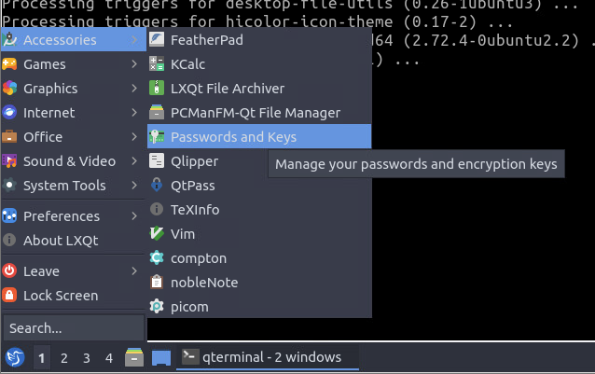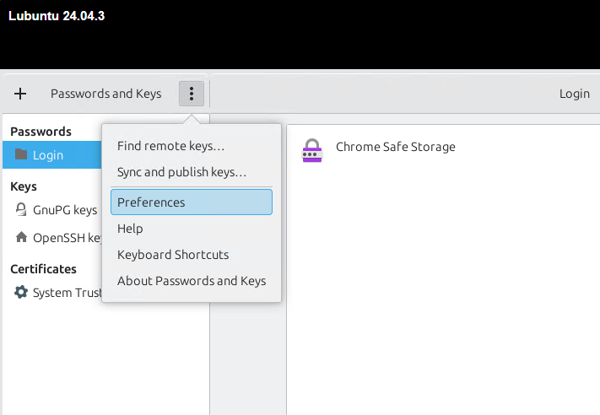

You will see there are two default key servers.
- ldap://keyserver.pgp.com
- hkps://keys.openpgp.org

Close the Preferences window.

To import a public key from a key server, click the drop-down menu and select Find remote keys. Then enter an email address.
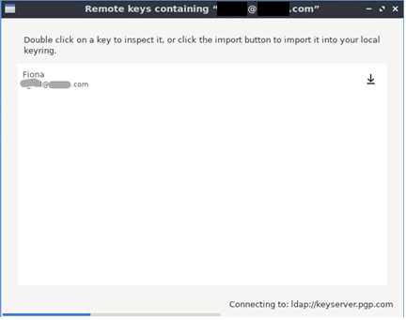
As you can see, it found my public key on the key server. Because this is my own key, I don’t need to import it.
If this is another person’s key, you can click the import button, so it will be added to your key ring.
And if you run command gpg --list-keys, you can see it’s been added to your key ring.

By default, Passwords and Keys (Seahorse) only show your own key. To show other keys, click the show any option.
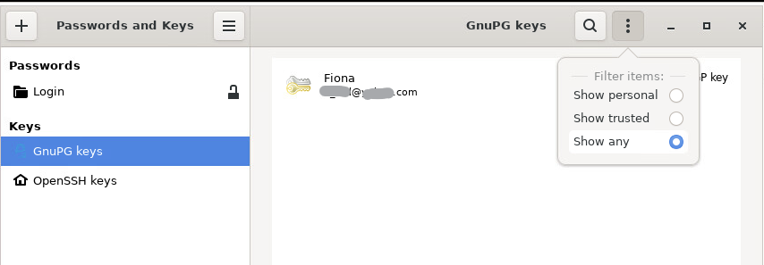

Right-click on another person’s key (e.g., from earlier exercise) and select Property, you will be able to check the key’s fingerprint. As explained earlier, you need to contact the key’s owner and verify if it’s the fingerprint is correct.

If the fingerprint is correct, you should sign the public key by clicking the sign key button.

Part 3: GPG Encryption and Decryption Process (Pair Activity)

In this part, you will work in pairs to practice GPG encryption and decryption. One student will act as the sender, and the other as the receiver. You will generate key pairs, exchange public keys, encrypt a message, and decrypt it.

How GPG Encryption Works
- Public Key Encryption: The sender encrypts a file using the receiver’s public key.
- Private Key Decryption: The receiver decrypts the file using the receiver’s own private key.

- Generate a GPG Key Pair
Each student should generate their own GPG key pair. Run:
gpg --full-gen-key

Follow the same steps as you did in Part 1:
- Select option 9 for ECC (default).
- Select option 1 to generate an ed25519 key
- Set an expiration date (or leave it as "0" for no expiration).
- Enter your name and email address when prompted.
- Set a secure passphrase (this protects your private key).

After completion, verify your key with:
gpg --list-keys

- Exchange Public Keys
Each student must share their public key with their partner. To export your public key:
gpg --export --armor your_partner@example.com > mypublickey.asc
Send mypublickey.asc to your partner (e.g., via email).

Import your partner's public key:
gpg --import mypartnerpublickey.asc

Check that the key is imported successfully:
gpg --list-keys

- Encrypt a Message for Your Partner
Create a sample text file:
echo "This is a secret message for my partner." > secret.txt

Encrypt it using your partner’s public key:
gpg --encrypt --recipient your_partner@example.com --armor secret.txt
- The --armor flag ensures the file is ASCII armored, generating a .asc file (which is the encrypted version).
- You can also encrypt for multiple recipients by using multiple --recipient options.

This creates a file named secret.txt.asc, which is encrypted and can only be decrypted by your partner.

Send secret.txt.asc to your partner.

- Decrypt the Message
The receiving partner should decrypt the message using their private key:
gpg --decrypt secret.txt.asc

If prompted, enter your passphrase to unlock your private key. You should now see the original message!

- Signing and Verifying Messages (Optional, But Recommended)
To ensure authenticity, the sender can sign the message before encrypting:
gpg --sign --encrypt --recipient your_partner@example.com --armor secret.txt

The receiver can verify the signature while decrypting:
gpg --decrypt secret.txt.asc

If the signature is valid, it confirms the message has not been tampered with and came from the expected sender.

Complete this: Pair Programming Challenge – Encrypt and Decrypt Messages with a Classmate

Pair up with a classmate (a different classmate if you’ve already paired up with someone) and decide who will act as the sender and who will be the recipient (or act as both and each write/send their own message).
- You and a partner exchange public keys.
- Your partner encrypts a file (with some appropriate message) using your public key and sends it to you (using email on the VMs browser or some other agreed upon method).
- You decrypt the file using your private key allowing you to read the message they wrote.

This ensures that:
- Only you (the intended recipient) can read the message.
- Even if someone intercepts the file, they cannot decrypt it without your private key.

Once completed answer the following questions:

Who did you pair up with? Ryan Thomas Were you able to decrypt their message? Yes

Part 4: Using Digital Signatures (Signing and Verifying Files)

Digital signatures verify the authenticity and integrity of files. This section covers signing files, verifying signatures, and combining signing with encryption.

Signing a File (Without Encryption)
Use this when confidentiality isn't needed, but you want to prove authorship and ensure the file hasn’t been altered.

- Create a Test File:
echo "This is a test text file" > test.txt

- Sign the file with your private key:
gpg --clearsign test.txt

- The --clearsign option signs the document with your private key but leaves the content readable (clear text).
- GPG will prompt you to enter your passphrase to unlock the private key.
- After signing, a new file (test.txt.asc) is created containing the original content and the digital signature.

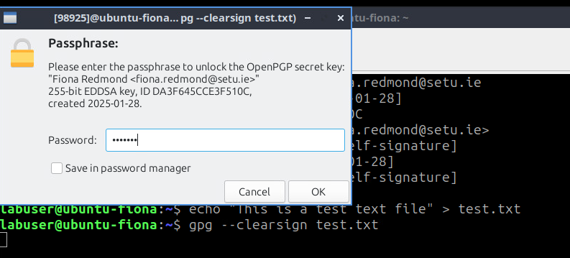

If you completed this in your home directory then you should find the newly created test.txt.asc file there like so:
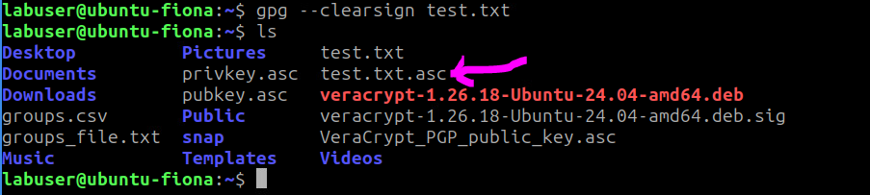

- View the Signed File: (Use vi or nano)
vi test.txt.asc

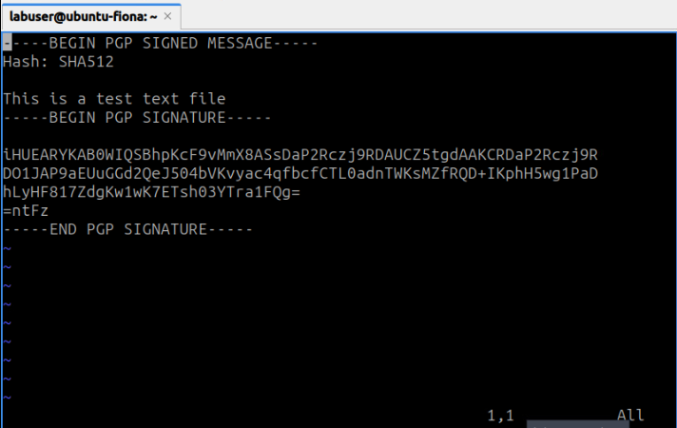

- The file contains both the original content and the signature, which is appended to the end.
- You can also see the hash algorithm used, typically something like SHA256.

- Verify the Signature
gpg --verify test.txt.asc

This process checks that:
- The document has not been altered.
- The signature matches the public key of the sender, confirming authenticity.

If the signature is valid, it confirms the file’s integrity and authenticity with an output that says "Good signature".

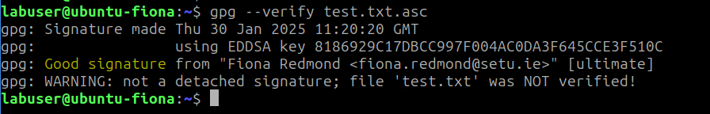

Signing and Encrypting a File (For Confidentiality)
Use this when you need both authenticity and encryption for secure communication.

- Sign and encrypt a file for a recipient:
gpg --armor --recipient user-id -e --sign test.txt

This encrypts test.txt using the recipient’s public key while also signing it with your private key.

- Recipient decrypts and verifies: The recipient can decrypt the file using their private key, and the verification of the signature happens automatically during decryption:
gpg --decrypt test.txt.asc

If the signature is valid, the sender is authenticated, and the message integrity is confirmed.
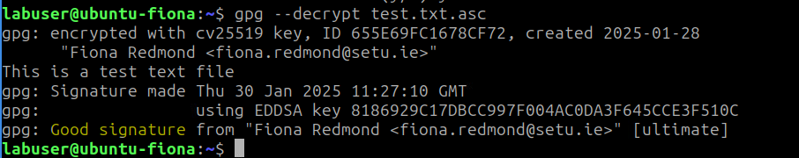

Summary:
Digital Signatures: Prove the authenticity and integrity of files.
- Signing without encryption ensures that the recipient can verify the document's authenticity and that it hasn't been tampered with.
- Signing with encryption adds confidentiality, meaning only the recipient can decrypt and read the content while still verifying the authenticity.

This approach is useful for ensuring both integrity and confidentiality in communication, which is essential in sensitive or secure exchanges.

Complete this box by pasting a screenshot of:

Your Ubuntu VM (with the name of your VM visible) showing the successful verification of a signed file.

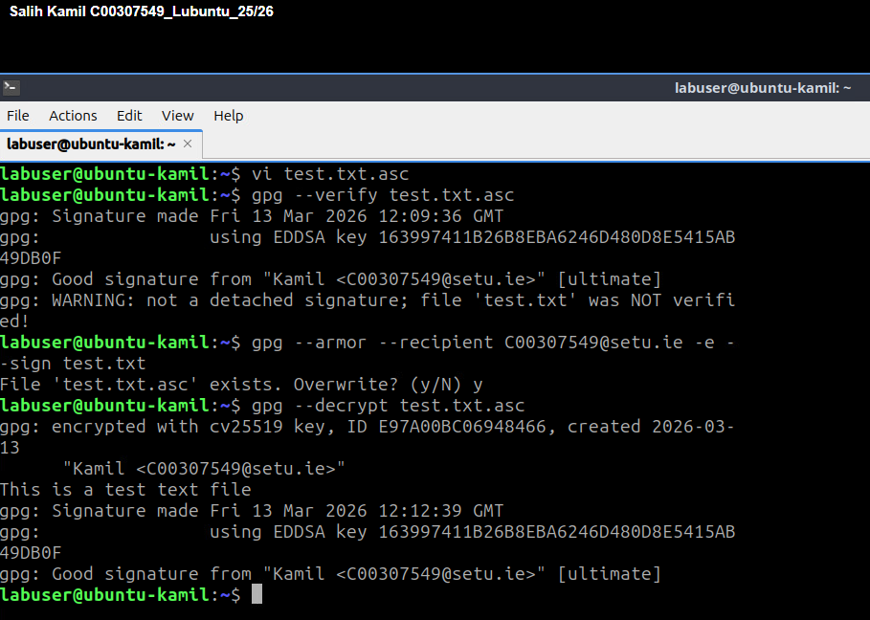

Part 5: How to Verify PGP Signature of Downloaded Software

In this part, you'll learning how to verify the PGP signature of software downloaded from the internet. This process helps ensure that the software hasn't been tampered with and that it originates from the legitimate software author. Here's how to do it:

Linux users can securely install software from their distribution’s repositories. But there are times when you need to download and install software from a website (e.g., using wget). How can you be sure that the software you downloaded wasn’t tampered with?

Some software authors sign their software using a PGP program such as GPG (GNU Privacy Guard). In that case, you can verify the integrity of software using GPG.

The process is relatively simple:
- You download the public key (.asc file) of the software author.
- Check the public key’s fingerprint to ensure that it’s the correct key.
- Import the correct public key to your GPG public keyring.
- Download the PGP signature file (.sig) of the software.
- Use public key to verify PGP signature. If the signature is correct, then the software wasn’t tampered with.

We will use VeraCrypt as an example to show you how to verify PGP signature of downloaded software.

Example: Verify PGP Signature of Software Called Veracrypt
VeraCrypt isn’t included in Ubuntu repository. We can download VeraCrypt Linux installer from official website. As we have Ubuntu 24.04 desktop on our VM, so we will download the .deb file for Ubuntu 24.04 (GUI)
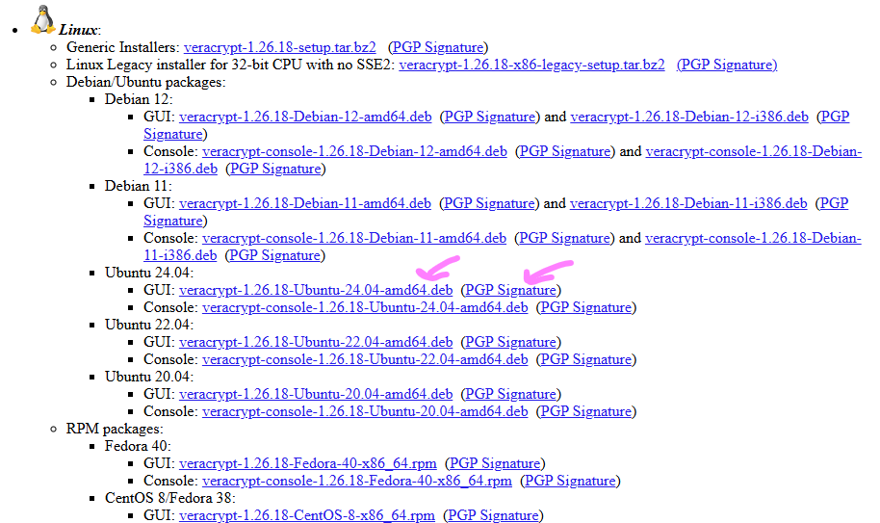

As shown above on the VeraCrypt download page, you can also find the PGP public key and PGP signature download link. Click the links to download these two files through the browser or…

- Download the Software Installer: Use a command like wget to download the software you need. For example, to download VeraCrypt's installer for Ubuntu:
wget https://launchpad.net/veracrypt/trunk/1.26.18/+download/veracrypt-1.26.18-Ubuntu-24.04-amd64.deb

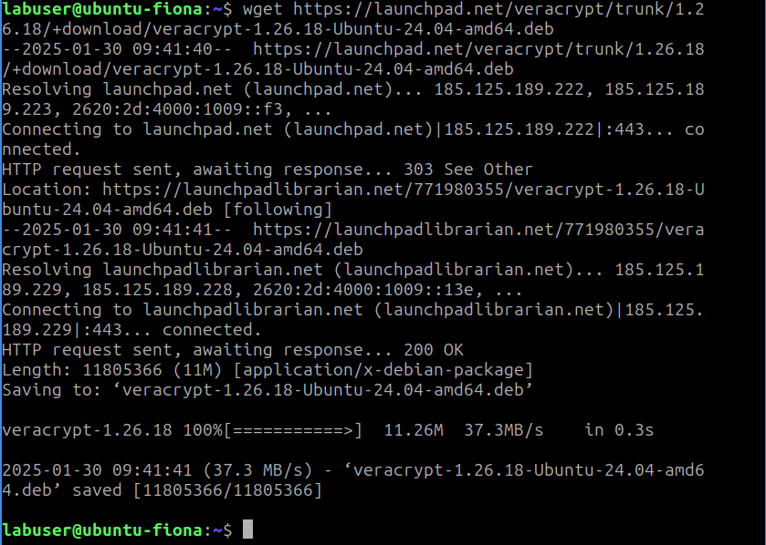

- Download the Software Author’s PGP Public Key: This key is used to verify the integrity of the downloaded software. You can find the public key on the software's website (scroll to bottom of webpage) or download it via a direct link:
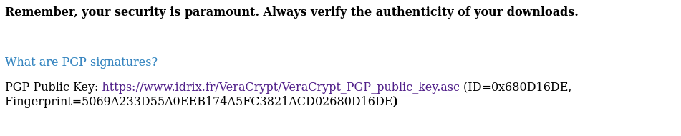

wget https://www.idrix.fr/VeraCrypt/VeraCrypt_PGP_public_key.asc

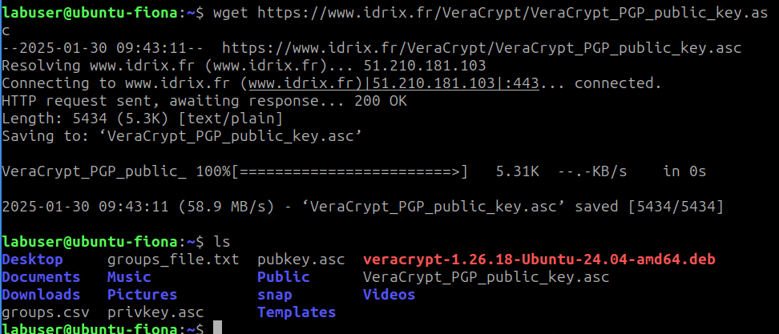

- Check the Public Key’s Fingerprint: Before using the public key, you need to verify that it is the correct one. Use the following command to show the fingerprint of the public key:
gpg --show-keys VeraCrypt_PGP_public_key.asc
- The output will display the public key’s fingerprint (a long string of characters).
- Compare this fingerprint with the one published on the official software website to ensure it's the correct key. If they match, it means the public key is legitimate.
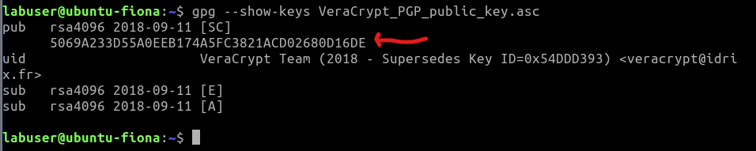

Compare it with the fingerprint published on VeraCrypt website.
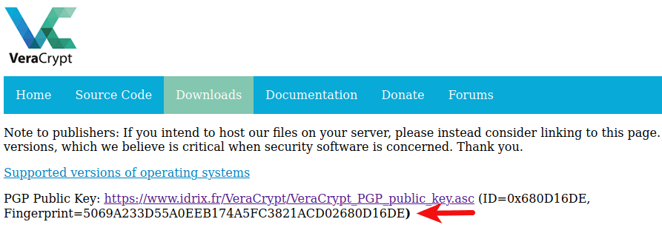

As you can see, the two fingerprints are identical, which means the public key is correct.

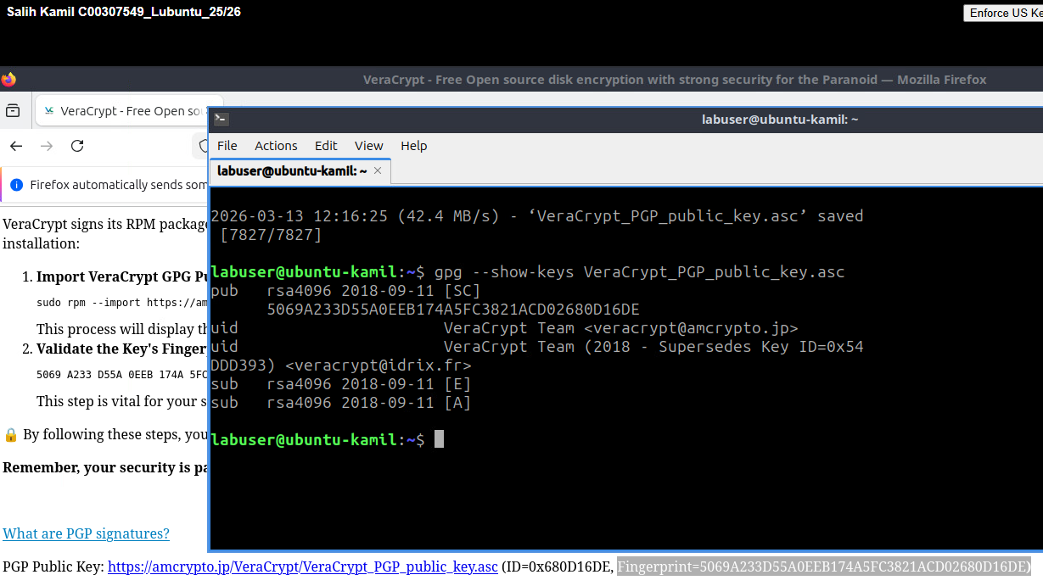

- Import the Public Key: After verifying the key’s authenticity, you can import it to your GPG public keyring:

gpg --import VeraCrypt_PGP_public_key.asc

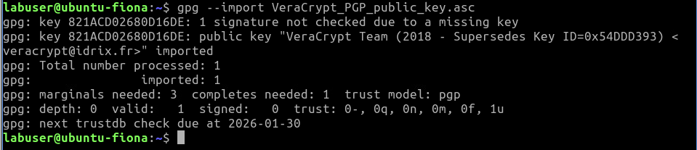

- Download the PGP Signature File: Software authors often provide a separate .sig (signature) file that corresponds to the software. You can download this file from the same website where you downloaded the software.

- Verify the Software Signature: Now, use the public key to verify the PGP signature. This ensures the software has not been altered. Run the following command, replacing the file names with your actual downloaded files:

gpg --verify veracrypt-1.26.18-Ubuntu-24.04-amd64.deb.sig veracrypt-1.26.18-Ubuntu-24.04-amd64.deb

- If the output says "Good Signature", this means the verification is successful, and the software was not tampered with.
- If it says "Bad Signature", the software might have been corrupted or tampered with, and you should not trust the download.

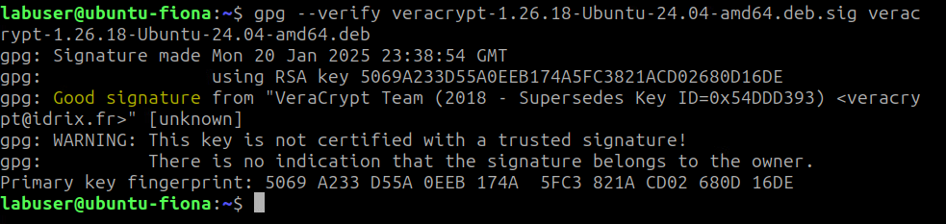

How Signature Verification Works:
- The PGP signature is a hash of the software file, which is then encrypted using the software author's private key.
- When you run the gpg --verify command, GPG:
  - Uses the public key to decrypt the signature (i.e., the hash value).
  - Calculates the hash of the software installer you downloaded.
  - Compares both hash values.
  - If they match, it confirms that the software has not been modified since the author signed it.

Complete this box by pasting a screenshot of:

Your Ubuntu VM (with the name of your VM visible) showing the successful verification of VeraCrypt or any other software you downloaded.

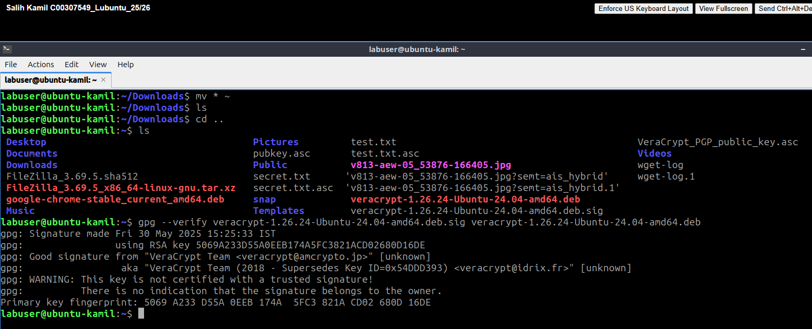

Importing a Public Key from a Trusted Source (Optional)
Instead of manually downloading a public key, you can import it directly from a key server if the software author has provided their key ID. Here's how:

- Import the public key from a public key server:
gpg --recv-keys <key-ID>
Replace <key-ID> with the actual key ID (e.g., 0x680D16DE).

- Check the fingerprint of the downloaded key to verify:
gpg --fingerprint <key-ID>

Again, compare the fingerprint to the one listed on the official website to ensure it’s correct.

If you receive an error like gpg: keyserver receive failed: No data, try using a different key server:
gpg --keyserver hkps://keyserver.ubuntu.com --recv-keys <key-ID>

That’s it! In this lab you verified the PGP signature of software downloads.

Summary:
- Downloading and verifying the PGP signature of software is crucial for ensuring its authenticity and integrity.
- By checking the software author’s public key and verifying the PGP signature, you can confirm that the software hasn’t been altered.
- This process is especially important when downloading software from the internet, as opposed to using a trusted software repository.

