Lab 4 Part A: Network Monitoring with Nmap

INSTRUCTIONS:
- Rename this document by substituting out FirstNameLastName with your own.
- Login and complete tasks as labuser.
- Complete this lab on both of your servers.
- Complete all green boxes in this lab sheet.
- Submit your renamed document to the relevant submission link on Blackboard before the deadline.

In this lab, you will learn how to install and use Nmap (Network Mapper), a versatile tool that scans networks to find open ports, detect running services, and identify operating systems.

Step 1 - Installing and Using Nmap

- System Update
sudo apt update -y # For Debian-based distros (like Ubuntu)
sudo dnf update -y # For RedHat-based distros (like Rocky)

- Install Nmap
Install Nmap if it’s not already installed using the following commands:
sudo apt-get install nmap # For Ubuntu
sudo dnf install nmap # For Rocky

- Verify Installation
Check if Nmap is successfully installed by checking its version:
nmap -version
Output:
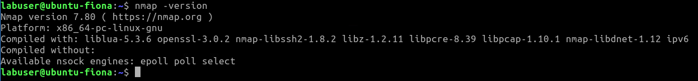

Now that Nmap utility is successfully installed, you can use it to scan a server or a host. After scanning the host, you will see a report where it will display the host running status and the state of all the ports scanned.

- Scan a Domain (e.g., google.ie):
nmap google.ie

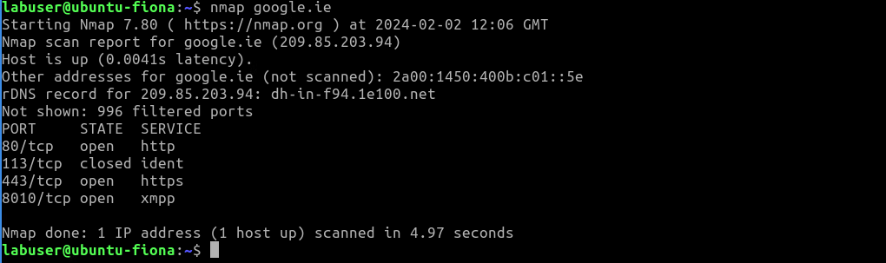

With no flags set, Nmap will, by default:
- Scan for the top 1000 commonly used ports (list of these ports can be modified in the nmap-services file).
- Nmap with attempt a TCP SYN connection to ports when running with a privileged user.
- Sends ICMP echo requests to target hosts to confirm if it is alive or not.
- Will perform a DNS reverse lookup to get the hostname.

From the output above we can see three open ports, 996 filtered ports and 1 closed port. A port that cannot be determined by Nmap as closed or open, which may be due to a firewall, is filtered.

- Scan the Localhost:
Scan your local machine to check for open ports:
nmap localhost

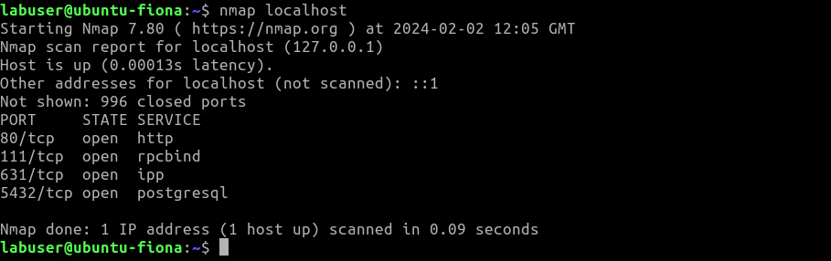

From the output above we can see four open ports and 996 closed ports.
- Check Available Options
Learn more about Nmap's options:
nmap --help
man nmap

Warning: Legal issues with port scanning
It is always advisable to get written authorisation/permission from the owner of the target network before initialising any scan. For example – http://scanme.nmap.org/ has authorised itself to be scanned. You could read in detail on the official website.

- Perform a Fast Scan
Using parameter -F, we can perform a fast scan. We will scan scanme.nmap.com, which has authorised itself to be scanned. This fast scan option will scan only the top 100 most commonly used ports of each protocol it is asked to scan.
sudo nmap -F scanme.nmap.org

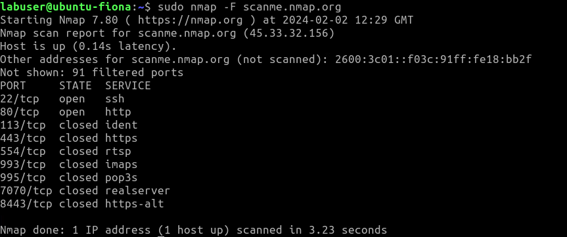

Try scanning your other VM (whichever one you are not on now)
sudo nmap -F 192.168.56.10 # or sudo nmap -F 192.168.56.20

- Scan a Subnet
Scan an entire subnet (adjust as per your network):
nmap 192.168.56.0/24

It may not include a result for your Rocky Linux VM. You could try temporarily stopping the firewall (firewalld) on your Rocky Linux VM and rerunning this nmap command to scan all machines on your private network /24 subnet.
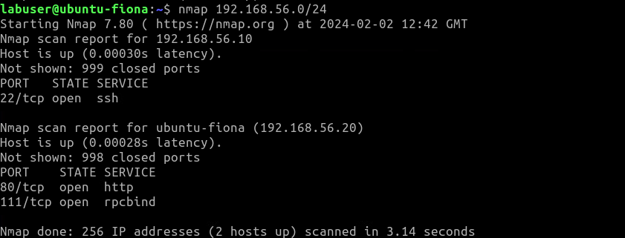
- Scan Multiple Hosts
Scan multiple machines at once:
nmap 192.168.56.10 192.168.56.20

- Scan a Specific Port
Use the -p flag to scan specific ports, e.g., port 80:
nmap -p 80 scanme.nmap.org

- Scan Top Ports
Use --top-ports to scan multiple top ports at once:
nmap --top-ports 5 scanme.nmap.org

- Find Open Ports
Use the --open flag to find open ports on a target:
nmap --open scanme.nmap.org

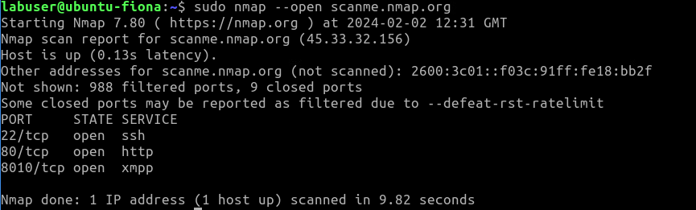

Complete this by answering the following questions:

What ports are open on your Rocky Linux VM? 22/tcp — SSH (Secure Shell)

What ports are open on your Ubuntu VM? None

- Redirect Results to a File
By default, Nmap prints the output on the terminal, but when scanning a large network, it is better to save the results in a file for better analysis. You can save the results of its scans in different file formats.

Use the -oN option to save scan results to a file:
nmap -oN results.txt scanme.nmap.org

- OS and Service Version Detection
Detect the operating system of a machine:
nmap -O localhost

- Version Scanning
Detect service versions running on a target:
nmap -sV <ipaddress>

Imagine you discover a machine with an IP address of 192.168.56.15 on your network, but you do not know what sort of system it is. The nmap command might provide a clue as to what sort of system it is by probing it. With benefits like this, you should consider routinely running the nmap command and consider it part of your intrusion detection game plan.

- Discover the Network Path to a Host (Traceroute):
Trace the network path to a specific host:
nmap --traceroute <target>

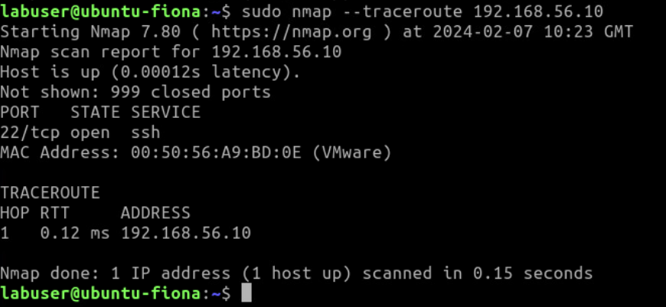

- Troubleshoot ‘Host Seems Down’ Error:
If you get a Host seems down error, run Nmap with -Pn:
nmap -Pn 192.168.1.1

