Lab 4 Part B: Network Monitoring and IDS with Tripwire


INSTRUCTIONS:
- Rename this document by substituting out FirstNameLastName with your own.
- Login and complete tasks as labuser.
- Complete this lab on your Rocky Linux server.
- Complete all green boxes in this lab sheet.
- Submit your renamed document to the relevant submission link on Blackboard before the deadline.

Installing and Using an IDS (Tripwire)
In this lab, you will learn how to install and configure Tripwire, a Host-Based Intrusion Detection System (IDS) on your Rocky Linux VM. Tripwire helps monitor file system changes to maintain system integrity. You’ll also learn how to verify the Tripwire configuration and add new rules for monitoring.

Step 1 - Install Tripwire on Rocky Linux
- Update your system
Login to your Rocky Linux VM and update all packages.
sudo dnf update -y
sudo dnf upgrade -y

- Install EPEL (if not already installed)
Since Tripwire isn’t found in the official repository, install EPEL (Extra Packages for Enterprise Linux):
sudo dnf install epel-release -y

- Install Tripwire IDS
Install the Tripwire IDS software:
sudo dnf install tripwire -y

- Switch to Root User:
Switch to the root user to perform the necessary configurations:
su root

- Create Tripwire Keys
After installation, generate the key files required by Tripwire using:
sudo tripwire-setup-keyfiles
The command will generate two key files 'site-key' and 'local-key', and you will be asked for the passphrase for each
of them.

Tripwire works with these 2 key files.
- site-key: It's used to secure Tripwire configuration. So any changes to the tripwire configuration will not be applied until we generate the configuration again, and we will be prompted for the 'site-key' passphrase for that.
- local-key: It's used for verifying the tripwire binary. When we want to update the tripwire system database, we need to run the tripwire command and we will be prompted for the passphrase for 'local-key'.

Enter your passphrase for the site-key and local-key when prompted.

Tripwire has been installed on Rocky Linux, and new tripwire configuration and keys are located in the '/etc/tripwire' directory.

Step 2 - Configure Tripwire Policy

- Initialise the Tripwire Database
Run the following command to initialise the database and verify there are no errors:
sudo tripwire --init

- Handle Directory Errors:
If you receive “No such file or Directory” errors, run the following command to log the missing directories:
sh -c "tripwire --check | grep Filename > no-directory.txt"

All directories and files that don't exist on the Rocky Linux system are listed in the file 'no-directory.txt'

- View the output file:
cat no-directory.txt

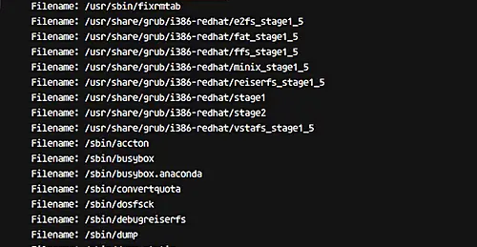

Option to Resolve Errors:
- You have three options:
  - Option 1: Manually comment out the missing directories in the twpol.txt file.
  - Option 2: Use a script to automate the process
  - Option 3: Leave the configuration as is and continue to receive errors.

For Option 1, you would comment them out (heads up there is A LOT) if you wished to receive no errors - therefore making it easier in future to spot NEW file changes (potential security threats).

For Option 2, you could either run the following directly in the command line or create a bash script file with the contents shown below and then add executable permissions before running the script, as you would have done in semester 1:

for f in $(grep "Filename:" no-directory.txt | cut -f2 -d:); do
sed -i "s|\($f\) |#\\1|g" /etc/tripwire/twpol.txt
done

- Regenerate and Re-Sign Tripwire Configuration: whether you go for option 1 or 2, after editing the configuration file, regenerate and re-sign it using:

twadmin -m P /etc/tripwire/twpol.txt

- Enter your site-key passphrase to re-sign the policy.

- Reinitialise Tripwire Database: to ensure there are no errors:
tripwire --init

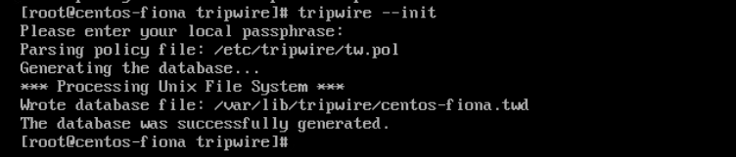

Step 3 - Verifying Tripwire Configuration and Checking the System

- Run a System Check
Verify the Tripwire configuration by running a system check:
tripwire --check

And you should get a result similar to the following:
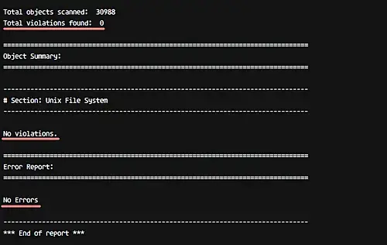
So this means there is no error and no system violation found on our system.

- Add a New File for Testing:
Go to the root home directory and create a new file:
cd ~/
touch module-labs.txt

- Check the System Again:
After adding the new file, re-run the system check:
tripwire --check
And you will get the result of the new violation on the system with severity 100 as below.

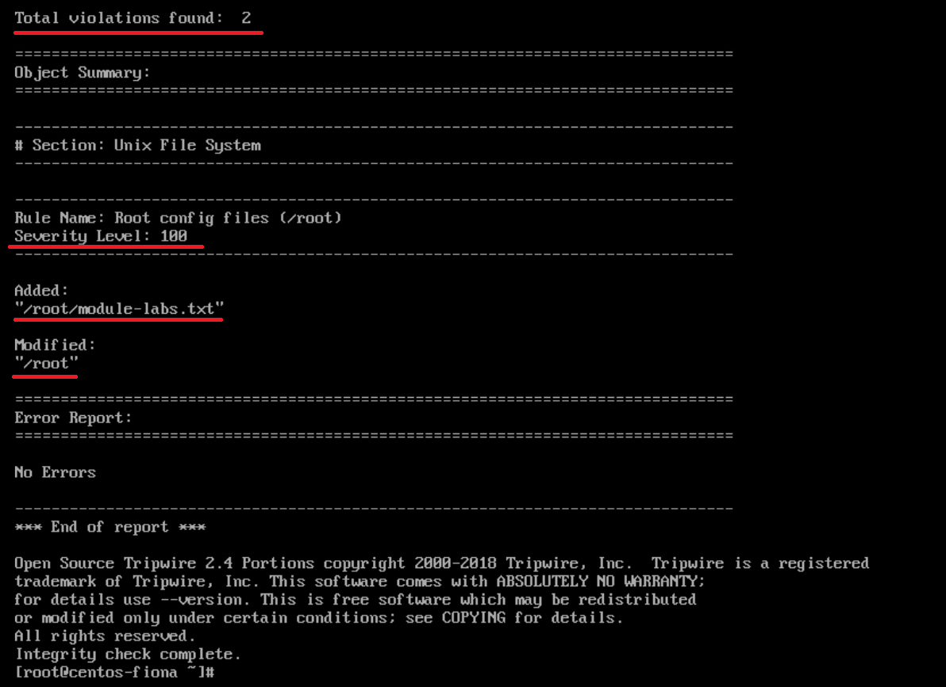

At this stage, Tripwire is installed and configured for Rocky Linux system.

Step 4 – Adding a New Rule to the Tripwire Policy

- Edit the Tripwire Policy Configuration:
Go to the Tripwire configuration directory and open the twpol.txt file for editing:
cd /etc/tripwire/
vi twpol.txt

To perform this work, we need to define the rule name, severity, directory for monitoring, and type of files.

In this step, we will create a new rule named 'Wordpress Data' for a WordPress installation in the '/var/www/' directory, with severity 'HIGH/SIG_HI', and all files in that directory are critical (both their ownership as well as source code cannot be changed).

- Add a New Rule
Add a new rule at the end of the file for monitoring the /var/www directory (for a WordPress installation):
# Ruleset for Wordpress
(
rulename = "Wordpress Data",
severity= $(SIG_HI)
)
{
/var/www -> $(SEC_CRIT);
}

Save and exit.

- Regenerate and Re-Sign the Policy:
After adding the rule, regenerate and re-sign the Tripwire policy:
twadmin -m P /etc/tripwire/twpol.txt
Type your 'site-key' passphrase.

- Reinitialise the Database:
Initialise the database again to apply the new rule:
tripwire --init
Type the 'local-key' passphrase.

A new rule set has been added and applied to the Tripwire policy configuration.

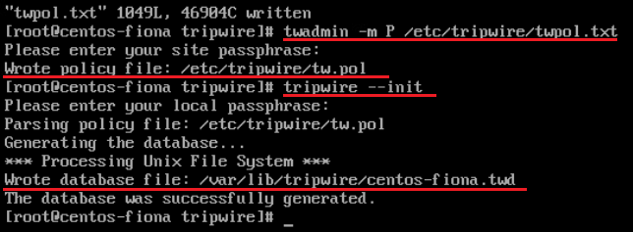

- Test the New Rule:
Create a new file in the /var/www/directory (you may need to create the www directory inside /var):
cd /var/www/
touch sismodule2.php

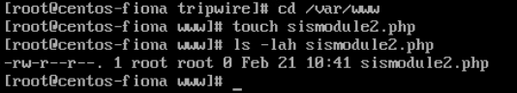

- Check the System Again:
Run Tripwire to check the system for the new violation:
tripwire --check

The report should show a violation in the /var/www/ directory with a high severity level (100).

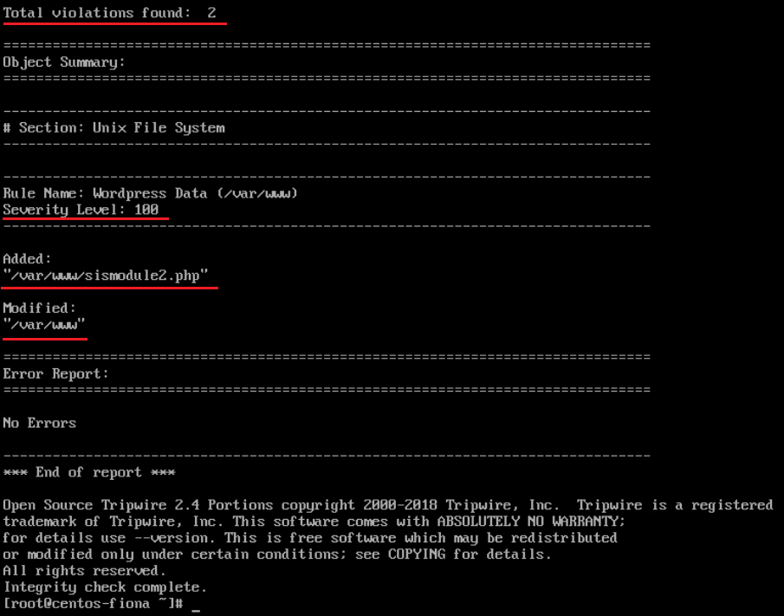
A new rule has been added and applied to the Tripwire Policy configuration.

Complete this box by pasting a screenshot of:

Your Rocky Linux VM (with the name of your VM visible) showing that you successfully installed and setup Tripwire by showing the violation detected (similar to image above)..

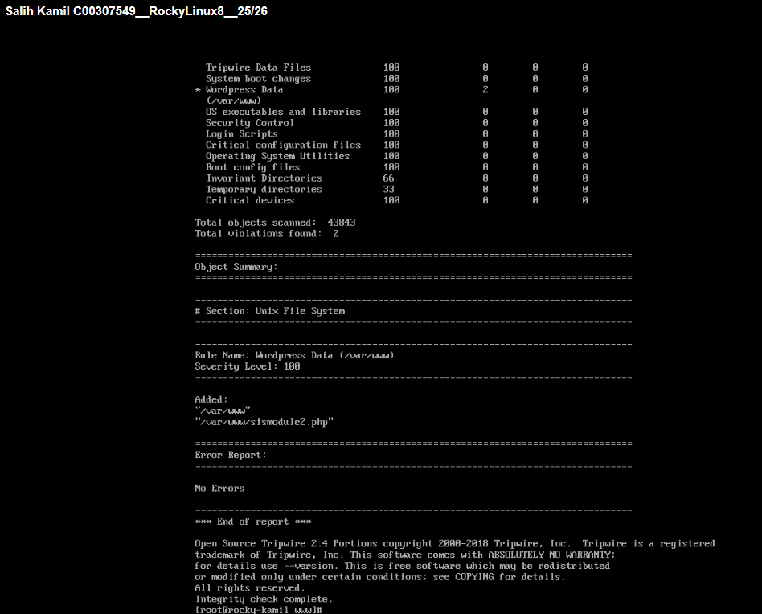

Step 5 - Where to Go From Here?
Now that Tripwire is installed and configured, you can explore additional options such as:
- Scheduling daily Tripwire checks and sending automatic email notifications for any violations. This would be useful for automating system integrity monitoring.

Step 6 - Discover Any Known Vulnerabilities And Exposures with Tripwire

Complete this:

Discover any known vulnerabilities and exposures with Tripwire:

- Search for vulnerabilities (CVEs) related to Tripwire at cvedetails.com or cve.org or cve.mitre.org
- Document one of the most recent CVE (Common Vulnerabilities and Exposures) related to Tripwire in the following format:

CVE-ID or Name: CVE-2024-4332
Max CVSS: 9.3 (Critical)
EPSS Score: 0.75%
Published: 03 June 2024
Brief Description:
CVE-2024-4332 is an authentication bypass vulnerability in the REST and SOAP APIs of Tripwire Enterprise 9.1.0. When LDAP/Active Directory SAML authentication and the “Auto-synchronize LDAP Users, Roles, and Groups” feature are enabled, attackers who know a valid username may bypass authentication. This could allow remote attackers to gain privileged API access and view or modify sensitive data.

Provide an analysis of how the implemented security measures address or mitigate these vulnerabilities:
Tripwire helps mitigate risks by monitoring system files and configurations for unauthorized changes. If an attacker exploits the vulnerability and modifies system data, Tripwire can detect these changes and alert administrators. Applying patches, restricting API access, and using strong authentication also help reduce the risk.

Which version(s) of Tripwire was the vulnerability found with? 9.1.0

Check which version of Tripwire you installed on your VM and take note of the version here: 2.4.3.7.0

