Lab 5A: Install and Configure Nagios


INSTRUCTIONS:
- Rename this document by substituting out FirstNameLastName with your own.
- Login and complete tasks as labuser.
- Complete this lab on your Ubuntu server.
- Complete all green boxes in this lab sheet.
- Submit your renamed document to the relevant submission link on Blackboard before the deadline.

- Before You Start
Ensure that your Lubuntu system is up-to-date by running:
sudo apt update
sudo apt upgrade

- Install Required Dependencies
Nagios has dependencies that need to be installed. Use apt to install them:
sudo apt-get install wget unzip curl openssl build-essential libgd-dev libssl-dev libapache2-mod-php php-gd php apache2 -y

- Download and Install Nagios Core:
Download and extract Nagios Core:
wget https://assets.nagios.com/downloads/nagioscore/releases/nagios-4.5.0.tar.gz

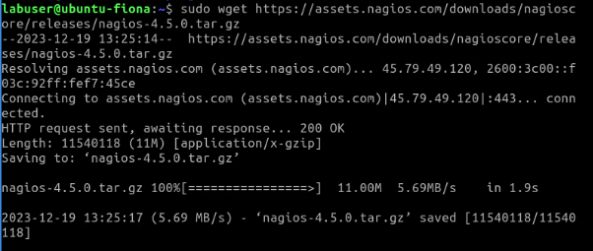

- Once downloaded, extract the downloaded file with the following command:
tar -xvzf nagios-4.5.0.tar.gz

- Change the directory to the extracted directory and configure the Nagios Core with the following command:
cd nagios-4.5.0

- Compile and install Nagios:
./configure --with-httpd-conf=/etc/apache2/sites-enabled
# You should get the following output:
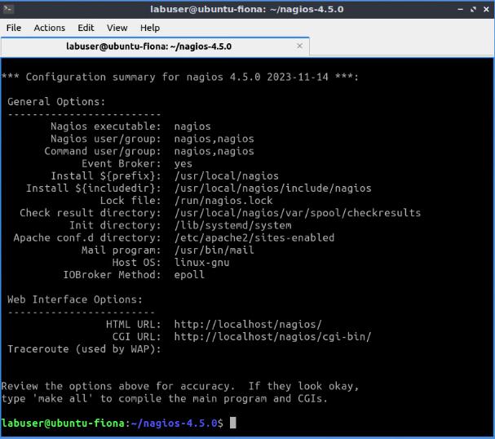

- Run the following command to compile the Nagios:
make all

- Create a Nagios user and group: and add Nagios user to the www-data group with the following command:
sudo make install-groups-users

sudo usermod -a -G nagios www-data

- Install the Nagios Core using the following command:
sudo make install

# You should get the following output:

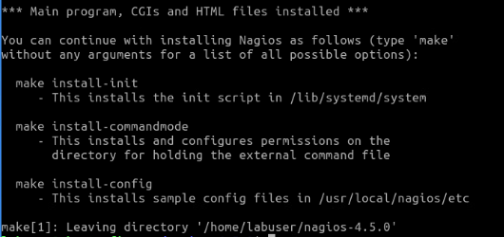

- Once the Nagios Core is installed, you will need to create a systemd service file to manage the Nagios service. You can create the systemd init script with the following command:
sudo make install-daemoninit

- Set the proper permission on the Nagios installation directory with the following command:
sudo make install-commandmode

- Create a sample Nagios configuration file with the following command:
sudo make install-config

- Install the Nagios web interface with the following command:
sudo make install-webconf

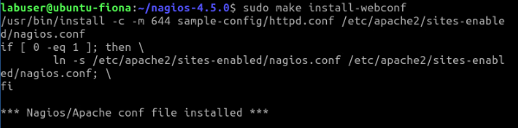

- Configure Apache: Enable Apache's CGI and rewrite modules:
sudo a2enmod cgi rewrite

- Restart the Apache service to apply the changes:
sudo systemctl restart apache2

- Install the theme for the Nagios web interface:
sudo make install-exfoliation

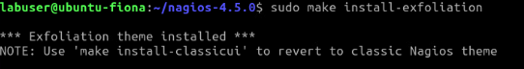

- Set Nagios Admin Password:
Set a password for the Nagios admin user:
sudo htpasswd -c /usr/local/nagios/etc/htpasswd.users nagiosadmin

Enter a password as prompted. I used the password labuser as it is easy to remember.

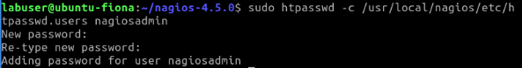

Install Nagios Plugins

- Next, you will need to download the Nagios plugins to monitor the system services. You can download it from the Git repository with the following command:
cd # to bring you back to your home directory
# note the command below is one long command
sudo wget https://github.com/nagios-plugins/nagios-plugins/releases/download/release-2.4.7/nagios-plugins-2.4.7.tar.gz

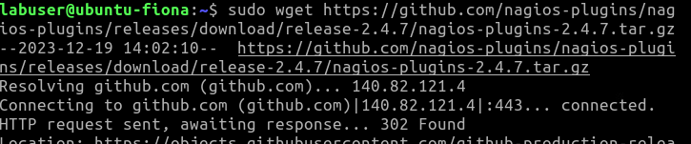

- Once downloaded, extract the downloaded file with the following command:
tar -xvzf nagios-plugins-2.4.7.tar.gz

- Change the directory to extracted directory and configure it with the following command:
cd nagios-plugins-2.4.7

./configure --with-nagios-user=nagios --with-nagios-group=nagios

- Install it with the following command:
make
make install

- Verify the sample Nagios configuration files before starting it with the following command:
sudo /usr/local/nagios/bin/nagios -v /usr/local/nagios/etc/nagios.cfg

# You should get the following output:

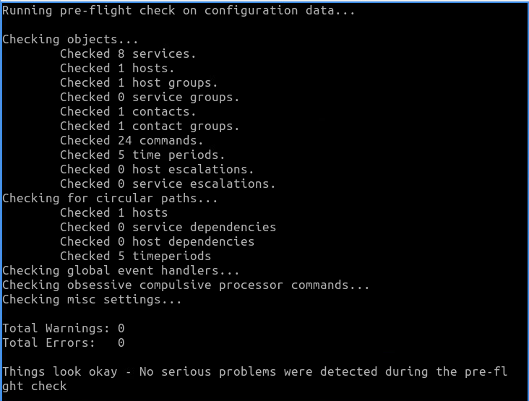
- Start and Enable Nagios Service:
sudo systemctl start nagios
sudo systemctl enable nagios
sudo systemctl status nagios

- Access Nagios Web Interface:
Open a web browser and navigate to:

http://localhost/nagios or http://<Your_ubuntu_IP_Address>/nagios.

Log in using the credentials you set earlier (nagiosadmin and the password labuser).

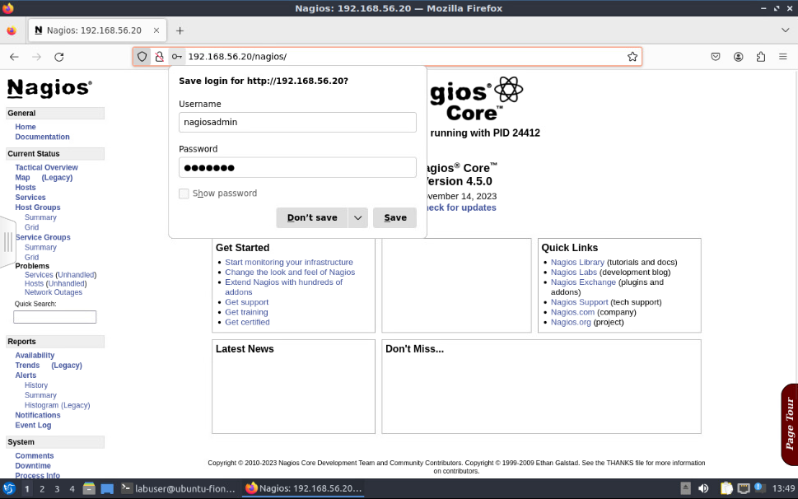

This lab provides a basic setup of Nagios on Ubuntu. Defining checks will require further configuration within Nagios. Examples of such configurations include adding hosts and services according to your requirements. Bear in mind, if you were accessing Nagios remotely, you would need to ensure you have proper firewall rules setup to allow access to Nagios' web interface.

Troubleshooting: Nagios Reports “check_ping not found”

If your localhost has a status of down and shows an error or systemctl status nagios reports an error similar to:
(No output on stdout) stderr: execvp(/usr/local/nagios/libexec/check_ping, ...) failed. errno is 2: No such file or directory

This indicates that Nagios Core is running but cannot execute a required plugin (it can’t find them).

Before proceeding, answer the following:
- Does the directory /usr/local/nagios/libexec exist? Yes
- Is it empty? No
- Did the plugins compile successfully? Yes
- Where did make install place the plugins? /usr/local/nagios/libexec
By doing a Google search of the error… one of the first results may be this forum link below. Investigate what it suggests.

https://askubuntu.com/questions/817827/no-output-on-stdout-stderr-execvp-usr-local-nagios-libexec-check-ping-in-ub

Your goal is to have your localhost with a status of UP like so:

Complete this box by pasting screenshot(s) of:

Your Ubuntu VM (with the name of your VM visible) showing Nagios successfully running in the browser and your localhost with a status of UP.

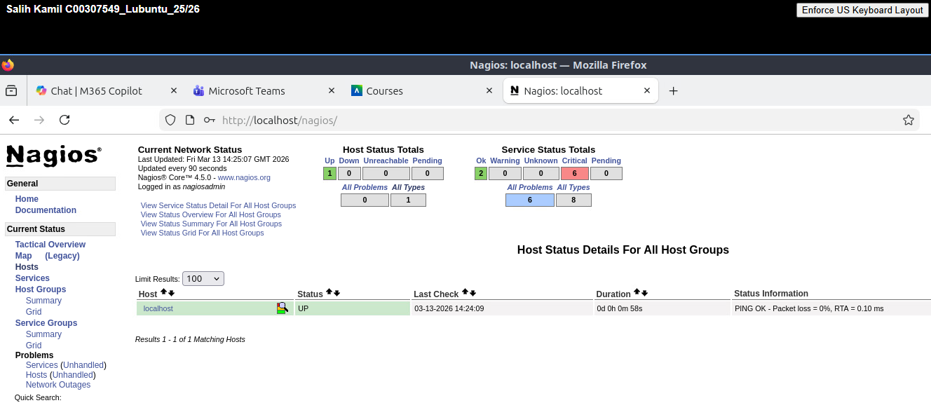

Using Nagios on Ubuntu 24.04
Nagios can monitor and manage many tasks including:
- Monitor Network Devices
- Monitor Servers
- Monitor Applications and Services
- Monitor System Metrics
- Alerting and Notifications
- Custom Monitoring
- Historical Reporting
- Downtime Scheduling
- Event Handlers

Add Rocky Linux Host in Nagios
- Now that Nagios is up and running on your Ubuntu server you should configure it to monitor your Rocky Linux Server.
Examine how your localhost is configured:
- Main config: /usr/local/nagios/etc/nagios.cfg
- Localhost (Lubuntu) config: /usr/local/nagios/etc/objects/localhost.cfg
- Notice how nagios.cfg references localhost.cfg.

To monitor Rocky Linux, what needs to happen?
- Hint: Create a new config file and include it in nagios.cfg

Create a config file for Rocky Linux:
sudo vi /usr/local/nagios/etc/objects/rocky.cfg

Ensure at least one service (e.g., ping) is defined
Make sure host and service names are correct

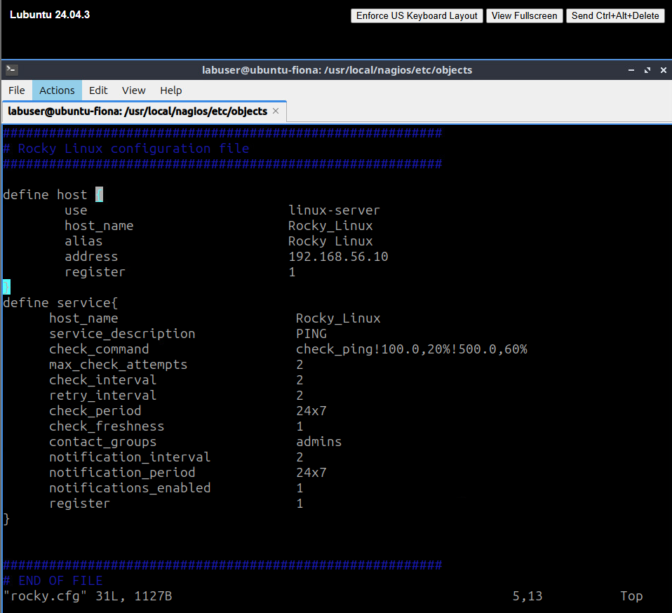
(to save yourself typing all this out you could search on the Lubuntu browser for the contents which you could paste in easily such as the one provided on this website but will need some careful tweaking:
https://tecadmin.net/monitor -remote-linux-host-using-nagios/
NOTE: You must define a host AND at least one service such as ping for that host for Nagios to recognise the host.
Include your new config file in nagios.cfg (similar to how localhost.cfg is included)
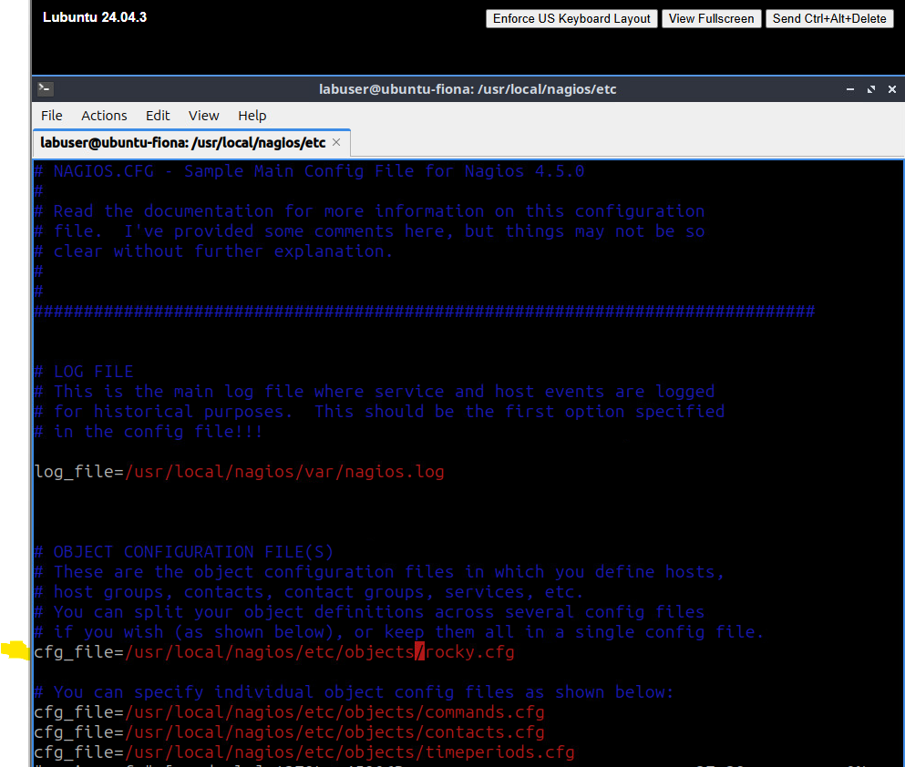

Validate and restart Nagios:
sudo /usr/local/nagios/bin/nagios -v /usr/local/nagios/etc/nagios.cfg
sudo systemctl restart nagios

Refresh Nagios web interface and verify your Rocky Linux host shows UP.
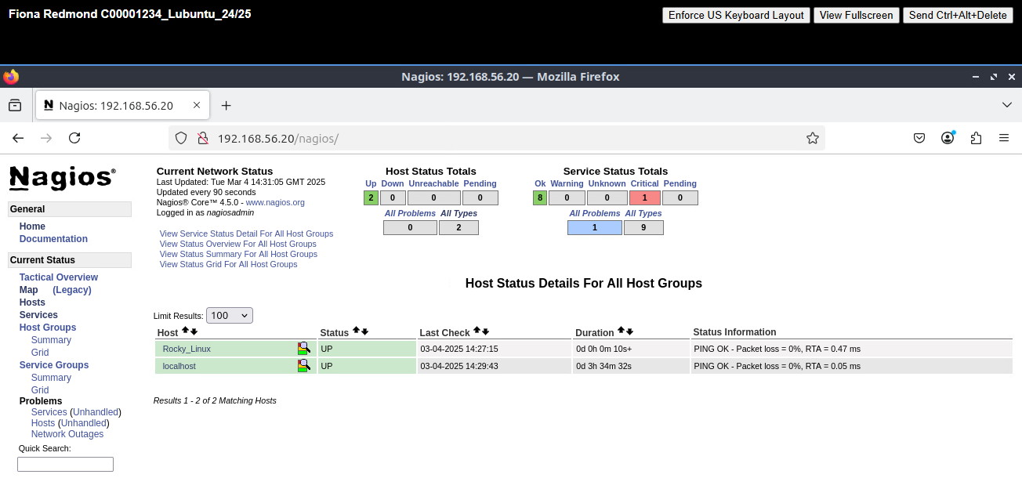

Complete this box by pasting screenshot(s) of:

Your Ubuntu VM (with the name of your VM visible) showing your Nagios system successfully monitoring your Rocky Linux server.

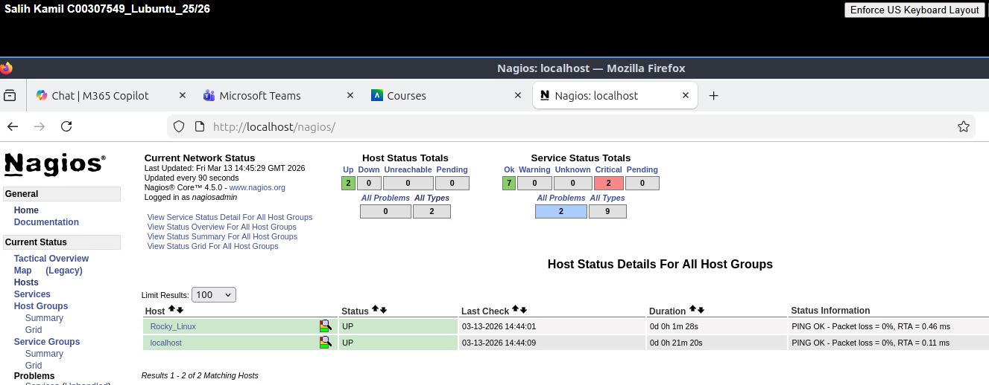

- Discover Any Known Vulnerabilities And Exposures with Nagios Core
Complete this:
Discover any known vulnerabilities and exposures with Nagios Core:

- Search for vulnerabilities (CVEs) related to Nagios Core at cvedetails.com or cve.org or cve.mitre.org
- Document one of the most recent CVE (Common Vulnerabilities and Exposures) related to Nagios Core in the following format:

CVE-ID or Name: CVE-2025-34286
Max CVSS: 9.4 (Critical)
Published: 2025-10-30
Brief Description: A remote code execution vulnerability in Nagios XI versions before 2026R1 allows an authenticated administrator to inject malicious commands through the CCM Run Check feature due to improper input validation, potentially allowing attackers to execute arbitrary commands on the server.

