Lab 7: Setting up Lynis

INSTRUCTIONS:

- Rename this document by substituting out FirstNameLastName with your own.
- Login and complete tasks as labuser.
- Complete this lab on your Ubuntu VM.
- Complete all green boxes in this lab sheet.
- Submit your renamed document to the relevant submission link on Blackboard before the deadline.

In this lab you will learn how to setup Lynis on Ubuntu and perform various security auditing scans and dive into the reports that the Lynis tool provides. Read on to start auditing!

- Update the System:
First, update your apt package repositories.
sudo apt update && sudo apt upgrade

- Update the package list:
Next, run the commands below to update the package list.
sudo apt-get -y update # Update the package list

- Install Lynis:
Install Lynis with the apt package manager.
sudo apt install lynis -y # Install Lynis

- Check the version of Lynis installed:
sudo lynis show version

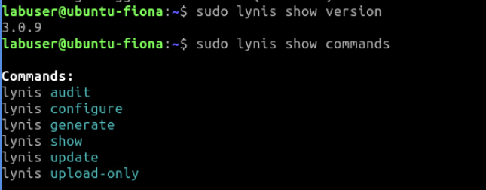

- Checking Lynis Commands and Settings
With Lynis installed, it is time to check some of its commands and configuration options. Run the show command with the commands argument to see all of the various Lynis commands.

sudo lynis show commands

Lynis has various settings to customise its behaviour. Run lynis show settings to inspect the multiple settings defined in the Lynis configuration file. The configuration file is generally located at the /etc/audit directory.

When Lynis runs, it looks for the configuration file in the /etc/audit directory first. Failing to find it, it will attempt to find it in your home directory.

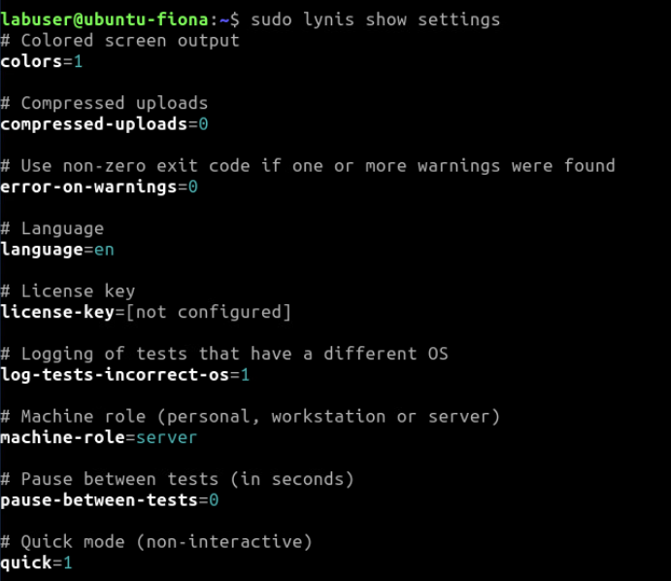

For a complete list of Lynis options and syntax, run the man lynis command.

- Invoking an Audit
Lynis is an auditing tool, so let’s run your first security audit. When you run a security audit, Lynis checks the system and software configuration for any security issues. Run the lynis audit system command as seen below to perform an audit on your system.

Running Lynis as root (or another user with full rights) is recommended to test everything available on your system. The scan will offer recommendations for improvement and show which parts of your system lack security hardening.

sudo lynis audit system

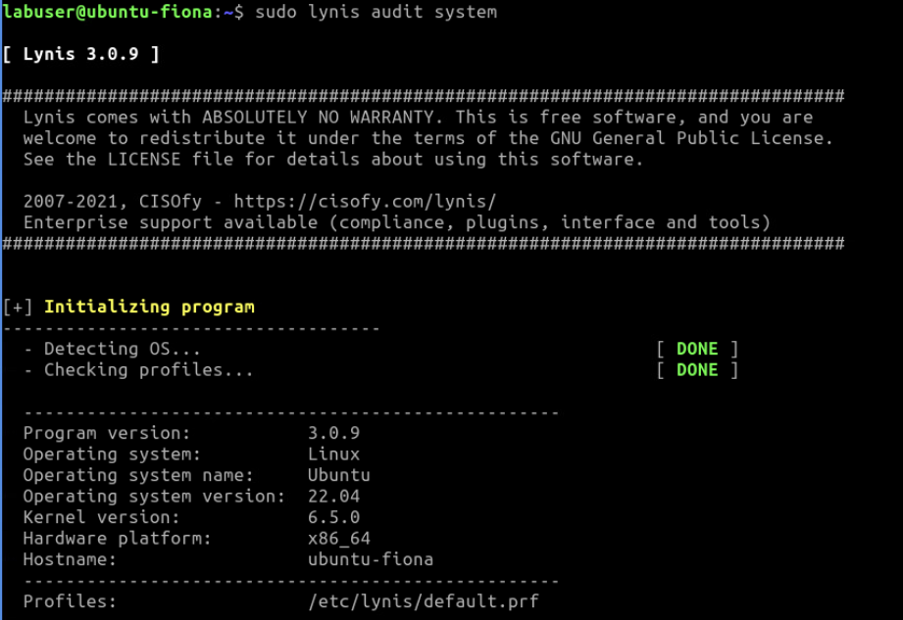
The result of the command is an extensive report, which you will see broken down in the following sections. So, keep in mind that the next screenshots are the result of running the lynis audit system report.

- Understand the Audit Report
Recall from the chapter notes, the system audit provides an extensive report of various areas, including:

- Directories and files related to logging and auditing
- Services like the SSH daemon, Apache web server, MySQL database, and others
- Security aspects like password strength, file system quotas, and memory usage (heap)

To categorise severity, Lynis has several status states and also color-coded results indicating the severity of each issue found.
- OK – All required tests were completed successfully.
- WARNING – A problem that should be checked and fixed when possible.
- FAIL – A test failed that may affect system security.
- FOUND – Lynis found the requested object, usually used for locating specific files.
- NOT FOUND – Lynis was unable to locate the requested object.
- SUGGESTION – A non-critical suggestion that should be evaluated for action.
- DONE – Typically used to indicate that a task is done, such as querying data.

Space doesn’t permit me to show the entire scan output, but I can show you a couple of example snippets:

Understanding Users, Groups and Authentication Results
Users, groups and Authentication Scanning admin accounts, UIDs, GIDs, /etc/passwd, sudoers & PAM files, password aging, single-user mode, failed login & umask.

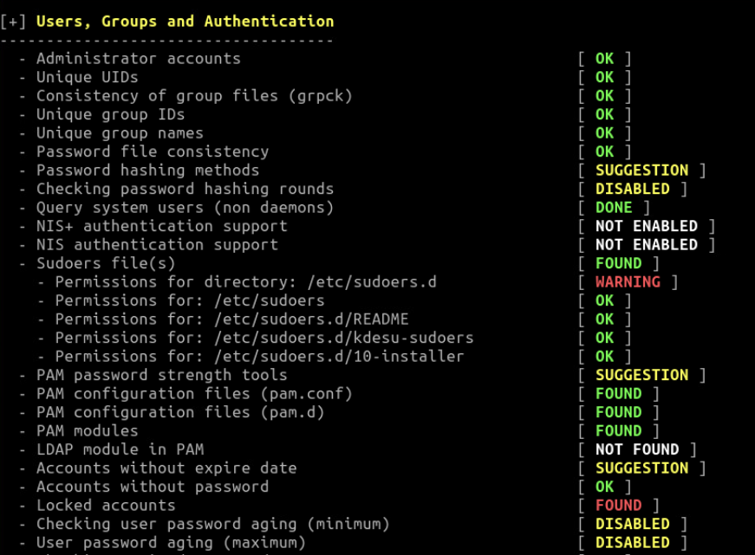

Understanding “Kernel” Results
In Kernel Scanning run level, CPU support, kernel version, kernel type, /etc/inittab & loaded kernel modules.
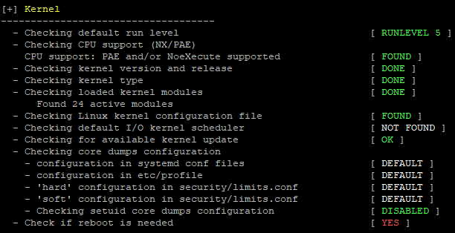
Evaluating “Memory and Processes” Results
Lynis performs many tests to check how much memory is in use and other related process issues. For example, when an application uses too much memory, it can become a Denial of Service (DoS) vector. Lynis checks if services such as like httpd or sshd are leaking information.

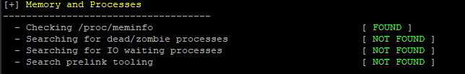

Verifying “Software: firewalls” Results
Checking the iptables kernel module, used policies of iptables chains. Also verify software firewalls like CSF, UCF, etc. It checks the configuration of firewalls and local services, it collects data for further analysis.
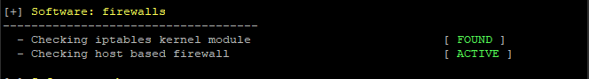

System Boot and Services are scanned and show booting and service issues present in the system.

[+] Boot and services
------------------------------------
- Service Manager [ systemd ]
- Checking UEFI boot [ DISABLED ]
- Checking presence GRUB [ OK ]
- Checking presence GRUB2 [ FOUND ]
- Checking for password protection [ WARNING ]
- Check running services (systemctl) [ DONE ]
Result: found 21 running services
- Check enabled services at boot (systemctl) [ DONE ]
Result: found 28 enabled services
- Check startup files (permissions) [ OK ]

This warning message shows that I don’t have password protection for my GRUB2 bootloader. That may or may not be a big deal because the only way someone can exploit it is to gain physical access to the machine. If it’s a server that’s locked away in a room that only a few trusted individuals can access, then I’m not going to worry about it, unless rules from an applicable regulatory agency dictate that I do. If it’s a desktop machine that’s out in an open cubicle, then I would fix that.

In the File systems section, we can see some items with the SUGGESTION flag next to them. File System Scans available mount points and check if mounted separately or mounted on / file system. Also checking the mount point flags and added properly. fstab file, swap partition, /proc, /tmp and /tmp sticky bit.

[+] File systems
------------------------------------
- Checking mount points
- Checking /home mount point [ SUGGESTION ]
- Checking /tmp mount point [ SUGGESTION ]
- Checking /var mount point [ SUGGESTION ]
- Query swap partitions (fstab) [ OK ]
- Testing swap partitions [ OK ]
- Testing /proc mount (hidepid) [ SUGGESTION ]
- Checking for old files in /tmp [ OK ]
- Checking /tmp sticky bit [ OK ]
- ACL support root file system [ ENABLED ]
- Mount options of / [ NON DEFAULT ]

Malware Scanning malware related tools like chkrootkit, Rootkit Hunter, LMD & clamscan.

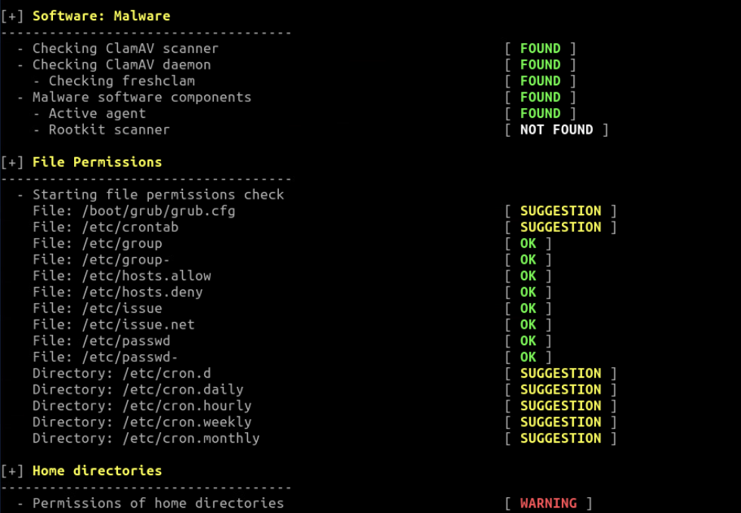

File Permissions scanning in this for all kind of file permissions

Warnings and Suggestions
After the scanning is finished Warnings and Suggestions details are improvised for us to improve the security of the system and also to rectify any issues that are there in the system.

For example, the warning below tells you Lynis performed a system scan, and you should reboot the host due to a probable kernel upgrade. You’ll see that each warning has a test ID associated with it. In this case, the ID is TIME-3185. You can find more about the warning through its ID.

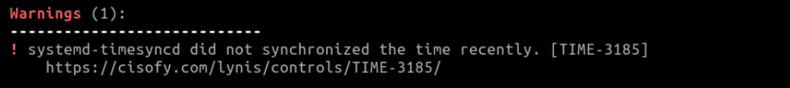

Let’s dig into a specific warning. To do that, run the show details command providing the test ID you want to know more about. The same TIME-3185 as before, for example. The full command follows.

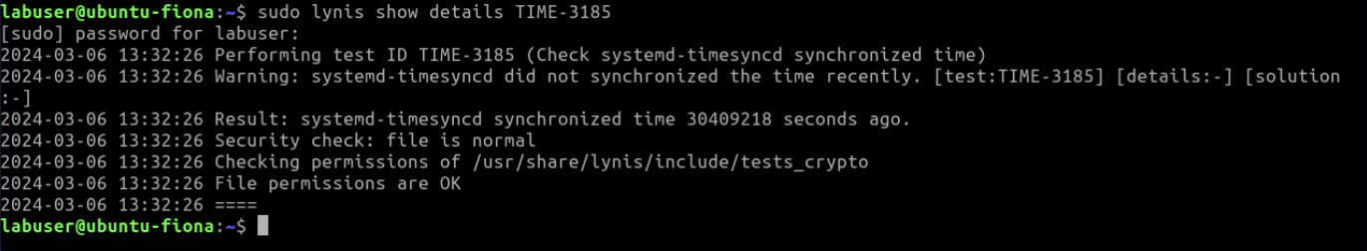
You can find the test ID for suggestions precisely the same as you can with warnings.

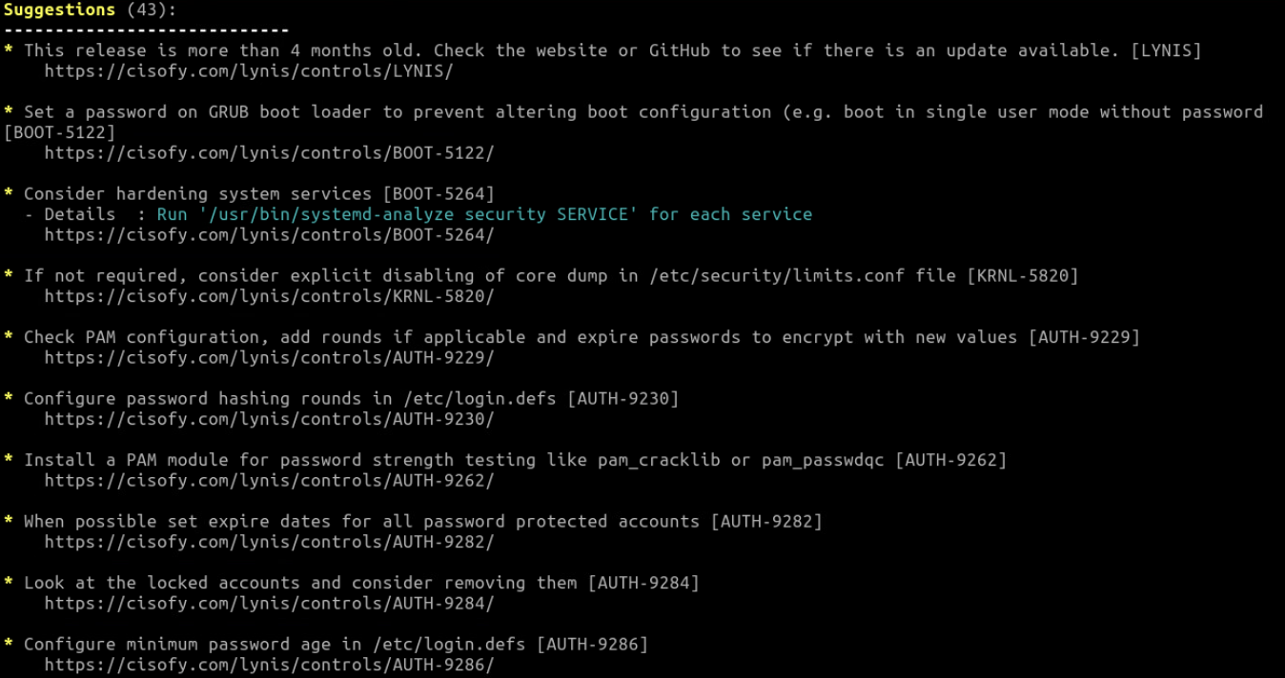

Here, I get detailed information from the report about every suggestion so I show details of 1 of the 43 suggestions reported:

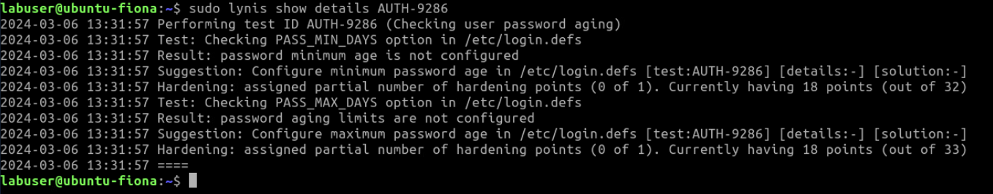

Lynis Hardening Index is a unique index to Lynis which gives the auditor an idea of how well a system is hardened. The number is an indicator of measures taken. To implement security safeguards firstly determine the findings present in the system and apply all the measures or suggestions given after scanning. Hardening Lynis and Unix Systems are essential to get security inline with security policies.

The last thing we’ll look at is the scan details section at the end of the output:

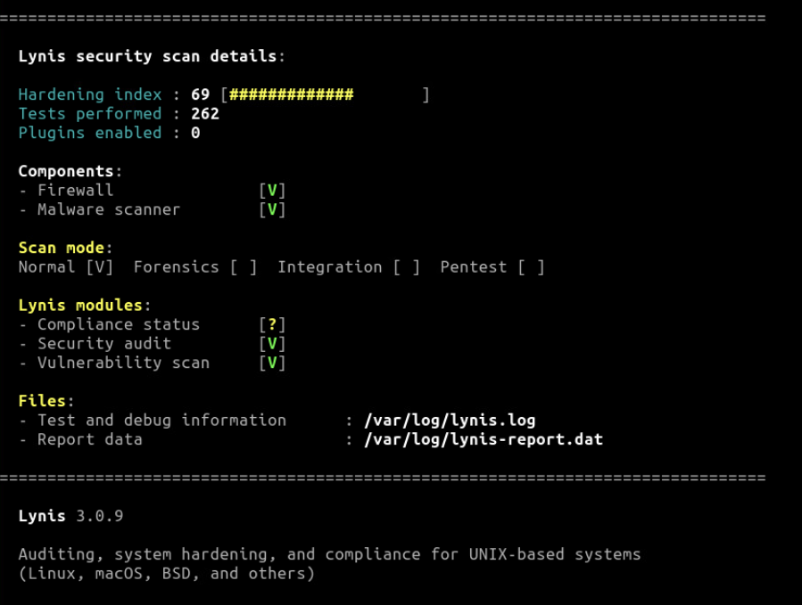

Complete this box by pasting screenshot(s) of:

Your Ubuntu VM (with the name of your VM visible) to show that you got Lynis successfully installed and setup by running a security audit.

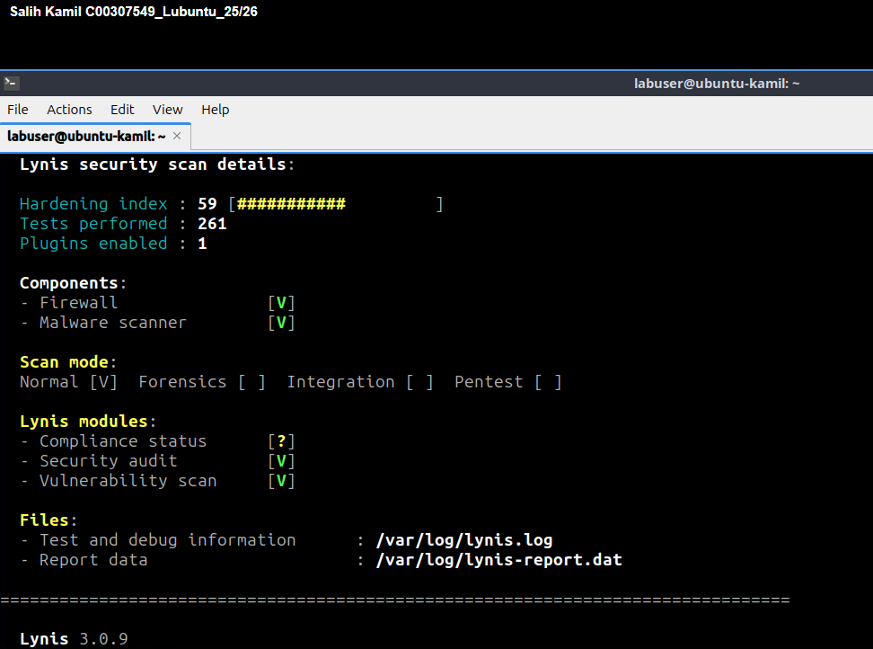

- Discover Any Known Vulnerabilities And Exposures with Lynis

Complete this:

Discover any known vulnerabilities and exposures with Lynis:

- Search for vulnerabilities (CVEs) related to Lynis at cvedetails.com or cve.org or cve.mitre.org
- Document one of the most recent CVE (Common Vulnerabilities and Exposures) related to Lynis in the following format:

CVE-ID or Name: CVE-2020-13882
Max CVSS: Not explicitly provided in the source; TOCTOU (race condition) vulnerabilities are typically medium severity (~5–6) depending on context.
EPSS Score: Not provided in the CVE record
Published: 2020-06-18
Brief Description: CISOfy Lynis versions before 3.0.0 have an Incorrect Access Control vulnerability due to a TOCTOU (Time-of-Check to Time-of-Use) race condition. The routine that checks log and report file permissions could be bypassed locally. An unprivileged attacker could manipulate log/report files during the permission check, potentially enabling unauthorized file access or additional local attacks.

Provide an analysis of how the implemented security measures address or mitigate these vulnerabilities:
The vulnerability is caused by a TOCTOU race condition in file permission checks. It is mitigated by running Lynis with proper file permissions, using atomic file operations, limiting user privileges, and updating to Lynis ≥ 3.0.0, which fixes the issue.
Which version(s) of Lynis was the vulnerability found with? Versions before 3.0.0

Check which version of Lynis you installed on your VM and take note of the version here: 3.0.9

